**Activity Sheet Name Lesson 7**

**Chemical Reactions**

**Part 1 - What is a Chemical Reaction? Date**

# DEMONSTRATION

1. **Your teacher lit a candle and told you that this was a chemical reaction. What are the *reactants* in this chemical reaction?**
2. **What are the *products* in this chemical reaction?**
3. **Where do the atoms come from that make the carbon dioxide and the water on the right side of the equation?**

**CH4**

methane

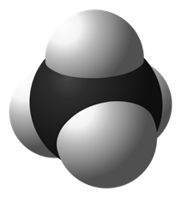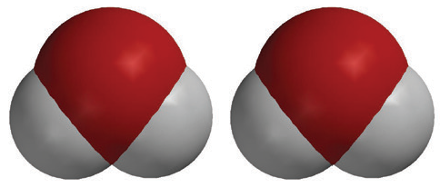

**2O2**

oxygen

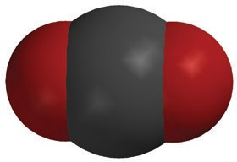

**CO2**

carbon dioxide

**2H2O**

water

+

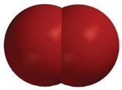

+



# ACTIVITY

## Question to Investigate

Where do the atoms in the products of a chemical reaction come from?

## Materials for Each Student

* + Atom model cut-outs (carbon, oxygen, and hydrogen)
  + Sheet of colored paper or construction paper
  + Colored pencils
  + Scissors
  + Glue or tape

## Procedure

### Prepare the Atoms

1. Color the carbon atoms black, the oxygen atoms red, and leave the hydrogen atoms white.
2. Use scissors to carefully cut out the atoms.

### Build the Reactants

1. On a sheet of paper, place the atoms together to make the molecules of the reactants on the left side of the chemical equation for the combustion of methane.
2. Write the chemical formula under each molecule of the reactants. Also draw a plus sign (+) sign between the reactants.

### Build the products

1. Draw an arrow after the second oxygen molecule to show that a chemical reaction is taking place.
2. Rearrange the atoms in the reactants to make the molecules in the products on the right side of the arrow.
3. Write the chemical formula under each molecule of the products. Also draw a + sign between the products.

Tell students that in a chemical reaction, the atoms in the reactants come apart, rearrange, and make new bonds to form the products.

### Represent the chemical equation

1. Use your remaining atoms to make the reactants again to represent the chemical reaction as a complete chemical equation.
2. Glue or tape the atoms to the paper to make a more permanent chemical equation of the combustion of methane.

# EXPLAIN IT WITH ATOMS & MOLECULES

# In a chemical equation, like the one below, you will notice that there are regular-sized numbers in front of some of the molecules and small numbers after certain atoms within a molecule. The little number is called the subscript and tells how many of a certain type of atom are in a molecule. The bigger number is called the coefficient and tells how many of a particular type of molecule there are.

If there is a coefficient in front of the molecule and a subscript after an atom, multiply the coefficient and the subscript to get the number of atoms. For example, in the products of the chemical reaction there are two water molecules, or 2H2O. The coefficient means that there are two molecules of water. The subscript means that each water molecule has two hydrogen atoms. Since each water molecule has 2 hydrogen atoms and there are two water molecules, there must be (2 × 2) = 4 hydrogen atoms.

**CH4**

methane



**2O2**

oxygen



**CO2**

carbon dioxide

**2H2O**

water

+



+



**4. Count the number of atoms on each side of the equation below and write this in the chart.**

|  |  |  |
| --- | --- | --- |
| **CH4 + 2O2 CO2 + 2H2O** | | |
| **Atom** | **Reactants** | **Products** |
| Carbon |  |  |
| Hydrogen |  |  |
| Oxygen |  |  |

**5. Are atoms created or destroyed in a chemical reaction?**

**How do you know?**

**6. In a physical change, like changing state from a solid to a liquid, the sub- stance itself doesn’t really change. How is a chemical change different from a physical change?**

# TAKE IT FURTHER

# Molecules made up of only carbon and hydrogen are called hydrocarbons. The candle and the hydrocarbons listed below react with oxygen in a chemical reaction called combustion.

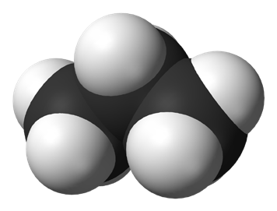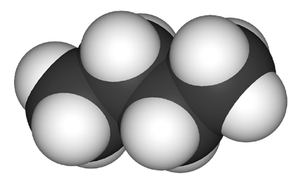

**CH4**

methane

**C3H8**

propane

**C4H10**

butane

Fuel in gas stoves in many home kitchens

Fuel in outdoor gas grills

Fuel in disposable lighters

**7. Count the number of carbon, hydrogen, and oxygen atoms in the reactants and products of each equation to see if the equation is balanced. Record the number of each type of atom in each chart.**

Combustion of Propane C3H8 + O2  3CO2 + 4H20

|  |  |  |
| --- | --- | --- |
| **C3H8 + 5O2** | | **3CO2 + 4H2O** |
| **Atom** | **Reactant side** | **Product side** |
| Carbon |  |  |
| Hydrogen |  |  |
| Oxygen |  |  |

2C4H10 + 13O2 8CO2 + 10H2O Combustion of Butane

|  |  |  |
| --- | --- | --- |
| **2C4H10 + 13O2** | | **8CO2 + 10H2O** |
| **Atom** | **Reactant side** | **Product side** |
| Carbon |  |  |
| Hydrogen |  |  |
| Oxygen |  |  |

**Activity Sheet Name Lesson 7**

**Part 2 – Production of a Gas Date**

DEMONSTRATION

1. **Your teacher combined a liquid (vinegar) and a solid (baking soda). You observed bubbling, which is made from gas. Do you think a chemical reaction occurred?**

**Why?**

1. **Look at the chemical equation for the reaction between vinegar and baking soda to answer the following questions.**

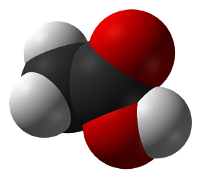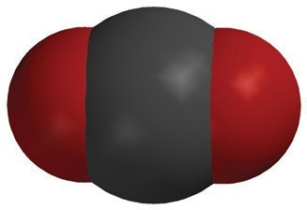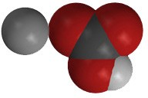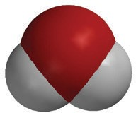

+

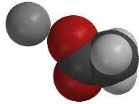

+

+

**C2H4O2**

acetic acid

**NaHCO3**

sodium bicarbonate

**NaC2H3O2**

sodium acetate

**H2O**

water

**CO2**

carbon dioxide

**What are the *reactants* in this chemical reaction?**

**What are the *products* in this chemical reaction?**

1. **How many of each type of atom appears on each side of the chemical equation?**

|  |  |  |
| --- | --- | --- |
| **C2H4O2 + NaHCO3 NaC2H3O2 + H2O + CO2** | | |
| **Atom** | **Reactants** | **Products** |
| Carbon |  |  |
| Hydrogen |  |  |
| Oxygen |  |  |
| Sodium |  |  |

1. **What does the statement “*Mass* is conserved during a chemical reaction” mean?**

# ACTIVITY

## Question to investigate

How can you make just the right amount of foam that rises to the top of the graduated cylinder without overflowing?

## Materials for each group

* + Vinegar in a cup
  + Baking soda in a cup
  + Detergent solution in a cup
  + Dropper
  + Graduated cylinder (50 mL)
  + Measuring spoons (⅛, ¼, and ½ teaspoon)
  + Plastic waste container

## Procedure

1. Decide on how much vinegar and baking soda you will use and write these amounts in the chart on the activity sheet.
2. Use a graduated cylinder to measure the amount of vinegar your group agreed on.
3. Cartoon of girls wearing glasses and holding glasses and measuring thermometer

   Description automatically generatedPour the vinegar in a small cup and add 1 drop of detergent. Swirl gently to mix.
4. Add the amount of baking soda your group agreed on to the empty graduated cylinder.
5. Place the graduated cylinder in a plastic waste container.
6. Pour the vinegar and detergent from the cup into the graduated cylinder. Observe the level of foam in the graduated cylinder.
7. Rinse the graduated cylinder over the waste container.

|  |  |  |  |  |
| --- | --- | --- | --- | --- |
| **Adjust the amounts of baking soda and vinegar to create just enough foam to rise to the top of the graduated cylinder without overflowing.** | | | | |
|  | **Demonstration** | **First try** | **Second try** | **Third try** |
| Vinegar | 10 mL |  |  |  |
| Baking soda | 1/2 teaspoon |  |  |  |
| Detergent | 1 drop | 1 drop | 1 drop | 1 drop |
| How close did the foam get to the top of the cylinder? | Overflowed |  |  |  |

# EXPLAIN IT WITH ATOMS & MOLECULES



+



+

+

**C2H4O2**

acetic acid

**NaHCO3**

sodium bicarbonate

**NaC2H3O2**

sodium acetate

**H2O**

water

**CO2**

carbon dioxide

1. **Why, on the molecular level, does changing the amount of baking soda or vinegar affect the amount of carbon dioxide gas produced?**
2. **What would you do if you wanted to make more carbon dioxide?**
3. **Could you just keep adding more and more baking soda to the same amount of vinegar to get more carbon dioxide?**

**Why or why not?**

**Activity Sheet Name Lesson 7**

**Part 3 - Forming a Precipitate Date**

# A person pouring liquid into a glass Description automatically generatedDEMONSTRATION

1. **Your teacher combined two clear colorless solutions. One was a sodium carbonate solution and the other was a magnesium sulfate solution. Do you think a chemical reaction occurred when these two substances were combined?**

**Why or why not?**

1. **What is a precipitate?**

# ACTIVITY

## Question to Investigate

How do you know when a precipitate is formed in a chemical reaction?

## Materials for Each Group

* 1. Baking soda
  2. Calcium chloride
  3. Water
  4. Graduated cylinder
  5. Measuring spoon (½ teaspoon) or balance
  6. 2 clear plastic cups
  7. Masking tape
  8. Pen

## Procedure

1. Use masking tape and a pen to label 2 plastic cups *Baking Soda Solution* and *Calcium Chloride Solution*.
2. Use a graduated cylinder to add 20 mL of water to each cup.
3. A person pouring water into a glass

   Description automatically generatedAdd 2 g (about ½ teaspoon) of calcium chloride to the water in its labeled cup. Swirl until as much of the calcium chloride dissolves as possible.
4. Add 2 g (about ½ teaspoon) of baking soda to the water in its labeled cup. Swirl until as much of the baking soda dissolves as possible. Some undissolved baking soda may remain in the bottom of the cup.
5. Carefully pour the baking soda solution into the calcium chloride solution. Try not to pour in any undissolved baking soda. Observe.
6. **What do you observe when you combine baking soda solution and calcium chloride solution?**
7. **How do you know that a chemical reaction occurs when you combine baking soda solution and calcium chloride solution?**

# EXPLAIN IT WITH ATOMS & MOLECULES

1. **Look at the chemical equation for the reaction between calcium chloride and sodium bicarbonate and answer the following questions.**

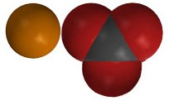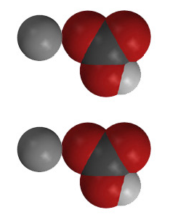

+

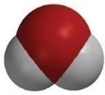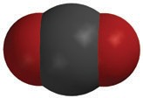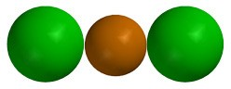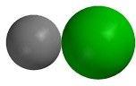

+

+

+

**CaCl2**

calcium chloride

**2NaHCO3**

sodium bicarbonate

**CaCO3**

calcium carbonate

**2NaCl**

sodium chloride

**H2O**

water

**CO2**

carbon dioxide

**What gas is produced in the chemical reaction?**

**What do you think is the precipitate?**

|  |  |  |
| --- | --- | --- |
| **How many of each type of atom appears on each side of the chemical equation?** | | |
| **Atom** | **Reactant side** | **Product side** |
| Calcium |  |  |
| Chlorine |  |  |
| Sodium |  |  |
| Hydrogen |  |  |
| Carbon |  |  |
| Oxygen |  |  |

# ACTIVITY

## Question to Investigate

Can you separate the calcium carbonate from the rest of the products?

## Materials for Each Group

* Coffee filter or paper towel
* Tall clear plastic cup

## Procedure

1. A cartoon of a child pouring milk into a glass

   Description automatically generatedUse a large enough coffee filter (or paper towel) so that you can push it about ⅓ of the way into the cup and still have enough left to hold it around the outside of the cup.
2. While holding the coffee filter in place, pour the products into the center of the coffee filter.
3. Allow the liquid to drip through the filter. This may take 5-10 minutes.
4. Set the precipitate aside and allow the water to evaporate.
5. **Is filtering the calcium carbonate and allowing the water to evaporate a chemical change or a physical change?**

**Why?**

# ACTIVITY

## Question to Investigate

Is the solubility of the precipitate different than the solubility of baking soda and calcium chloride?

**Materials for Each Group**

* Dry precipitate on paper towel
* Balance
* 3 small plastic cups
* Graduated cylinder
* ¼ teaspoon
* Popsicle stick (optional)
* Calcium chloride
* Baking soda
* Water

**Procedure**

1. Label 3 cups sodium bicarbonate, calcium chloride, and precipitate.
2. Use a spoon or popsicle stick to scrape the precipitate into a pile.
3. Scoop up the precipitate into a ¼ teaspoon until it is as full as possible. Place the ¼ teaspoon of precipitate into its labeled cup.
4. A hand pouring liquid into a measuring cup

   Description automatically generatedPlace ¼ teaspoon of sodium bicarbonate and calcium chloride into their labeled cups.
5. Add 25 mL of water to each cup and gently swirl until the solids dissolve as much as possible. Look to see the amount of solid that remains undissolved in each cup.

**7. Did the precipitate dissolve like the sodium bicarbonate and the calcium chloride?**

**Explain how this is evidence that a chemical reaction took place.**

***Take it Further***

1. **Use objects such as gum drops, beads, M&Ms, Legos, or other small objects to represent the atoms in two of the three chemical reactions you have covered. The three chemical equations are written below. Tape or glue the objects to poster board and write down the chemical formula for the reactants and products.**

**CH4**

methane



**2O2**

oxygen



**CO2**

carbon dioxide

**2H2O**

water

+



+



+



+

+

**C2H4O2**

acetic acid

**NaHCO3**

sodium bicarbonate

**NaC2H3O2**

sodium acetate

**H2O**

water

**CO2**

carbon dioxide



+



+

+

+

**CaCl2**

calcium chloride

**2NaHCO3**

sodium bicarbonate

**CaCO3**

calcium carbonate

**2NaCl**

sodium chloride

**H2O**

water

**CO2**

carbon dioxide

**Activity Sheet Name Lesson 7 – Part 4**

**Energy Changes in Chemical Reactions Date**

# ACTIVITY

## Question to Investigate

Does the temperature increase, decrease, or stay the same in the reaction between baking soda and vinegar?

## Materials

* Vinegar in a cup
* Baking soda in a cup
* Thermometer

## A hand pouring a liquid into a measuring cup Description automatically generatedProcedure

1. Place a thermometer in the vinegar. Read the thermometer and record the temperature on the activity sheet.
2. While the thermometer is in the cup, add all the baking soda from your cup.
3. Watch the thermometer to observe any change in temperature. Record the temperature after it has stopped changing.
4. **Did the temperature increase, decrease, or stay the same when you combined baking soda and vinegar?**
5. **What is the lowest temperature reached during your group’s reaction?**

## Question to Investigate

Does the temperature increase, decrease, or stay the same in the reaction between baking soda solution and calcium chloride?

## Materials

* + Baking soda solution in a cup
  + Calcium chloride in a cup
  + Thermometer

## Procedure

1. Place a thermometer in the baking soda solution. Read the thermometer and record the temperature on the activity sheet.
2. While the thermometer is in the cup, add all the calcium chloride from the cup.
3. Watch the thermometer to observe any change in temperature. Record the temperature when it stops changing.
4. **Did the temperature increase, decrease, or stay the same when you combined baking soda solution and calcium chloride?**
5. **What is the highest temperature reached during your group’s reaction?**

# EXPLAIN IT WITH ATOMS & MOLECULES

When the temperature of a chemical reaction decreases, the reaction is called an *endothermic* reaction. When the temperature of a chemical reaction increases, the reaction is called an *exothermic* reaction.

**Vinegar and baking soda reaction**



+



+

+

**C2H4O2**

acetic acid

**NaHCO3**

sodium bicarbonate

**NaC2H3O2**

sodium acetate

**H2O**

water

**CO2**

carbon dioxide

1. **Is this an endothermic or exothermic reaction? _____________________**
2. **For the reaction between vinegar and baking soda, draw an energy arrow on the reactant side and another on the product side to compare the amount of energy used and released during the reaction.**
3. **What do the arrows show about the amount of energy required to break the bonds of the reactants compared to the amount of energy released when the products are formed?**

**Baking soda solution and calcium chloride reaction**



+



+

+

+

**CaCl2**

calcium chloride

**2NaHCO3**

sodium bicarbonate

**CaCO3**

calcium carbonate

**2NaCl**

sodium chloride

**H2O**

water

**CO2**

carbon dioxide

1. **Is this an endothermic or exothermic reaction? _______________________**
2. **For the reaction between baking soda and calcium chloride, draw an energy arrow on the reactant side and another on the product side to compare the amount of energy used and released during the reaction.**
3. **What do the arrows show about the amount of energy required to break the bonds of the reactants compared to the amount of energy released when the products were formed?**

# TAKE IT FURTHER

**11. This is the chemical equation you saw back in Lesson 1. Now that you know more about atoms, molecules, and chemical reactions, explain why this is a balanced chemical equation.**

