**Lesson 4: The Water Molecule and Dissolving**

**Storyline Summary:**

Students have now been introduced to the water molecule and how it is covalently bonded. In this series of lessons students learn that water is a *polar* molecule which makes water molecules attract one another and kind of “stick” to each other.

In addition, because of its polarity, water is capable of dissolving more substances than any other molecule. Water easily dissolves salt in our oceans and sugar in our coffee by pulling the molecules away from each other into smaller and smaller pieces we can no longer see. Understanding the dissolving power of the polarity of water will be key as students learn more about what other substances are dissolved into our oceans and how they influence its acidity.

**Note:** This lesson includes four parts. Depending on the length of time you spend on each component, this lesson will probably take at least four class periods.

**What Students Do**

**Part 1** - Students look closely at the bonding of hydrogen and oxygen in a water molecule to discover the polar nature of the water molecule. Students do an activity comparing the evaporation of water to less polar isopropyl alcohol.

**Part 2** – Students investigate surface tension and see that the polar nature of water molecules contributes to the phenomenon of surface tension.

**Part 3** – Students compare the solubility of salt in water and in alcohol to see that the more polar water is a better dissolver of the ionic substance, salt.

**Part 4** – Students compare the solubility of sugar in water, alcohol, and oil to see that the more polar water is a better dissolver of the polar substance, sugar.

**What Students Learn**

* Water is a polar molecule.
* The polarity of water molecules makes water a good dissolver of ionic and polar substances.

**Materials & Preparation**

**Part 1 – Water is a Polar Molecule**

***Materials for Each Group***

* Styrofoam water molecule models from Chapter 2, Lesson 2 (two per student)
* Permanent markers (blue and red)
* Isopropyl alcohol (70% or higher)
* Water
* Brown paper towel
* Droppers

**Part 2 – Surface Tension**

***Materials for the Demonstration***

* 1 clear plastic cup
* Water
* 1 standard size paper clip
* 1 large paper clip

***Materials for Each Group***

* Water
* Isopropyl alcohol (70% or higher)
* Dish detergent in cup
* Test tubes
* 2 pennies
* 2 droppers
* 2 toothpicks

**Part 3 – How Does Water Dissolve Salt?**

***Materials for Each Group***

* Construction paper, any color
* Scissors
* Tape or glue
* Water
* Isopropyl alcohol (70% or higher)
* Salt
* Balance
* 2 clear plastic cups
* 2 small plastic cups
* Graduated cylinder

**Part 4 – How Does Water Dissolve Sugar?**

***Materials for Each Group***

* M&M’s
* Water
* Mineral oil
* Isopropyl alcohol (70%)
* Small white plastic plate
* 3 clear plastic cups
* White paper

**Part 1: Water is a Polar Molecule**

(From Middle School Chemistry – Chapter 5, Lesson 1)

***Key Concepts***

* The water molecule, as a whole, has 10 protons and 10 electrons, so it is neutral.
* In a water molecule, the oxygen atom and hydrogen atoms share electrons in covalent bonds, but the sharing is not equal.
* In the covalent bond between oxygen and hydrogen, the oxygen atom attracts electrons a bit more strongly than the hydrogen atoms.
* The unequal sharing of electrons gives the water molecule a slight negative charge near its oxygen atom and a slight positive charge near its hydrogen atoms.
* When a neutral molecule has a positive area at one end and a negative area at the other, it is a *polar* molecule.
* Water molecules attract one another based on the attraction between the positive end of one water molecule and the negative end of another.

***Summary***

Students will be introduced to the idea that water has a slight positive charge at one end of the molecule and a slight negative charge at the other (a polar molecule). Students view animations, make illustrations, and use their own water molecule models to develop an understanding of how the polar nature of water molecules can help explain some important characteristics of water.

***Objective***

Students will be able to explain, on the molecular level, what makes water a polar molecule. Students will also be able to show in a drawing that the polar nature of water can explain some of water’s interesting characteristics and help explain its evaporation rate compared to a less polar liquid.

***Evaluation***

The activity sheet will serve as the “Evaluate” component of each 5-E lesson plan. The activity sheets are formative assessments of student progress and understanding. A more formal summative assessment is included at the end of each chapter.

***Safety***

Be sure you and the students wear properly fitting goggles. Isopropyl alcohol is flammable. Keep it away from flames or spark sources. Read and follow all warnings on the label. Use in well-ventilated room. Dispose of small amounts down the drain or according to local regulations. Have students wash hands after the activity.

***Materials for Each Group***

* Styrofoam water molecule models from Chapter 2, Lesson 2 (two per student)
* Permanent markers (blue and red)
* Isopropyl alcohol (70% or higher)
* Water
* Brown paper towel
* Droppers

# ENGAGE

## Show students examples of water molecules’ attraction for one another.

Remind students that they have looked at the covalent bonding between oxygen and hydrogen atoms which creates the water molecule. Tell students that they will need to look even more closely at those bonds to really understand why water behaves the way that it does. An understanding of water at this detailed level will eventually help students better understand the processes of ocean acidification.

**Project the video *Water Balloon*.**

[www.acs.org/middleschoolchemistry/simulations/chapter5/lesson1.html](http://www.acs.org/middleschoolchemistry/simulations/chapter5/lesson1.html)

This video is shot in extreme slow motion to show how water molecules are cohesive and tend to stay together.

**Project the video *Water Fountain*.**

[www.acs.org/middleschoolchemistry/simulations/chapter5/lesson1.html](http://www.acs.org/middleschoolchemistry/simulations/chapter5/lesson2.html)

Point out that the water is able to stay together in these arcs because water molecules are very attracted to each other.

# EXPLAIN

## Show molecular model animations that illustrate why water molecules are attracted to each other.

**Project the animation *Polar Water Molecule*.**

[www.acs.org/middleschoolchemistry/simulations/chapter5/lesson1.html](http://www.acs.org/middleschoolchemistry/simulations/chapter5/lesson1.html)

First Frame of the Animation

## Electrons are shared between atoms in a covalent bond.

Remind students how the shared electrons in a water molecule are attracted to the protons in both the oxygen and the hydrogen atoms. These attractions hold the atoms together.

## Water molecules are neutral.

Be sure students realize that no protons or electrons are gained or lost. The water molecule has a total of 10 protons and 10 electrons (8 from the oxygen atom and 1 from each of the two hydrogen atoms). Since it has the same number of protons and electrons, the water molecule is neutral.

Click “Play”

## The electron cloud model shows where electrons are in a molecule.

Tell students that another way to see the difference in where the electrons are is by using the electron cloud model. Remind students that it’s impossible to know the exact location of an electron, so sometimes the regions occupied by electrons are shown as “clouds” around the nucleus in an atom or molecule.

## Unequal sharing of electrons makes water a polar molecule.

Tell students that the oxygen atom attracts electrons a little more strongly than hydrogen does. So even though the electrons from each atom are attracted by both the oxygen and the hydrogen, the electrons are a bit more attracted to the oxygen. This means that electrons spend a bit more time at the oxygen end of the molecule. This makes the oxygen end of the molecule slightly negative. Since the electrons are not near the hydrogen end as much, that end is slightly positive. When a covalently bonded molecule has more electrons in one area than another, it is called a *polar* molecule.

## The electron cloud model can show an unequal sharing of electrons.

Point out that the electron cloud around the oxygen is darker than the electron cloud around the hydrogen. This shows that electrons are more attracted to the oxygen end of the molecule than the hydrogen end, making the water molecule polar.

Click “Next”

## Color can be added to an electron cloud model to show where electrons are more or less likely to be.

Tell students that this is another model of a water molecule. In this model, color is used to show the polar areas of the water molecule. The negative area near the oxygen atom is red, and the positive area near the hydrogen atoms is blue.

**Project the animation *Attraction between water molecules*.**

[www.acs.org/middleschoolchemistry/simulations/chapter5/lesson1.html](http://www.acs.org/middleschoolchemistry/simulations/chapter5/lesson3.html)

Ask students:

## What do you notice about the way water molecules orient themselves?

The red (oxygen) area of one water molecule is near the blue (hydrogen) end of another water molecule.

## Why do water molecules attract one another like this?

Since the oxygen end of a water molecule is slightly negative and the hydrogen end is slightly positive, it makes sense that water molecules attract one another.

## Give each student an activity sheet for Part 1.

Students will record their observations and answer questions about the activity on the activity sheet. The *Explain It with Atoms & Molecules* and *Take It Further* sections of the activity sheet will either be completed as a class, in groups, or individually, depending on your instructions. Look at the teacher version of the activity sheet to find the questions and answers.

## Show students that the bonds between atoms in a molecule are different from the polar attractions between molecules.

**Project the image *Attractions on different levels***

[www.acs.org/middleschoolchemistry/simulations/chapter5/lesson1.html](http://www.acs.org/middleschoolchemistry/simulations/chapter5/lesson4.html)

Students may be confused about the bonds within a water molecule and the attractions between water molecules.

**The bonds *within* molecules and the polar attractions *between* molecules**

Explain to students that the interaction between the oxygen of one water molecule and the hydrogen of another is different than the sharing of electrons between the oxygen and the hydrogens within the water molecule itself.

## It’s all about attractions between positive and negative.

Point out to students that attractions between positive and negative works on three different levels.

* 1. A single *atom* stays together because of the attraction between the positively charged protons and the negatively charged electrons.

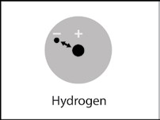

* 1. In a molecule, *two or more atoms* stay together because of the mutual attraction between the positively charged protons from one atom and the negatively charged electrons from the other atom. This causes the covalent or ionic bonding that holds atoms or ions together.

* 1. *Two or more water molecules* stay together because of the positive and negative parts of the molecules attracting each other.

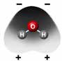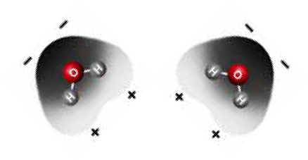

# EXPLORE

## Have students design a test to compare the rate of evaporation between water and alcohol.

Remind students that water molecules are very polar. The strong attractions between water molecules affect water’s surface tension, boiling point, and rate of evaporation. Tell students that they will do an experiment to compare the evaporation rates of water and another liquid that isn’t as polar.

Ask students:

## Do you think a substance like water with polar molecules would evaporate faster or slower than a substance like alcohol with molecules that are not as polar?

The more-polar molecules will stick together more and will probably evaporate more slowly than less polar molecules. Less-polar molecules should evaporate faster because they are not as attracted to each other.

## How could you design a quick and easy evaporation test to compare the rate of evaporation between water and alcohol?

* + - What materials will you need?
    - Should you use the same amount of water and alcohol?
    - How will you know if one evaporates faster than the other?
    - Is there a way to do it so that it will not take a lot of time?

Students should say that they will need the same small amount of water and alcohol. These liquids should be placed at the same time on a surface like a brown paper towel so that students can tell when each liquid evaporates.

1. **Have students follow the procedure below to compare the rate of evaporation between water and alcohol.**

**Question to Investigate**

Does water evaporate faster or slower than less-polar alcohol?

## Materials for Each Group

* Isopropyl alcohol (70% or higher)
* Water
* Brown paper towel
* Droppers

## A close-up of a hand holding a pipette Description automatically generatedProcedure

1. At the same time, place 1 drop of water and 1 drop of alcohol on a brown paper towel. Observe.

## Expected Results

The dark spot on the paper towel made by the alcohol will turn lighter faster than the dark spot made by the water. This indicates that the alcohol evaporates more quickly than the water.

***Note****: This test is fine for middle school students but there is something about the test that does not make it completely fair. There are many more water molecules in a drop of water than alcohol molecules in a drop of alcohol. The test would be more fair if the same number of water and alcohol molecules are placed on the paper towel. This requires a way to “count” molecules. Determining the number of particles in a sample is a basic concept in chemistry, but is beyond the scope of a middle school chemistry unit. Even if the same number of water and alcohol molecules were used in this activity, the alcohol would evaporate faster.*

Read more about counting molecules in *Teacher Background.*

# EXPLAIN

## Discuss student observations and describe the differences in polarity between water and alcohol molecules.

Ask students:

## Which evaporated faster, water or alcohol?

The alcohol evaporated faster.

**Project the image *Water and Alcohol Molecules*.**

[www.acs.org/middleschoolchemistry/simulations/chapter5/lesson1.html](http://www.acs.org/middleschoolchemistry/simulations/chapter5/lesson4.html)

Tell students that understanding about polarity can help explain why water evaporates more slowly than alcohol.

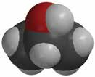

**–**

**+**

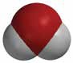

**–**

**–**

**+**

**+**

Remind students that the oxygen-hydrogen (O–H) bonds in water make it a polar molecule. This polarity makes water molecules attracted to each other.

Explain that the oxygen–hydrogen (O–H) bond in the alcohol molecule is also polar. But, the carbon–hydrogen (C–H) bonds in the rest of the alcohol molecule are nonpolar. In these bonds, the electrons are shared more or less evenly.

Because there are both polar and nonpolar areas on the alcohol molecule, they are somewhat less attracted to each other than water molecules are to each other. This makes it easier for alcohol molecules to come apart and move into the air as a gas. This is why alcohol evaporates faster than water.

# EXTEND

## Have students consider how polarity might affect the temperature at which water and alcohol boil.

You know that water and alcohol have different characteristics because of the molecules they are made of and how these molecules interact with each other.

**Project the image *Water and Alcohol Boiling*.** [www.acs.org/middleschoolchemistry/simulations/chapter5/lesson1.html](http://www.acs.org/middleschoolchemistry/simulations/chapter5/lesson4.html)

This illustration shows that alcohol boils at a lower temperature than water.

* Water boils at 100 °C
* Alcohol boils at 82.5 °C

Ask students:

## Knowing what you do about the polarity of water and alcohol, explain why alcohol boils at a lower temperature than water.

## 

The polar characteristic of water molecules causes them to attract each other well. The less polar alcohol molecules do not attract one another as strongly as water molecules do. It takes more energy to make water boil than it does to make alcohol boil. In other words, alcohol boils at a lower temperature than water.

**Part 2—Surface Tension**

(From Middle School Chemistry – Chapter 5, Lesson 2)

***Key Concepts***

* The attraction of molecules at the surface of a liquid is called *surface tension*.
* The polarity of water molecules can help explain why water has a strong surface tension.

***Summary***

Students will observe several phenomena related to the polarity of water molecules. They will observe a demonstration of a paper clip being placed on the surface of water. Students will place drops of water in an already-filled test tube and on the surface of a penny. They will compare the way water behaves with the less polar liquid isopropyl alcohol and will see how detergent affects water’s surface tension. Students will relate these observations to an explanation of surface tension at the molecular level.

***Objective***

Students will be able to explain, on the molecular level, the effects of polarity on water’s surface tension.

***Evaluation***

The activity sheet will serve as the “Evaluate” component of each 5-E lesson plan. The activity sheets are formative assessments of student progress and understanding. A more formal summative assessment is included at the end of each chapter.

***Safety***

* Be sure you and the students wear properly fitting goggles. Isopropyl alcohol is flammable. Keep it away from flames or spark sources. Read and follow all warnings on the label. Use in a well-ventilated room.
* Paper towels wet with alcohol should be allowed to evaporate. Dry paper towel can then be placed in the trash.
* Small amounts of isopropyl alcohol can be disposed of down the drain or according to local regulations.
* Have students wash hands after the activity.

***Materials for the Demonstration***

* 1 clear plastic cup
* Water
* 1 standard size paper clip
* 1 large paper clip

***Materials for Each Group***

* Water
* Isopropyl alcohol (70% or higher)
* Dish detergent in cup
* Test tubes
* 2 pennies
* 2 droppers
* 2 toothpicks

**ENGAGE**

## Do a demonstration to show water’s surface tension.

Tell students that there is another everyday phenomenon that shows that water molecules are attracted to one another. This attraction is again the result of the polarity of water molecules.

Either do the following demonstration for students or show them the video *Water’s surface tension* at [www.acs.org/middleschoolchemistry/simulations/chapter5/lesson2.html](http://www.acs.org/middleschoolchemistry/simulations/chapter5/lesson1.html)

## Materials

* + 1 clear plastic cup
  + Water
  + 1 standard size paper clip
  + 1 large paper clip

## Teacher Preparation

Unbend the large paper clip until it is straight. Then bend it into a “U” shape. Bend the bottom of each end out a little bit as shown. This will be your device for picking up and placing the smaller paper clip onto the surface of the water. It works like tweezers, but in reverse: allow it to spread it apart in order to pick up the paper clip and squeeze it to release the paper clip.

**Procedure**

1. Place water in one cup until it is about 3/4 full.
2. Use your device to pick up a paper clip. Do this by squeezing the ends of the device together a bit and placing them inside the paper clip. Then allow the ends to spread apart so that the tension of the ends pushes against the inside of the paper clip and holds it in place.
3. Very carefully lower the paper clip so that it lies flat on the surface of the water. Slowly squeeze the device to release the paper clip.

## Expected Results

The paper clip should rest on the surface of the water. This may take a couple of tries.

Ask students:

## Why do you think a paper clip, which is more dense than water, can stay on the surface of water?

Remind students that paper clips are more dense than water and would normally sink. Help students realize that the paper clip in the demo stayed on the surface of the water because of something having to do with the water molecules at the water’s surface, called *surface tension*.

## Have students relate their observations in the demo to a water strider standing on the surface of water.

**Project the image *Water Strider and Molecule*.** [www.acs.org/middleschoolchemistry/simulations/chapter5/lesson2.html](http://www.acs.org/middleschoolchemistry/simulations/chapter5/lesson1.html)

Point out how the surface of the water seems to bend but not break under the water strider’s legs. Tell students that what they see is another example of water’s surface tension.

Ask students:

## Why do you think water has such a strong surface tension?

Encourage students to think about what they already know about the strong attraction between water molecules. Students should remember that water molecules are very attracted to each other and this attraction is the basis for surface tension. This will be explained in more detail later in this lesson.

## Give each student an activity sheet for Part 2.

Students will record their observations and answer questions about the activity on the activity sheet. The *Explain It with Atoms & Molecules* and *Take It Further* sections of the activity sheet will either be completed as a class, in groups, or individually depending on your instructions. Look at the teacher version of the activity sheet to find the questions and answers.

# EXPLORE

## Have students carefully add single drops of water to a filled test tube.

Tell students that there is another phenomenon that is caused by water’s surface tension. It is water’s ability to fill beyond the top of a container.

## Question to Investigate

How much water can you add to a full test tube?

## Materials for Each Group

* Water
* Dropper
* Test tube
* Penny
* 2 paper towels

## Procedure

1. A person pouring liquid into a test tube

   Description automatically generatedPour water into a test tube so that the water is very near the top of the test tube.
2. Hold the test tube up to eye level and use a dropper to carefully add drops of water, one at a time, to the test tube.
3. Watch the water at the top of the test tube while you add the drops. Continue adding drops until the water spills.
4. Place a penny on a paper towel.
5. While watching from the side, add single drops of water to the penny. Continue adding drops until the water spills.

## Expected Results

While looking from the side, students will see that the water forms a dome on the top of the test tube and on the penny.

Ask students:

## What did the water look like as you added it to the top of the test tube and the penny?

The water makes a “dome” or “hill” of water above the top of the test tube and penny.

# EXPLAIN

## Explain how attractions between water molecules give water its strong surface tension.

**Project the image *Why Water Beads*.**

[www.acs.org/middleschoolchemistry/simulations/chapter5/lesson2.html](http://www.acs.org/middleschoolchemistry/simulations/chapter5/lesson2.html)

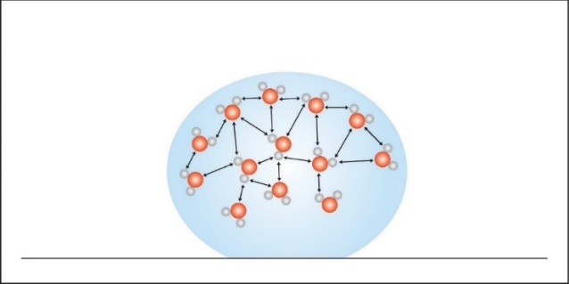

Explain to students that water’s surface tension is based on the attractions between water molecules at the surface and the water molecules in the rest of the water. A water molecule beneath the surface feels attractions from all the molecules around it. But the molecules at the surface only feel attractions from the molecules next to them and beneath them. These surface molecules are pulled together and inward by these attractions. This inward pull has the effect of compressing the surface molecules which form a tight arrangement over the water’s surface. This tight arrangement at the surface is called *surface tension*.

The inward pull from the attractions of the molecules results in the smallest possible surface for a volume of water, which is a sphere. This is why water forms a round drop or dome at the top of the filled test tube and on the surface of a penny.

# EXPLORE

## Have students compare the surface tension of water and alcohol.

Ask students:

## How could we compare the surface tension of water and alcohol?

Students may suggest placing an equal number of drops of each liquid on wax paper, overfilling a test tube, or comparing the number of drops that can be added to the top of a penny.

***Note****: Even though there are many ways to compare the surface tension of water and alcohol, the procedure written below compares each liquid on the surface of a penny. In order to make this as fair a test as possible, students should place each liquid on two similar pennies that are either both “heads” or “tails.” They should also be sure to add single drops of each liquid slowly and carefully.*

## Question to Investigate

Which has a greater surface tension, water, or alcohol?

## Materials for Each Group

* 2 pennies
* 2 droppers
* Water
* Isopropyl alcohol (70% or higher)
* A hand pouring liquid into a dropper

  Description automatically generatedPaper towel

## Procedure

1. Place two pennies on a paper towel.
2. Use a dropper to add drops of water to the surface of a penny. Count the drops until the water overflows.
3. Use a dropper to add drops of alcohol to the surface of the other penny. Count the drops until the alcohol overflows.

## Expected Results

The water beads up on the penny and the alcohol spreads out flat. Many more drops of water can be added to the penny than drops of alcohol.

# EXPLAIN

## Discuss student observations and why students were not able to get as many drops of alcohol on a penny.

**Project the image *Water and Alcohol*.**

[www.acs.org/middleschoolchemistry/simulations/chapter5/lesson2.html](http://www.acs.org/middleschoolchemistry/simulations/chapter5/lesson1.html)

Review that water molecules are polar and that they are very attracted to each other. Point out that alcohol molecules are polar in only one area, making them somewhat attracted to each other. They are not as attracted to other alcohol molecules as water is to other water molecules.

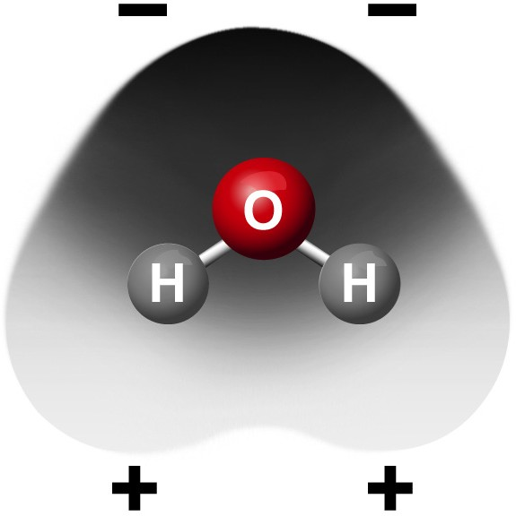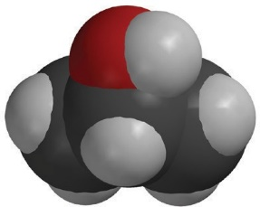

**–**

**+**

## Water and Alcohol on Pennies

Explain that water’s attraction pulls itself together into a tight arrangement. Explain that alcohol molecules don’t have a structure that is as good as water’s for attraction to itself. Alcohol molecules only have 1 O–H bond and they have some C–H bonds that are pretty nonpolar. There is not as strong an attraction between them as there is between water molecules.

The shape of the water molecule and its polarity at the top and the bottom give water molecules lots of opportunities to attract. Almost anywhere two water molecules meet they can be attracted to each other.

But alcohol has a different size and shape and has its polar part on one end. Alcohol molecules can meet at areas where they would not attract as strongly. The water is more attracted to itself than to the metal of the penny. The alcohol is a bit less attracted to itself, so it spreads more on the penny.

# EXPLORE

## Have students add detergent to the water on a penny.

**Question to Investigate**

How does detergent affect water’s surface tension?

## Materials

* Dish detergent in cup
* 2 pennies
* Dropper
* 2 toothpicks
* Paper towel

## Procedure

1. Place 2 clean dry pennies on a flat surface like a table or desk.
2. A child using a stick to put a liquid on a plate

   Description automatically generated with medium confidenceUse a dropper to add water to both pennies. Add the same number of drops to each penny so that the water stacks up in a dome shape about the same height on both.
3. Gently touch the water on one penny with a toothpick. Watch the surface of the water as you touch it.
4. Dip the toothpick in liquid detergent and then touch the water on the other penny with the toothpick.

***Note****: This activity works best if the dome of water on the pennies is pretty high.*

## Expected Results

Touching the water with the toothpick causes the surface of the water to be pressed down and bend. Touching the water with the toothpick and detergent causes the water to collapse and spill off the penny.

# EXPLAIN

## Explain how detergent interferes with water’s surface tension.

**Project the image *Water and Detergent*.**

[www.acs.org/middleschoolchemistry/simulations/chapter5/lesson2.html](http://www.acs.org/middleschoolchemistry/simulations/chapter5/lesson2.html)

Explain that detergent is made from molecules that have a charged end and a longer uncharged end. The detergent molecules spread out over the surface of the water with the charged end in the water and the uncharged end sticking out. The water molecules at the surface are attracted to the charged end of the detergent molecules. As the surface water molecules are attracted outward, this acts against their inward attraction that was creating the surface tension. This reduces the surface tension, and the water does not hold its round shape and thus spills.

# EXTEND

## Discuss how the polarity of the material that the water is placed on affects how the water absorbs or beads up.

Ask students:

## If water absorbs into a paper towel but does not absorb into wax paper, what does that say about the polarity of paper and wax paper?

The molecules that make up paper are probably polar, and the molecules that make up wax are probably nonpolar.

**Project the animation *Water on Paper Towel*.**

[www.acs.org/middleschoolchemistry/simulations/chapter5/lesson2.html](http://www.acs.org/middleschoolchemistry/simulations/chapter5/lesson2.html)

Explain that paper towel and other paper is made from cellulose. Cellulose is made from repeating molecules of glucose that are bonded together. The glucose molecule has many O–H bonds, which are polar. Polar water molecules are attracted to polar cellulose.

**Project the animation *Water on Wax Paper*.**

[www.acs.org/middleschoolchemistry/simulations/chapter5/lesson2.html](http://www.acs.org/middleschoolchemistry/simulations/chapter5/lesson2.html)

Tell students that wax is made from paraffin, which is repeating carbon–hydrogen bonds. The C–H bond is not very polar, so water is more attracted to itself than to the wax. This causes the water to bead up on wax paper.

**Part 3—Why Does Water Dissolve Salt?**

(From Middle School Chemistry – Chapter 5, Lesson 3)

***Key Concepts***

* The polarity of water molecules enables water to dissolve many ionically bonded substances.
* Salt (sodium chloride) is made from positive sodium ions bonded to negative chloride ions.
* Water can dissolve salt because the positive part of water molecules attracts the negative chloride ions, and the negative part of water molecules attracts the positive sodium ions.
* The amount of a substance that can dissolve in a liquid (at a particular temperature) is called the *solubility* of the substance.
* The substance being dissolved is called the solute, and the substance doing the dissolving is called the solvent.

***Summary***

Students will make a 2-D model of a salt crystal and use water molecule cutouts to show how water dissolves salt. After seeing an animation of water dissolving salt, students will compare how well water and alcohol dissolve salt. They will relate their observations to the structure of salt, water, and alcohol on the molecular level.

***Objective***

Students will be able to explain, on the molecular level, why water can dissolve salt. Students will be able to identify the variables in their experiment. Students will also be able to explain why a less polar liquid, such as alcohol, is not good at dissolving salt.

***Evaluation***

The activity sheet will serve as the “Evaluate” component of each 5-E lesson plan. The activity sheets are formative assessments of student progress and understanding. A more formal summative assessment is included at the end of each chapter.

***Safety***

Be sure you and the students wear properly fitting goggles. Isopropyl alcohol is flammable. Keep it away from flames or spark sources. Read and follow all warnings on the label. Alcohol should be disposed of according to local regulations. Have students wash hands after the activity.

***Materials for Each Group***

* Construction paper, any color
* Scissors
* Tape or glue
* Water
* Isopropyl alcohol (70% or higher)
* Salt
* Balance
* 2 clear plastic cups
* 2 small plastic cups
* Graduated cylinder

**ENGAGE**

## Make a model of a salt crystal.

Water’s polar nature allows it to dissolve salt and other substances in the ocean. Let students know that studying water’s ability to dissolve substances in the ocean will build toward an understanding of how the ocean is becoming more acidic.

**Project the image *Sodium Chloride Crystal*.** [www.acs.org/middleschoolchemistry/simulations/chapter5/lesson3.html](http://www.acs.org/middleschoolchemistry/simulations/chapter5/lesson1.html)

## Remind students of the ionic bonding they have seen between sodium and chlorine, and that the green balls represent negative chloride ions, and the gray balls represent positive sodium ions.

Ask students:

## What is it about water molecules and the ions in salt that might make water able to dissolve salt?

The positive and negative polar ends of a water molecule are attracted to the negative chloride ions and positive sodium ions in the salt.

## Give each student an activity sheet for Part 3.

Students will record their observations and answer questions about the activity on the activity sheet. The *Explain It with Atoms & Molecules* and *Take It Further* sections of the activity sheet will either be completed as a class, in groups, or individually, depending on your instructions. Look at the teacher version of the activity sheet to find the questions and answers.

## Question to Investigate

How does salt dissolve in water?

## A group of circles with letters and numbers Description automatically generatedMaterials

* Activity sheet with sodium and chloride ions and water molecules
* Construction paper, any color
* Scissors
* Tape or glue

## Procedure

*Make a model of a salt crystal*

1. Cut out the ions and water molecules.
2. Arrange the ions on a piece of construction paper to represent a 2-D salt crystal. Do not tape these pieces down yet.

## Project an image and have students model what happens when salt dissolves in water.

Show students a series of four pictures to help explain the process of water dissolving salt.

**Project the image *Sodium Chloride Dissolving in Water*.** [www.acs.org/middleschoolchemistry/simulations/chapter5/lesson3.html](http://www.acs.org/middleschoolchemistry/simulations/chapter5/lesson3.html)

Point out that several water molecules can arrange themselves near an ion and help remove it from the crystal. Show students that the positive area of a water molecule will be attracted to the negative chloride ion and that the negative area of a water molecule will be attracted to the positive sodium ion.

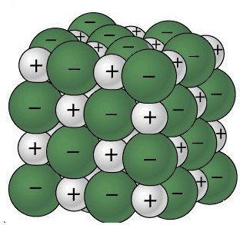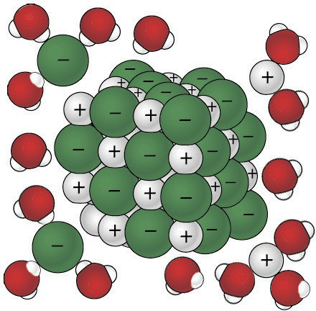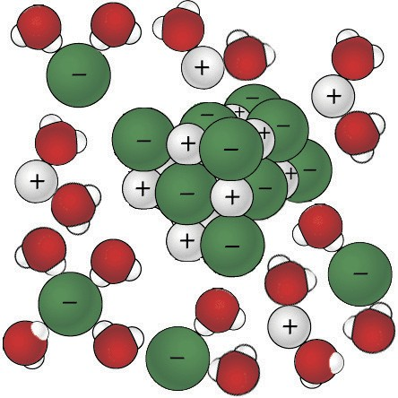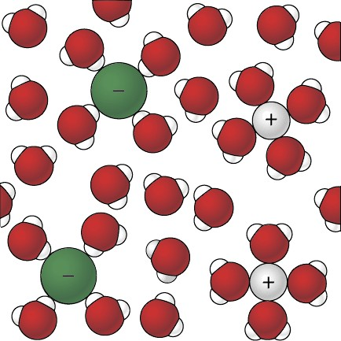

***Model how water dissolves salt***

* 1. A person and person pointing at a sign

     Description automatically generatedLook at the pictures showing how water molecules dissolve salt. Then arrange the water molecules around the sodium and chloride ions in the correct orientation. The positive part of the water molecules should be near the negative chloride ion. The negative part of the water molecules should be near the positive sodium ion.
  2. Move the water molecules and sodium and chloride ions to model how water dissolves salt.
  3. Tape the molecules and ions to the paper to represent water dissolving salt.

**Project the animation *Sodium Chloride Dissolving in Water*.** [www.acs.org/middleschoolchemistry/simulations/chapter5/lesson3.html](http://www.acs.org/middleschoolchemistry/simulations/chapter5/lesson1.html)

Point out that the water molecules are attracted to the sodium and chloride ions of the salt crystal. Explain that the positive area of a water molecule is attracted to a negative chloride ion. The negative area water of a water molecule is attracted to a positive sodium ion. Dissolving happens when the attractions between the water molecules and the sodium and chloride ions overcome the attractions of the ions to each other. This causes the ions to separate from one another and become thoroughly mixed into the water.

Tell students that the amount of a substance that can dissolve in a liquid (at a particular temperature) is called *solubility*. Point out the similarity in the words dissolve and solubility. Also tell them that the substance that is dissolved is called the solute. The substance that does the dissolving is called the solvent.

# EXPLORE

# Have students conduct an experiment to find out whether water or isopropyl alcohol would be better at dissolving salt.

Ask students to make a prediction:

## Think about the polarity of water molecules and alcohol molecules. Do you think alcohol would be just as good, better, or worse than water at dissolving salt?

Discuss how to set up a test to compare how water and alcohol dissolve salt. Be sure students identify variables such as:

* Amount of water and alcohol used
* Amount of salt added to each liquid
* Temperature of each liquid
* Amount of stirring

## Question to Investigate

Is alcohol just as good, better, or worse than water at dissolving salt?

## Materials for Each Group

* Water
* Isopropyl alcohol (70% or higher)
* Salt
* Balance
* 2 clear plastic cups
* 2 small plastic cups
* Graduated cylinder

## Procedure

* 1. In separate cups, measure two samples of salt that weigh 5 g each.
  2. A cartoon of hands pouring salt into a glass

     Description automatically generatedPlace 15 mL of water and alcohol into separate cups.
  3. At the same time, add the water and alcohol to the samples of salt.
  4. Swirl both cups the same way for about 20 seconds and check for the amount of salt dissolved.
  5. Swirl for another 20 seconds and check. Swirl for the last 20 seconds and check.
  6. Carefully pour off the water and alcohol from the cups and compare the amount of undissolved salt left in each cup.

## Expected Results

There will be less undissolved salt in the cup with the water than the alcohol. This means that more salt dissolved in the water than in the alcohol.

# EXPLAIN

## Discuss how differences in the polarity of alcohol and water explain why water dissolves salt better than alcohol.

Ask students:

## Is alcohol just as good, better, or worse than water at dissolving salt?

Alcohol does not dissolve salt as well as water does.

Read more about polarity in *teacher Background.*

## How do you know?

There was more salt left behind in the cup with the alcohol.

## Think about the polarity of water and alcohol to explain why water dissolves more salt than alcohol.

Have students look at the models of water and alcohol molecules on their activity sheet.

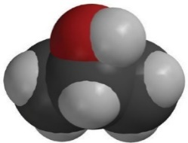

**–**

**+**

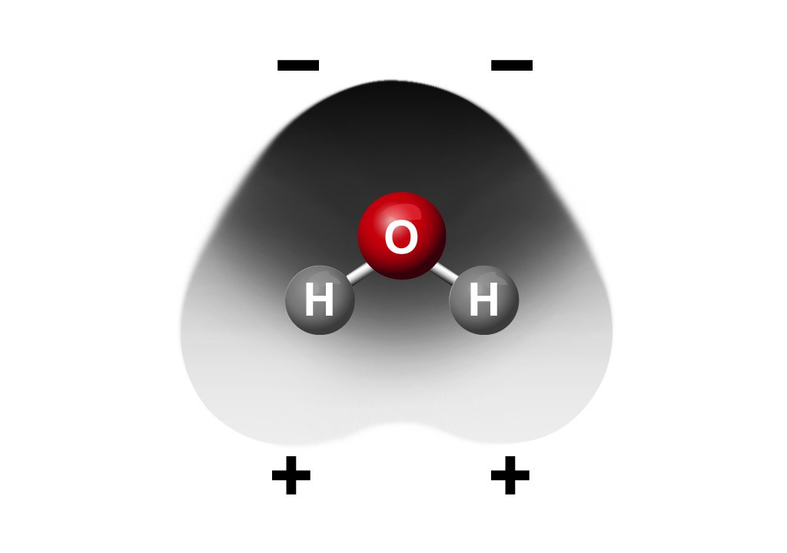

Remind students that isopropyl alcohol has an oxygen atom bonded to a hydrogen atom, so it does have some polarity but not as much as water. Since water is more polar than alcohol, it attracts the positive sodium and negative chloride ions better than alcohol. This is why water dissolves more salt than alcohol does. Another way of saying this is that the solubility of salt is greater in water than in alcohol.

# EXTEND

## Have students compare the solubility of two different ionic substances in water.

Compare the solubility of the ionic substances calcium carbonate (CaCO3) and sodium carbonate (Na2CO3) in water.

Ask students:

## How could you compare the solubility of sodium carbonate and calcium carbonate?

Students should suggest measuring equal amounts of each substance and adding equal amounts of water at the same temperature.

## Question to Investigate

Do all ionic substances dissolve in water?

## Materials for Each Group

* Sodium bicarbonate
* Calcium carbonate
* Water
* 2 clear plastic cups
* 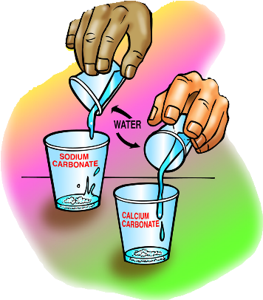2 small plastic cups
* Balance

## Procedure

* 1. Label two clear plastic cups Sodium Bicarbonate and Calcium Carbonate.
  2. Measure 2 g each of sodium bicarbonate and calcium carbonate and put them in their labeled cups.
  3. Measure 30 mL of water into each of two empty cups.
  4. At the same time, pour the water into the sodium bicarbonate and calcium carbonate cups.
  5. Gently swirl both cups for about 1 minute.

## Expected Results

The sodium bicarbonate will mostly dissolve, but the calcium carbonate will not. Explain that not all ionically bonded solids dissolve in water.

## Discuss student observations.

Ask students:

## Do all ionic substances dissolve in water? How do you know?

Because calcium carbonate does not dissolve in water, students should realize that not all ionic substances dissolve in water.

Explain that on the molecular level, the ions that make up calcium carbonate are attracted so strongly to each other that the attraction by water molecules cannot pull them apart.

That is a good thing because calcium carbonate is the material that seashells and bird eggs are made of. Calcium phosphate is another ionic solid that does not dissolve in water. This is also good because it is the material that makes up bones and teeth.

With enough water, sodium bicarbonate is pulled apart into ions that are incorporated throughout the water, forming a solution. The sodium and bicarbonate ions will not settle to the bottom and cannot be filtered out of the water.

But calcium carbonate does not break up into its ions. Instead, it is just mixed in with the water. If given enough time, the calcium carbonate will settle to the bottom or can be filtered out of the water. Sodium bicarbonate dissolved in water is a good example of a solution, and undissolved calcium carbonate is a mixture, not a solution.

***Note****: The bicarbonate ion is different from the single atom ions such as sodium (Na+) and chloride (Cl–) that students have seen so far. The bicarbonate ion* *(HCO3–) is composed of more than one atom. These types of ions, called polyatomic ions, are made up of a group of covalently bonded atoms that act as a unit. They commonly gain or lose one or more electrons and act as an ion. Another common polyatomic ion is the sulfate ion (SO2-). This ion is part of Epsom salt as magnesium sulfate (MgSO4) and many fertilizers as potassium sulfate (K2SO4). You can decide if you would like to introduce students to these two common polyatomic ions.*

**Part 4: Why Does Water Dissolve Sugar?**

(From Middle School Chemistry – Chapter 5, Lesson 4)

***Key Concepts***

* For a liquid to dissolve a solid, the molecules of the liquid and solid must attract one another.
* The bond between the oxygen and hydrogen atoms (O–H bond) in sugar (sucrose) gives the oxygen a slight negative charge and the hydrogen a slight positive charge. Sucrose is a polar molecule.
* The polar water molecules attract the negative and positive areas on the polar sucrose molecules which makes sucrose dissolve in water.
* A nonpolar substance like mineral oil does not dissolve a polar substance like sucrose.

***Summary***

Students will observe the dissolving of the sugar coating from an M&M when it is placed in water. Students will then help design an experiment to see if the type of liquid the M&M is placed in affects how much of the coating dissolves.

***Objective***

Students will be able to explain, on the molecular level, how the polar characteristic of water and sugar interact so that water dissolves sugar. Students will be able to identify and control the variables in their experiment. Students will also be able to explain why a nonpolar liquid, such as mineral oil, is not good at dissolving sugar.

***Evaluation***

The activity sheet will serve as the “Evaluate” component of each 5-E lesson plan. The activity sheets are formative assessments of student progress and understanding. A more formal summative assessment is included at the end of each chapter.

***Safety***

Be sure you and the students wear properly fitting goggles. Isopropyl alcohol is flammable. Keep it away from flames or spark sources. Read and follow all warnings on the label. Dispose of isopropyl alcohol and mineral oil according to local regulations. Warn students not to eat the M&M’s. Have students wash hands after the activity.

***Materials for Each Group***

* M&M’s
* Water
* Mineral oil
* Isopropyl alcohol (70%)
* Small white plastic plate, and piece of white paper
* 3 clear plastic cups

# ENGAGE

# Let students know that other substances are dissolved in the ocean that are not ionically bonded like salt. Tell students that they will experiment with a familiar substance to see why it dissolves in water even though it is not ionically bonded.

## Help students realize that the candy coating of an M&M is made mostly of sugar and a bit of coloring.

Distribute M&M’s to students and have them look at the outside candy coating. Then have students break an M&M to look closely at the coating from the inside.

Ask students:

## What do you think the coating of an M&M is made from?

Students will see the layer of color with a layer of white beneath it and suggest that the coating is made of sugar and coloring. Explain that the coating is mostly sugar.

* + **Have you ever noticed what happens to the coating of an M&M when it gets wet?**

The color comes off and if it gets wet enough, the entire coating comes off, leaving the chocolate behind.

Tell students that in this activity, they will see what happens to the sugar and color coating of an M&M when it is placed in water.

## Give each student an activity sheet for Part 4.

Students will record their observations and answer questions about the activity on the activity sheet. The *Explain It with Atoms & Molecules* and *Take It Further* sections of the activity sheet will either be completed as a class, in groups, or individually, depending on your instructions. Look at the teacher version of the activity sheet to find the questions and answers.

## Have students place an M&M in a cup of water and observe.

**Question to Investigate**

What happens to the sugar and color coating of an M&M when it is placed in water?

## Materials

* Clear plastic cup
* Water
* M&M
* White paper

## A cartoon of a glass on a napkin Description automatically generatedProcedure

1. Pour enough room temperature water into clear plastic cup so that the water is deep enough to completely cover an M&M and place this cup on a piece of white paper.
2. Once the water has settled, place 1 M&M in the center of the cup. Be careful to keep the water and M&M as still as possible. Observe for about 1 minute.

## Expected Results

The coating will dissolve from the M&M, revealing a white layer under the color and then the brown chocolate underneath. The colored coating of the M&Ms will collect in a circular pattern around the M&M. Students may also mention the white streaks in the water from the sugar coating.

## Discuss student observations.

Ask students:

## What do you notice about the M&M and the water?

The color comes off and moves through the water in a circular pattern.

* + **What do you think is happening when the color and sugar come off the M&M?**

Point out to students that because the water makes the colored coating come off the M&M and mix into the water, the water is dissolving the sugar and color.

***Note****: There are actually two processes happening in this activity. The color and sugar are dissolving in the water, but they are also diffusing. In order to focus on the amount that dissolves from an M&M, students should look at the amount of coating missing from the M&M, instead of the size of the circle of color in the water.*

## Knowing what you do about the polarity of water, why do you think water dissolves sugar?

Students may think that sugar is made of ionic bonds like salt. Or they might think that sugar has positive and negative areas and this is why water is attracted to it.

# EXPLAIN

## Show students how the polar areas of a sucrose molecule cause it to dissolve in water.

Explain to students that sugar is made of large molecules called sucrose. Each sucrose molecule is made of atoms that are covalently bonded.

Ask students:

## The chemical formula for sucrose is C12H22O11. What do these letters and numbers mean?

Sucrose is made up of 12 carbon atoms, 22 hydrogen atoms, and 11 oxygen atoms.

**Project the image *Sucrose*.** [www.acs.org/middleschoolchemistry/simulations/chapter5/lesson4.html](http://www.acs.org/middleschoolchemistry/simulations/chapter5/lesson3.html)

Explain that the first picture is a ball-and-stick model of a single sucrose molecule. The next picture is a space-filling model of a single sucrose molecule. The last picture is two sucrose molecules attract- ed to each other. These two molecules will separate from each other when sugar dissolves. Point out that in the areas on a sucrose molecule where oxygen is bonded to hydrogen (O–H bond), the oxygen is slightly negative, and the hydrogen is slightly positive. This makes sucrose a polar molecule.

Two sucrose molecules closely associated due to oppositely charged polar areas

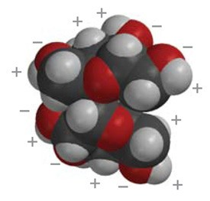

Sucrose space-filling model

Sucrose ball-and-stick model

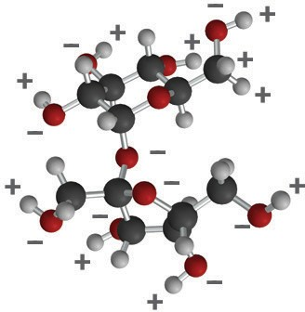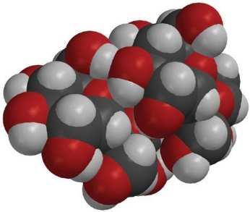

–

+

–

+

+ –

–

+

+

–

**Project the image *Water Dissolves Sucrose*.** [www.acs.org/middleschoolchemistry/simulations/chapter5/lesson4.html](http://www.acs.org/middleschoolchemistry/simulations/chapter5/lesson4.html)

Explain that a sugar cube (about a half a teaspoon of sugar) is made up of at least one billion trillion sucrose molecules. When sugar dissolves, these whole sucrose molecules separate from one another. The molecule itself doesn’t come apart: The atoms that make up each molecule stay together as a sucrose molecule.

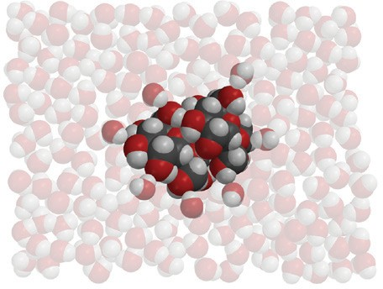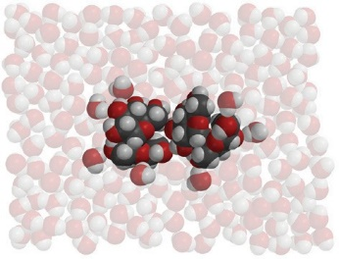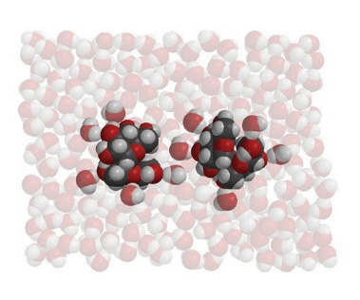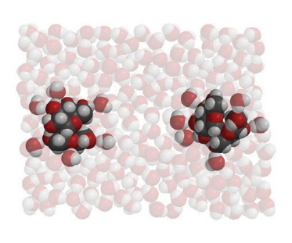

**Project the animation Sucrose.** [www.acs.org/middleschoolchemistry/simulations/chapter5/lesson4.html](http://www.acs.org/middleschoolchemistry/simulations/chapter5/lesson4.html)

Explain that sucrose has polar areas caused by the same type of oxygen–hydrogen covalent bonds as in the water molecule. Point out the O–H bonds on the outer edges of the molecule. Point out that the bonding of the oxygen and hydrogen in the sucrose makes parts of the sucrose molecule polar in a similar way as in a water molecule. The area near the hydrogen is positive (blue) and the area near the oxygen is negative (red).

**Project the animation *Water Dissolves Sucrose*.** [www.acs.org/middleschoolchemistry/simulations/chapter5/lesson4.html](http://www.acs.org/middleschoolchemistry/simulations/chapter5/lesson2.html)

Tell students that sugar molecules are attracted to each other and held together by the attraction between these polar areas of the molecules.

Help students notice how the positive (blue) area of a water molecule is attracted to the negative (red) area of a sucrose molecule. It also works the other way around. The negative (red) area of a water molecule is attracted to the positive (blue) area of the sucrose molecule.

Explain that the positive and negative areas on water molecules interact with these negative and positive parts of sucrose molecules. When the attraction between water molecules and sucrose molecules overcomes the attraction the sucrose molecules have to other sucrose molecules, they will separate from one another and dissolve.

Point out that one whole sucrose molecule breaks away from another whole sucrose molecule. The molecule itself does not come apart into individual atoms.

***Note****: Although the focus is on dissolving the polar sugar molecules, the food coloring used to color the M&M is also made from polar molecules. This helps explain why the coloring also dissolves.*

# EXPLORE

## Have students conduct an experiment to compare how well water, alcohol, and oil dissolve the sugar and color coating of an M&M.

Ask students to make a prediction:

## Do you think water, alcohol, or oil would be better at dissolving the sugar and color coating of an M&M?

Discuss with students how to design an experiment to compare how well water, alcohol, and vegetable oil dissolve the color and sugar coating from an M&M. Be sure students identify variables such as:

* Amount of water, alcohol, and oil used
* Temperature of each liquid
* Same color of M&M
* Time and location the M&M’s are placed in each liquid

## Question to Investigate

Is water, alcohol, or oil better at dissolving the color and sugar coating from an M&M?

## Materials

* 3 M&Ms (same color)
* Water
* Mineral oil
* Isopropyl alcohol (70%)
* 3 clear plastic cups
* White paper

## Procedure

1. A cartoon of hands holding cups of liquid

   Description automatically generatedLabel 3 cups *Water*, *Alcohol*, and *Oil*. Add 15 mL of water, alcohol, and mineral oil to their labeled cups.
2. Place the three cups on a white sheet of paper.
3. At the same time, add 1 M&M to each liquid. Then gently swirl the liquid and M&M in each cup for about 30 seconds.

## Expected Results

Water—The sugar and color dissolve from the M&M.

Alcohol—The color dissolves only slightly and the sugar coating doesn’t seem to dissolve.

Oil—Neither the color nor the sugar dissolves

# EXPLAIN

## 6. Show students the molecular structures for water, alcohol, and oil and discuss how this relates to their observations.

**Project the image *Polarity of Water, Alcohol, and Oil*.** [www.acs.org/middleschoolchemistry/simulations/chapter5/lesson4.html](http://www.acs.org/middleschoolchemistry/simulations/chapter5/lesson4.html)

Show students the polar areas on a water molecule, isopropyl alcohol molecule, and an oil molecule.

## Water

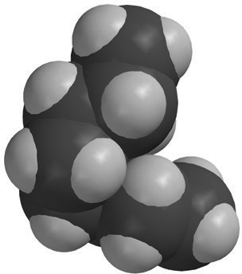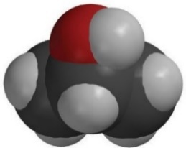

**–**

**+**

**+**

**+**

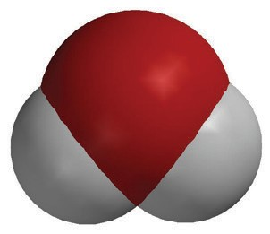

**_**

**_**

Water molecules are polar. The polar water dissolves the polar coloring and the polar sugar.

## Isopropyl Alcohol (70%)

The alcohol is 30% water and 70% alcohol and is not a good dissolver. Alcohol molecules have only one polar area and also have a larger nonpolar area. This makes alcohol not a good dissolver of polar sub- stances. Also, the water and alcohol interact, which means the water doesn’t even dissolve the sugar or color as well as it normally would.

## Oil

Oil molecules are not polar so they cannot dissolve either the coloring

or the sugar.

# EXTEND

# Show students the molecular structure for citric acid.

**Project the image *Citric Acid.***

[www.acs.org/middleschoolchemistry/simulations/chapter5/lesson4.html](http://www.acs.org/middleschoolchemistry/simulations/chapter5/lesson4.html)

Explain that the projected image is a model of a citric acid molecule. Tell students that citric acid is the substance that gives lemons, limes, grapefruit, and oranges their tangy sour taste. Citric acid is very soluble in water and is dissolved in the water in the fruit.

Ask students:

## Why do you think citric acid is so soluble in water? HINT: The chemical formula for citric acid is C6H8O7.

Every place there is an O–H bond, there is an uneven sharing of electrons.

The oxygen atoms in an O–H bond have a slightly negative charge and the hydrogen atoms in the bond have a slightly positive charge. Because water molecules are also polar, the positive ends of water molecules are attracted to the negative areas of the citric acid molecules. The negative ends of water molecules are attracted to the positive areas of the citric acid molecules. These mutual attractions will overcome the attractions citric acid molecules have for other citric acid molecules, causing them to mix thoroughly in the water and dissolve.

1. **Review with students what they know so far about the characteristics of the water molecule and why it’s a good dissolver.**

Ask students:

* **The main reason why water is a good dissolver is because the water molecule is *polar*. What makes water a polar molecule?**

The water molecule is polar because of the way the oxygen atom and hydrogen atoms are covalently bonded to each other. Because the oxygen atom attracts the electrons a little more than the hydrogen atoms, the oxygen area of the molecule has a slight negative charge, and the hydrogen atoms have a slight positive charge.

* **Why do the positive and negative areas of the water molecule make it a good dissolver?**

The positive and negative areas of the water molecule make it a good dissolver because these areas attract the oppositely charged ions of ionically bonded substances and pull them apart.

The positive and negative areas of the water molecule are also attracted to the oppositely charged areas of substances like sugar that are composed of polar molecules.

* **Do you think that water could possibly dissolve liquids or even gases?**

Students may not realize that liquids and gases can “dissolve” in water. After letting students know this is possible, students may be able to conclude that the molecules that make up the liquids and gases may have charged areas for the water molecules attract.

Let students know that this will be an important factor to understanding the process of ocean acidification.