**Activity Sheet Name Lesson 4 – Part 1**

**Water is a Polar Molecule Date**

# EXPLAIN IT WITH ATOMS & MOLECULES

This model of a water molecule shows the number of electrons that can be found in each energy level. It also shows that oxygen and hydrogen share electrons in a covalent bond. But it doesn’t show where electrons are most likely to be at any given moment.

1. **Do the shared electrons in the water molecule spend more time near the oxygen atom or the hydrogen atoms?**

**Why?**

1. **In an electron cloud model with red and blue colors, what do the colors and positive and negative signs on the electron cloud model represent?**
2. **Why are water molecules so attracted to each other?**
3. **Attractions are important in three different ways. Draw a line between the picture and the description of the attractions.**

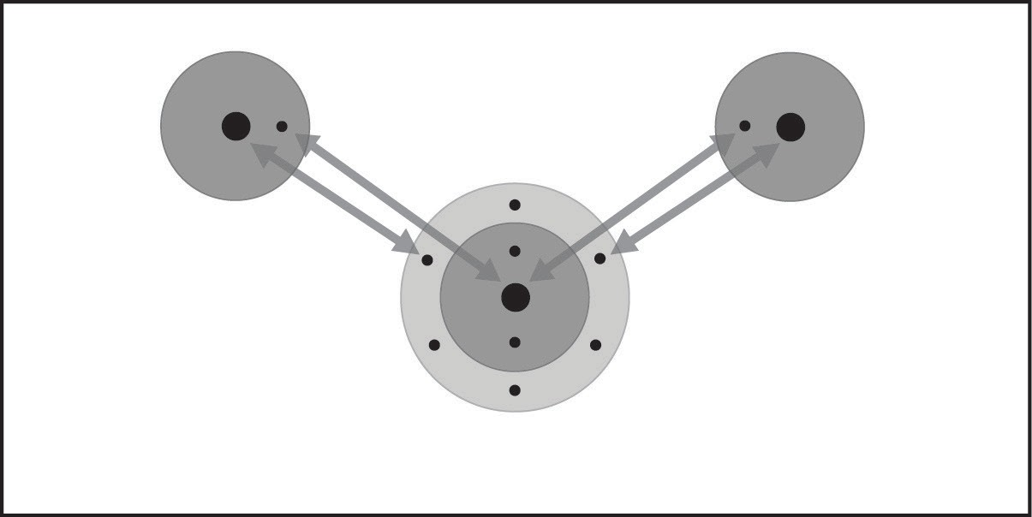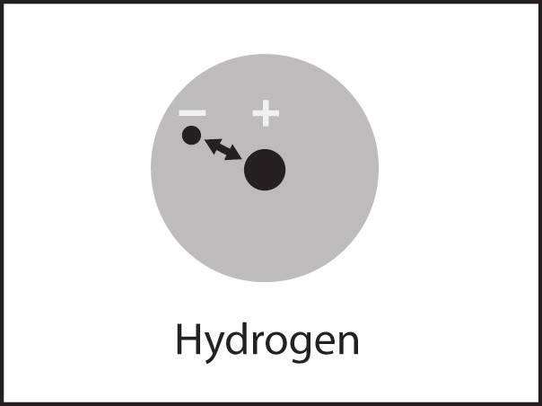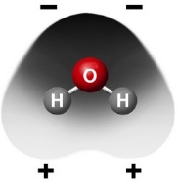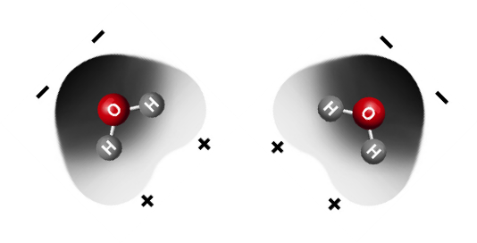

Within an atom

Between the atoms in a molecule

Between molecules

The electrons of each atom are attracted to the protons in the other atom.

These mutual attractions keep two or more atoms together as a covalently bonded molecule.

The positive areas of one molecule are attracted to the negative areas of another molecule. These mutual attractions keep a substance together.

The electrons are attracted to the protons in an atom. These attractions keep an atom together.

# ACTIVITY

## Question to Investigate

Does water evaporate faster or slower than less-polar alcohol?

## Materials for Each Group

* + Isopropyl alcohol (70% or higher)
  + Water
  + A cartoon of hands holding pipettes

    Description automatically generatedBrown paper towel
  + Droppers

## Procedure

1. At the same time, place 1 drop of water and 1 drop of alcohol on a brown paper towel. Observe.
2. **Which evaporated faster, water or alcohol?**
3. **The following molecular models show the polar regions of alcohol and water. Why does alcohol evaporate faster?**

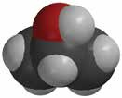

**–**

**+**

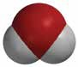

**–**

**–**

**+**

**+**

# TAKE IT FURTHER

1. **This illustration shows that alcohol boils at a lower temperature than water. Knowing what you do about the polarity of water and alcohol, explain why alcohol boils at a lower temperature than water.**

**Activity Sheet Name ____________________**

**Lesson 4 – Part 2**

**Surface Tension Date ________________**

# EXPLAIN IT WITH ATOMS & MOLECULES

1. **You saw a demonstration of a paper clip floating at the surface of water. Paper clips are more dense than water and usually sink. Why do you think the paper clip was able to stay on the surface of the water?**

# ACTIVITY

## Question to Investigate

How much water can you add to a full test tube?

## Materials for Each Group

* + Water
  + Dropper
  + Test tube
  + Penny
  + 2 paper towels

## Procedure

1. Pour water into a test tube so that the water is very near the top of the test tube.
2. Hold the test tube up to eye level and use a

dropper to carefully add drops of water, one at a time to the test tube.

1. Watch the water at the top of the test tube while you add the drops. Continue adding drops until the water spills.
2. Place a penny on a paper towel.
3. While watching from the side, add single drops of water to the penny. Continue adding drops until the water spills.
4. **What did the water look like as you added it to the top of the test tube and the penny?**
5. **Use the illustration to explain why water has a strong surface tension.**

# ACTIVITY

## Question to Investigate

Which has a greater surface tension, water or alcohol?

## Materials for Each Group

* + 2 pennies
  + 2 droppers
  + Water
  + Isopropyl alcohol (70% or higher)
  + A hand holding a dropper over a pair of glasses

    Description automatically generatedPaper towel

## Procedure

1. Place two pennies on a paper towel.
2. Use a dropper to add drops of water to the

surface of a penny. Count the drops until the water overflows.

1. Use a dropper to add drops of alcohol to the surface of the other penny. Count the drops until the alcohol overflows.
2. **How many drops of each liquid were you able to get on a penny?**

**Alcohol _______ Water ______**

1. **Does alcohol or water have a greater surface tension?**

**How do you know?**

1. **How does the polarity of alcohol and water molecules affect the surface tension of each liquid?**

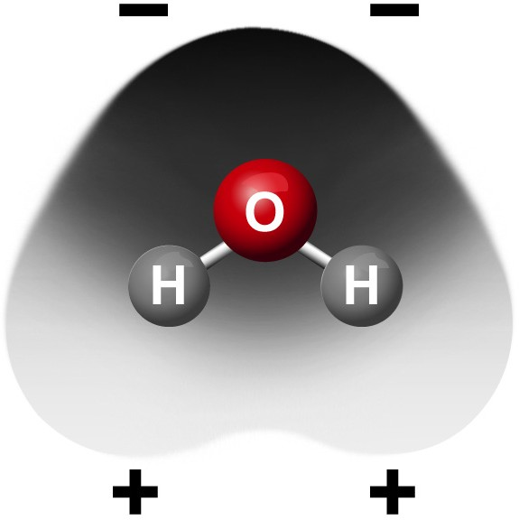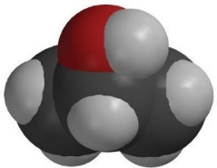

**–**

**+**

# ACTIVITY

## Question to Investigate

How does detergent affect water’s surface tension?

## Materials

* + Dish detergent in cup
  + 2 pennies
  + Dropper
  + 2 toothpicks
  + Paper towel

## Procedure

1. Place 2 clean, dry pennies on a flat surface like a table or desk.
2. A child wearing goggles and holding a stick

   Description automatically generatedUse a dropper to add water to both pennies. Add the same number of drops to each penny so that the water stacks up in a dome shape about the same height on both.
3. Gently touch the water on one penny with a toothpick. Watch the surface of the water as you touch it.
4. Dip the toothpick in liquid detergent and then touch the water on the other penny with the toothpick.
5. **What happens when you add a small amount of detergent to a large drop of water?**
6. **Use the illustration to explain how detergent interferes with water’s surface tension.**

# TAKE IT FURTHER

1. **If water absorbs into a paper towel but does not absorb into wax paper, what does that say about the polarity of paper and the polarity of wax paper?**

**Activity Sheet Name ____________________**

**Lesson 4 – Part 3**

**Why Does Water Dissolve Salt? Date ________________**

# INTRODUCTION

1. **A green and white spheres with black crosses

   Description automatically generatedWhat is it about water molecules and the ions in salt that might make water able to dissolve salt?**

## Question to Investigate

How does salt dissolve in water?

## Materials

* + Activity sheet with sodium and chloride ions and water molecules
  + Construction paper, any color
  + Scissors
  + Tape or glue

## Procedure

*Make a model of a salt crystal*

1. Cut out the ions and water molecules.
2. Arrange the ions on a piece of construction paper to represent a 2-dimensional salt crystal. Do not tape these pieces down yet.

*Model how water dissolves salt*

1. A person and person pointing at a sign

   Description automatically generatedLook at an image and animation showing how water molecules dissolve salt. Then arrange the water molecules around the sodium and chloride ions in the correct orientation. The positive part of the water molecules should be near the negative chloride ion. The negative part of the water molecules should be near the positive sodium ion.
2. Move the water molecules and sodium and chloride ions to model how water dissolves salt.
3. Tape the molecules and ions to the paper to represent water dissolving salt.
4. **Describe what happens when water dissolves salt.**

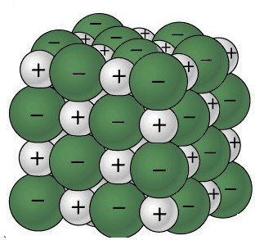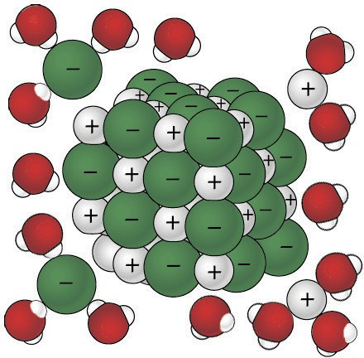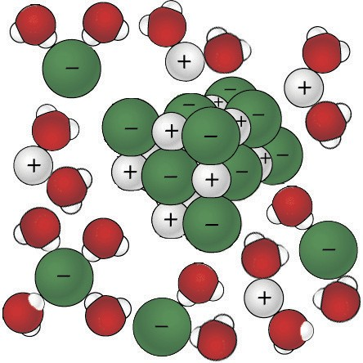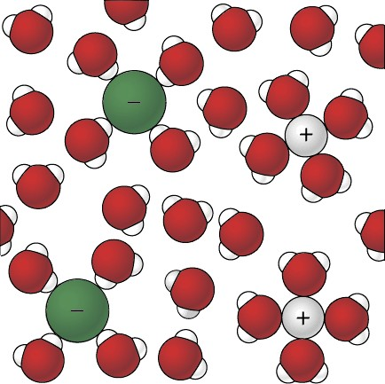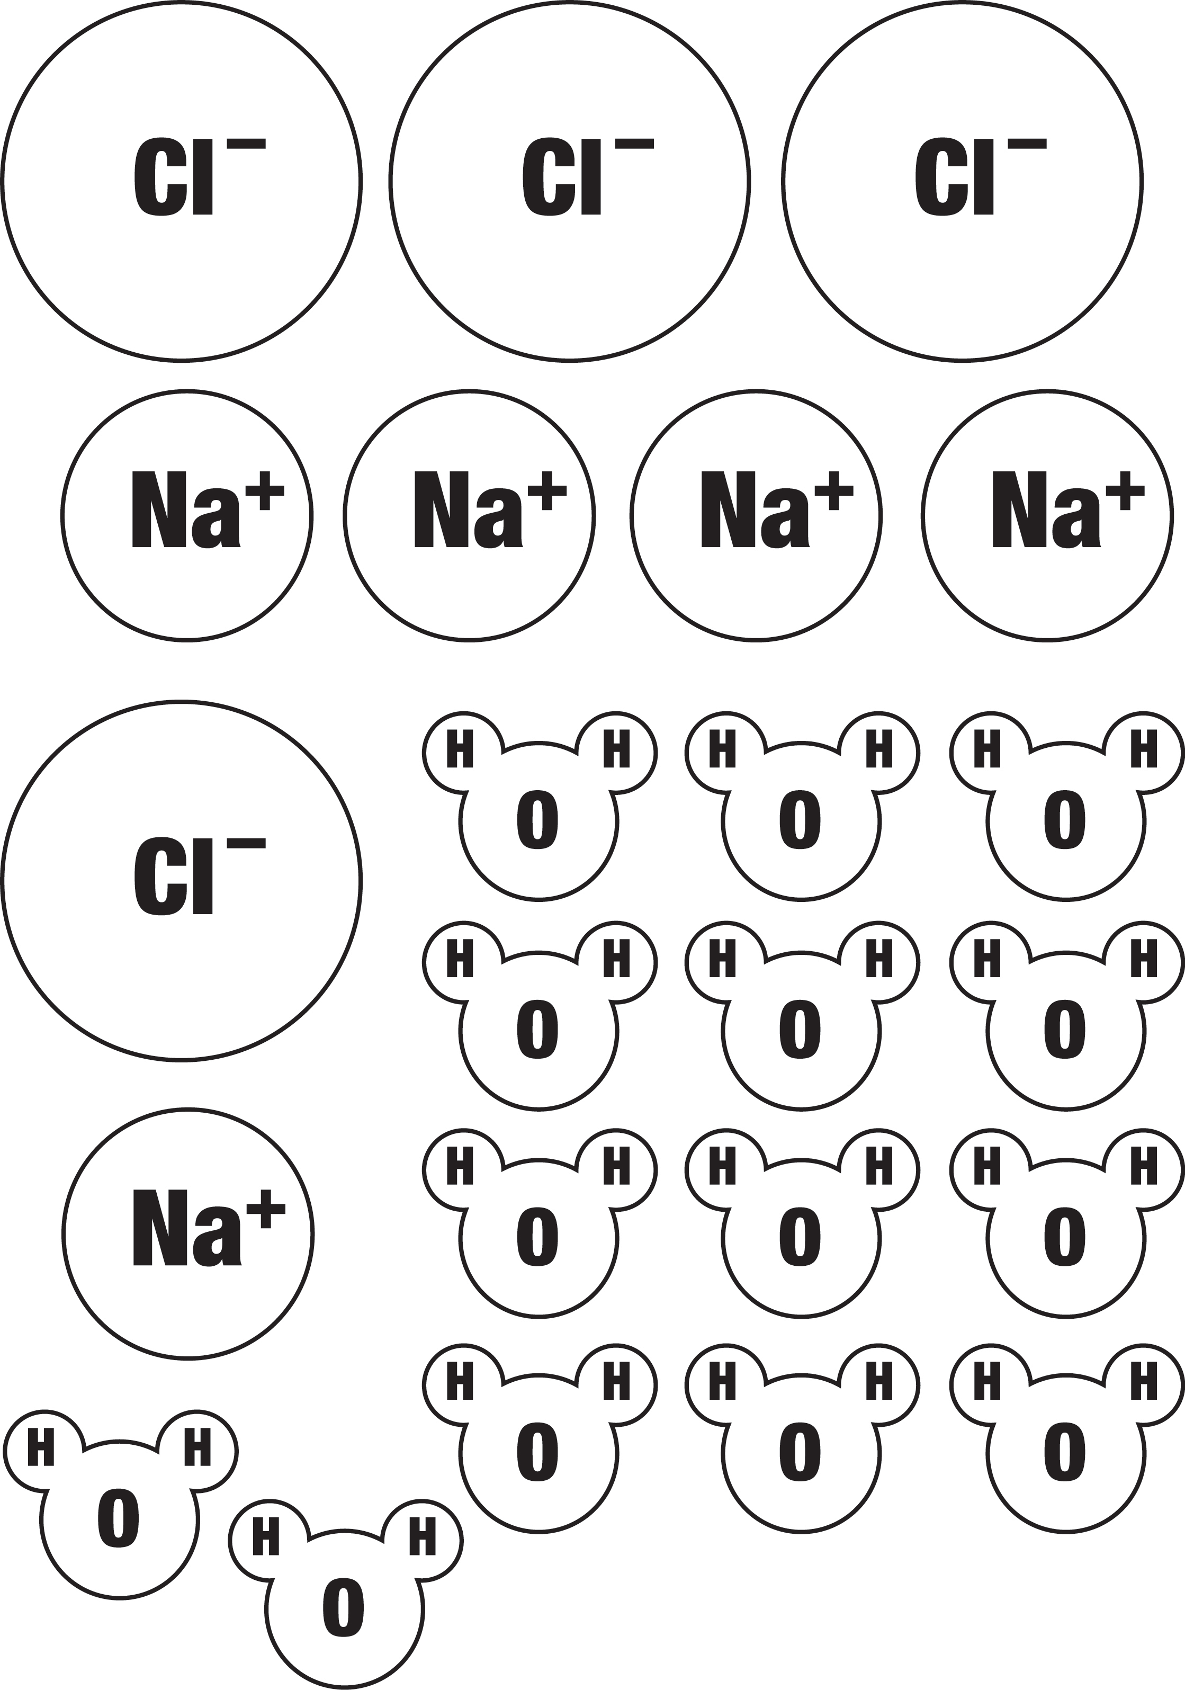

# ACTIVITY

## Question to Investigate

Is alcohol just as good, better, or worse than water at dissolving salt?

## Materials for Each Group

* + Water
  + Isopropyl alcohol (70% or higher)
  + Salt
  + Balance
  + 2 clear plastic cups
  + 2 small plastic cups
  + Graduated cylinder

## Procedure

1. A cartoon of hands pouring salt into small glasses

   Description automatically generatedIn separate cups, measure two samples of salt that weigh 5 grams each.
2. Place 15 mL of water and alcohol into separate cups.
3. At the same time, add the water and alcohol to the samples of salt.
4. Swirl both cups the same way for about 20 seconds and check for the amount of salt dissolved.
5. Swirl for another 20 seconds and check. Swirl for the last 20 seconds and check.
6. Carefully pour off the water and alcohol from the cups and compare the amount of undissolved salt left in each cup.
7. **Select two variables and explain how they are controlled in this procedure.**
8. **Is alcohol just as good, better, or worse than water at dissolving salt? ________**

**How do you know?**

# EXPLAIN IT WITH ATOMS & MOLECULES

1. **Think about the polarity of water and alcohol to explain why water dissolves salt better than alcohol does.**

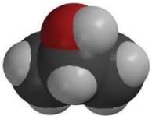

**–**

**+**

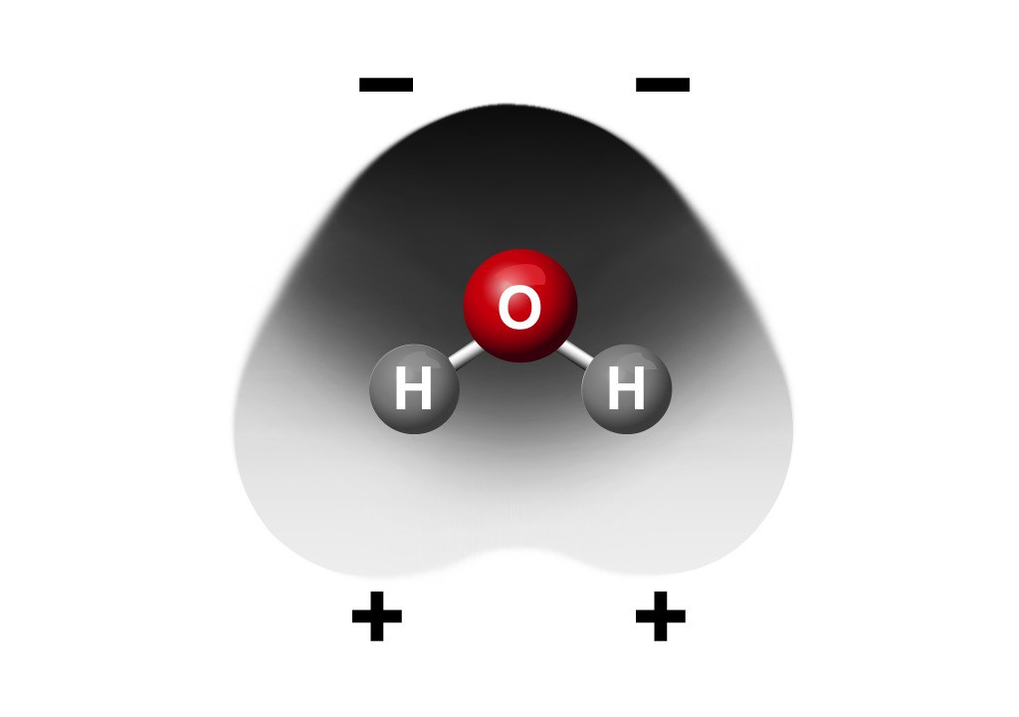

# TAKE IT FURTHER

## Question to Investigate

Do all ionic substances dissolve in water?

## Materials for Each Group

* + Sodium bicarbonate
  + Calcium carbonate
  + Water
  + 2 clear plastic cups
  + 2 small plastic cups
  + Balance

## A close-up of a hand pouring water into a cup Description automatically generatedProcedure

1. Label two clear plastic cups sodium bicarbonate and calcium carbonate.
2. Measure 2 g each of sodium bicarbonate and calcium carbonate and put them in their labeled cups.
3. Measure 30 mL of water into each of two empty cups.
4. At the same time, pour the water into the sodium bicarbonate and calcium carbonate cups.
5. Gently swirl both cups for about 1 minute.
6. **Do all ionic substances dissolve in water?**

**How do you know?**

**Activity Sheet Name Lesson 4 – Part 4**

**Why Does Water Dissolve Sugar? Date**

# INTRODUCTION

## Question to Investigate

What happens to the sugar and color coating of an M&M when it is placed in water?

## Materials

* Clear plastic cup
* Water
* M&M
* White paper

## Procedure

1. Pour enough room temperature water into a clear plastic cup so that the water is deep enough to completely cover an M&M and place this cup on a piece of white paper.
2. Once the water has settled, place 1 M&M in the center of the cup. Be careful to keep the

water and M&M as still as possible. Observe for about 1 minute.

1. **What happens to the sugar and color coating when an M&M is placed in water?**
2. **Knowing what you do about the polarity of water, why do you think water dissolves sugar?**

# EXPLAIN IT WITH ATOMS & MOLECULES

1. **Sucrose makes up the sugar we commonly use. The chemical formula for sucrose is C12H22O11. What do these letters and numbers mean?**
2. **What do the + and – signs around certain parts of the sucrose molecule mean?**

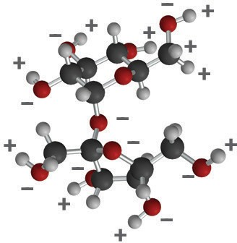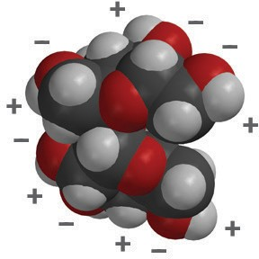

Sucrose ball-and-stick model

Sucrose space-filling model

1. **Look at the pictures below and describe what happens when water dissolves sucrose. Be sure to discuss the polarity of both water and sucrose.**

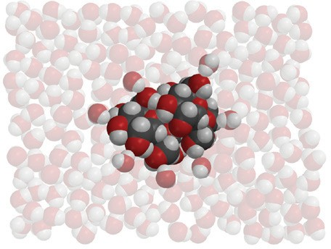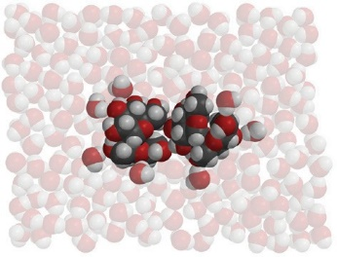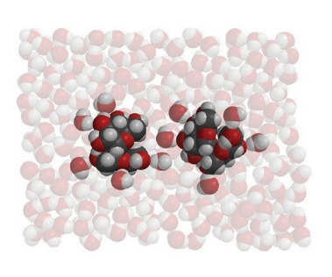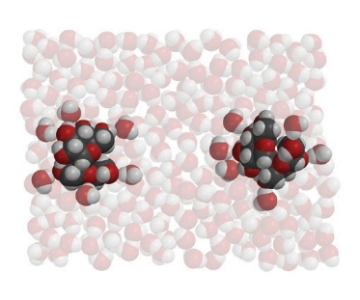

# ACTIVITY

## Question to Investigate

Is water, alcohol, or oil better at dissolving the color and sugar coating from an M&M?

## Materials

* + 3 M&M’s (same color)
  + Water
  + Mineral oil
  + Isopropyl alcohol (70%)
  + 3 clear plastic cups
  + White paper

## A cartoon of hands holding a few cups of liquid Description automatically generatedProcedure

1. Label 3 cups *Water*, *Alcohol*, and *Oil*. Add 15 mL of water, alcohol, and mineral oil to their labeled cups.
2. Place the three cups on a white sheet of paper.
3. At the same time, add 1 M&M to each liquid. Then gently swirl the liquid and M&M in each cup for about 30 seconds.
4. **Draw a line from the solvent to the description to show how well each solvent dissolves the sugar and color coating of an M&M.**

Water doesn’t dissolve the sugar and color at all.

Isopropyl alcohol dissolves the sugar and color very well.

Mineral oil dissolves a small amount of the sugar and color.

# EXPLAIN IT WITH ATOMS & MOLECULES

|  |  |  |
| --- | --- | --- |
| **The polarity of a solvent and how well sucrose dissolves in it** | | |
| **Solvent** | **How polar is the solvent?**  *nonpolar / slightly polar / very polar* | **How does the polarity of the solvent affect how well sucrose dissolves in it?** |
| **Water** |  |  |
| **Isopropyl alcohol** |  |  |
| **Oil** |  |  |

***TAKE IT FURTHER***

1. **Citric acid occurs naturally in fruits like oranges, lemons, and limes. It is dissolved in the water within the fruit and contributes to the fruit’s sour taste. When it isn’t dissolved in water, citric acid molecules are attracted to other citric acid molecules within a crystal.**

**The chemical formula for citric acid is C6H8O7 and it is very soluble in water.**

**Why do you think citric acid is so soluble in water?**

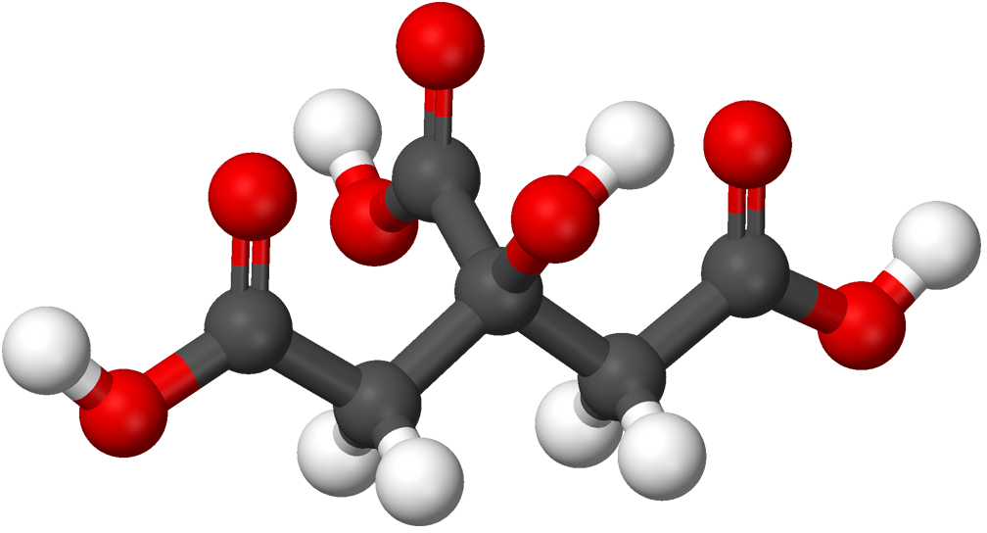

Ball-and-stick model of citric acid molecule

1. **Now that you’ve seen ionic and polar solids dissolve, in the next lesson you’ll see that liquids and even gases can dissolve. What characteristic do you think the liquid or gas molecules will need in order to dissolve in water?**