**Activity Sheet Answers**

**Lesson 3**

**Part 1: Energy Levels, Electrons, and Covalent Bonding**

***EXPLAIN IT WITH ATOMS & MOLECULES***

1. Write a short caption under each picture to describe the process of covalent bonding.

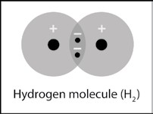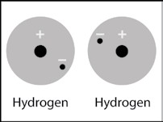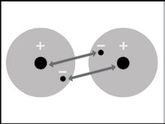

Two hydrogen atoms are near each other.

The electron from each hydrogen atom feels an attraction from the proton in the other atom.

The attractions bring the two hydrogen atoms together and the electrons are shared by both atoms making a covalent bond.

1. What are two conditions atoms must have to form covalent bonds with one another?

There has to be strong enough attraction by the protons in each atom for the electrons in the other atom. And there must be room for the electrons on the outer energy level of both atoms.

1. Why is a hydrogen molecule (H2) more stable than two individual hydrogen atoms?

The electrons form a covalent bond which means that each electron can be near two protons instead of just 1. In a covalent bond, the electrons are shared between the two atoms.

1. Why can’t a third hydrogen atom join the H2 molecule to make H3?

A hydrogen molecule (H2) is made up of two hydrogen atoms sharing two electrons on the first energy level. If another hydrogen atom comes along, the electron from that hydrogen atom cannot be shared on the first energy level because there is no room. It would have to be further away from the nucleus and would not feel a strong enough attraction. Also, the electrons in the H2 molecule would not feel a strong enough attraction to that one proton to move further away from the two protons they are attracted to.

1. Write a short caption beside each picture to describe the process of covalent bonding.

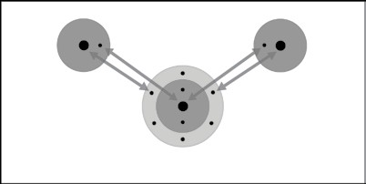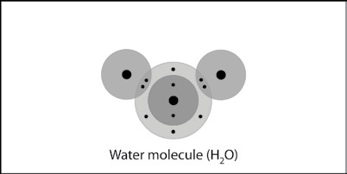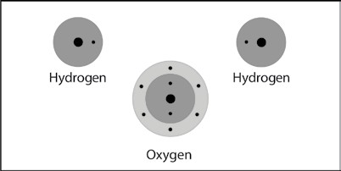

Two hydrogen atoms and one oxygen atom are near each other.

The electrons in each hydrogen atom feel the attraction of the protons in the oxygen atom.

And the electrons on the outer energy level of oxygen feel the attraction for the proton from hydrogen.

The attractions bring the atoms together in a covalent bond.

1. Why can’t a third hydrogen atom join the water molecule (H20) to make H3O?

If another hydrogen atom comes along, the electron from that hydrogen atom cannot be shared on the second energy level of oxygen because there is no room. It would have to be further away from the nucleus and would not feel a strong enough attraction. Also, the electrons already in the H2O molecule would not feel a strong enough attraction to that one proton to move further away from the protons they are already attracted to.

***ACTIVITY***

1. What were the bubbles made out of in this activity?

The bubbles that formed in the solution were Hydrogen gas (H2) and Oxygen gas (O2).

1. Why was there more hydrogen gas produced than oxygen gas?

HINT: Look back at the drawings showing the number of hydrogen and oxygen atoms that bond to form a water molecule.

More hydrogen gas was produced because each water molecule contains more hydrogen than it does oxygen. In one water molecule, there are two hydrogen atoms, while there is only one oxygen atom.

***TAKE IT FURTHER***

1. Briefly describe the process of covalent bonding between two oxygen atoms to make an oxygen molecule. Be sure to mention attractions between electrons and protons and the number of electrons in the outer energy level for the atoms in the final molecule.

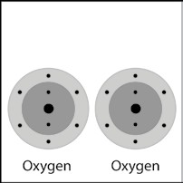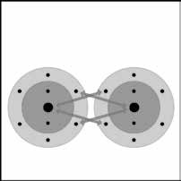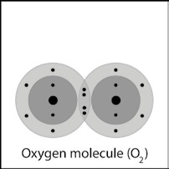

Each oxygen atom has 6 electrons in its outer energy level.

Electrons from each oxygen atom feel an attraction from protons in the other atom.

The attractions bring the two oxygen atoms together to make a double covalent bond which forms an oxygen molecule from the two oxygen atoms.

1. Briefly describe the process of covalent bonding between the carbon and the four hydrogen atoms to make a methane molecule. Be sure to mention attractions between electrons and protons and the number of electrons in the outer energy level for the atoms in the final molecule.

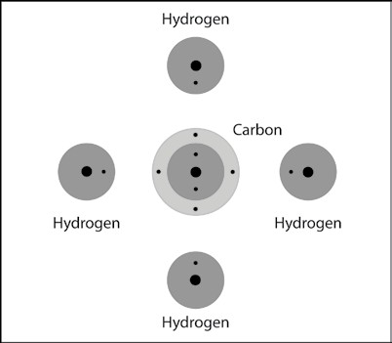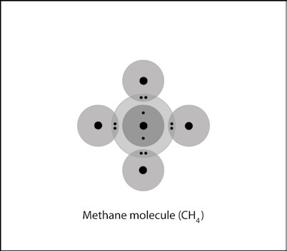

Initially, each Hydrogen atom has a single outermost electron, while the carbon atom has four outermost electrons.

Electrons within the hydrogen atoms and the central carbon atom feel an attraction from protons in the other atom.

The attractions bring the atoms together to form four covalent bonds. Each hydrogen atom now has 2 electrons in its outer energy level, while the carbon atom has 8 electrons in its outer energy level.

1. Briefly describe the process of covalent bonding between the carbon and the two oxygen atoms to make a carbon dioxide molecule. This molecule has two double bonds. Be sure to mention attractions between electrons and protons and the number of electrons in the outer energy level for the atoms in the final molecule.

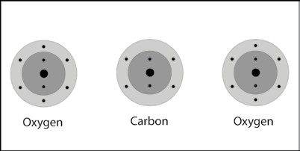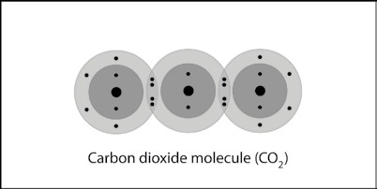

Initially, each oxygen atom has 6 outermost electrons, while the carbon atom has four outermost electrons.

Electrons within the oxygen atoms and the carbon atom feel an attraction from protons in the other atom.

The attractions bring the atoms together to form two double covalent bonds. Each atom now has 8 electrons in its outer energy level.

**Part 2: Energy Levels, Electrons, and Ionic Bonding**

***EXPLAIN IT WITH ATOMS & MOLECULES***

1. What is the basic difference between covalent and ionic bonding?

In covalent bonding, each atom attracts the other atom’s electrons and electrons from each atom end up being shared by both atoms. In ionic bonding, the attractions are less balanced, and electrons are attracted by one atom significantly more than another. One or more electrons ends up being transferred to the atom with the stronger attraction. This creates a positive and a negative ion which attract and form an ionic bond.

1. Write a short caption beside each picture to describe the process of ionic bonding.

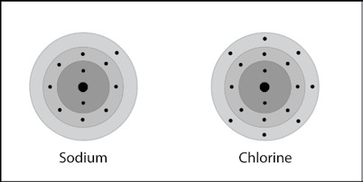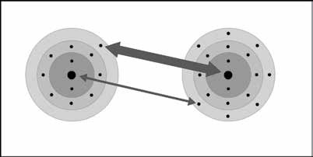

Sodium and chlorine atoms are near each other.

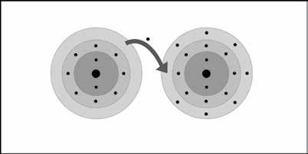

The chlorine attracts an electron from the sodium more strongly than the sodium attracts an electron from the chlorine.

An electron is transferred from the sodium to the chlorine.

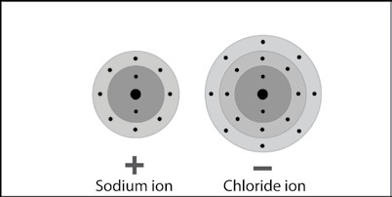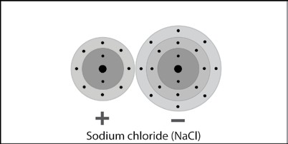

Since the sodium loses and electron, it has one more proton than electrons and becomes a positive ion. Since the chlorine gains an electron, it has one more electron than protons and becomes a negative ion.

The oppositely charged ions attract and form an ionic bond to make sodium chloride.

***ACTIVITY***

1. Knowing what you do about sodium and chloride ions, why are salt crystals cube-shaped?

Salt crystals are cube-shaped because the sodium and chloride ions bond together in an alternating pattern in three dimensions.

***TAKE IT FURTHER***

In the very first lesson you saw that carbon dioxide from different sources could enter water and make that water acidic. Those examples were like models of the process of ocean acidification. Certain characteristics of water and carbon dioxide make this possible.

Now that you know more about the water and carbon dioxide molecules, work with a partner to think of what questions we need to answer to begin to understand the first steps of ocean acidification?

Some examples of questions might be:

* How does the carbon dioxide get into the water?
* What is it about the water and carbon dioxide molecules that allows the carbon dioxide to stay in the water?
* Does the carbon dioxide dissolve into the water like the carbon dioxide in club soda?
* How do carbon dioxide and water become carbonic acid?
* Can the carbonic acid in the ocean hurt people?