**Lesson 2: Atom Fundamentals**

**Storyline Summary:**

Picking up from the end of Lesson 1, the class discusses that to understand ocean acidification, they will first need to understand the main components of ocean water which are water and salt. To do this, the class will have to begin with the basics of understanding atoms and how they join together to make water, salt, and other substances. This lesson focuses on the parts of the atom. Lesson 3 introduces covalent and ionic bonding in water, salt, and other substances.

**Note:** This lesson has three parts: Depending on the amount of time you spend on class discussion, the lesson should take about three class periods.

**What Students Do**

**Part 1** - Students investigate the attraction and repulsion of protons and electrons by exploring static electricity on strips of plastic bag material to begin to learn about the parts of the atom.

**Part 2** –Students focus on the first 20 elements of the periodic table and play a game to improve their understanding of the relation between an atom’s protons, neutrons, and electrons and its position in the Periodic Table.

**Part 3** – Students learn about the energy levels of atoms and play a game to help them understand and review the basic concepts about energy levels.

**What Students Learn**

* Atoms are composed of protons, neutrons, and electrons.
* Protons have a positive charge, electrons have a negative charge, and neutrons have no charge.
* The basics of the periodic table including the meaning of atomic number, and atomic mass.
* Atoms have energy levels surrounding them where the electrons are.
* Only a certain number of electrons can be in any energy level.

**Materials & Preparation**

**Part 1 – Protons, Neutrons, and Electrons**

(From Middle School Chemistry - Chapter 4, Lesson 1)

**Materials for Each Group**

* Plastic grocery bag
* Scissors
* Inflated balloon
* Small pieces of paper, confetti-size

**Materials for the Demonstration**

* Sink
* Balloon

## A white sheet of paper with numbers and symbols Description automatically generatedPart 2 – The Periodic Table

## (From Middle School Chemistry - Chapter 4, Lesson 2)

## Teacher preparation

Print out the 20 pages of element cards. The first page is shown. Laminate each page and cut out the cards. For Lesson 2, you will need the 5 cards for each element from the left side of each sheet. You will also need the card in the upper right corner. This is the atom name card.

Students can also try playing the ***Periodic Table Game, Game #1***.

[www.acs.org/middleschoolchemistry/simulations/chapter4/lesson2.html](http://www.acs.org/middleschoolchemistry/simulations/chapter4/lesson2.html)

This is an online version of the periodic table card game from this lesson that you can assign as class work or homework after students have played the game in the classroom.

**Part 3 - The Periodic Table and Energy Level Models**

## (From Middle School Chemistry - Chapter 4, Lesson 3)

## Teacher preparation

Be sure that the 20 atom name cards are posted around the room. You will need the five cards on the right-hand side of each of the 20 atom description sheets. This lesson is intended as a follow-up to chapter 4, lesson 2.

Students can try playing the ***Periodic Table Game, Game #2.***

[www.acs.org/middleschoolchemistry/simulations/chapter4/lesson3.html](http://www.acs.org/middleschoolchemistry/simulations/chapter4/lesson3.html)

This is an online version of the periodic table card game from this lesson that you can assign as class work or homework after students have played the game in the classroom.

**Part 1 – Protons, Neutrons, and Electrons**

(From Middle School Chemistry - Chapter 4, Lesson 1)

***Key Concepts***

* Atoms are made of extremely tiny particles called protons, neutrons, and electrons.
* Protons and neutrons are in the center of the atom, making up the nucleus.
* Electrons surround the nucleus.
* Protons have a positive charge.
* Electrons have a negative charge.
* The charge on the proton and electron are exactly the same size but opposite.
* Neutrons have no charge.
* Since opposite charges attract, protons and electrons attract each other.

***Summary***

Students will put a static charge on a strip of plastic by pulling it between their fingers. They will see that the plastic is attracted to their fingers. Students will be introduced to the idea that rubbing the strip with their fingers caused electrons to move from their skin to the plastic giving the plastic a negative charge and their skin a positive charge. Through these activities, students will be introduced to some of the characteristics of electrons, protons, and neutrons, which make up atoms.

***Objective***

Students will be able to explain, in terms of electrons and protons, why a charged object is attracted or repelled by another charged object. They will also be able to explain why a charged object can even be attracted to an uncharged object. Students will also be able to explain that the attraction between positive protons and negative electrons holds an atom together.

***Evaluation***

The activity sheet will serve as the “Evaluate” component of each 5-E lesson plan. The activity sheets are formative assessments of student progress and understanding.

***Safety***

Be sure you and the students wear properly fitting goggles.

***Materials for Each Group***

* Plastic grocery bag
* Scissors
* Inflated balloon
* Small pieces of paper, confetti-size

***Materials for the Demonstration***

* Sink
* Balloon

# ENGAGE

Have a class discussion about where the investigation into ocean acidification should begin. Ask students where the class should start if they want to understand the chemistry of the ocean. Since the ocean is mostly salt water, try to lead the discussion to investigating the chemistry of water and salt – the primary components of the oceans.

The class should agree that water is a good place to start, and that salt can be explored after water. Ask students if they know what “H2O” means. If students do not know, explain that H2O is a water molecule made up of 2 atoms of hydrogen and 1 atom of oxygen.

Discuss the idea that to really understand the water molecule and the properties of water, students will need to learn about atoms and how they are connected together. They can then apply this understanding to water molecules for a deeper understanding about the nature and characteristics of water. And this will lead to a better understanding of ocean acidification.

## Show a picture of a pencil point and how the carbon atoms look at the molecular level.

**Project the image *Pencil Zoom.***

[www.acs.org/middleschoolchemistry/simulations/chapter4/lesson1.html](http://www.acs.org/middleschoolchemistry/simulations/chapter4/lesson1.html)

Students may already be familiar with the parts of the atom but reviewing the main points is probably a good idea.

Ask students questions such as the following:

* + **What are the three different tiny particles that make up an atom?** Protons, neutrons, and electrons.

## Which of these is in the center of the atom?

Protons and neutrons are in the center (nucleus) of the atom. You may want to mention that hydrogen is the only atom that usually has no neutrons. The nucleus of most hydrogen atoms is composed of just 1 proton. A small percentage of hydrogen atoms have 1 or even 2 neutrons. Atoms of the same element with different numbers of neutrons are called *isotopes*. These will be discussed in Lesson 2.

## What zooms around the nucleus of an atom?

Electrons

* + **Which one has a positive charge, a negative charge, and no charge?** Proton—positive; electron—negative; neutron—no charge. The charge on the proton and electron are exactly the same size but opposite. The same number of protons and electrons exactly cancel one another in a neutral atom.

***Note****: The picture shows a simple model of the carbon atom. It illustrates some basic information like the number of protons and neutrons in the nucleus. It also shows that the number of electrons is the same as the number of protons. This model also shows that some electrons can be close to the nucleus and others are further away. One problem with this model is that it suggests that electrons orbit around the nucleus in perfect circles on the same plane, but this is not true.*

*The more widely accepted model shows the electrons as a more 3-dimensional “electron cloud” surrounding the nucleus. Students will be introduced to these ideas in a bit more detail in Lesson 3. But for most of our study of chemistry at*

*the middle school level, the model shown in the illustration will be very useful. Also, for most of our uses of this atom model, the nucleus will be shown as a dot in the center of the atom.*

## Show animations and explain that protons and electrons have opposite charges and attract each other.

**Project the animation *Protons and Electrons.***

[www.acs.org/middleschoolchemistry/simulations/chapter4/lesson1.html](http://www.acs.org/middleschoolchemistry/simulations/chapter4/lesson1.html)

Explain to students that two protons repel each other and that two electrons repel each other. But a proton and an electron attract each other. Another way of saying this is that the same or “like” charges repel one another and opposite charges attract one another.

Since opposite charges attract each other, the negatively charged electrons are attracted to the positively charged protons. Tell students that this attraction is what holds the atom together.

**Project the animation *Hydrogen Atom.***

[www.acs.org/middleschoolchemistry/simulations/chapter4/lesson1.html](http://www.acs.org/middleschoolchemistry/simulations/chapter4/lesson1.html)

Explain to students that in a hydrogen atom, the negatively charged electron is attracted to the positively charged proton. This attraction is what holds the atom together.

Tell students that hydrogen is the simplest atom. It has only 1 proton, 1 electron, and 0 neutrons. It is the only atom that does not have any neutrons. Explain that this is a simple model that shows an electron going around the nucleus.

Click on the button “Show cloud” and explain to students that this is a different model. It shows the electron in the space surrounding the nucleus that is called an electron cloud or energy level. It is not possible to know the location of an electron but only the region where it is most likely to be. The electron cloud or energy level shows the region surrounding the nucleus where the electron is most likely to be.

***Note****: Inquisitive students might ask how the positively charged protons are able to stay so close together in the nucleus: Why don’t they repel each other? This is a great question. The answer is well beyond an introduction to chemistry for middle school, but one thing you can say is that there is a force called the “Strong Force,” which holds protons and neutrons together in the nucleus of the atom. This force is much stronger than the force of repulsion of one proton from another.*

*Another good question: Why doesn’t the electron smash into the proton? If they are attracted to each other, why don’t they just collide? Again, a detailed answer to this question is beyond the scope of middle school chemistry. But a simplified answer has to do with the energy or speed of the electron. As the electron gets closer to the nucleus, its energy and speed increases. It ends up moving in a region surrounding the nucleus at a speed that is great enough to balance the attraction that is pulling it in, so the electron does not crash into the nucleus.*

# EVALUATE

## Give each student an activity sheet for Part 1.

Have students answer questions about the illustration on the activity sheet. Students will record their observations and answer questions about the activity on the activity sheet. The *Explain It with Atoms & Molecules* and *Take It Further* sections of the activity sheet will either be completed as a class, in groups, or individually, depending on your instructions.

# EXPLORE

## 3. Do an activity to show that electrons and protons attract each other.

Students can see evidence of the charges of protons and electrons by doing an activity with static electricity.

***Note****: When two materials are rubbed together in a static electricity activity, one material tends to lose electrons while the other material tends to gain electron. In this activity, human skin tends to lose electrons while the plastic bag, made of polyethylene, tends to gain electrons.*

## Question to investigate

What makes objects attract or repel each other?

## Materials for each group

* + Plastic grocery bag
  + Scissors

## Procedure, part 1

*Charged plastic and charged skin*

1. Cut 2 strips from a plastic grocery bag so that each is about 2–4 cm wide and about 20 cm long.
2. Hold the plastic strip firmly at one end. Then grasp the plastic strip between the thumb and fingers of your other hand as shown.
3. A close-up of a hand

   Description automatically generatedQuickly pull your top hand up so that the plastic strip runs through your fingers. Do this three or four times.
4. Allow the strip to hang down. Then bring your other hand near it.
5. Write “attract” or “repel” in the chart on the activity sheet to describe what happened.

## Expected results

The plastic will be attracted to your hand and move toward it. Students may notice that the plastic is also attracted to their arms and sleeves. Let students know that later in this lesson they will investigate why the plastic strip is also attracted to surfaces that have not been charged (neutral).

***Note****: If students find that their plastic strip does not move toward their hand, it must not have been charged well enough. Have them try charging their plastic strip by holding it down on their pants or shirt and then quickly pulling it with the other hand. Then they should test to see if the plastic is attracted to their clothes. If not, students should try charging the plastic again.*

# EXPLAIN

## Show students models comparing the number of protons and electrons in the plastic and skin before and after rubbing them together.

Tell students that the plastic strip and their skin are made of molecules that are made of atoms. Tell students to assume that the plastic and their skin are neutral—that they have the same number of protons as electrons.

**Project the image *Charged plastic and hand*.**

[www.acs.org/middleschoolchemistry/simulations/chapter4/lesson1.html](http://www.acs.org/middleschoolchemistry/simulations/chapter4/lesson1.html)

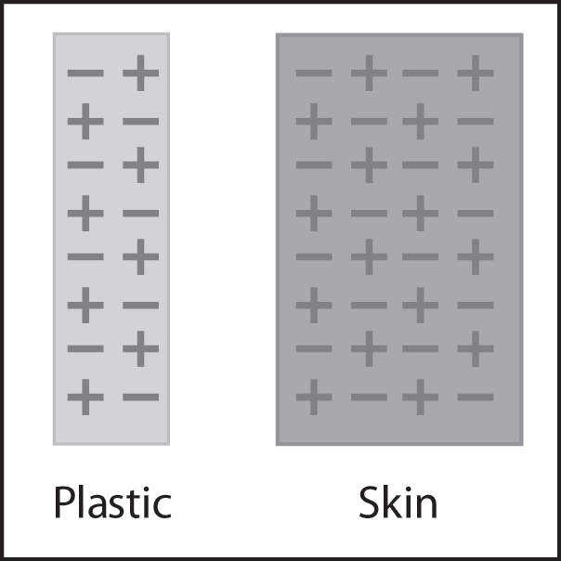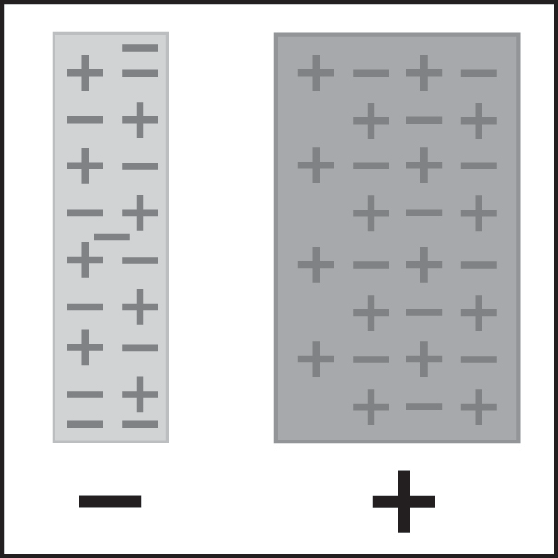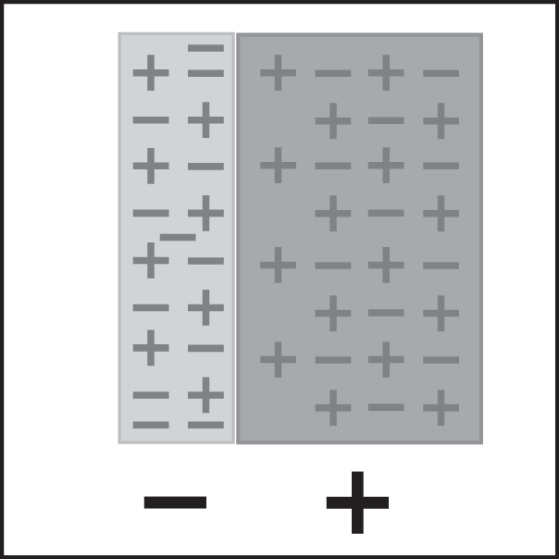

Protons and electrons before rubbing

Protons and electrons after rubbing

Opposites attract

# 

# Point out that before the students pulled the plastic between their fingers, the number of protons and electrons in each is the same. Then, when students pulled the plastic through their fingers, electrons from their skin got onto the plastic. Since the plastic has more electrons than protons, it has a negative charge. Since their fingers gave up some electrons, their skin now has more protons than electrons, so it has a positive charge. The positive skin and the negative plastic attract each other because positive and negative attract.

# EXPLORE

## A cartoon of a hand holding a blue ribbon Description automatically generatedHave students investigate what happens when a rubbed plastic strip is held near a desk or chair.

**Procedure, part 2**

*Charged plastic and neutral desk*

* 1. Charge one strip of plastic the same way you did previously.
  2. This time, bring the plastic strip toward your desk or chair.
  3. Write “attract” or “repel” in the chart.

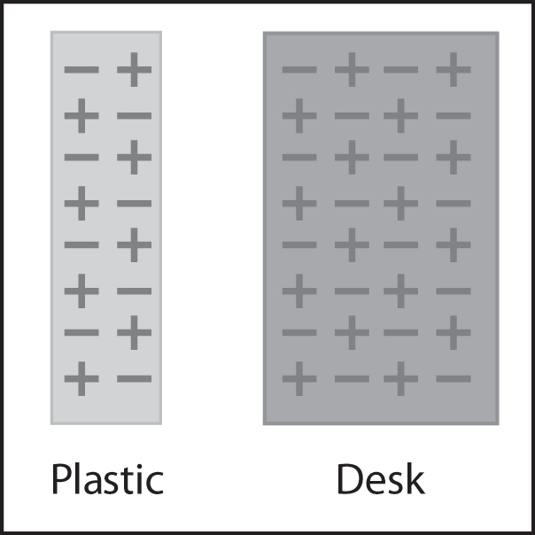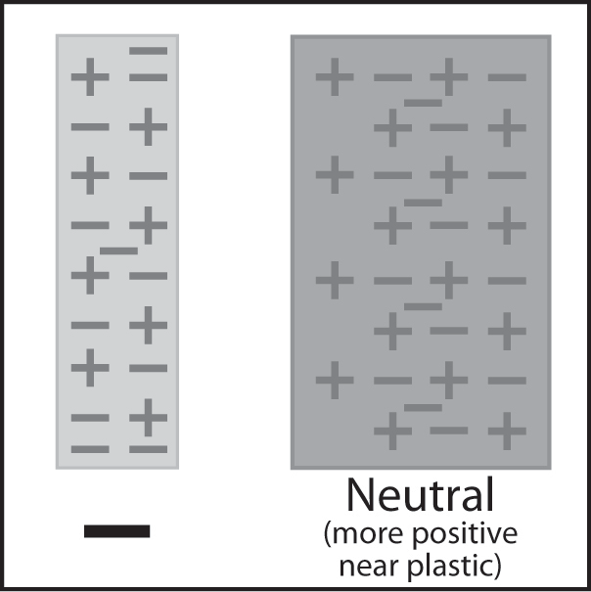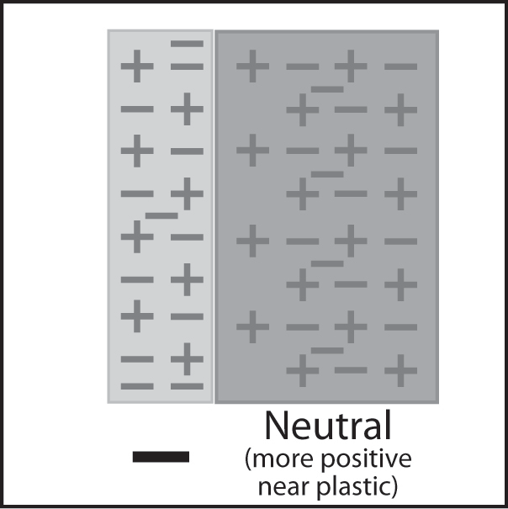

## 6. Have students charge two pieces of plastic and hold them near each other to see if electrons repel one other.

Ask students to make a prediction:

* What do you think will happen if you charge two strips of plastic and bring them near each other?

## Procedure, part 3

*2 pieces of charged plastic*

1. Charge two strips of plastic
2. Slowly bring the two strips of plastic near each other.
3. Write “attract” or “repel” in the chart on the activity sheet.

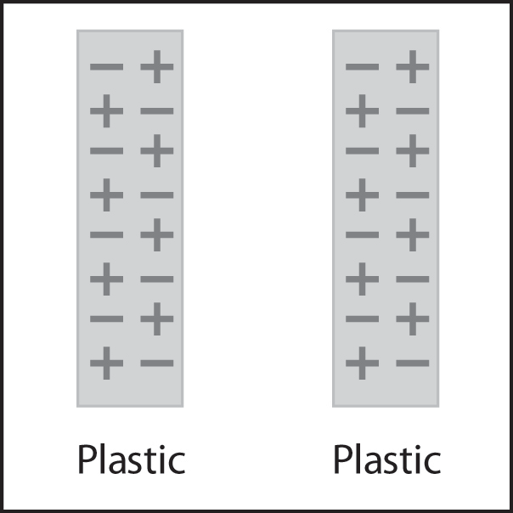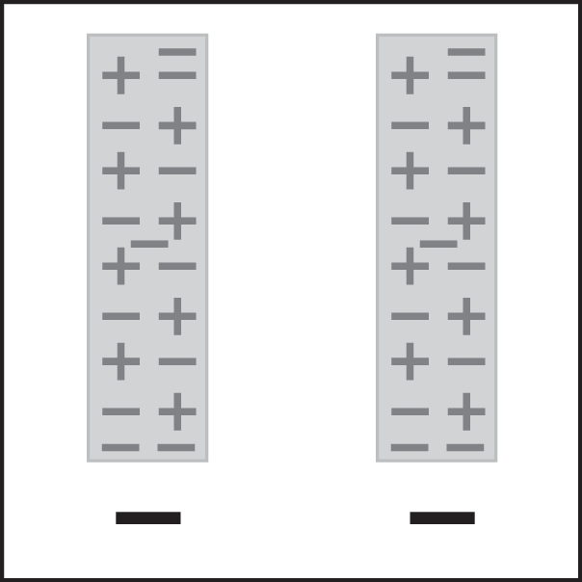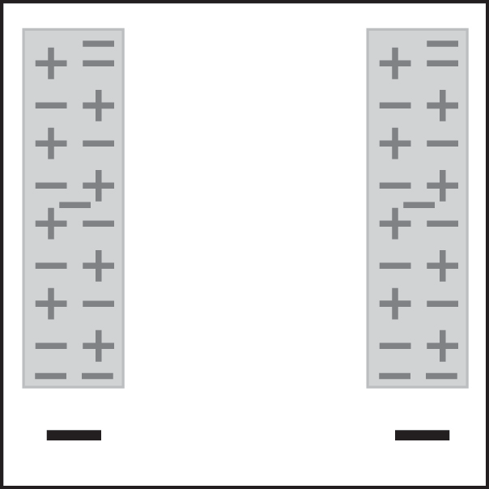

Two neutral plastic strips

Two charged plastic strips

Like charges repel

## Expected results

The strips will move away or repel each other. Since both strips have extra electrons on them, they each have extra negative charge. Since the same charges repel one another, the strips move away from each other.

Ask students:

## What happened when you brought the two pieces of plastic near each other?

The ends of the strips moved away from each other.

* + **Use what you know about electrons and charges to explain why this happens.** Each strip has extra electrons so they are both negatively charged. Because like charges repel, the pieces of plastic repelled each other.

# EXTEND

## 7. Have students apply their understanding of protons and electrons to explain what happens when a charged balloon is brought near pieces of paper.

**Materials for each group**

* Inflated balloon
* Small pieces of paper, confetti-size

## Procedure

* Rub a balloon on your hair or clothes.
* Bring the balloon slowly toward small pieces of paper.

## Expected results

The pieces of paper will jump up and stick on the balloon.

Ask students:

## What did you observe when the charged balloon was held near the pieces of paper?

The paper pieces moved up and stuck on the balloon.

## Use what you know about electrons, protons, and charges to explain why this happens.

When you rub the balloon on your hair or clothes it picks up extra electrons, giving the balloon a negative charge. When you bring the balloon near the paper, the electrons from the balloon repel the electrons in the paper. Since more protons are at the surface of the paper, it has a positive change. The electrons are still on the paper, just not at the surface, so overall the paper is neutral. Opposites attract, so the paper moves up toward the balloon.

**8. Show the simulation *Balloons and Static Electricity* from the University of Colorado at Boulder’s Physics Education Technology site.**

<http://phet.colorado.edu/simulations/sims.php?sim=Balloons_and_Static_Electricity>

In the simulation, check the boxes “show all charges” and “wall”. Uncheck everything else. In this simulation, you can rub the balloon a little bit on the sweater and see that some of the electrons from the sweater move onto the balloon. This gives the balloon a negative charge. Since the sweater lost some electrons, it has more protons than electrons, so it has a positive charge. If you move the balloon toward the sweater, it will be attracted. This is like moving the charged plastic strip toward the cloth it was rubbed on.

You can also move the balloon toward the wall. The excess negative charge on the balloon repels negative charge on the surface of the wall. This leaves more positive charge on the surface of the wall. The negatively charged balloon is attracted to the positive area on the wall. This is like moving the charged plastic strip toward the finger.

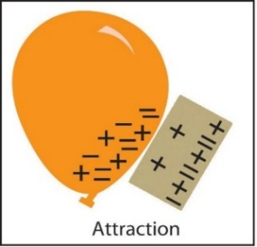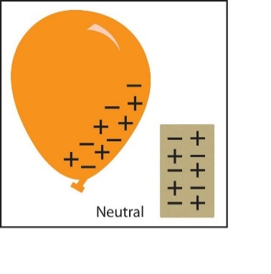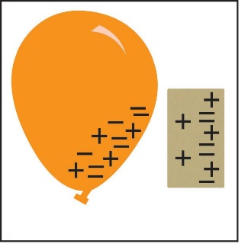

# EXTRA EXTEND

## 9. Demonstrate how electrons can attract a stream of water.

Either do the following demonstration or show the video *Balloon and Water*. [www.acs.org/middleschoolchemistry/simulations/chapter4/lesson1.html](http://www.acs.org/middleschoolchemistry/simulations/chapter4/lesson1.html)

## Materials for the demonstration

* Sink
* Balloon

## Procedure

1. Rub a balloon on your shirt or pants to give it a static charge.
2. Turn on the faucet so that there is a very thin stream of water.

3. Slowly bring the charged part of the balloon close to the stream of water.

## Expected results

The stream of water should bend as it is attracted to the balloon.

Ask students:

## What did you observe when the charged balloon was held near the stream of water?

The stream of water bent toward the balloon.

## Use what you know about electrons, protons, and charges to explain why this happens.

When you rub the balloon on your hair or clothes it picks up extra electrons, giving the balloon a negative charge. When you bring the balloon near the stream of water, the electrons from the balloon repel the electrons in the water. Since more protons are at the surface of the water, it has a positive change. Opposites attract, so the water moves toward the balloon.

**10. Let students know that they will apply what they now know about atoms to understanding the basics of the Periodic Table.**

Now that students know the basic parts of the atom, explain that all known substances on Earth and in the universe are made up of atoms represented in the Periodic Table.

**Ask students:**

* **How might the Periodic Table help us understand the chemistry of ocean water?**

Since both water and salt are made up of different atoms, getting information about these atoms from the Periodic Table could be useful.

Let students know that their next two lessons contain information and games to learn about the atoms in the Periodic Table.

**Part 2: The Periodic Table**

(From Middle School Chemistry - Chapter 4, Lesson 2)

***Key Concepts***

* The periodic table is a chart containing information about the atoms that make up all matter.
* An element is a substance made up of only one type of atom.
* The atomic number of an atom is equal to the number of protons in its nucleus.
* The number of electrons surrounding the nucleus of an atom is equal to the number of protons in its nucleus.
* Different atoms of the same element can have a different number of neutrons.
* Atoms of the same element with different numbers of neutrons are called “isotopes” of that element.
* The atomic mass of an element is the average mass of the different isotopes of the element.
* The atoms in the periodic table are arranged to show characteristics and relationships between atoms and groups of atoms.

***Summary***

Students will begin to look closely at the periodic table. They will be introduced to the basic information given for the elements in most periodic tables: the name, symbol, atomic number, and atomic mass for each element. Students will focus on the first 20 elements. They will try to correctly match cards with information about an element to each of the first 20 elements. Students will then watch several videos of some interesting chemical reactions involving some of these elements.

***Objective***

Students will identify different atoms by the number of protons in the nucleus and realize that the number of electrons equals the number of protons in a neutral atom. They will also be able to explain the meaning of atomic number and atomic mass.

***Evaluation***

The activity sheet will serve as the “Evaluate” component of each 5-E lesson plan. The activity sheets are formative assessments of student progress and understanding.

***About this Lesson***

Lessons 2 and 3 both use the 20 sheets of atom description cards – one sheet for each element.

## Teacher preparation

Print out the 20 pages of element cards. The first page is shown. Laminate each page and cut out the cards. For Lesson 2, you will need the 5 cards for each element from the left side of each sheet. You will also need the card in the upper right corner. This is the atom name card. Tape each of the 20 atom name cards to a spot in the room where students can place the cards that match that atom nearby. For Lesson 3, you will need the atom name card, taped in the same location in the room, and the four cards beneath it. Divide the class into 10 groups of 2 or 3 students each.

Students can also try playing the ***Periodic Table Game, Game #1***.

[www.acs.org/middleschoolchemistry/simulations/chapter4/lesson2.html](http://www.acs.org/middleschoolchemistry/simulations/chapter4/lesson2.html)

This is an online version of the periodic table card game from this lesson that you can assign as class work or homework after students have played the game in the classroom.

# ENGAGE

## 1. Introduce students to the periodic table.

**Project the image *Periodic Table*.**

[www.acs.org/middleschoolchemistry/simulations/chapter4/lesson2.html](http://www.acs.org/middleschoolchemistry/simulations/chapter4/lesson2.html)

Tell students that this is the periodic table. Explain that each box contains information about a different atom. The periodic table shows all the atoms that everything in the known universe is made from. It’s kind of like the alphabet in which only 26 letters, in different combinations, make up many thousands of words. The 100 or so atoms of the periodic table, in different combinations, make up millions of different substances.

***Note****: It is often confusing for students to see the terms “atom” and “element” used interchangeably as if they are the same thing. Explain to students that an atom is the smallest particle or “building block” of a substance. An element is a substance made up of all the same type of atom. For instance, a piece of pure carbon is made up of only carbon atoms. This piece of pure carbon is a sample of the element carbon. The people who developed the periodic table could have called it the Periodic Table of the Atoms but they did not have a firm understanding of atoms at that time. Since they were working with actual samples of elements such as copper, mercury, sulfur, etc., they called it the periodic table of the elements.*

## Optional

Just for fun, you might want to play one or both of the following songs.

* *The Elements* by Tom Lehrer with animation by Mike Stanfill

[www.privatehand.com/flash/elements.html](http://www.privatehand.com/flash/elements.html)

* *Meet the Elements* by They Might be Giants  
  [www.youtube.com/watch?v=Uy0m7jnyv6U](http://www.youtube.com/watch?v=Uy0m7jnyv6U)

## 2. Explain the meaning of the numbers and letters in the boxes in the periodic table.

Tell students that the class will focus on the first 20 elements over 2 days. On the first day, they will look at the number of protons, electrons, and neutrons in the atoms of each element. On the second day, they will look at the arrangement of electrons in the atoms.

## Give each student a copy of the periodic table of the elements, the periodic table of elements 1–20, and the activity sheet for Part 2.

Students will use the periodic table of elements 1**–**20, along with the activity sheet, in the lesson they will do today.

**Project the image *Periodic Table of the First 20 Elements*.**

[www.acs.org/middleschoolchemistry/simulations/chapter4/lesson2.html](http://www.acs.org/middleschoolchemistry/simulations/chapter4/lesson2.html)

**Project the image *Element explanation*.** [www.acs.org/middleschoolchemistry/simulations/chapter4/lesson2.html](http://www.acs.org/middleschoolchemistry/simulations/chapter4/lesson2.html)

Explain what the numbers and letters in each box on the periodic table represent.

## Explain atomic mass.

The atomic mass of an element is based on the mass of the protons, neutrons, and electrons of the atoms of that element. The mass of the proton and neutron are about the same, but the mass of the electron is much smaller (about 1/2000 the mass of the proton or neutron). The vast majority of the atomic mass is contributed by the protons and neutrons.

For any element in the periodic table, the number of electrons in an atom of that element always equals the number of protons in the nucleus. But this is not true for neutrons.

Atoms of the same element can have different numbers of neutrons than protons. Atoms of the same element with different numbers of neutrons are called *isotopes* of that element. The atomic mass in the periodic table is an *average* of the atomic mass of the isotopes of an element. For the atoms of the first 20 elements, the number of neutrons is either equal to or slightly greater than the number of protons.

For example, the vast majority of carbon atoms have 6 protons and 6 neutrons, but a small percentage have 6 protons and 7 neutrons, and an even smaller percentage have 6 protons and 8 neutrons. Since the majority of carbon atoms have a mass very close to 12, and only a small percentage are greater than 12, the average atomic mass is slightly greater than 12.

## 3. Describe the activity students will do to learn about the first 20 elements of the periodic table.

Show students that you have 100 cards (5 for each of the first 20 elements). Explain that each card contains information about one of the first 20 atoms of the periodic table. The students’ job is to read the card carefully, figure out which atom the card is describing, and put the card at the spot in the room for that atom.

Review the information about protons, electrons, and neutrons students need to know in order to match the cards with the correct element:

## Proton

* + Positively charged particle in the nucleus of the atom.
  + The number of protons in an atom’s nucleus is the atomic number.

## Electron

* + Negatively charged particle surrounding the nucleus of the atom.
  + The number of electrons surrounding the nucleus of an atom is equal to the number of protons in the atom’s nucleus.

## Neutron

* + Particle in the nucleus that has almost the same mass as a proton but has no charge.
  + For the atoms of the first 20 elements, the number of neutrons is either equal to or slightly greater than the number of protons.

To match the number of neutrons listed on your card to the correct element, look for an element on the periodic table so that if you add the number of neutrons on your card to the protons of the element, you will get close to the atomic mass for that element.

For example, you may have a card that says that the atom you are looking for has 5 neutrons. You would look at the periodic table to find an atom that you could add 5 to its number of protons that would give you a sum close to the atomic mass given for that element. The answer is beryllium (Be), which has 4 protons and an atomic mass of 9.01.

**Note:** There are a few neutron cards that have two possible correct elements instead of just one:

* + 6 Neutrons—Boron or Carbon
  + 10 Neutrons—Fluorine or Neon
  + 12 Neutrons—Sodium or Magnesium
  + 16 Neutrons—Phosphorous or Sulfur
  + 20 Neutrons—Potassium or Calcium

# EXPLORE

## A hand putting a card in a ballot box Description automatically generated4. Have groups work together to place each card with its correct atom.

Distribute the cards to groups. If you have 10 groups, each group will get 10 cards. Be available to help students who have trouble with the neutrons and atomic mass.

## 5. Discuss the placement of the cards for two or three atoms.

Select two or three atoms and review whether the cards were placed correctly. This review will help reinforce the concepts about the structure of atoms and help students determine the number of protons, electrons, and neutrons in each type of atom.

Have students begin filling out the activity sheet with the following information:

* + Number of protons
  + Number of electrons
  + Number of neutrons (usually)

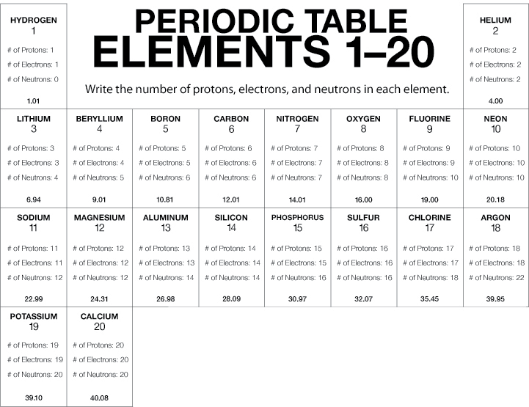

**Note:** The number of neutrons may be different in the atoms of the same element. The atoms of an element with different numbers of neutrons are called isotopes of that element. The number of neutrons shown in the chart represents the most common isotope for that element.

# EXTEND

## 6. Let students know that the next lesson will be about how the location of electrons in an atom affects its characteristics.

Students now know that atoms have a certain number of protons, neutrons, and electrons. They also know that the number of protons equals the number of electrons.

Tell students that where the electrons are around the nucleus of the atom has a big effect on how the atom behaves and which other atoms it can connect to.

Since water molecules are made from hydrogen and oxygen atoms, it’s important to know where their electrons are and how the atoms bond to make a water molecule.

Since salt is made from sodium and chlorine, it’s important to know where their electrons are and how they bond to make a salt crystal.

Let students know that in the next three activities, they will learn where electrons are around an atom and how the atoms in water and salt are bonded together.

**Part 3: The Periodic Table and Energy-Level Models**

(From Middle School Chemistry - Chapter 4, Lesson 3)

***Key Concepts***

* The electrons surrounding an atom are located in regions around the nucleus called “energy levels”.
* An energy level represents the 3-dimensional space surrounding the nucleus where electrons are most likely to be.
* The first energy level is closest to the nucleus. The second energy level is a little farther away than the first. The third is a little farther away than the second, and so on.
* Each energy level can accommodate or “hold” a different number of electrons before additional electrons begin to go into the next level.
* When the first energy level has 2 electrons, the next electrons go into the second energy level until the second level has 8 electrons.
* When the second energy level has 8 electrons, the next electrons go into the third energy level until the third level has 8 electrons.
* When the third energy level has 8 electrons, the next 2 electrons go into the fourth energy level.
* The electrons in the energy level farthest from the nucleus are called *valence* electrons.
* Atoms in the same column (group) in the periodic table have the same number of valence electrons.

***Summary***

Students will again focus on the first 20 elements. Students will first look at a diagram and animation to understand the basic pattern of the arrangement of electrons on energy levels around an atom. Students will be given cards with information about the electrons and energy levels for each of the first 20 atoms. They will again try to correctly match the cards with each element.

***Objective***

Students will be able to interpret the information given in the periodic table to describe the arrangement of electrons on the energy levels around an atom.

***Evaluation***

The activity sheet will serve as the “Evaluate” component of each 5-E lesson plan. The activity sheets are formative assessments of student progress and understanding.

***About this Lesson***

Be sure that the 20 atom name cards are posted around the room. You will need the five cards on the right-hand side of each of the 20 atom description sheets. This lesson is intended as a follow-up to chapter 4, lesson 2.

Students can try playing the ***Periodic Table Game, Game #2.***

[www.acs.org/middleschoolchemistry/simulations/chapter4/lesson3.html](http://www.acs.org/middleschoolchemistry/simulations/chapter4/lesson3.html)

This is an online version of the periodic table card game from this lesson that you can assign as class work or homework after students have played the game in the classroom.

**ENGAGE**

1. **Introduce students to the idea that electrons surround the nucleus of an atom in regions called energy levels.**

Review with students that in lesson two they focused on the number of protons, neutrons, and electrons in the atoms in each element. In this lesson, they will focus on the arrangement of the electrons in each element.

**Project the image *Energy level cross-section*.** [www.acs.org/middleschoolchemistry/simulations/chapter4/lesson3.html](http://www.acs.org/middleschoolchemistry/simulations/chapter4/lesson3.html)

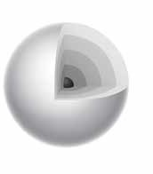

Explain to students that electrons surround the nucleus of an atom in three dimensions, making atoms spherical. They can think of electrons as being in the different energy levels like concentric spheres around the nucleus. Since it is very difficult to show these spheres, the energy levels are typically shown in 2 dimensions.

**Project the image *Oxygen atom*.**

[www.acs.org/middleschoolchemistry/simulations/chapter4/lesson3.html](http://www.acs.org/middleschoolchemistry/simulations/chapter4/lesson3.html)

Explain that this energy level model represents an oxygen atom. The nucleus is represented by a dot in the center, which contains both protons and neutrons. The smaller dots surrounding the nucleus represent electrons in the energy levels. Let students know that they will learn more about electrons and energy levels later in this lesson.

Have students look at the *Periodic table of the elements 1–20* they used in lesson 2 to answer the following question:

* + **How do you know this model is an oxygen atom?**

If students can’t answer this question, point out that there are 8 electrons. Because neutral atoms in the periodic table have the same number of electrons as protons, the atom must have 8 protons. The number of protons is the same as the atomic number, so the atom is oxygen.

Read more about energy level models in *Teacher Background.*

**2. Have groups work together to place each card with its correct atom.**

Show students that you have 80 cards (4 for each of the first 20 elements). Before distributing the cards, explain that each card contains information about electrons and energy levels for the first 20 elements of the periodic table.

The students’ job is to read the card carefully, figure out which element the card is describing, and put the card at the spot in the room for that element. Remind students that they will need to count the electrons in order to identify each atom. Once students understand what their assignment is, distribute the cards to groups.

**3. Discuss the placement of the cards for two or three atoms.**

After all cards have been placed at the 20 different atoms, select two or three atoms and review whether the cards were placed correctly. This review will help reinforce the concepts about the structure of atoms and help students determine the number of protons and electrons in each atom.

**Give each student a *Periodic Table of Energy Levels* activity sheet** **for Part 3.** This table contains energy level models for the first 20 elements. The electrons are included only for the atoms at the beginning and end of each period.

**EXPLORE**

**4. Project the *Periodic table of energy levels* and discuss the arrangement of electrons as students complete their activity sheet.**

**Project the image *Periodic table of energy levels*.** [www.acs.org/middleschoolchemistry/simulations/chapter4/lesson3.html](http://www.acs.org/middleschoolchemistry/simulations/chapter4/lesson3.html)

The image you project contains all of the electrons for elements 1–20. However, the periodic table on the activity sheet contains electrons only for the elements at the beginning and end of each period. Discuss the arrangement of electrons within the energy levels for these atoms and have students fill in the electrons for the other atoms.

***Note****: In the energy level diagrams, the electrons are spread out evenly in the level. Some books show them spread out this way and some show them in pairs. The pairing of electrons is meant to represent that pairs of electrons are in separate orbitals within each energy level. At the middle school level, it is not necessary for students to learn about electron orbitals. This information is offered so that it is clearer to you why electrons are often shown in pairs in energy level diagrams. An orbital defines a region within an energy level where there is a high probability of finding a pair of electrons. There can be a maximum of two electrons in each orbital. This is why the electrons are often shown in pairs within an energy level.*

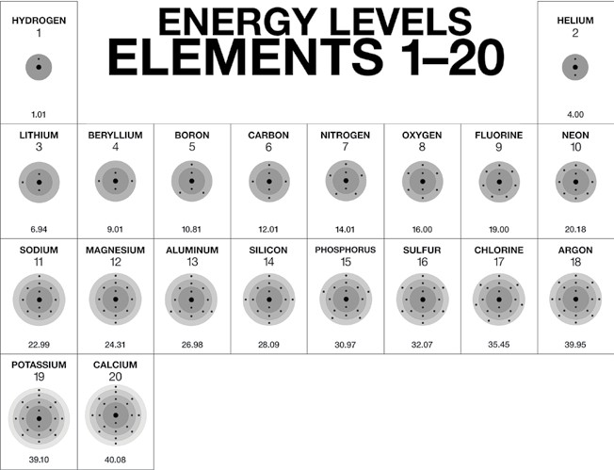

Tell students that the rows across on the periodic table are called ***periods***.

**Period 1**

* **Hydrogen**

Explain that hydrogen has 1 proton and 1 electron. The 1 electron is on the first energy level.

* **Helium**

Explain that helium has 2 protons and 2 electrons. The 2 electrons are on the first energy level.

**Period 2**

* **Lithium**

Explain that lithium has 3 protons and 3 electrons. There are 2 electrons on the first energy level and 1 electron on the second. Explain that the first energy level can only have 2 electrons so the next electron in lithium is on the next (second) level.

* **Neon**

Explain that neon has 10 protons and 10 electrons. There are 2 electrons on the first energy level and 8 electrons on the second level.

* **Beryllium–fluorine**

Help students fill in the correct number of electrons in the energy levels for the rest of the atoms in period 2.

**Period 3**

* **Sodium**

Explain that sodium has 11 protons and 11 electrons. There are 2 electrons on the first energy level, 8 electrons on the second level, and 1 electron on the third energy level. Explain that the second energy level can only have 8 electrons so the next electron in sodium must be on the next (third) level.

* **Argon**

Explain that argon has 18 protons and 18 electrons. There are 2 electrons on the first energy level, 8 electrons on the second level, and 8 electrons on the third energy lev- el. Have students complete the energy level model for argon in their periodic table.

* **Magnesium–chlorine**

Help students fill in the correct number of electrons in the energy levels for the rest of the atoms in period 3.

**Period 4**

* **Potassium**

Explain that potassium has 19 protons and 19 electrons. There are 2 electrons on the first energy level, 8 electrons on the second level, 8 electrons on the third energy level, and 1 on the fourth energy level. Explain that after the third energy level has 8 electrons, the next electron goes into the fourth level.

* **Calcium**

Help students fill in the correct number of electrons in the energy levels for calcium.

***Note****: Students may wonder why an energy level can hold only a certain number of electrons. The answer to this is far beyond the scope of a middle school chemistry unit. It involves thinking of electrons as 3-dimensional waves and how they would interact with each other and the nucleus.*

**EXPLAIN**

**5. Have students look for patterns in rows and columns of the first 20 elements in the periodic table.**

Continue to project the image *Periodic table of energy levels for elements 1–20* and have students look at their activity sheets to find patterns in the number of electrons within each energy level.

**Have students look at the periods (rows going across).**

*Number of energy levels in each period*

* + The atoms in the first period have electrons in 1 energy level.
  + The atoms in the second period have electrons in 2 energy levels.
  + The atoms in the third period have electrons in 3 energy levels.
  + The atoms in the fourth period have electrons in 4 energy levels.

*How the electrons fill in the energy levels*

* + First energy level = 1, 2

Read more about the periodic table in *Teacher Background*

* + Second energy level = 1, 2, 3, …8
  + Third energy level = 1, 2, 3, …8
  + Fourth energy level = 1, 2

A certain number of electrons go into a level before the next level can have electrons in it. After the first energy level contains 2 electrons (helium), the next electrons go into the second energy level. After the second energy level has 8 electrons (neon), the next electrons go into the third energy level. After the third energy level has 8 electrons (argon), the next 2 electrons go into the fourth energy level.

***Note****: The third energy level can actually hold up to 18 electrons, so it is not really filled when it has 8 electrons in it. But when the third level contains 8 electrons, the next 2 electrons go into the fourth level. Then, believe it or not, 10 more electrons continue to fill up the rest of the third level. Students do not need to know this.*

**Have students look at the groups (columns going down).**

Tell students that the vertical columns in the periodic table are called **groups**or **families**. Ask students to compare the number of electrons in the outermost energy level for the atoms in a group. Students should realize that each atom in a group has the same number of electrons in its outermost energy level. For instance, hydrogen, lithium, sodium, and potassium all have 1 electron on their outer energy level. Let students know that these electrons in the outermost energy level are called *valence* electrons. They are the electrons responsible for bonding, which students will investigate in the next lesson.

**EXTEND**

**6. Compare the way different elements react chemically and relate this to their location on the periodic table.**

Tell students that in the periodic table atoms in the same column, called a group, share certain characteristics and can react in a similar way.

**Project the video *Sodium in water and potassium in water*.** [www.acs.org/middleschoolchemistry/simulations/chapter4/lesson3.html](http://www.acs.org/middleschoolchemistry/simulations/chapter4/lesson3.html)

Students will see that although potassium reacts more vigorously than sodium, the reactions are similar. Have students look at the periodic table to see where sodium and potassium are in relation to one another.

**Project the video *Calcium in water*.** [www.acs.org/middleschoolchemistry/simulations/chapter4/lesson3.html](http://www.acs.org/middleschoolchemistry/simulations/chapter4/lesson3.html)

Students will see that this reaction is different from the sodium and the potassium. Have them locate calcium on the periodic table and point out that it is in a different group than sodium and potassium.

**Project the videos *Sodium in acid and potassium in acid*.** [www.acs.org/middleschoolchemistry/simulations/chapter4/lesson3.html](http://www.acs.org/middleschoolchemistry/simulations/chapter4/lesson3.html)

Show sodium reacting with acid and then potassium reacting with acid. The HCl is hydrochloric acid. The HNO3 is nitric acid. Each acid is used in two different concentrations.

Make sure students realize that the sodium and potassium react in a similar way even though the potassium reacts more vigorously.

**Project the video *Calcium in acid*.** [www.acs.org/middleschoolchemistry/simulations/chapter4/lesson3.html](http://www.acs.org/middleschoolchemistry/simulations/chapter4/lesson3.html)

Point out that calcium reacts differently from the sodium and the potassium.

Ask students:

* **Do elements in the same group have similar properties and react in similar ways?**

Students should realize that sodium and potassium are in the same group and react similarly. Calcium is near them on the periodic table, but is in a different group, so it reacts differently.

**7. Let students know that in the next activities they will explore how atoms combine to make molecules like water, and crystals like salt.**

Let students know that they now have the key to understanding how and why atoms bond the way they do to make different substances, including the main components of ocean water – water and salt.