Activity Sheet Name Lesson 10
The Effect of Acidity on Ocean Organisms Date

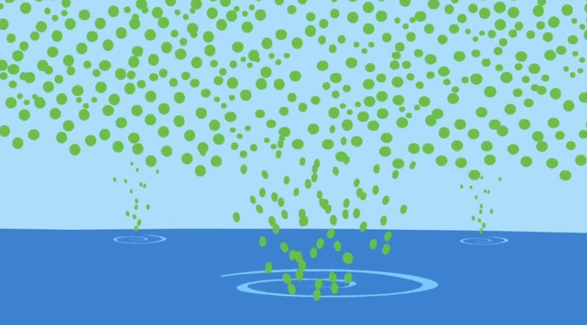
You saw a video in class showing how ocean acidification affects shell-making organisms and the effect this can have on the ocean food chain. Look at the scenes from the video and answer the questions for each scene.
- Carbon dioxide in the atmosphere is represented by green dots. When the carbon dioxide reacts with the water in the ocean, what is produced?

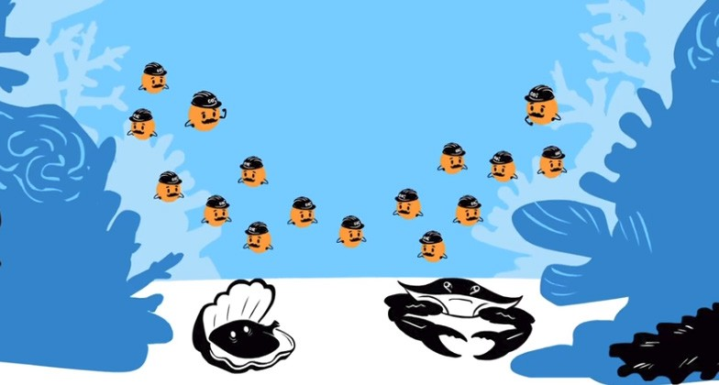
- Carbonate ions are represented by orange dots wearing construction hats. These carbonate ions normally combine with calcium ions to form what shell-making material?

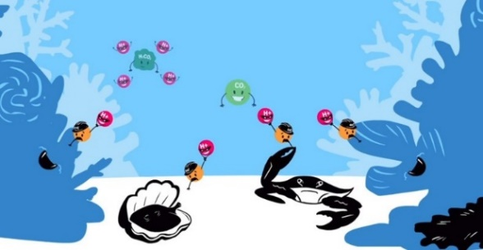
- Carbonic acid is represented by green blobs which break down to form bicarbonate ion (not shown) and hydrogen ions shown in red.
Describe what is happening with the carbonate ion and the hydrogen ion and why this is bad for shell-making organisms.

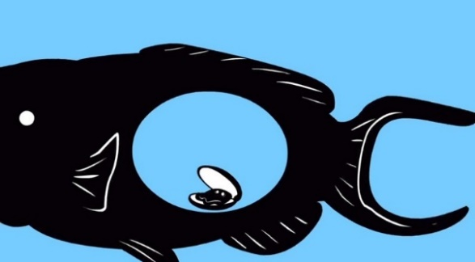
- The video shows that because of ocean acidification, fish that eat shelled organisms will have less to eat. Explain the reasoning behind that conclusion.

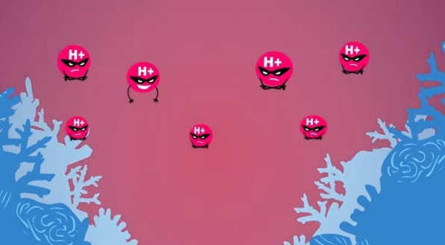
- The hydrogen ions are shown making the ocean water more acidic. Has ocean water actually become an acid, or become more acidic than it was in the past?


- The oceans could eventually be acidic enough that shells could actually be at risk of dissolving.

What is the major way to slow down the process of ocean acidification?

- Based on your teacher’s instructions, you can work individually or in a group to begin researching ways that society can produce less carbon dioxide to reduce the rate of ocean acidification.
Some possible topics could be:

Increasing and improving renewable energy sources
Wind
Solar
Geothermal
Biofuels
Hydroelectric

Increasing and improving transportation technology
Battery technology for electric cars, trucks, and buses
Hydrogen fuel cells

