Activity Sheet Answers
Lesson 10
The Effect of Acidity on Ocean Organisms

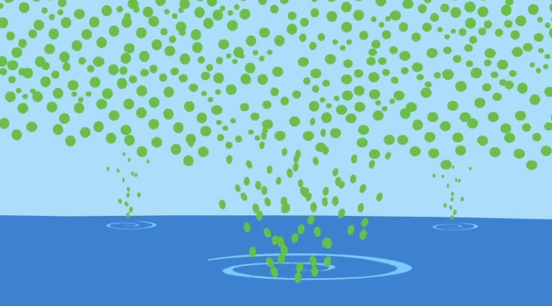
You saw a video in class showing how ocean acidification affects shell-making organisms and the effect this can have on the ocean food chain. Look at the scenes from the video and answer the questions for each scene.
- Carbon dioxide in the atmosphere is represented by green dots. When the carbon dioxide reacts with the water in the ocean, what is produced?

Carbon dioxide reacting with water produces carbonic acid.
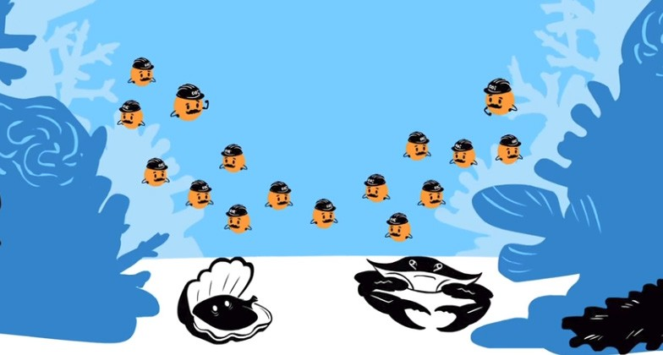
- Carbonate ions are represented by orange dots wearing construction hats. These carbonate ions normally combine with calcium ions to form what shell-making material?

Carbonate ions bond to calcium ions to produce calcium carbonate.
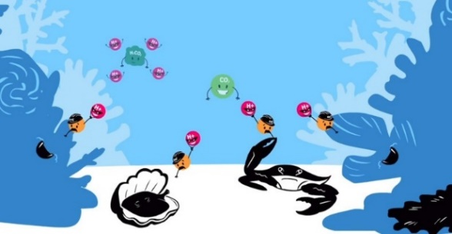
- Carbonic acid is represented by green blobs which break down to form bicarbonate ion (not shown) and hydrogen ions shown in red.
Describe what is happening with the carbonate ion and the hydrogen ion and why this is bad for shell-making organisms.
The hydrogen ion is bonding to the carbonate ion and becoming bicarbonate. Calcium ions that would have bonded to the carbonate can’t bond to the bicarbonate so it’s harder for them to make calcium carbonate for shells.

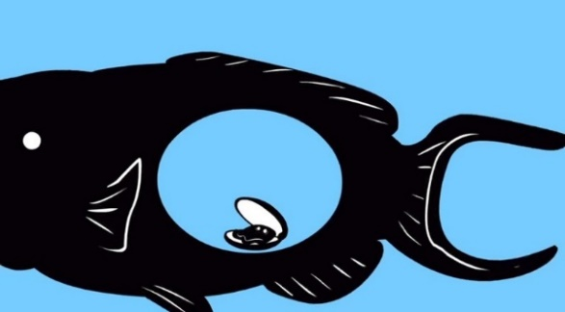
- The video shows that because of ocean acidification, fish that eat shelled organisms will have less to eat. Explain the reasoning behind that conclusion.
If shell-making organisms have to spend extra energy making shells, they will not grow as large and will not have as many offspring. Fish that eat these shelled organisms will have less to eat.
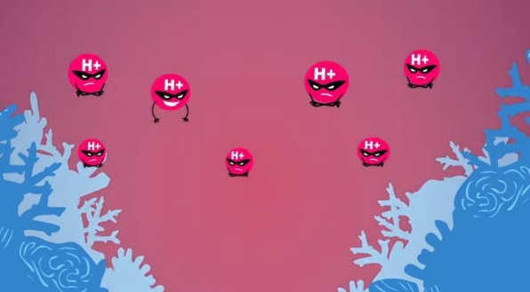
- The hydrogen ions are shown making the ocean water more acidic. Has ocean water actually become an acid, or become more acidic than it was in the past?
Ocean water is not actually acidic. It is still basic but it has gotten more acidic over the last hundred years or so.


- The oceans could eventually be acidic enough that shells could actually be at risk of dissolving.

What is a way to slow down the process of ocean acidification?

One way to slow down ocean acidification is to reduce the amount of carbon dioxide that gets into the ocean. A good way to do this is by putting less carbon dioxide into the atmosphere. Burning less fossil fuel will put less carbon dioxide into the atmosphere.

