Lesson 1 - Introduce the Ocean Acidification Phenomenon
Storyline Summary
The unit starts with a class discussion asking students what they know about issues related to the health of the Earth. Students will likely mention global warming (climate change) and air and water pollution. It’s unlikely that students will mention “ocean acidification”. If necessary, lead students to discuss what they know about problems related to oceans. Accept any ideas - this is the time to get a better idea of what students know about or may be interested in.

Let students know that the unit they are starting will tackle a problem that involves the atmosphere, the oceans, and human activity. Explain that it is a complex problem that can be understood if the class works together to break the problem down into manageable parts. If students investigate and work hard to understand each part, the class can put it all together to get a deep understanding of an important issue that affects the health of the planet. They will also have a better understanding of what needs to happen to start solving the problem.

Focusing student interest on not just understanding the ecological issues we face, but also how to resolve those issues is important throughout the unit- after all, that is the role of scientists!
In this lesson, students view demonstrations and conduct activities that show that carbon dioxide can make water acidic. Explain that these activities have something to do with what is happening with our oceans. Ask students to make hypotheses about the connection to oceans, but do not correct any of their ideas and do not reveal any explanations at this time.
Finally, hand out the article: “Carbon Dioxide: Too Much of a Good Thing” and have students read, take notes, and share their questions about the good and bad of carbon dioxide and its role in ocean acidification. Let students know that the class will work together to generate questions to use to explore how carbon dioxide makes our oceans more acidic and what can be done to slow or even reverse the process.
Note: This lesson includes an introduction to the Ocean Acidification phenomenon, a teacher demonstration, and two student activities. Depending on the length of time you spend on each component, this lesson will probably take at least two class periods.

What Students Do:
Students discuss environmental issues related to the health of the earth and particularly about the oceans. They observe an indicator solution becoming acidic when carbon dioxide is added to it in different ways. As a class, students begin generating questions about how this process relates to the problem of oceans becoming more acidic (ocean acidification).

Students read an article about excess carbon dioxide and environmental issues related to it and generate questions based on the activities and article to develop a plan to learn more about ocean acidification.

What Students Learn:
- Carbon dioxide (CO₂) gas added to water causes water to become acidic.
- Burning a candle produces carbon dioxide gas.
- Sharing observations, questions, and discussion generates curiosity and strengthens understanding.

Materials & Preparation
Materials for the initial Demonstration
- Bromothymol blue indicator solution
- Water
- 2 clear plastic cups
- Straw
Materials for the final Demonstration
- Tea light candle
- Matches
- 2 small clear plastic cups
- 2 glass flasks large enough to be safely held over candle flame
- Water
- Bromothymol blue indicator

Materials for Each Group
- Water
- Bromothymol blue indicator solution in cup
- Carbonated water (club soda or seltzer water) in wide, clear, plastic cup
- Baking soda in wide, clear, plastic cup
- Vinegar
- 2 small clear plastic cups
- 4 wide clear plastic cups
- 4 taller, clear, plastic cups
- Graduated cylinder

Introduce the Ocean Acidification Phenomenon
Have a class discussion about environmental issues students are concerned about.
Ask students if they have heard about some of the issues in the news regarding the health of the environment. Students may mention climate change (global warming) or air and water pollution. They might mention plastic waste in the oceans, or the problems caused by oil spills.
See if students have a general idea that there are certain gases in the atmosphere that are the main cause of global warming. You could see if students know that one of these gases is carbon dioxide (CO₂). If no one mentions it, you can let students know that too much CO₂ in the atmosphere is the main cause of global warming.
Let students know that carbon dioxide in the atmosphere causes another environmental problem that they will be investigating in a series of upcoming lessons. Introduce students to the idea that a lot of the CO₂ from the atmosphere ends up in the ocean. This carbon dioxide interacts with ocean water and makes the water more acidic. Introduce the term “Ocean Acidification”. Let students know that they will investigate the cause of ocean acidification, but they will also explore possible solutions to the problem.

Note: If students are not yet familiar with acids, bases, and pH, let them know that the chemical meaning of acids and bases will be covered in later lessons. For now, you can tell students that acids and bases are like chemical opposites, and that a measurement called the “pH scale” tells whether water is acidic, basic, or neutral.
Students may be familiar with pool water being tested for pH. A chemical called a pH indicator is added to a sample of pool water and a change in color indicates whether the water is basic, neutral, or acidic. The indicator also shows how basic or acidic the water is.
Tell students that pure water is neutral on the pH scale. Let students know that ocean water is naturally slightly basic and that the term “Ocean Acidification” doesn’t mean that the ocean is actually becoming an acid. It means that the ocean is tending to become more acidic, but not crossing over neutral to actually become an acid. Explain that even a small change in acidity is very significant to organisms in the ocean which are very sensitive to changes in pH.
Tell students that in this lesson they will look at some different ways to explore and model the problem of ocean acidification.

Carbon Dioxide Can Make Water Acidic
(From Middle School Chemistry - Chapter 6, Lesson 10)

Summary
The teacher blows into a bromothymol blue indicator solution until it changes color. Students interpret this color change and explain that the solution becomes acidic. Students explore whether carbon dioxide from other sources, namely carbonated water, a chemical reaction between baking soda and vinegar, and a burning candle can also make a solution acidic. Students then apply their observations to the environmental problem of ocean acidification by doing research on this issue.

Note: If students are not yet familiar with the concept of pH or acid-base indicators, you can keep it very simple for the purpose of these demonstrations and activities. Let students know that they will be using a substance called Bromothymol blue indicator. Explain that an indicator changes color when an acid or base is added to it. For bromothymol blue indicator, it is green/blue-green in neutral water and becomes green-yellow or yellow in an acid. Let students know that they will learn more about acids, bases, and pH later in the unit.
Objective
Students will be able to explain that carbon dioxide from any source reacts chemically with water to make the water more acidic.

Safety
Be sure you and the students wear properly fitting goggles during the activity and wash hands afterwards. Use vinegar in a well-ventilated room.

Materials for the Demonstration
- Bromothymol blue indicator solution
- Water
- 2 clear plastic cups
- Straw

Materials for Each Group
- Water
- Bromothymol blue indicator solution in cup
- Carbonated water (club soda or seltzer water) in wide, clear, plastic cup
- Baking soda in wide, clear, plastic cup
- Vinegar
- 2 small clear plastic cups
- 4 wide clear plastic cups
- 4 taller, clear, plastic cups
- Graduated cylinder

ENGAGE
- Do a demonstration to show that adding CO₂ gas to water can make the water become acidic.
Materials for the Demonstration
  - Bromothymol blue indicator solution
  - Water
  - 2 clear plastic cups
  - Straw
Teacher Preparation
Make indicator solution
You will need about 100 mL of indicator solution for your demonstrations. Use 100 mL of water with about 4-5 mL of bromothymol blue. In the activities, each group will need about 80 mL of indicator solution. Make the students’ indicator solution in a similar ratio to yours and pour at least 80 mL of this dilute indicator solution into a clean plastic cup for each student group.
Note: Your local tap water is likely fine for the demonstrations and activities in this lesson. Technically, bromothymol blue is green in water with a neutral pH. The indicator solution you make may be green, blue-green, or blue depending on the pH of your tap water. Any of these colors will work in the demonstrations and experiments. For the purpose of this lesson, we will show the bromothymol blue solution as blue-green in tap water. If your bromothymol blue solution not green, blue-green, or blue, you can use distilled water which is available in grocery stores and pharmacies.
Prepare for the Demonstration
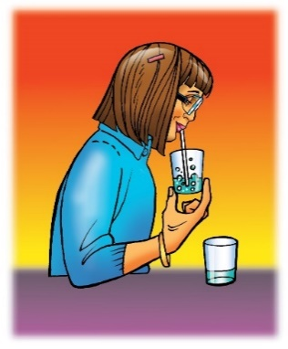
Pour about 25 mL of indicator solution into each of two clear plastic cups for you to use in the demonstration.

Procedure
- Show students both samples of bromothymol blue indicator solution. Place a straw in one of the samples so that the straw goes all the way to the bottom of the cup.
- Hold the cup so that students can clearly see the liquid. Blow into the straw until the indicator solution changes from blue-green to yellow.
Ask students:
  - Does blowing into the indicator solution change its pH?
Yes, the color changes, so there must be a change in pH, too.
- Does the solution become a little more acidic or a little more basic?
The color change shows that the solution is a little more acidic.
Tell students that a chemical reaction occurs between the molecules of carbon dioxide (CO₂) and water (H₂O) to create a very small amount of an acid called carbonic acid (H₂CO₃).
Give each student an activity sheet.
Students will record their observations and answer questions about the
activity on the activity sheet. The Explain It with Atoms & Molecules and Take It Further sections of the activity sheet will either be completed as a class, in groups, or individually, depending on your instructions.

EXPLORE
- Have students use carbonated water as a source of CO₂ to see if the gas will change the pH of an indicator solution.
Question to Investigate
Will carbon dioxide from carbonated water change the pH of an indicator solution?
Materials for Each Group
  - Bromothymol blue indicator solution in a plastic cup
  - Water
  - Carbonated water (club soda or seltzer water) in a wide clear plastic cup
  - 1 wide, clear, plastic cup
  - 2 taller, clear, plastic cups
  - Graduated cylinder

Teacher Preparation
Pour 25 mL of carbonated water into a wide, clear, plastic cup for each group.

Procedure
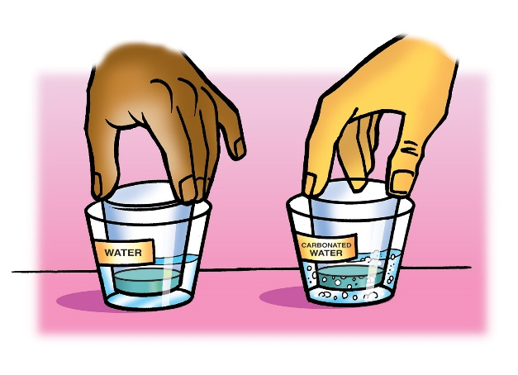
- Measure 30 mL of indicator solution and divide it evenly into two small, clear, plastic cups.
- Add 25 mL of water to a wide plastic cup and 25 mL of carbonated water to another wide cup.
- Stand the small cups with indicator solution in the liquid in the wider cups as shown.
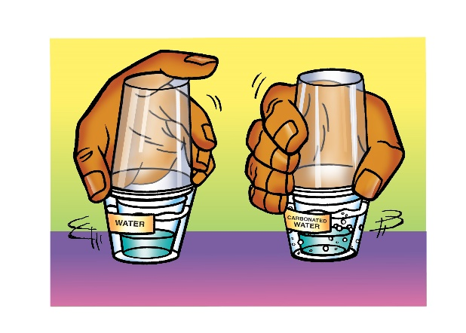
- Turn the two tall cups upside down and place them over the two wider cups.
- While holding the top and bottom cups to keep them together, gently swirl both sets of cups. Watch the color of the indicator in both cups to see if there is any change.
- Compare the color of the indicator in both cups.

Expected Results
The indicator inside the cups with water remained blue-green, while the indicator with the carbonated water turned yellow.

- Discuss student observations and what will happen in the following activity.
Ask students:
  - Did either indicator change color?
Only the indicator with the carbonated water changed color.
  - What does the color change tell you about the pH of the indicator solution? Is it acidic or basic?
The indicator solution is now acidic.
  - The carbonated water should not have splashed into the indicator. Why did the indicator solution change color in one set of cups?
The carbon dioxide from the carbonated water dissolved in the indicator solution. The molecules of carbon dioxide reacted with the water, forming carbonic acid, and changed the color of the indicator.

Tell students that they have seen carbon dioxide gas from your breath and carbon dioxide gas from carbonated water turn an indicator solution acidic.

Ask students:
  - Do you think carbon dioxide gas produced during a chemical reaction will also turn an indicator solution acidic?
Carbon dioxide from any source should cause the indicator solution to become acidic. The amount of carbon dioxide gas produced and dissolved in the indicator solution may cause the color of the indicator to vary, but on the acidic side.
  - What is a common chemical reaction do you know of that produces carbon dioxide gas?
Students should remember that vinegar and baking soda react, producing carbon dioxide gas. Tell students that they will combine baking soda and vinegar in the next activity.
- Use a chemical reaction to produce CO₂ to see if it changes the pH of an indicator solution.
Question to Investigate
Will carbon dioxide gas produced in the baking soda and vinegar reaction change the pH of an indicator solution?

Materials for Each Group
- Bromothymol blue indicator solution in cup
- Water
- Baking soda in small plastic cup
- Vinegar in cup
- 2 small clear plastic cups
- 1 wide clear plastic cups
- 2 taller clear plastic cups
- Graduated cylinder

Teacher Preparation
- Pour about 50 mL of vinegar in a wide plastic cup for each group.
- Place about ½ teaspoon of baking soda in a small plastic cup for each group.

Procedure
- Measure and pour 25ml of vinegar into two wide plastic cups.
- Pour 15ml of bromothymol blue indicator into two clean small plastic cups.
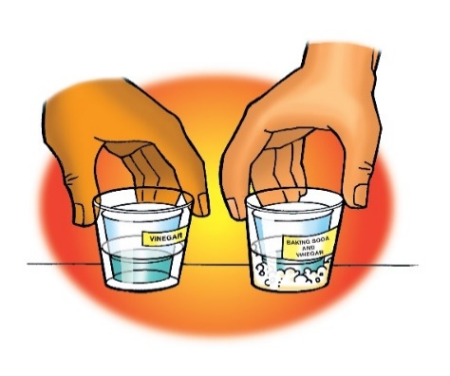
- Pour all the baking soda into one of the cups of vinegar. Do not pour anything into the other.
- Stand the small cups with indicator solution in both the wider cups as shown.
- Turn the two tall cups upside down and place them over the two wider cups.
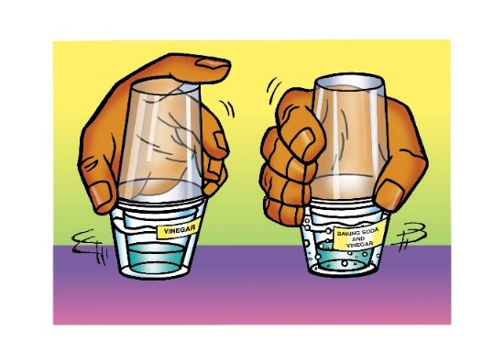
- While holding the top and bottom cups to keep them together, gently swirl both sets of cups. Watch the color of the indicator in both cups to see if there is any change.
- Compare the color of the indicator in each cup to find out whether the solution is acidic, neutral, or basic.
Expected Results
The indicator inside the cup with only vinegar remained blue-green while the indicator inside the cup with the vinegar and baking soda reaction turned yellow.
- Discuss student observations.
Ask students:
  - Did either indicator change color?
Only the indicator with the chemical reaction changed color.
  - Why did one set of cups only have vinegar in the bottom?
The indicator solution in the set of cups with only vinegar in the bottom serves as a “control”. It is possible that vinegar by itself causes the indicator to change color. Since this indicator did not change color, it must be the carbon dioxide gas produced by the chemical reaction, and not just the vinegar that caused the color change.
  - What does the color of the indicator solution tell you about the pH of each solution? Is it acidic, neutral, or basic?
The color change shows that the indicator solution is acidic.

- Demonstrate that carbon dioxide from a candle flame will also make water acidic.
Materials for the Demonstration
- Tea light candle
- Matches
- 2 small clear plastic cups
- 2 glass flasks large enough to be placed over the candle
- Water
- Bromothymol blue indicator
Safety
Be sure you and the students wear properly fitting goggles. Be careful when lighting the candle. Be sure that the match and candle are completely extinguished when you are finished with the demonstration.

Teacher Preparation
If you do not have any dilute indicator solution, make some by adding about 3 mL of bromothymol blue indicator to 50 mL of water.
Divide the dilute indicator solution equally into two small cups.
Note
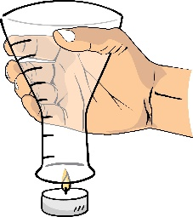
After holding the flask over the candle for about 10 seconds, dilute bromothymol blue indicator solution will be added to the flask that was over the candle and to another flask as a control. Both flasks are swirled. The indicator will react with carbon dioxide in the flask that was over the candle but will not react in the other flask. This indicates that the candle produced a gas that made the solution acidic.

Procedure
- Carefully light a tea light candle or other small candle.
- Have 2 flasks available. Hold one flask above the candle as shown.
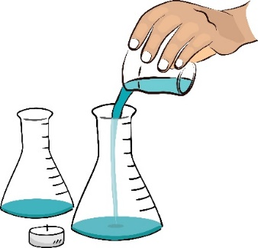
- Hold it there for about 10 seconds and then turn the flask over.
- Gently pour about 25 mL of indicator solution into both flasks and swirl both.

Expected Results
The indicator will change color from blue-green to yellow in the flask that was over the candle.

- Have a class discussion about what gas was probably produced by the flame.
Ask students:
- What gas was probably produced by the flame and how do you know?
Carbon dioxide was probably produced by the flame because it reacted the same way to the indicator solution as the other samples of carbon dioxide.
- Have students read “Carbon Dioxide: Too Much of a Good Thing” about carbon dioxide and its role in the environment.
As a class, students will use information from the reading and observations from the demonstrations and experiments to develop questions that the class will need to explore to understand ocean acidification and possible ways of reducing its impact.
EXTEND
- Ask students what they need to know more about to better understand the process of ocean acidification.
Ask students if they need to understand more about the ocean and carbon dioxide to better understand how carbon dioxide makes ocean water acidic.
The class should agree that knowing more about ocean water and carbon dioxide is necessary for a deeper understanding of ocean acidification.
Ask students what else they have questions about related to ocean acidification. Some examples of questions could be:
- How does carbon dioxide and water become an acid?
- Can the acid in the ocean hurt people swimming in the ocean?
- Is there a way to make the ocean less acidic?

Make a list of questions on the board or chart paper. Let students know that the class will continue to add more questions as they learn more from each lesson. Explain that these questions will drive the investigation forward and will be called the Driving Question Board or DQB.
Tell students that in the next class, they will take a close look at the main components of ocean water to begin their study of ocean acidification.

