**Activity Sheet Name Lesson 1**

**Carbon Dioxide Can Make a Solution Acidic Date**

***DEMONSTRATION***

1. **Your teacher blew through a straw into a bromothymol blue indicator solution until it changed color.**

**Did the indicator solution become acidic or basic?**

1. **What chemical from your teacher’s breath do you think caused the indicator to change color?**

***ACTIVITY***

**Question to Investigate**

Will carbon dioxide from carbonated water change the pH of an indicator solution?

**Materials for Each Group**

* + Bromothymol blue indicator solution in a plastic cup
  + Water
  + Carbonated water in a wide clear plastic cup
  + 1 wide, clear, plastic cup
  + 2 taller, clear, plastic cups
  + Graduated cylinder

**Procedure**

1. A close-up of hands holding a cup of water

   Description automatically generatedMeasure 30 mL of bromothymol blue indicator solution and divide it evenly into two small clear plastic cups.
2. Add 25 mL of water to a wide plastic cup and 25 mL of carbonated water to another wide cup.
3. Stand the small cups with indicator solution in the liquid in the wider cups as shown.

1. A close-up of a pair of hands holding a glass

   Description automatically generatedTurn the two tall cups upside down and place them over the two wider cups.
2. While holding the top and bottom cups to keep them together, gently swirl both sets of cups. Watch the color of the indicator in both cups to see if there is any change.
3. Compare the color of the indicator to find out whether the solution is acidic, neutral, or basic.
4. **What color is the sample of indicator solution in the water and in the carbonated water?**
5. **What does the color of the indicator solution tell you about the pH of each solution? Is it acidic, neutral, or basic?**
6. **The carbonated water and water should not have splashed into the indicator solutions. Why did the indicator solution change color in one set of cups but not the other?**

***ACTIVITY***

**Question to Investigate**

Will carbon dioxide gas produced in the baking soda and vinegar reaction change the pH of an indicator solution?

**Materials for Each Group**

* + Bromothymol blue indicator solution in cup
  + Water
  + Baking soda in wide clear plastic cup
  + Vinegar in cup
  + 2 small, clear, plastic cups
  + 1 wide, clear, plastic cups
  + 2 taller, clear, plastic cups
  + Graduated cylinder

**Procedure**

1. A close-up of hands holding a cup of water

   Description automatically generatedMeasure 30 mL of universal indicator solution and pour it into a clean, small, plastic cup.
2. Pour half the indicator solution into another small cup so that you have two equal samples.
3. Measure and pour 25 mL of vinegar into the cup with the wide cup with the baking soda and into the other empty wide cup.
4. A close-up of a pair of hands holding a measuring cup

   Description automatically generatedStand the small cups with indicator solution in both of the wider cups as shown.
5. Turn the two tall cups upside down and place them over the two wider cups.
6. While holding the top and bottom cups to keep them together, gently swirl both sets of cups. Watch the color of the indicator in both cups to see if there is any change.
7. Compare the color of the indicator to find out whether the solution is acidic, neutral, or basic.
8. **What color is the sample of indicator solution in the vinegar and in the vinegar and baking soda?**

**7. What does the color of the indicator solution tell you about the pH of each solution? Is it acidic, neutral, or basic?**

1. **What was the purpose of having one set of cups with only vinegar, while the other had vinegar and baking soda?**
2. **The baking soda and vinegar should not have splashed into their indicator solutions. Why did the indicator solution change color in the set of cups with vinegar and baking soda?**

1. **Your teacher used a flask to collect the gases produced from a candle flame. Your teacher then put bromothymol blue indicator solution into that flask and into another empty flask.**A hand pouring blue liquid into a beaker

   Description automatically generated

**What did you observe?**

1. **What does the color of the indicator tell you about the pH of the solution? Is it acidic, basic, or neutral?**
2. **What gas from the burning candle caused the solution to become acidic?**
3. **You read the article “*Carbon Dioxide: Too Much of a Good Thing*”. What two major problems are being caused by too much carbon dioxide in the atmosphere?**

***EXPLAIN IT WITH ATOMS & MOLECULES***

1. **Water and carbon dioxide gas react to produce carbonic acid. As more carbon dioxide is released into the atmosphere, why is that a problem for our oceans?**

**CO2**

carbon dioxide

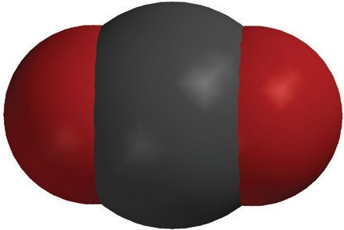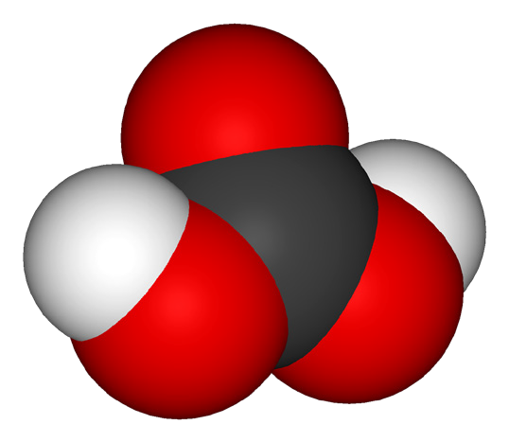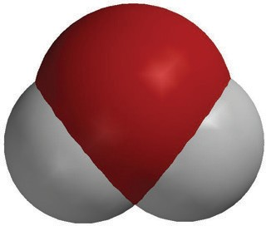

**H2O**

water

**H2CO3**

carbonic acid

+



***TAKE IT FURTHER***

1. **Based on the reading you did, the observations you made, the chemical equation above, and class discussion, what are one or two questions you have about the problem of ocean acidification?**