**Activity Sheet Name ___________________**

**Lesson 7 – Density and Floating and Sinking of Solids**

**Date _______________**

**Part 1**

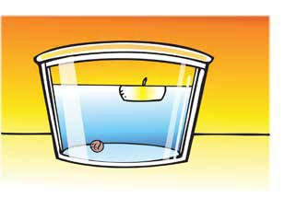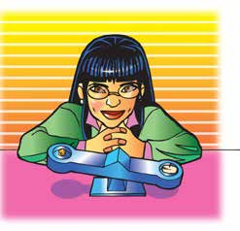

**Demonstration 1: Comparing the mass of a candle and a piece of clay.**

**Your teacher compared the mass of a wax candle and a piece of clay. The candle was heavier than the clay, but the candle floated, and the clay sank.**

**Use information from the next two demonstrations to explain why the candle floats and the clay sinks.**

**Demonstration 2: Comparing the mass of water to an equal volume of wax and clay.**

Your teacher compared the mass of a wax candle to the mass of an equal volume of water.

1. **Which weighs more, wax or an equal volume of water?**
2. **Which is more dense, wax or water? Explain:**

**Comparing the mass of clay to the mass of an equal volume of water.**

Your teacher compared the mass of clay to the mass of an equal volume of water.

1. **Which weighs more, clay or an equal volume of water?**
2. **Which is more dense, clay or water? Explain:**
3. **After seeing the demonstrations, how does *density* explain why wax floats on water and clay sinks in water?**

# EXPLAIN IT WITH ATOMS & MOLECULES

1. **Water is made up of small molecules containing oxygen and hydrogen atoms. Water molecules are closely packed together. Wax is made of carbon and hydrogen atoms connected together in long chains. Explain on the molecular level why water is more dense than wax.**

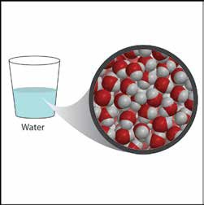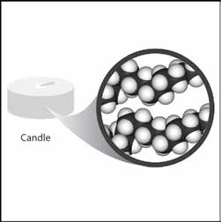

1. **Clay is made of oxygen and heavier atoms such as silicon and aluminum. Explain on the molecular level why clay is more dense than water.**

# TAKE IT FURTHER

1. **A giant log can float on a lake while a tiny grain of sand sinks to the bottom. Explain why a very heavy object like the log floats while a very light grain of sand sinks.**
2. **Remember that the density of water is 1 g/cm3. Predict whether the following objects will sink or float.**

|  |  |  |
| --- | --- | --- |
| **Will these objects sink or float?** | | |
| Object | Density (g/cm3) | Sink or float |
| Cork | 0.2–0.3 |  |
| Anchor | 7.8 |  |
| Wooden oar | 0.4 |  |
| Apple | 0.9 |  |
| Orange with peel | 0.84 |  |
| Orange without peel | 1.16 |  |

1. **What can you say about the density of the orange peel?**

**How is the orange peel like a life jacket for the orange?**

1. **If a peach has a volume of 130 cm3 and sinks in water, what can you say about its mass?**
2. **If a banana has a mass of 150 grams and floats in water, what can you say about its volume?**

# Part 2

# DEMONSTRATION

1. **Your teacher showed you one candle floating in water and another identical candle sinking in alcohol.**

**Do water and alcohol have the same or different densities?**

**Which liquid is more dense?**

**How do you know?**

1. **A cartoon of a scale with two cups of liquid

   Description automatically generatedYour teacher placed equal volumes of water and alcohol on a balance.**

**Explain how this demonstration proves that water is more dense than alcohol. Be sure to mention both volume and mass.**

**Part 3**

**Activity – Does a Carrot Sink or Float?**

## **Materials for each group**

* Tall clear plastic cup
* Water
* Carrot slice about ¼ inch thick
* Salt
* Spoon

## **Procedure**

1. Pour water into a clear tall plastic cup until it is about ½-filled.
2. Place a slice of carrot in the water.
   1. **Is the carrot more or less dense than the fresh water?**

1. Add about 1 teaspoon of salt to the water and stir. Continue to stir until the carrot floats to the surface of the salt water. If the carrot does not float to the surface, add more salt and stir.

## **Is the carrot more or less dense than saltwater?**

## **Does adding salt change the density of the water? How do you know?**

## **What would you expect if you placed equal volumes of water and saltwater on opposite ends of a balance?**

* 1. **Adding salt to water increases both its mass and volume; which do you think it increases more, the mass of the water or the volume of the water? Explain.**

***TAKE IT FURTHER***

**Even though a carrot slice normally sinks in water, you made it float by adding mass to the water and increasing the water’s density. Does the mass of anything change in the Lava Lamp?**