Activity Sheet Name ___________________
Lesson 6 Date _______________
Density of Liquids and Why they Float or Sink

Part 1 – Calculating the Density of Different Volumes of Water
- In Lesson 3, Part 3, you measured the mass of 100 mL, 50 mL, and 25 mL of water. If you made those measurements, put your results for mass in the chart below and calculate the density for each sample.

Finding the density of different volumes of water
Volume of water (mL) | 100 milliliters | 50 milliliters | 25 milliliters
Mass of water (g)
Density of Water (g/cm³)

- You should notice a TREND in the “Density” column for the three rods. What is it? Why do you think this happens?

- Now make a graph of the mass & volume of the 3 samples of water. Use your “Graphing Checklist” to makes sure everything is included and in the right location! Draw the “best fit line” you can between the three points.

Put Volume on the x-axis, and Mass on the y-axis.

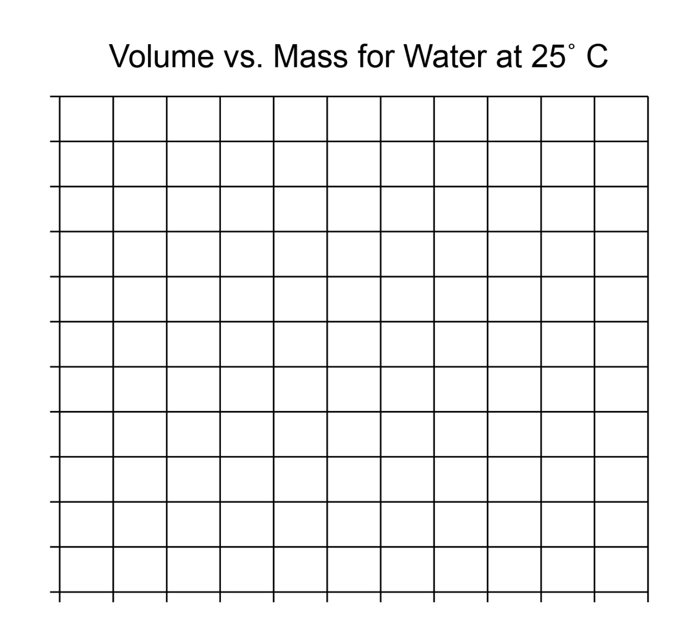

- Based on your “best fit” line, what would the mass of 34 ml of water be? Explain how
you know:

Part 2 – Comparing the Density of Water, Oil, and Alcohol
Your teacher will use the procedure below to demonstrate how to find the density of
25 mL of vegetable oil.
Teacher Demonstration – Density of Oil
- Find the mass of an empty graduated cylinder. Record the mass so students can see it and record it in their own chart.
- Pour 25 mL of vegetable oil into the graduated cylinder.
- Weigh the graduated cylinder with the oil in it. Record the mass in grams. Have students record it in their chart.
- Find the mass of only the oil by subtracting the mass of the empty graduated cylinder from the mass of the graduated cylinder with oil in it. Record the mass of 25 mL of oil. Have students record it in their chart.
- As a class, use the mass and volume of the oil to calculate its density. Record the density in g/cm³.

 | Oil | Water | Alcohol
Mass of empty graduated cylinder (g)

Mass of graduated cylinder + liquid (g)

Mass of Liquid (g)

Density of Liquid (g/cm³)

Density of water

Use the values from your chart in Lesson 3 to fill in the chart for 25 mL of water. Include the density of water.

Density of Isopropyl Alcohol
  - For the alcohol, find the mass of an empty graduated cylinder. Record the mass in grams in the chart.
  - Pour 25 mL of alcohol into the graduated cylinder. Try to be as accurate as possible by checking that the meniscus is right at the 25 mL mark.
3. Weigh the graduated cylinder with the alcohol in it. Record the mass in grams.
4. Find the mass of only the alcohol by subtracting the mass of the empty graduated cylinder from the mass of the graduated cylinder with alcohol in it. Record the mass of 25 mL of alcohol in the chart.
5. Use the mass and volume of the alcohol to calculate its density. Record the density in g/cm³ in the chart.

When your teacher poured the oil, water, and alcohol into a graduated cylinder, explain why the oil floated on the water and the alcohol floated on the oil.
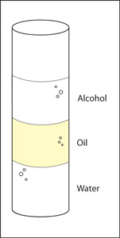

EXPLAIN IT WITH ATOMS & MOLECULES

- Water molecules are smaller and have less mass than alcohol and oil molecules. Explain why water is more dense than alcohol and oil.

TAKE IT FURTHER
The fact that the material in the Lava Lamp sometimes floats and sometimes sinks probably has something to do with its density.
What can you say for sure about the density of the blob material compared to the surrounding liquid, at the bottom of the Lava Lamp and then at the top?

