**Lesson 5 – Activity Sheet Answers**

**Understanding Density as a Relationship Between Mass and Volume**

**Part 1 – Same Volume but Different Mass**

**DEMONSTRATION**

Your teacher placed a copper and an aluminum cube on a balance. Even though the cubes are the same size and shape, the copper has a greater mass than the aluminum. Both cubes are solid and are not hollowed out anywhere inside. The copper cube is made up of only copper atoms and the aluminum cube is made up of only aluminum atoms.

1. **Look at the drawing of the copper and aluminum cubes and their atoms.**

**If copper atoms are a little larger than aluminum atoms, fewer of them can fit in the same volume. How can a copper cube be heavier than an aluminum cube?**

The copper atoms have a lot more mass than the aluminum atoms. So even though there are fewer copper atoms than aluminum atoms, the copper cube has more mass.

1. **The density of a substance like copper or aluminum is its mass divided by its volume (how much space it takes up).**

**Density = mass/volume or D = m/v.**

**Which is more dense, copper or aluminum? How do you know?**

Copper is more dense because the copper cube has more mass than the aluminum cube in the same volume.

1. **Calculate the density of a cube using the following information:**
   * **Each side is 4 cm long.**
   * **The mass of the cube is 128 g.**

**Show your work.**

Volume = 4 cm x 4 cm x 4 cm = 64 cm3.

Density = 128g/64cm3 = **2g/cm3**

**Part 2 - Different Volumes but Same Mass**

***DEMONSTRATION***

Think about the longest, middle-sized, and shortest rods your teacher showed you. All these samples have the same mass, but their volumes are different.

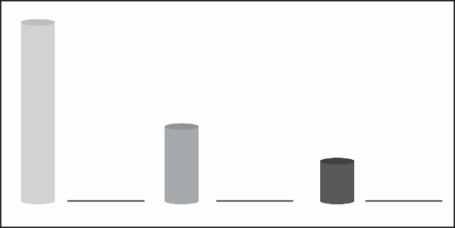

Least dense

Medium dense

Most dense

1. **Predict the densities of each sample by writing a phrase from the box on the line next to each sample.**

Most dense, Least dense, Medium dense

**Based on mass and volume, explain why you think each rod is either the most dense, least dense, or in-between:**

If all the masses are the same, then the largest rod must have the *lowest* density. Since D=m/v, the larger the value for Volume in the denominator of the equation, the smaller the calculated value of Density will be.   
  
Conversely, the smallest rod must be the densest because its value for volume is the smallest. With a small value for V in the denominator, the value for density goes up. So the smallest rod must be most dense. By the same logic, the medium sized rod should be somewhere between the smallest and largest rod in overall density.  
  
Looking at it a different way, if you have two different objects, one clearly larger in volume than the other, but you know they have the same mass, the only way that can be possible is if the small volume object is more dense than the larger volume object.

***EXPLAIN IT WITH ATOMS & MOLECULES***

The difference in density between the small, medium, and large rods can be explained based on the atoms and molecules they are made from. Refer to the chart of atomic size and mass to answer the following question about each substance.

1. **Polyethylene is made of carbon and hydrogen atoms. Polyvinyl chloride is also made of carbon and hydrogen atoms, but also has chlorine atoms.**

**Look at the size and mass of these atoms in the chart to explain why polyvinyl chloride is more dense than polyethylene.**

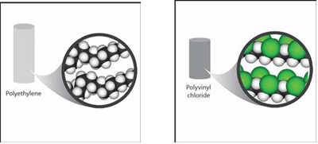

Polyvinyl chloride is denser than polyethylene because it contains atoms of chlorine which have a large mass for their size. The long molecule chains are also closer together in polyvinyl chloride than they are in polyethylene, contributing to its greater density.

1. **Brass is made of copper and zinc atoms. These atoms are pretty heavy for their size, but they are also packed together differently than the molecules of the plastics. How does the way these atoms pack together help make the brass more dense than the plastics?**

The way that copper and zinc atoms are packed closely together in brass makes it denser than the plastics because it means that there is more mass in a given volume of space, which is the definition of density.

***TAKE IT FURTHER***

**4. Based on the *Atomic Size and Mass* chart, a calcium atom is both bigger and heavier than a sulfur atom. But a piece of solid sulfur is more dense than a solid piece of calcium. In fact, sulfur is about 2 g/cm3, and calcium is about 1.5 g/cm3.**

**Based on what you know about the size, mass, and arrangement of atoms, explain why a sample of sulfur is more dense than a sample of calcium.**

Although sulfur atoms are less massive than calcium atoms, a sample of sulfur is denser than a sample of calcium. This is because the sulfur atoms are small and able to pack closely together. This enables sulfur to concentrate more mass into a unit of volume than calcium.

**Part 3 – Same Material but Different Volumes**

In previous lessons, you measured the mass of three rods of the same material but different lengths. You also measured the volume of those same rods using the water displacement method.

1. **Look at your data, and record the mass and volume of each of the three rods you measured from Lessons 3 and 4.**
2. **Then use the formula D=m/v to calculate the density of each of the three rods.**

|  |  |  |  |  |
| --- | --- | --- | --- | --- |
| Color of Cylinder  (Gray, Silver, or Orange) | Length of Cylinder (cm) | Average Mass (g) | Average Volume (cm3) | Density (g/cm3) |
| Orange | _6.8_cm | _14_g | _13_cm3 | _1.1_ g/cm3 |
| Orange | _5.3_cm | _11_g | _10_cm3 | _1.1_ g/cm3 |
| Orange | _3.8_cm | _8_g | _7_cm3 | _1.1_ g/cm3 |

1. **You should notice a TREND in the “density” column for the three rods. What is it?**

All the densities are the same. **Why do you think this happens?**

Since the rods are made from the same material, all their densities should be the same. Density is a characteristic property of the substance and doesn’t change based on the size of the sample.

1. **Make a graph that compares the mass and volume of the 3 same-colored rods you measured. Use your “Graphing Checklist” to makes sure everything is included and in the right location!**



Mass

Volume

1. **Does the straight line on the graph make sense when you look at the values for mass and volume for each rod? Explain:**

Since the materials are all the same, they should have the same densities. This means that any change in volume between rods should have a change in mass that is consistent between them. The ratio of volume to mass should be the same.

**Note:** Any differences are most likely due to measuring error in volume and rounding to the nearest whole number for mass and volume.

1. **The blocks in the illustration are all made from the same material. Calculate the density of each block. Do your results make sense? Explain.**

Sample A: D = 200g/100 cm3 = 2g/cm3

Sample B: D = 100g/50 cm3 = 2g/cm3

Sample C: D = 50g/25 cm3 = 2g/cm3

These results do make sense because all the blocks are the same material so their densities should all be the same. When the volume is halved, the mass is halved so the ratio of mass to volume stays the same.

1. **If you took a sample of aluminum foil from the roll in your kitchen and you found its density to be 2.7 g/cm³, what would you expect the density of a much larger sample to be? Explain:**

The density of the larger piece should also be 2.7 g/cm3 because density is a characteristic property of the substance. Density doesn’t change with the size of the sample.

1. **Do you think the density of the blob material in the Lava Lamp changes after the Lava Lamp is turned on? Explain.**

After the Lava Lamp is turned on and gets hot, the blob material seems to expand and become a dome shape. Since its volume increases but its mass stays the same, its density has to change.