Lesson 3 – Connecting Matter to Measuring and Modeling Mass
Storyline Summary:
Have a class discussion to help students realize that they need to know more about the blob-like material in order to explain how the Lava Lamp works.
Through discussion around their initial Lava Lamp models and their observations about solids, liquids, and gases, students should conclude that the stuff inside the Lava Lamp might be a kind of semi-solid waxy substance.
Students are introduced to the idea that all matter has mass and that the mass of the blobs might be important to the way the Lava Lamp works. Students realize that they can’t measure the mass of the actual blob but understanding more about mass and how particles that make up the blob affect its mass will help students eventually understand why the blobs rise and fall in the Lava Lamp.
For this lesson, the main idea is to connect mass with the particles in matter so that you and the students can agree on a way to model the mass of substances based on the particles they are composed of.
Note: This lesson covers a demonstration and two different activities and will take more than one class period.
What Students Do
Part 1 - Based on observing a teacher demonstration, students will see that a gas has mass and will model the mass of a gas.
Part 2 - Students measure the mass of three solid objects made from the same material. The class will decide on a way to model the mass of a solid.
Part 3 - Students measure and compare the mass of three different volumes of water and decide on a model for the mass of a liquid.
What Students Learn
- All matter has mass.
- The mass of an object is the result of the atoms and molecules it is made up of.
- The mass of a substance can be modeled by using dots or circles.
- More mass should be more dots, less mass should be fewer dots, but the spacing and size of the dots or circles should be the same for different masses of the same material.
Materials & Preparation:
- DQB (Driving Question Board) Organized into topics.
Part 1 – Materials for the Demonstration
- Basketball, very deflated
- Balance that measures in grams
- Pump
- Can of compressed gas (available at any office supply store)

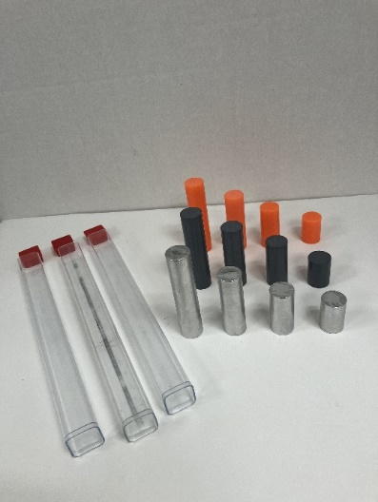
Part 2 – Materials
- Flinn Density and Slope Set (Each set contains 3 plastic tubes. Each tube contains 4 cylinders of different sizes but the same material (12 cylinders per Set). You may need two or three sets. These cylinders will also be used in Lesson 4, “Measuring Volume”
- Balance that measures in grams

Part 3 - Materials
- 100 mL graduated cylinder (1 for each group)
- Water
- Measuring Mass Student Handout

Return to the DQB and ask students if they think the mass of the blobs is important in how they move in the Lava Lamp.
Students may not know the meaning of mass, so you can begin a discussion about what mass is and how is it measured.
Explain to students that mass is a measure of the amount of matter in an object.
Note: You may want to explore the difference between “mass” and “weight”, or you may choose to simplify and use the terms interchangeably.
Mass is the amount of matter in an object, but weight is the effect of gravity on an object of a certain mass. For example, an object like a bowling ball, has the same amount of matter (mass) whether it’s on earth or on the moon. But its weight will be much greater on Earth because Earth’s gravity is much greater than the gravity of the moon.
Explain that a balance or scale that measures mass is designed in a way to factor out the pull of gravity and just show the mass of the object being measured.
Let students know that they will measure the mass of different amounts of the same material and agree on a way to model the different masses. By understanding what gives objects their mass, and a method for modeling mass, students will be better able to model the matter in the Lava Lamp.

Ask students:
- Do you think the mass of the blobs matters in making the blobs rise and fall?
Students may say that the blobs that rise are lighter and the blobs that sink are heavier.
Let students know that there may be more to the rising and sinking of the blobs than mass alone, but that looking at what gives an object its mass should help answer the question.
As the lesson progresses, be sure that students measure mass of both solids and liquids accurately, and that they model mass using the accepted method of greater mass represented by more circles or dots and lesser mass represented by fewer circles or dots.
PART 1 – Mass of a Gas
A Gas Has Mass
(From middle school chemistry, Chapter 1, Lesson 5, Steps 1-3)
Tell students that they have probably measured the mass of a solid or a liquid, but that it is less likely that they have measured the mass of a gas. Tell students that you will do a demonstration to see whether a gas has mass.
Materials for the Demonstration
- Basketball, very deflated
- Balance that measures in grams
- Pump
- Can of compressed gas (available at any office supply store)

ENGAGE
- Review the particle nature of gases and ask whether students think a gas has mass.
Remind students that gases are made of molecules but that the molecules are much further apart than the molecules in liquids or solids.
If students have trouble accepting that a gas is made up of molecules, you could try helping them by giving them some numbers to think about. Although these numbers are huge and may be difficult to comprehend, at least students will get the idea that a gas is definitely made of something, takes up space, and has mass. Tell students that in an amount of air about the size of a standard beach ball, there are about 6 × 10²³ gas molecules. This is about 600 billion trillion molecules.
Give each student an Activity Sheet for Part 1.
Students will record their observations and answer questions about the activity on the activity sheet. The Explain It with Atoms & Molecules section will either be completed as a class, in groups, or individually, depending on your instructions. Look at the teacher version of the activity sheet to find the questions and answers.

EXPLORE
- Do a demonstration to show that gas has mass.

You will need a balance that measures in grams for either demonstration. If you don’t have this type of balance, you can show videos of each demonstration.
www.acs.org/middleschoolchemistry/simulations/chapter1/lesson5.html
The point of the demonstration is to show that the particles that make up a substance, even a gas, is what gives the substance its mass. You will demonstrate that adding particles (molecules of gas) makes the mass increase, and that allowing molecules of a gas to escape, causes mass to decrease.
Materials for the demonstration
- Basketball, very deflated
- Balance that measures in grams
- Pump
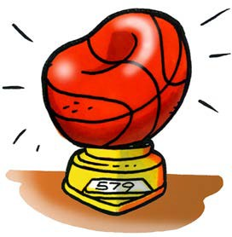
- Can of compressed gas (available at any office supply store)

Procedure
- Basketball
  - Place the deflated ball on the balance to get the initial mass.
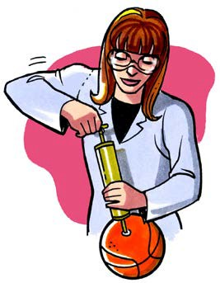
  - Ask students if they think the ball will weigh more or less after you pump air into it.
  - Pump as much air into the basketball as you can and then put it back on the balance.
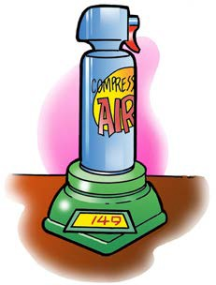
- Can of compressed gas
- Place a can of compressed gas on a scale and check its mass.
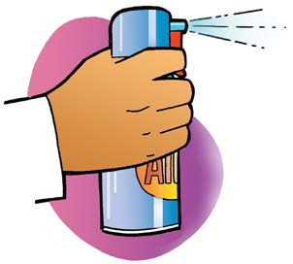
- Ask students whether it will weigh more, less, or the same if you squeeze the trigger and let some gas out.
- Shoot gas out of the can for a few seconds and then place the can back on the scale.

Expected results
The basketball should weigh 2–4 grams more than when it was deflated. The can will weigh a few grams less than it did initially.

Note: Students may have difficulty accepting that gases have mass when it seems like balloons and beach balls, for example, get lighter when we inflate them. This phenomenon is more complicated than what students need to know for now, but here is an explanation: When you add air to a balloon or beach ball it actually gets a little heavier. The reason why it seems lighter is not because it has less mass, but because its volume increases so much with a small increase in mass makes that the balloon or beach ball becomes less dense. This causes it to be more easily supported or buoyed up by the air around it. That is why it seems lighter when it is inflated.

EXPLAIN
4. Discuss the results and how to model the particles in the deflated and inflated basketball.
Now that students have before and after data for both the basketball and the can, have a class discussion about why the mass changed in both instances. Using “talk moves”, try to encourage students to move beyond “it increased/decreased”. Ask: What increased? and, more importantly: Why did the mass increase?
Ask students to describe what they think is the best way to model mass in the deflated and inflated basketball. Remind them that models should be straightforward and be easily interpreted and understood.
Students have already seen and worked with small circles or dots to represent atoms and molecules in solids, liquids, and gases so they should agree that circles or dots will work for modeling mass.
Since the deflated and inflated basketball both contain the same type of molecules, the circles or dots should look the same and also be pretty far apart to represent a gas. Since it’s the same material (air) in both basketballs, the spacing between the circles should be the same. The deflated ball should have fewer dots or circles and the inflated ball should have more dots to represent more matter and therefore more mass.

The goal is to lead students to the understanding that all matter, including gases, solids, and liquids are made of atoms and molecules that give them their mass. The related goal is to create models of mass that will eventually help explain how the Lava Lamp works.

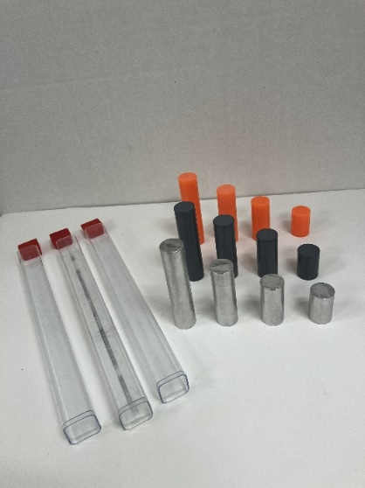
Part 2 – Mas of a Solid
Materials
- Balance that measures in grams
- Flinn Density and Slope Set
These cylinders will also be used in Lesson 4, about volume, and Lesson 5 about density.
Note: The Flinn Density and Slope set contains three long plastic containers, each containing 4 rods of the same material but different lengths. There are four silver rods (short, medium, long, and longest), four orange rods (short, medium, long, and longest), and four gray rods (short, medium, long, and longest).
In the entire set there are:
Silver, orange, and gray (Short: 2.5 cm)
Silver, orange, and gray (Medium: 3.5 cm)
Silver, orange, and gray (Long: 5 cm)
Silver, orange, and gray (Longest: 7 cm)

EXPLORE
1. Give each student an Activity Sheet for Part 2 and have groups measure the mass of 3 rods of the same material (same color) but different lengths.
Tell students that their group will measure the mass of solids and then liquids and model the mass in both. Let students know that they will use these measurements in later lessons so they should be sure they save their data.
Review how to measure mass with an electronic scale or balance, the importance of sharing data, examining human error, and averaging to determine the mass of an object.
Finding the Mass of Cylinders of the Same Material
Color of Cylinder  (Gray, Silver, or Orange) | Length of Cylinder | Mass (g)  Trial 1 | Mass (g)  Trial 2 | Average Mass (g)
 | ______cm | ______g | ______g | ______g
 | ______cm | ______g | ______g | ______g
 | ______cm | ______g | ______g | ______g
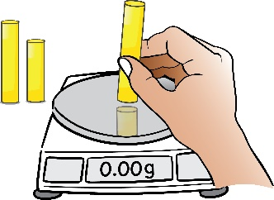
Have student groups use a balance to measure and record the mass of 3 rods of the same material (same color) but different lengths. It would be good to have different groups measure the same sets of rods so there are multiple trials. As a class, students can use the activity sheet to complete the data table, and then record their data in a class record. Students can then use multiple trials to calculate averages, see outliers, and discuss sources of error.
EXPLAIN
2. Discuss how to model the mass of rods that are the same material but different sizes.
Ask students:
- Should the model should be similar or different than the model for the gas in the basketball and then have students draw their models?
Students should say that the molecules are the same in the three rods because they are made from the same material so the circles or dots should be the same. This is similar to the deflated and inflated basketball which both contained air. But since it is a solid and not a gas, the circles or dots should be much closer together. The spacing between the circles or dots should be the same for all three rods. The longest rod should have the most circles or dots since it has the most mass. The shortest rod should have the fewest circles or dots since it has the lowest mass. The rod with the in-between mass should have a number of circles or dots between the other two.

Part 3 – Mass of a Liquid
Materials
- 100 mL graduated cylinder (1 for each group)
- Water
- Balance that measures in grams
ENGAGE
  - Review with students how to accurately measure the volume of a liquid.
Tell students that they will need to accurately measure the volume of water in a graduated cylinder. For accuracy, they will need to take the meniscus at the surface of the water into consideration.
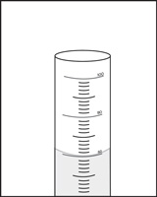
Explain to students that a meniscus is formed due to the attraction or cohesion of water molecules. Remind students of the way the water droplets stuck together on wax paper from Lesson 2 and the resulting surface tension and dome shape of the drops.
Explain that water placed in a narrow container like a test tube or graduated cylinder also has surface tension and forms an upside-down dome, called the meniscus, in the cylinder. To get an accurate measurement of volume, students need to read from the bottom of the meniscus to account for these cohesive forces, and the dip.

EXPLORE
2. Give each student an Activity Sheet and have students measure the mass of 100 mL,
50 mL, and 25 mL of water.
Have students measure and record the mass of 100 mL, 50 mL, and 25 mL of water by following instructions on the Student Activity Sheet.
For measuring the mass of a liquid, be sure to help students understand that they will need to first measure the mass of an empty graduated cylinder and subtract that mass from the mass of the graduated cylinder containing the liquid.

Materials for each group
  - Graduated cylinder (100 ml)
  - Water
  - Balance that measures in grams (able to measure over 100 g)
  - Dropper

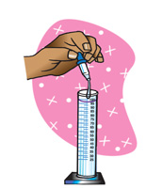
Procedure
- Find the mass of an empty graduated cylinder. Record the mass in grams in the chart on the activity sheet.
- Pour 100 mL of water into the graduated cylinder. Try to be as accurate as possible by checking that the meniscus is right at the 100-mL mark. Use a dropper to add or remove small amounts of water.
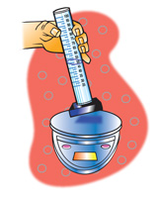
- Weigh the graduated cylinder with the water in it. Record the mass in grams.
- Find the mass of only the water by subtracting the mass of the empty graduated cylinder. Record the mass of 100 mL of water in the chart.
- Pour off water until you have 50 mL of water in the graduated cylinder. If you accidentally pour out a little too much, add water until you get as close as you can to 50 mL.
- Find the mass of 50 mL of water. Record the mass in the activity sheet.
- Next, pour off water until you have 25 mL of water in the graduated cylinder. Find the mass of 25 mL of water and record it in the chart.

Finding the mass of different volumes of water
Volume of water | 100 milliliters | 50 milliliters | 25 milliliters
Mass of graduated cylinder + water (g)
Mass of empty graduated cylinder (g)
Mass of water (g)

3. Have students draw a model of the mass of water in the three graduated cylinders.
Ask students if a model of the mass for water should be like the model for gas and a solid. Since all three samples were the same material (water), the circles or dots should be the same for both. The circles or dots should be slightly more spread out as a liquid than as a solid but much closer together than a gas.
Since it’s the same material in all three samples, the spacing between the circles or dots should be the same but the larger sample should have more dots to represent more matter and therefore more mass. The smallest amount of water should have the fewest circles or dots since it has the lowest mass. The volume of water in-between should have a number of circles or dots between the other two.

EXTEND
- Have a class discussion about matter having mass and taking up space to get to the importance of investigating volume.
By the end of this series of activities you can ask students: “How do you think that understanding and modeling the mass of the blobs might help us understand and model how the Lava Lamp works?”
This is not an easy question, but students might suggest that something about the mass of the blob might cause it to rise and sink.
Let students know that mass alone won’t explain why the blobs behave the way they do, so more work is needed.
Explain that the mass of the blob is important but that the amount of space the blob takes up or its “volume” matters too. As a class, decide that volume should be explored in the next series of activities.

