Activity Sheet Name ___________________
Lesson 3
Connecting Matter to Measuring and Modeling Mass Date _________________

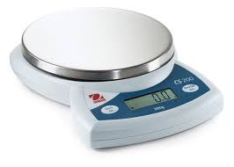
Purpose: To understand the relationship between matter and mass by measuring the mass of objects made from the same material and modeling mass.
Part 1 – Mass of a gas
Question: Does a gas have mass and how can you model different amounts of a gas?

DEMONSTRATION – BASKETBALL AND COMPRESSED GAS
The demonstrations with the basketball and the can of compressed air were meant to show something about gases and matter. Matter is anything that has mass and takes up space.
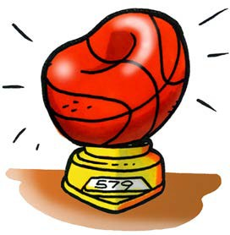
- Think about the demonstration with the deflated and inflated basketball. The basketball weighed more after it was inflated with air than when it was deflated. How does this show that gas is matter?

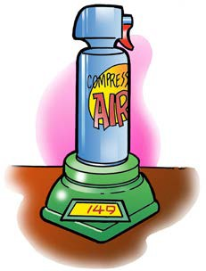
- Think about the demonstration with the can of compressed gas. The can weighed less after some gas was shot out of the can. How does this show that gas is matter?

EXPLAIN IT WITH ATOMS & MOLECULES
You saw an animation of gas molecules inside a balloon.
- What did you notice about the molecules of a gas?
  - Do the molecules of a gas have strong or weak attractions? __________
  - Are the molecules of a gas randomly or orderly arranged? ___________
  - When the molecules of a gas hit each other, do they normally stick together or bounce off? ________________
- In the space below, draw a model of the molecules inside the deflated and inflated basketball showing that one has more mass than the other.

Modeling Mass in a Gas
Deflated Basketball
Inflated Basketball

Part 2 - Mass of a Solid
Question: How can you model the mass of different amounts of the same solid material?
- Measure the mass of three solid cylinders of the same material (color) but different lengths. Record the length of each cylinder in the chart. Record the mass of the cylinders in the “Trial 1”column. (Remember to Zero the balance between each measurement)

Color of Cylinder  (Gray, Silver, or Orange) | Length of Cylinder | Mass (g)  Trial 1 | Mass (g)  Trial 2 | Average Mass (g)
 | ______cm | ______g | ______g | ______g
 | ______cm | ______g | ______g | ______g
 | ______cm | ______g | ______g | ______g

- After you have measured and recorded the mass of each of your cylinders, find another team that measured the same cylinders as you. Copy the mass of each of the cylinders as they measured them in the correct row in the “Trial 2” column.

- Compare your measurements - If you notice differences, work together to see if an error was made. Decide if the data is “close enough” or needs remeasuring.
Calculate the average mass of each cylinder and record it in the “Average Mass” column.

4. Based on your data, does the mass of each cylinder make sense when you compare their lengths? Explain:

Modeling Mass in a Solid
Use the spaces below to draw a model of the molecules in the three solid cylinders that you measured.
- Would the particles be the same distance apart and the same size in all the cylinders?

What would be the only difference between the particles in the three samples? ________

Color: Mass:
Color: Mass:
Color: Mass:

- If you cut one of the cylinders perfectly in half, what would be the mass of one half? Explain your answer based on atoms and molecules.

- Scientists often find that the measurements they make do not exactly match another scientist’s even when they expect them to be the same. Can you think of 2 things that might cause this to happen?

- If “human error” plays a factor in a scientist not “finding the right answer”, why would doing more than 1 trial be helpful?

Part 3 – Mass of a Liquid

Materials for each group
- Graduated cylinder, 100 mL
- Water
- Balance that measures in grams (able to measure over 100 g)
- Dropper

Procedure
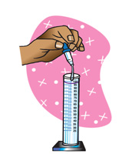
  - Find the mass of an empty graduated cylinder. Record the mass in grams in the chart on the activity sheet.
  - Pour 100 mL of water into the graduated cylinder. Try to be as accurate as possible by checking that the meniscus is right at the 100 mL mark. Use a dropper to add or remove small amounts of water.

  - Weigh the graduated cylinder with the water in it. Record the mass in grams.
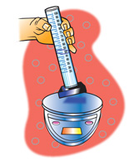
  - Find the mass of only the water by subtracting the mass of the empty graduated cylinder. Record the mass of 100 mL of water in the chart.
  - Pour off water until you have 50 mL of water in the graduated cylinder. If you accidentally pour out a little too much, add water until you get as close as you can to 50 mL.
  - Find the mass of 50 mL of water. Record the mass in the chart in the activity sheet.

Finding the mass of different volumes of water
Volume of water | 100 milliliters | 50 milliliters | 25 milliliters
Mass of graduated cylinder + water (g)
Mass of empty graduated cylinder (g)
Mass of water (g)
  - Next, pour off water until you have 25 mL of water in the graduated cylinder. Find the mass of 25 mL of water and record it in the chart.

Modeling the Mass in a Liquid
- Use the spaces below to draw a model of the molecules in the three samples of water that you measured.

- Would the particles be the same distance apart and the same size in all the pictures?

- What would be the only difference between the particles in the three samples?
100 Milliliters
50 Milliliters
25 Milliliters
25
50
100

