**Lesson 2 – Modeling Matter on the Molecular Level**

**Activity Sheet Answers**

***WHAT DID YOU OBSERVE?***

1. When you squeezed the drop of water out of the dropper, did the water break apart or did it hold together?

The water held together.

1. When you were pulling the drop around the wax paper, did the water seem to hold together or come apart easily?

The water held together in a drop.

1. When you tried to split your drop, did the drop separate easily?

It was not so easy to separate the drop.

1. Was it easy or difficult to make the drops come together?

The drops came together easily. When they touched, they quickly joined together.

***DEMONSTRATION***

1. Your teacher placed a drop of food coloring in a cup of water. The color slowly mixed into the water without being stirred. What does this tell you about water molecules?

The water molecules must be moving. The food coloring molecules may be moving too.

The movement of the molecules made the water and food coloring mix.

***EXPLAIN IT WITH ATOMS & MOLECULES***

1. Using circles and motion lines to represent water molecules, draw a model of water on the molecular level. Be sure to show that water molecules are:

* Randomly arranged
* Close together because they attract each other
* Moving

The circles should be close together, but not touching. Most circles should have two motion lines around them to signify movement.

1. What is it about water molecules that helps explain why the water drops were difficult to split apart but easy to join together?

Water molecules are attracted to one another.

***TAKE IT FURTHER***

1. Why do you think the water keeps its shape the moment the balloon is popped?

The water molecules are attracted to each other, and the film is in super slow motion.

1. Draw circles to represent the molecules in a solid, liquid, and gas. Because all three different substances are all at the same temperature, draw the same number of motion lines near the circles for each substance. Next to each box, write about the arrangement and motion of the molecules and the attractions the molecules have for one another.

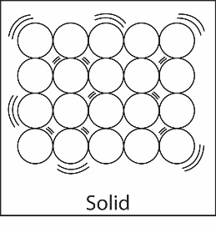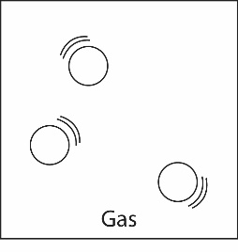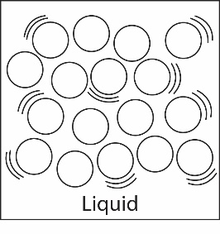

Attractions strong enough to keep atoms in orderly arrangement

Vibrate in fixed positions

Definite shape and volume

Attractions keep particles together, but they can slide past each other

Random arrangement

Definite volume, not definite shape

Attractions too weak to keep particles together

Particles move independently

No definite shape or volume

1. The material at the bottom of the Lava Lamp looks like it could be a soft or semi-solid. Do you think the attractions between the particles in the substance are very strong, very weak, or somewhere in-between? Explain.

Probably almost as strong as a regular solid but a little weaker so the molecules hold together well but can move past one another when warmed.