The Lava Lamp – A Groovy Phenomenon
Student Final Model 1
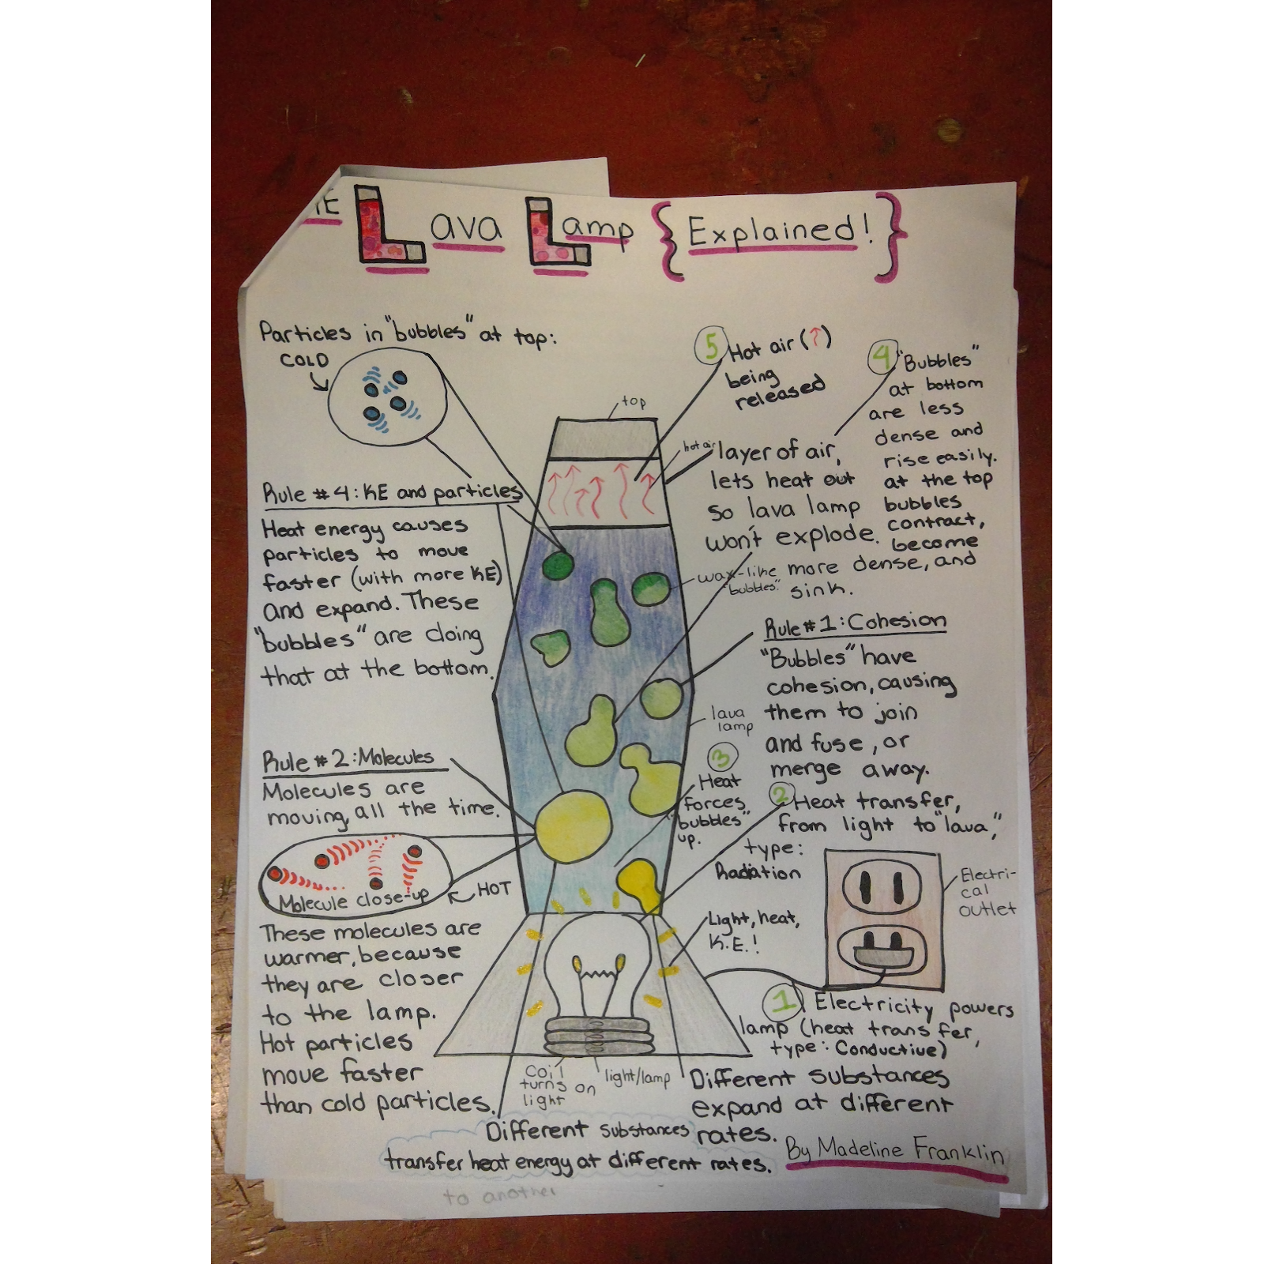
Student Final Model 2
