**Lesson 11 - Activity Sheet Answers**

**Connecting Temperature to Changes in Density**

***DEMONSTRATION***

You saw a jar of hot water placed upside down over a jar of cold water. The hot water stayed on top of the cold water without mixing.

1. **Why did the hot water stay on top of the cold water?**

The hot water stayed on top of the cold water because the hot water is less dense than the cold water.

1. **Why do you think the hot and cold water mixed when the cold water was placed on top?**

The hot and cold water mixed when the cold water was placed on top because the cold water is more dense than the hot water, so it immediately sank (or mixed) with the water below it.

***WHAT DID YOU OBSERVE?***

1. **Draw what you observed in the cup of room temperature water after adding blue cold water and yellow hot water.**

**Be sure to label the areas of cold and hot water.**

**Is *cold* water more, less, or the same density as room temperature water?**

**Is *hot* water more, less, or the same density as room temperature water?**

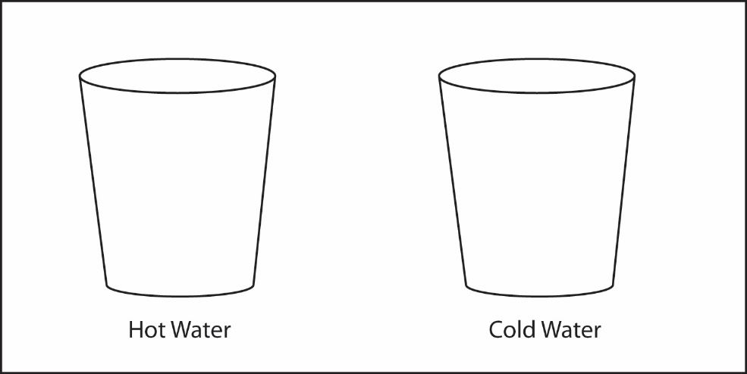

Room-temp. water

Cold blue water

Hot yellow water

The hot water floated to the top, while the cold water sank to the bottom. Cold water is more dense than room temperature water. Hot water is less dense than room temperature water.

***EXPLAIN IT WITH ATOMS & MOLECULES***

In the animation, you saw water molecules being heated and cooled.

1. **Look at the model of water molecules in the diagram below to help you compare the volume, mass, and density of cold and hot water.**

**Write *more*, *less*, or *same* in the chart to describe the volume, mass, and density of cold and hot water compared to room temperature water.**

|  |  |  |
| --- | --- | --- |
| **Comparing cold and hot water to room temperature water** | | |
|  | **Cold water** | **Hot water** |
| Volume | Less | More |
| Mass | Same | Same |
| Density | More | Less |

1. **Use what you know about density to answer the following questions.**

**Why does cold water sink in room temperature water?**

Cold water sinks in room temperature water because the molecules in cold water are just a bit closer together, which slightly decreases its volume. This slight decrease in volume leads to an increase in density, so the more dense cold water sinks.

**Why does hot water float on room temperature water?**

Hot water floats in room temperature water because the molecules in hot water are just a bit further apart, which slightly increases its volume. This slight increase in volume leads to a decrease in density, so the less dense hot water floats.

1. **Explain on the molecular level why heated blobs rise in the Lava Lamp and cooled blobs sink.**

When the blob material is heated, its molecules move fast enough to compete with attractions and move a little further apart. This increases the volume but the mass stays the same which makes the density decrease and the blob floats.   
When the blob material cools, its molecules move slow enough that attractions bring them a little closer together. This decreases the volume but the mass stays the same which makes the density increase and the blob sinks.