**Activity Sheet** **Name ___________________________**

**Lesson 10 Date _________________**

**Expansion and Contraction in Liquids, Solids, and Gases**

# Part 1 – Expanding and Contracting Liquids

## Question to investigate

What makes the liquid in a thermometer go up and down?

**Materials for each group**

* Student thermometer
* Magnifier
* Cold water
* Hot water (about 50 °C)

## Procedure

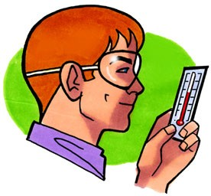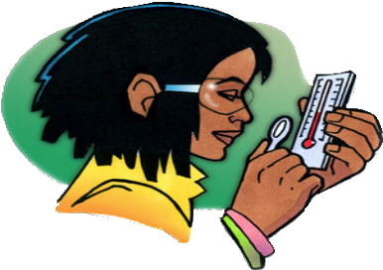

1. *Look closely at the parts of the thermometer.*
   1. Look closely at your thermometer. The liquid inside is probably a type of alcohol that’s been dyed red.
   2. Read the temperature in °C by having your eye on the same level as the top of the red liquid. What is the temperature?
   3. Use a magnifier to look closely at the thermometer from the front and from the side. Look at the bulb and the thin tube that contain the red liquid.
   4. Put your thumb or finger on the red bulb and see if the red liquid moves in the thin tube.
2. *Observe the red liquid in the thermometer when it is heated and cooled.*
   1. A thermometer in a glass

      Description automatically generated
   2. Place the thermometer in hot water and watch the red liquid. Keep it in the hot water until the liquid stops moving.

Record the temperature in °C.

* 1. Now put the thermometer in cold water. Keep it in the cold water until the liquid stops moving.

Record the temperature in °C.

# WHAT DID YOU OBSERVE?

1. **Based on what you know about the way molecules move in hot liquids, explain why the liquid in the thermometer goes up when heated.**
2. **Based on what you know about the way molecules move in cold liquids, explain why the liquid in the thermometer goes down when cooled.**

# EXPLAIN IT WITH ATOMS & MOLECULES

You saw an animated molecular model of a thermometer at different temperatures. Now you will draw your own model.

The drawing shows two close-ups of a thin tube in a thermometer like the one you used. One picture represents the thermometer in hot water, while the other is the thermometer in cold water.

1. **Based on what you know about the motion of molecules in a liquid and what you saw in the animations, draw circles to represent alcohol molecules in the liquid in the thermometer. Try to show the difference in distance between the molecules when the liquid is hot and cold. Use motion lines to represent their movement (fast or slow).**

# TAKE IT FURTHER

1. **Imagine that you have two thermometers that are identical in every way, except one has alcohol and the other has mercury inside. Each thermometer is placed in hot water that is 100 °C. The levels of the alcohol and mercury are shown in the picture.**

**Why do you think the liquids in the thermometers are at different levels even though they are in water that is the same temperature?**

**Hint**: Alcohol and mercury are both liquids but are made of different atoms and molecules. Use what you know about the motion and attractions the particles in a liquid have for one another to explain why the levels of alcohol and mercury in the thermometers are different.

**Part 2 – Expanding and Contracting Solids**

# EXPLAIN IT WITH ATOMS & MOLECULES

After you watch the molecular model animations of liquids and solids, answer the questions below.

1. **How is the motion of the atoms in solid metal different from the motion of the molecules in liquid water?**
2. **What is it about atoms and molecules in liquids and solids that keep them close to one another even though they are moving?**

# DEMONSTRATION

1. **At room temperature the metal ball fits through the ring. What happened when your teacher tried to push the heated ball through the ring?**

1. **What happened to the atoms in the heated metal ball so that it didn’t fit through the ring?**
2. A cup of liquid with a spoon

   Description automatically generated**After the ball was cooled by putting it in the water, why do you think it fit through the ring again?**

# EXPLAIN IT WITH ATOMS & MOLECULES

# In the animation, you saw that atoms in a solid move faster and get slightly further apart when heated. You also saw that they slow down and get slightly closer together when cooled.

1. **Draw a model of the atoms in the metal ball at room temperature and after it has been heated. Use circles and motion lines to show the speed and spacing of the atoms in the room temperature ball. Include captions like “atoms faster and further apart” or “atoms slower and closer together” to describe your drawings**

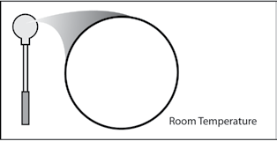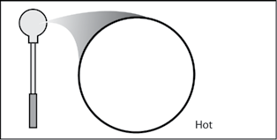

# TAKE IT FURTHER

Look at the picture of the road of a bridge. The road on a bridge gets colder in the winter and hotter in the summer than the road leading to it and away from it.

Many bridges have a flexible connection like the one shown in the picture.

**Knowing what you do about how solids act when they are heated and cooled, why do you think they put flexible connections in the road on a bridge?**

**Part 3 – Expanding and Contracting Gases**

# ACTIVITY

## Question to investigate

How do heating and cooling affect a gas?

## Materials for each group

* 2 clear plastic cups
* 8-oz plastic bottle
* Detergent solution in cup
* Hot water
* Cold water

## Procedure

1. *Warming the air inside the bottle*
   1. Pour hot water into an empty cup until it is about ½-full.
   2. A close-up of a hand holding a bottle

      Description automatically generatedTurn the bottle over and dip the opening of the bottle into the detergent to get a film of detergent covering the rim.
   3. While holding the bottle, slowly push the bottom of the bottle down into the *hot* water.
2. *Cooling the air inside the bottle*
3. Pour cold water into another cup until it is about ½-full.
4. A close-up of a hand holding a bottle

   Description automatically generatedIf there is still a bubble on the bottle, slowly push the bottom of the bottle down into the *cold* water.
5. If a bubble is not still on the bottle, make another bubble by dipping the opening into detergent and then pushing the bottom of the bottle into hot water again.
6. While holding the bottle, slowly push the bottom of the bottle down into the cold water.

# WHAT DID YOU OBSERVE?

**1. What happened to the film of detergent solution when you placed the bottle in hot water?**

1. **What happened to the bubble when you placed the bottle in cold water?**

# EXPLAIN IT WITH ATOMS & MOLECULES

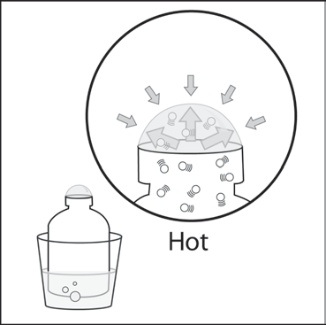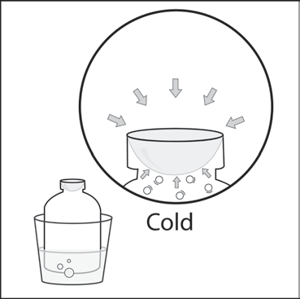

# You saw an animation showing the air molecules inside a bottle when it is placed in hot and cold water. Think of the animation and use the drawing as a reference to answer the following questions.

1. **What caused the bubble to form when you placed the bottle in hot water? Be sure to write about the speed of the molecules inside the bubble and the force on the bubble from the outside air.**
2. **Why did the bubble get smaller when you placed the bottle in cold water? Be sure to write about the speed of the molecules inside the bubble and the force on the bubble from the outside air.**

***TAKE IT FURTHER***

1. **You saw a gas expand and contract when heated and cooled. Do you think the blob material in the Lava Lamp expands a similar amount when heated and cooled? Why or why not?**