**Lesson 10 - Activity Sheet Answers**

**Expansion and Contraction in Liquids, Solids, and Gases**

**Part 1 – Expanding and Contracting Liquids**

***WHAT DID YOU OBSERVE?***

1. **Based on what you know about the way molecules move in hot liquids, explain why the liquid in the thermometer goes up when heated.**

The liquid in the thermometer goes up when the thermometer is heated because heating makes the alcohol molecules of the liquid move faster. The extra speed of the molecules competes with their attraction for one another and causes them to move slightly further apart. Since the molecules move further apart, the same amount of alcohol takes up more room in the thin tube of the thermometer. The liquid has nowhere else to go but up.

1. **Based on what you know about the way molecules move in cold liquids, explain why the liquid in the thermometer goes down when cooled.**

The liquid in the thermometer goes down when the thermometer is cooled because cooling makes the alcohol molecules of the liquid move more slowly. When they move more slowly, their attractions for one another are able to bring them slightly closer together. Since the molecules come closer together, the same amount of alcohol takes up less room in the thin tube of the thermometer and goes down.

***EXPLAIN IT WITH ATOMS & MOLECULES***

You saw an animated molecular model of a thermometer at different temperatures. Now you will draw your own model.

The drawing shows two close-ups of a thin tube in a thermometer like the one you used. One picture represents the thermometer in hot water, while the other is the thermometer in cold water.

1. **Based on what you know about the motion of molecules in a liquid and what you saw in the animations, draw circles to represent alcohol molecules in the liquid in the thermometer. Try to show the difference in distance between the molecules when the liquid is hot and cold. Use motion lines to represent their movement (fast or slow).**

The circles representing molecules should be farther apart and have more motion lines in the tube in hot water. The circles should be closer together and have fewer motion lines in the tube in cold water.

***TAKE IT FURTHER***

1. **Imagine that you have two thermometers that are identical in every way, except one has alcohol and the other has mercury inside. Each thermometer is placed in hot water that is 100 °C. The levels of the alcohol and mercury are shown in the picture.**

**Why do you think the liquids in the thermometers are at different levels even though they are in water that is the same temperature?**

**Hint**: Alcohol and mercury are both liquids but are made of different atoms and molecules. Use what you know about the motion and attractions the particles in a liquid have for one another to explain why the levels of alcohol and mercury in the thermometers are different.

The alcohol and the mercury thermometers go up by different amounts because the molecules that make up alcohol and the atoms that make up mercury are different. Since they are different, their attractions are different and the way they respond to heating and cooling are different. So even though they both go up and down when heated and cooled, they do it by different amounts.

**Part 2 – Expanding and Contracting Solids**

***EXPLAIN IT WITH ATOMS & MOLECULES***

After you watch the molecular model animations of liquids and solids, answer the questions below.

1. **How is the motion of the atoms in solid metal different from the motion of the molecules in liquid water?**

The atoms in solid metal vibrate back and forth but do not move past one another like the water molecules in liquid water.

1. **What is it about atoms and molecules in liquids and solids that keep them close to one another even though they are moving?**

The atoms or molecules that make up liquids and solids are kept near each other by the attraction between molecules or the attraction between atoms.

***DEMONSTRATION***

1. **At room temperature the metal ball fits through the ring. What happened when your teacher tried to push the heated ball through the ring?**

When the ball was heated it did not fit through the ring.

1. **What happened to the atoms in the heated metal ball so that it didn’t fit through the ring?**

Heating makes the atoms in the metal move faster. The extra speed of the atoms competes with their attractions for one another and causes them to move slightly further apart. Since the atoms move further apart, the size (volume) of the metal ball increases a little and will not fit through the ring.

1. **After the ball was cooled by putting it in the water, why do you think it fit through the ring again?**

Cooling makes the atoms in the metal move more slowly. When they move more slowly, their attractions for one another are able to bring them slightly closer together. Since the atoms come closer together, the size (volume) of the metal ball decreases a little and will fit through the ring again.

***EXPLAIN IT WITH ATOMS & MOLECULES***

You saw in the animation that atoms in a solid move faster and get slightly further apart when heated. You also saw that they slow down and get slightly closer together when cooled. Use this information to make your own drawing on the molecular level of the metal ball.

1. **Draw a model of the atoms in the metal ball at room temperature and after it has been heated. Use circles and motion lines to show the speed and spacing of the atoms in the room temperature ball. Include captions like “atoms faster and further apart” or “atoms slower and closer together” to describe your drawings.**

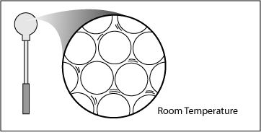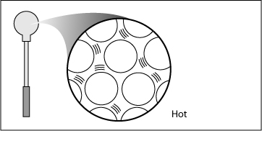

Atoms slower and closer together

Atoms faster and further apart

***TAKE IT FURTHER***

Look at the picture of the road of a bridge. The road on a bridge gets colder in the winter and hotter in the summer than the road leading to it and away from it.

Many bridges have a flexible connection like the one shown in the picture.

1. **Knowing what you do about how solids act when they are heated and cooled, why do you think they put flexible connections in the road on a bridge?**

If it gets cold enough, the bridge shrinks or contracts a little. If it gets hot enough, the bridge grows or expands a little. The flexible material allows the road to shrink a little in the cold or expand a little in the heat without weakening or cracking the road material.

**Part 3 – Expanding and Contracting Gases**

***WHAT DID YOU OBSERVE?***

1. **What happened to the film of detergent solution when you placed the bottle in hot water?**

When the bottle was placed in hot water, the soap film formed a bubble on top of the bottle.

1. **What happened to the bubble when you placed the bottle in cold water?**

When the bottle was placed in cold water, the bubble shrunk and may have gone inside the bottle.

***EXPLAIN IT WITH ATOMS & MOLECULES***

You saw an animation showing the air molecules inside a bottle when it is placed in hot and cold water. Think of the animation and use the drawing below as a reference to answer the questions at the top of the next page.

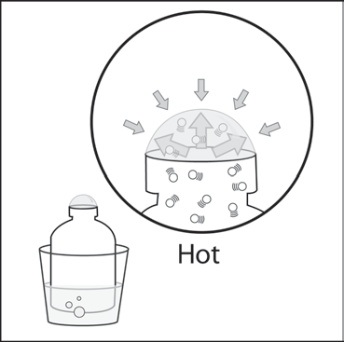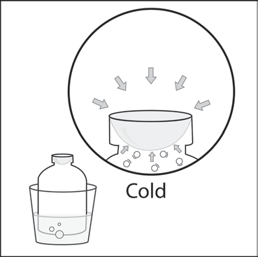

1. **What caused the bubble to form when you placed the bottle in hot water? Be sure to write about the speed of the molecules inside the bubble and the force on the bubble from the outside air.**

The bubble formed when the bottle was placed in hot water because the molecules that make up the air inside the bottle moved faster. These molecules hit the inside of the bottle and detergent film harder and more often. They pushed against the detergent film hard enough that it was able to overcome the outside air pressure and made the bubble grow.

1. **Why did the bubble get smaller when you placed the bottle in cold water? Be sure to write about the speed of the molecules inside the bubble and the force on the bubble from the outside air.**

The bubble shrinks when the bottle is placed in cold water because the molecules that make up the air inside the bottle moved slower. These molecules hit the inside of the bottle and detergent film less often and with less force. The outside air pressure pushed harder on the outside of the bubble than the molecules pushed from the inside so the bubble got smaller.

***TAKE IT FURTHER***

1. **You saw a gas expand and contract when heated and cooled. Do you think the blob material in the Lava Lamp expands and contracts a similar amount when heated and cooled? Why or why not?**

The blob material does expand and contract when heated and cooled but not nearly as much as a bubble of gas. The attractions between the molecules of the blob are much stronger than the attractions between the molecules of a gas. Therefore, when heated or cooled, the blob does not expand and contract as much as a gas.