Name:__________________________________ Period:_______ Date:____________________________________
The Lava Lamp – A Groovy Phenomenon
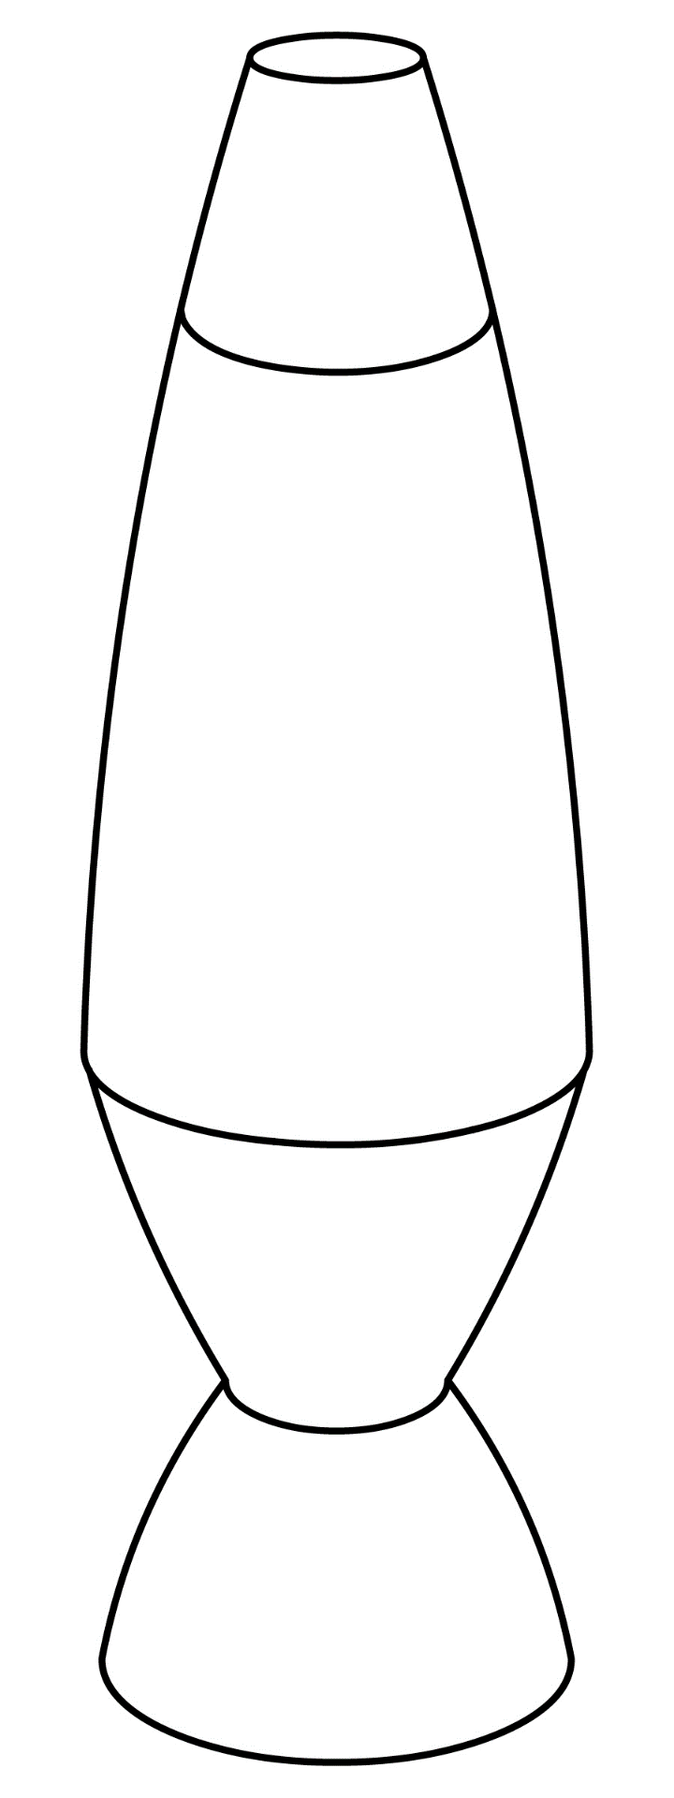
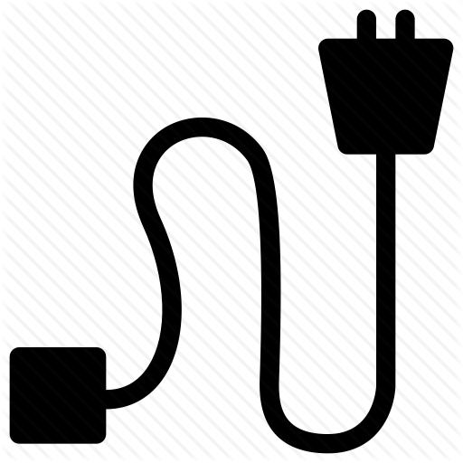
Observe a lava lamp in action then DRAW and LABEL on the picture of the lava lamp below to create a model showing how you think it might work. As you learn more about the Lava Lamp, you will modify and improve your model.

