Activity Sheet Name Chapter 3, Lesson 6
Temperature and Density Date

DEMONSTRATION
You saw a jar of hot water placed upside down over a jar of cold water. The hot water stayed on top of the cold water without mixing.
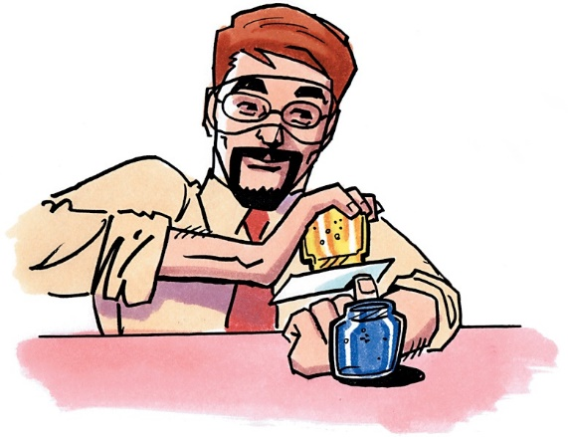
- Why did the hot water stay on top of the cold water?

- Why do you think the hot and cold water mixed when the cold water was placed on top?

ACTIVITY

Question to investigate
Is there a density difference between hot and cold water?

Materials for each group
  - Cold water (colored blue) in foam cup
  - Hot water (colored yellow) in foam cup
  - Room temperature water in clear plastic cup (colorless)
  - 2 droppers

Procedure
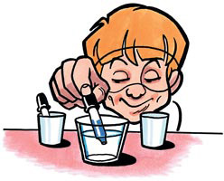
- Fill one dropper with blue cold water. Poke the end of the dropper about halfway into the colorless room temperature water.
- While observing from the side, very gently squeeze the dropper so that the cold water slowly flows into the room temperature water.
- Fill another dropper with yellow hot water. Poke the end of the dropper about halfway into the room temperature water.
- While observing from the side, very gently
squeeze the dropper so that the hot water slowly flows into the room temperature water.
- Record your observations on the activity sheet.

- Draw what you observed in the cup of room temperature water after adding blue cold water and yellow hot water.
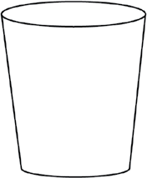

Be sure to label the areas of cold and hot water.

Is cold water more, less, or the same density as room temperature water?

Is hot water more, less, or the same density as room temperature water?

EXPLAIN IT WITH ATOMS & MOLECULES

In the animation, you saw water molecules being heated and cooled.

- Look at the model of water molecules in the diagram below to help you compare the volume, mass, and density of cold and hot water.
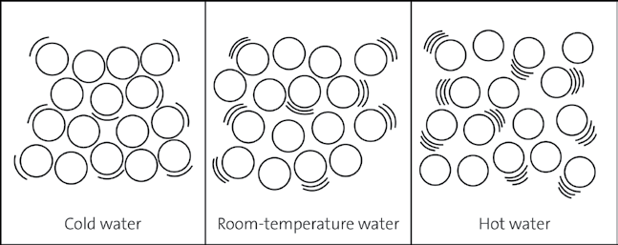

Write more, less, or same in the chart to describe the volume, mass, and density of cold and hot water compared to room temperature water.

Comparing cold and hot water to room temperature water
 | Cold water | Hot water
Volume
Mass
Density

- Use what you know about density to answer the following questions.

Why does cold water sink in room temperature water?

Why does hot water float on room temperature water?

TAKE IT FURTHER
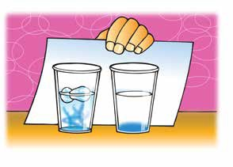
- Your teacher did a demonstration with two cups of water that both had food coloring on the bottom. Ice was placed in one cup of water, but not the other. The food coloring mixed more quickly in the cup that had the ice. Use what you know about the density of water at different temperatures to explain why this happened.

