Chapter 3—Student Reading
If you hold a solid piece of lead or iron in your hand, it feels heavy for its size. If you hold the same size piece of balsa wood or plastic, it feels light for its size. The property of an object that causes this effect is called density. The density of an object depends on its mass and its volume. The mass is the amount of matter in the object. The volume is the amount of space that the object takes up in three dimensions.

All the objects around you take up a certain amount of space, no matter what shape they are. They all have length, width, and depth so they take up space in three dimensions.
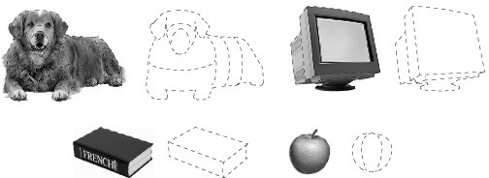

These pictures show that every object has a volume that takes up 3-dimensional space.
The volume of a wooden block, for instance is its length × width × height. For the block shown, the volume equals 5cm × 5cm × 4 cm = 100 cubic centimeters (cm³).
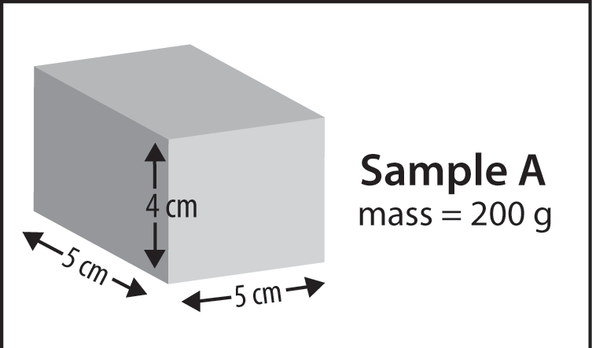
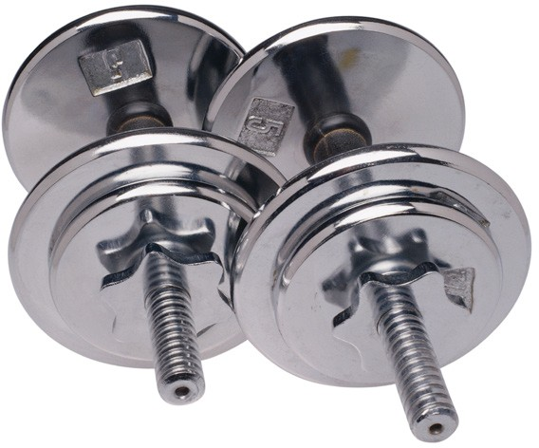
A mathematical equation for density is: Density = mass/volume or D = m/v. If something has a large mass compared to its volume, it has a high density. This is like a set of weights which can be small but heavy.
But if an object has a small mass compared to its volume it has a lower density. This is like an apple or a piece of wood which can seem light for its size.
Different types of plastic, metal, wood, and other materials have different densities. The density of a material is based on the atoms or molecules the substance is made from. For example, a copper and an aluminum cube of the same volume feel very different when you hold them. The copper cube feels much heavier than the aluminum cube. If you put them on a balance, you see that the copper cube has more mass than the aluminum cube.

Since the cubes have the same volume but the copper has a greater mass, the copper cube is more dense than the aluminum cube. This is true since D = m/v. If the cubes have the same volume, the one with the greater mass must be more dense.
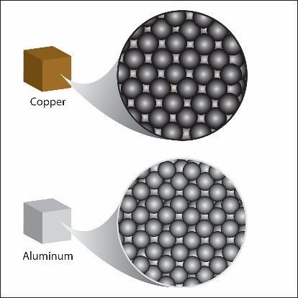
If you think about the atoms of the two metals, there can only be a couple of reasons why the copper is more dense than the aluminum:

- Copper atoms might have more mass than aluminum atoms.
- Copper atoms might be smaller than aluminum atoms so more can fit in the same volume.
- Copper atoms might be arranged differently than aluminum atoms so more can fit in the same volume.

Either one or any combination of these explanations could be the reason why the copper cube has more mass. Copper atoms are a little larger than aluminum atoms so there are fewer copper atoms in the copper cube than aluminum atoms in the aluminum cube. But copper atoms have much more mass than aluminum atoms. So even though there are fewer copper atoms, their extra mass makes the copper cube heavier than the aluminum cube of the same size and shape (volume).

A sample of a substance with a higher density will always have a greater mass than the same size sample of a substance with a lower density. For example, a sample of lead weighs more than the same size sample of wax.

A small sample of a substance with a high density may weigh as much or more than a larger sample of a substance with a lower density. For example, a small piece of iron may weigh as much or more than a larger piece of plastic.

A closer look at mass and volume
In order to find the density of a substance, you need to measure the mass and the volume of a sample of the substance.

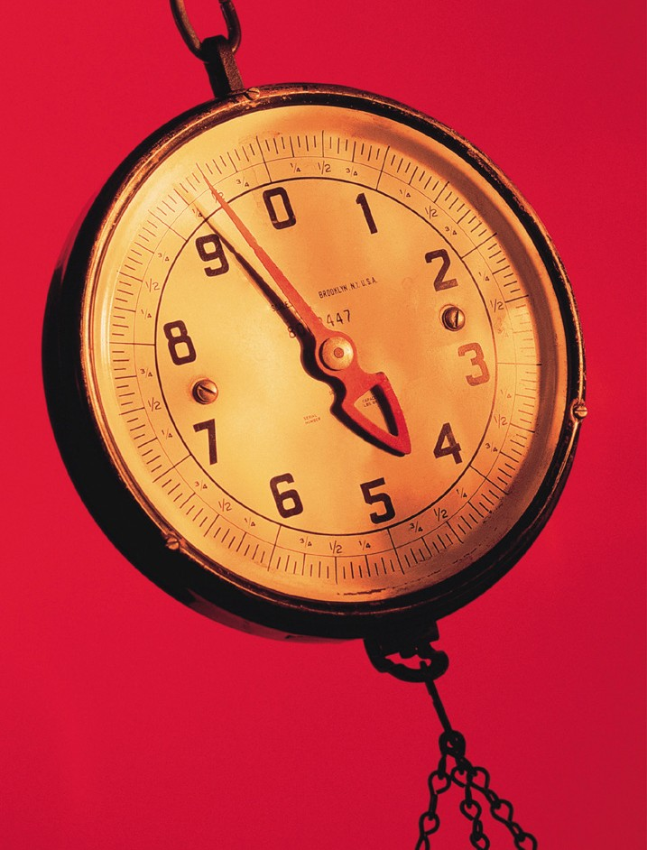
Mass is the amount of matter in an object.
People are often confused between the meaning of “mass” and “weight”. The meaning of mass and weight are different, but they are related to each other. Let’s say you have an object like a bowling ball. The bowling ball, like everything else, is made of a certain amount of matter. Let’s call the amount of matter that makes up the bowling ball the mass of the bowling ball. You hook the bowling ball to a scale that shows that the amount of mass that makes up the bowling ball weighs 9 pounds.

Then you do something unusual: You fly the bowling ball and the scale to the moon and hook the bowling ball to the same scale again. The moon has less gravity than Earth so the bowling ball is not pulled down as hard as it was on Earth.

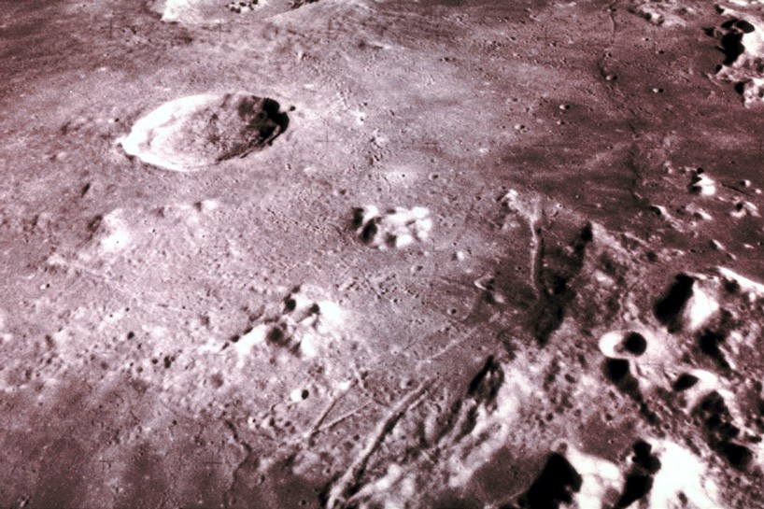
Let’s say that on the moon, the scale shows that the mass that makes up the bowling ball weighs only 1.5 pounds. You know that the bowling ball itself didn’t change. It is still made of the same amount of matter so it still has the same mass. The only thing that changed was the force of gravity pulling down on the bowling ball.

So mass is a measure of the amount of matter that makes up an object. Weight is a measure of the force of gravity on a certain mass.

So how can you measure the mass of an object by putting it on a scale? Since gravity is pulling down on the object, why doesn’t a scale always measure weight? That is a great question and the answer has to do with how the scale is made.

When you put an object on a scale, of course the scale “feels” the effect of gravity but the scale is programmed or calibrated to do an internal calculation to factor out the effect of gravity and to display only the mass.

The density of copper is greater than the density of plastic or wood
If you compared the density of a copper cube and a plastic cube of the same volume, the copper is more dense. This is because copper atoms are much more massive and packed more closely together than the atoms that make up the plastic. This gives copper a fairly high density.

Plastics are made mostly of carbon and hydrogen atoms which are not as massive for their size. They are connected together in long chains and not packed as tightly as the atoms in copper. This makes plastic less dense than copper.

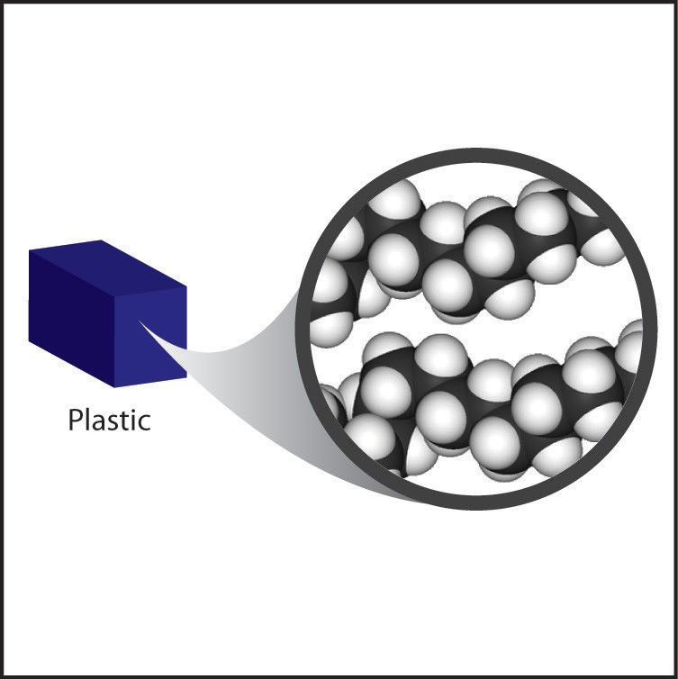

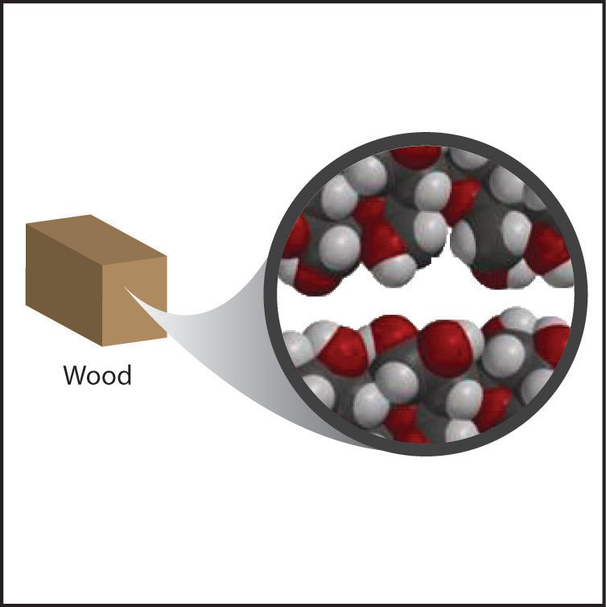
Wood is made of carbon, hydrogen, and oxygen atoms. These are pretty similar in size and mass to the atoms in plastics. Wood is also made mostly of long molecules that are arranged and packed together to make the structure of the wood.

Because of the size, mass, and arrangement of its molecules, the density of wood is more similar to plastic than to copper.

Finding volume using the water displacement method
Sometimes finding the volume of an object is not as easy as simply using a metric ruler to measure its length, width, and height. Another method is the water displacement method. There are two basic ways of doing the water displacement method to find volume.
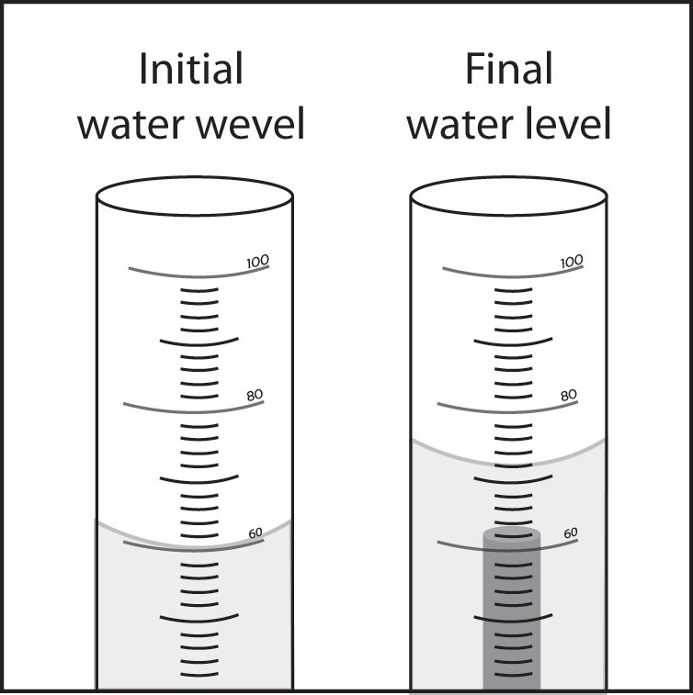
Fill a graduated cylinder with water to a level that is high enough so that the object placed in the water will be submerged. Record the initial level of the water.

Carefully place an object in the water and let it sink to the bottom. If it doesn’t sink, push it down gently with something thin like a pencil point so that it is just under the surface. The water level will rise. Record the final water level.

Subtract the initial water level from the final water level to calculate the volume of water that was displaced by the object. The volume of water displaced by an object equals the volume of the object. In this case the final water level (72 mL) minus the initial water level (60 mL) = 12 mL. Since one milliliter is the same as one cubic centimeter (cm³), the volume of the object is 12 cm³.

Another water displacement method:
Place a cup or beaker in a larger container. Fill the cup as full as possible until it is ready to overflow. Gently place an object in the water and let it sink to the bottom. If it doesn’t sink, push it down gently with something thin like a pencil point so that the object is just under the surface.

Some water will flow out of the cup and into the outer container. This water was displaced by the object. Carefully pour this water into a graduated cylinder to measure its volume. The volume of the displaced water equals the volume of the object.

The density of a substance is the same no matter what the size of the sample.
This means that a big piece of wax, for example, has the same density as a small piece of the same wax. Take water for instance. 100 mL of water has a mass of 100 grams.
Since density = mass/volume, this sample of water has a density of 100 grams/100 mL = 1 gram/mL = 1 g/cm³.

50 mL of water has a mass of 50 grams. The density of this sample of water is 50 grams/50 mL = 1 gram/ cm³.

Water or any substance always has the same density no matter what the size of the sample.

Density in sinking and floating
The density of an object and the density of the liquid it is placed in determine whether an object sinks or floats.

Even though one object might be heavier than another, the heavy one might float and the lighter one might sink. An example is a piece of clay and a heavier wax candle placed in water. Even though the wax is heavier than the clay, the wax floats and the clay sinks.

This is possible because it’s not only the mass of the object that matters in sinking and floating it’s the object’s density compared to the density of water.

An object that is less dense than water will float. An object that is more dense than water will sink. This is why the clay sinks in water and the wax floats. The clay is more dense than water and the wax is less dense than water.

Since water is more dense than wax, a volume of water has more mass than an equal volume of wax. You can prove this by putting a volume of wax and an equal volume of water on opposite ends of a balance. The balance will show that the water has a greater mass than the wax. This means that the water is more dense than the wax. This is why the wax floats.

Wax is made of carbon and hydrogen atoms linked together into long molecules. These atoms are pretty light and the arrangement of the molecules makes wax less dense than water.
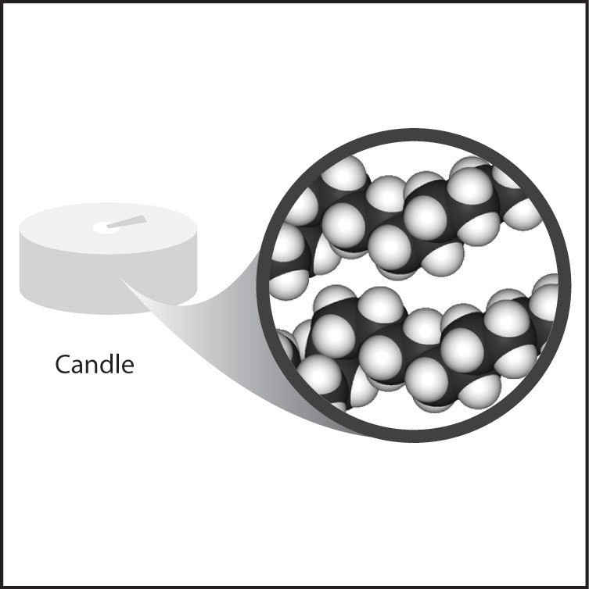
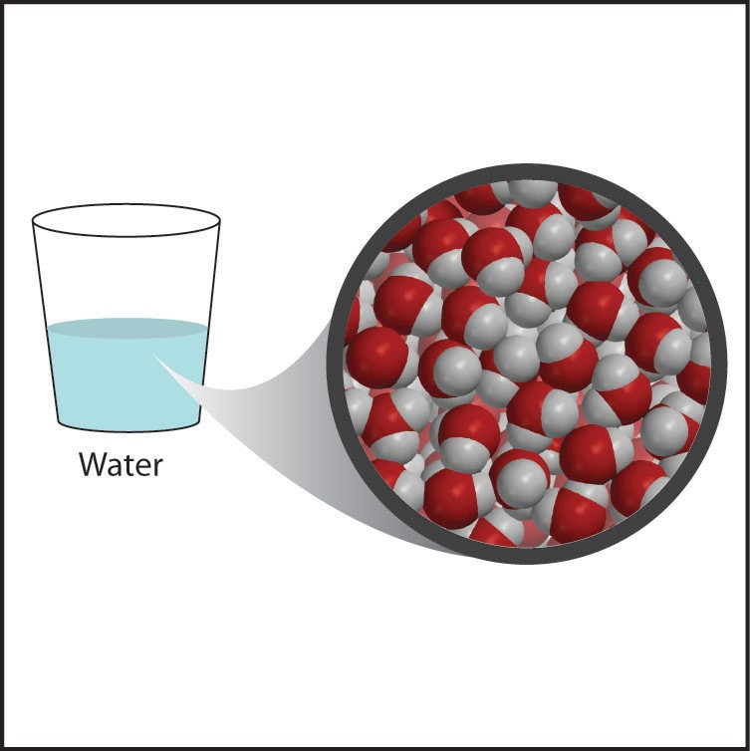

If you put a volume of clay and an equal volume of water on opposite ends of a balance, the balance will show that the clay has more mass. This means that the clay is more dense than the water. This is why the clay sinks. Clay is made from oxygen and heavier atoms like aluminum and silicon. The mass of these atoms and their arrangement make clay more dense than water.
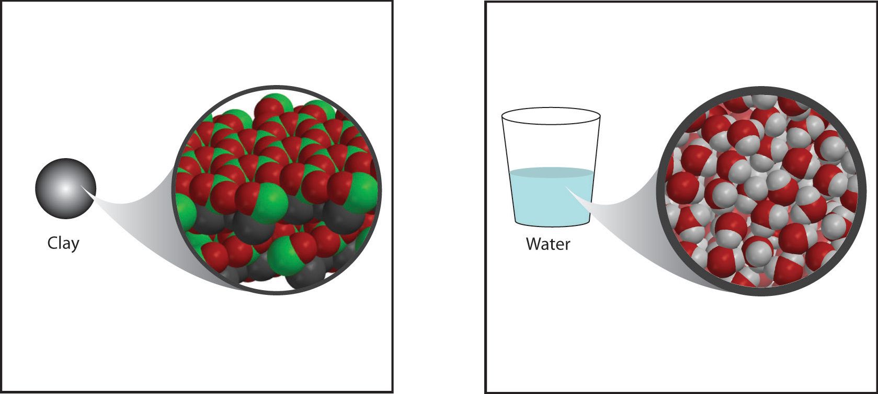

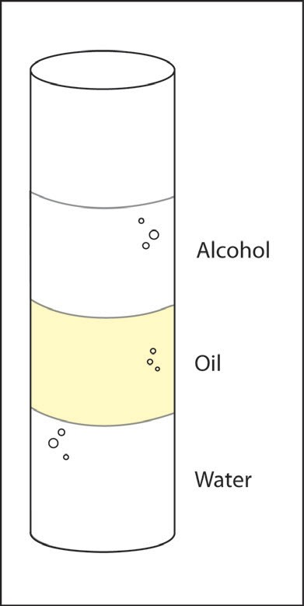
Liquids can sink and float in other liquids
Sinking and floating applies to liquids too. You can test this by carefully placing different liquids together in a graduated cylinder. For example, if you add vegetable oil to water, the oil floats on the water. If you add isopropyl alcohol, the alcohol floats on the oil.

This means that oil is less dense than water and alcohol is less dense than oil.

The density of an object or the water it is placed in can be changed so that an object that normally sinks will float.

If an object sinks in water, this means that the object is more dense than the water. There are two possible ways to make the object float. You can increase the density of the water so that the water becomes more dense than the object. Or you could increase the volume of the object so that the object becomes less dense than the water.

If you put a slice of carrot in water, the carrot sinks. This is because the carrot is more dense than water. But if you dissolve something like salt in the water, the density of the water increases.

This happens because the mass of the water increases a lot but the volume does not increase as much. Since D=m/v, increasing mass a lot and volume just a little will result in an increase in density. If enough salt dissolves, the density of the water can be increased enough that the salt water will become more dense than the carrot and the carrot will float.

Why do heavy boats float?
Why can boats float when they are made out of material that is more dense than water?

An object made from dense material can float if its volume is made large enough. Here’s an example: If you have a cube of clay that is 3 cm on each side, the cube has a volume of 3 cm × 3 cm × 3 cm = 27 cm³. Let’s say that the cube has a mass of 60 grams. The density of the clay cube is 60 g/27 cm³ = 2.2 g/cm³. Since the density of water is 1 g/cm³, the clay cube sinks.

But you can take the same cube of clay and press it down into a thin pancake and form it into a bowl that is like half a sphere. If it has a diameter of 8 cm, the clay bowl will have a volume of about 134 cm³ or more than four times the volume of the cube. The density of the bowl is now 60 g/ 134 cm³ = .45 g/cm³. The density of the clay itself doesn’t change but the density of the object does. The increase in the volume of the object decreases the density so that the density of the bowl is less than the density of water so the bowl floats.

The temperature of a substance affects its density.
When a substance like a solid or a liquid is heated, its molecules move faster and get slightly further apart. The substance still has the same mass but it takes up a larger volume. Since D=m/v, a larger volume results in a decreased density.

This can be shown pretty easily with liquids. If hot water is carefully placed on cold water, the hot water floats because it is less dense than the cold water.
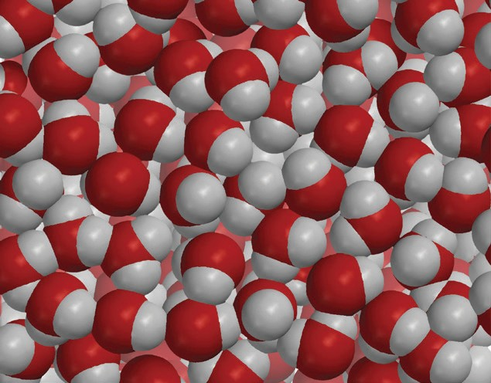
When water is cooled, its molecules move slower and get a little closer together. The water still has the same mass but it takes up a smaller volume. Since D=m/v, a smaller volume results in an increased density. If cold water is placed on hot water, the cold water sinks because it is more dense than the hot water.

Ice is less dense than liquid water.
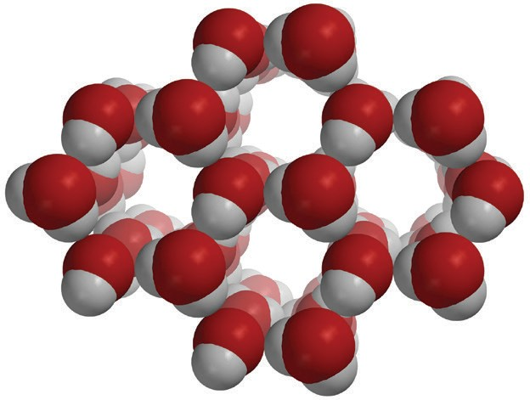
Normally, when a liquid is cooled, its molecules slow down and the attractions between molecules bring them closer together. But water is different. When water gets below 4 °C, its molecules actually begin getting a little further apart as they orient themselves into the crystal structure of ice. Since the mass does not change but the ice occupies a larger volume than the water, the density of ice is less than the density of water. This is why ice floats in water.

