February/March 2017 Teacher's Guide

Background Information

for

Iron in the Diet: Power on Your Plate?

Table of Contents

About the Guide 2
Background Information 3
References 18
Web Sites for Additional Information 19

About the Guide

Teacher’s Guide team leader William Bleam and editors Pamela Diaz, Regis Goode, Diane Krone, Steve Long and Barbara Sitzman created the Teacher’s Guide article material.
E-mail: bbleam@verizon.net

Susan Cooper prepared the anticipation and reading guides.

Patrice Pages, ChemMatters editor, coordinated production and prepared the Microsoft Word and PDF versions of the Teacher’s Guide.
E-mail: chemmatters@acs.org

Articles from past issues of ChemMatters and related Teacher’s Guides can be accessed from a DVD that is available from the American Chemical Society for $42. The DVD contains the entire 30-year publication of ChemMatters issues, from February 1983 to April 2013, along with all the related Teacher’s Guides since they were first created with the February 1990 issue of ChemMatters.

The DVD also includes Article, Title, and Keyword Indexes that cover all issues from February 1983 to April 2013. A search function (similar to a Google search of keywords) is also available on the DVD.

The ChemMatters DVD can be purchased by calling 1-800-227-5558. Purchase information can also be found online at http://tinyurl.com/o37s9x2.

Background Information
(teacher information)
Iron, the element

History

Iron is the second most abundant metal in the Earth’s crust (aluminum is the most abundant), but pure iron in nature is rare. Iron oxidizes readily when exposed to air and water; thus it is frequently found as an oxide. Ancient artifacts made of iron are rare since it oxidizes so readily.

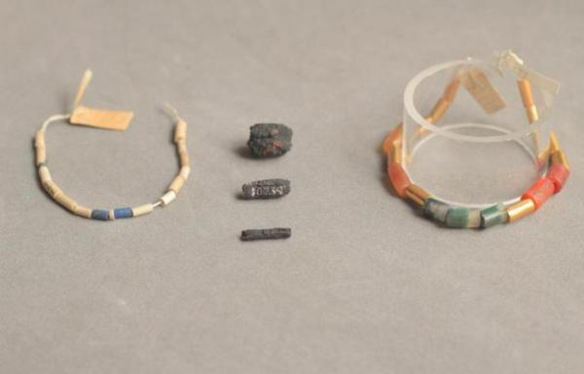
There is archeological evidence that man has used iron for more than 5000 years. The earliest iron is believed to be derived from meteorites, as evidenced by its high nickel content. Beads found in Egypt date back to 3200 BC and contain 7.5% nickel, which indicates it was from a meteorite. During this time iron was rare and expensive. Assyrian writings state that iron was eight times more valuable than gold. Iron was a ceremonial metal, and frequently the iron jewelry was set in gold.
Ancient Egyptian iron beads held in a British museum were hammered from pieces of meteorites, rather than iron ore.

(http://www.upi.com/Some-of-worlds-earliest-iron-artifacts-came-from-outer-space/35871377035528/)

It is believed that, around 1500 B.C., the ancient Hittites of Asia Minor (Turkey today) were the first to smelt (heating of ore to extract the metal) iron from its ore. The Iron Age began around 1300–1200 BC. At this time iron became cheaper than bronze. There is evidence that the addition of carbon to iron to form steel occurred as early as 1000 BC and, initially, probably happened accidentally. There are several references of iron in the Bible. Moses compares the bondage in Egypt to a furnace for smelting iron and speaks of the iron ore of Canaan. In Genesis, Tubal-Cain, seven generations from Adam, is referred to as a worker of iron.

Ancient Egyptians called iron “ba-ne-pe” which means “metal from heaven” since it was believed to be a gift from the gods since it came from meteorites. The word iron comes from the Anglo-Saxon word “iren”, which is believed to be derived from earlier words meaning “holy-metal” because it was used to make the swords used in the Crusades. The symbol Fe comes from the Latin word for iron, ferrum.

Properties

Iron is arguably one of the most important elements to man. It is the only element to have an age named after it. The physical and chemical properties are given below.

Physical properties
Atomic number: 26
Atomic mass: 55.857
Silvery white or grayish metal
Ductile
Malleable
Melting point: 1535⁰C
Boiling point: 2750⁰C
Density: 7.87 g/mL
Conducts electricity and heat
Four allotropic forms (alpha, beta, gamma and omega)
Alpha form (most common at room temperature) is magnetic

Chemical Properties
Active metal
Readily combines with oxygen in most air
Reacts with hot water or steam to produce hydrogen gas
Reacts with most acids
Nontoxic
Common oxidation states: Fe⁺², Fe⁺³

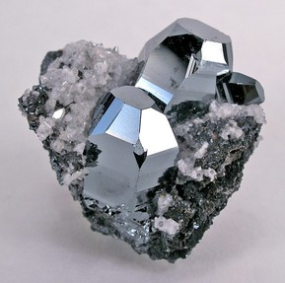
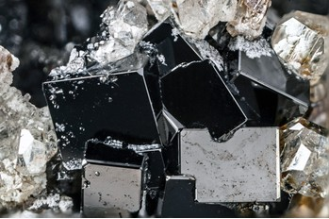
Iron is the fourth most abundant element in the Earth’s crust making up about 5%. The most common minerals from which iron is obtained are hematite, or iron(III) oxide (Fe₂O₃), and magnetite, iron(II) oxide (Fe₃O₄). Other mineral sources of iron that are increasing in importance are siderite, or iron(II) carbonate (FeCO₃), and taconite. Taconite is a low grade ore that is actually a mixture of hematite and silica. The largest producers of iron reserves are in China, Australia, Brazil, India, and Russia.
Hematite, Fe₂O₃

(http://www.mindat.org/min-1856.html
Magnetite, Fe₃O₄

(http://www.mindat.org/min-2538.html)

Uses and production

Elemental iron is the most commonly used metal. The production of iron is 90–95% of the worldwide production of all metals. Iron is primarily used to make steel and related alloys used for construction and manufacturing. Iron and steel are used in a wide range of products.

In general, those products can be classified into categories: (1) automotive; (2) construction; (3) containers, packaging, and shipping; (4) machinery and industrial equipment; (5) rail transportation; (6) oil and gas industries; (7) electrical equipment; and (8) appliances and utensils.

(http://www.chemistryexplained.com/elements/C-K/Iron.html#ixzz4S4zH7xlj)

Iron is also used to make knives and swords, weapons and armor. It could be argued that it was the ability to produce iron that gave civilizations political and military power.

Iron has been extracted from its ore and used in a variety of forms since ancient times. A blast furnace is used to reduce iron oxides to iron metal. A blast furnace is a huge chemical reactor capable of continuous operation and reaches temperatures approaching 2000 ºC. The blast furnace is charged with a mixture of iron ore, coke (purified coal) and limestone (calcium carbonate, CaCO₃). The coke serves as the fuel producing the high heat needed when it burns with blasts of air: C + O₂ CO₂. The coke also produces carbon monoxide when burned, which (chemically) reduces the iron oxide to iron metal:
2 C + O₂ 2 CO
Fe₂O₃ + 3 CO 2 Fe + 3 CO₂

At the high temperatures in the blast furnace, the limestone is decomposed to calcium oxide:
CaCO₃ CaO + CO₂

The calcium oxide reacts with the other impurities, such as silicates, in the iron ore and forms what is known as slag.
CaO + SiO₂ CaSiO₃

The slag in the blast furnace is liquid and runs down through the furnace to form a layer on top of the molten iron. The slag is collected and cooled. When cooled it becomes very hard and rocklike, so it is often used in road making.
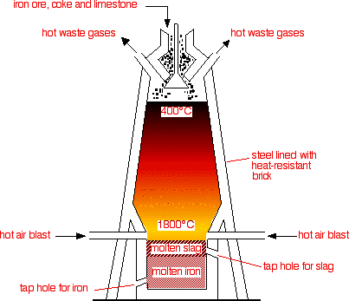

Blast furnace

(http://www.chemguide.co.uk/inorganic/extraction/iron.html)

The iron collected from the blast furnace is generally called pig iron, which contains
4–5% carbon and is hard and very brittle. It is ideal for casting (pouring into a mold) since, when melted, it flows readily. Cast iron will shatter when hit hard. It is used to make cookware, pipes and manhole covers.

A more malleable form of iron is wrought iron (wrought meaning worked). Wrought iron has very little carbon (0.02–0.08%). The carbon is removed by heating in what is known as a puddling furnace:

The puddling furnace required the stirring of the molten metal, kept separate from the charcoal fire, through an aperture by a highly skilled craftsman called a puddler; this exposed the metal evenly to the heat and combustion gases in the furnace so that the carbon could be oxidized out. As the carbon content decreases, the melting point rises, causing semi-solid bits of iron to appear in the liquid mass. The puddler would gather these in a single mass and work them under a forge hammer, and then the hot wrought iron would be run through rollers (in rolling mills) to form flat iron sheets or rails.

(http://www.anselm.edu/homepage/dbanach/h-carnegie-steel.htm)

The mass production of wrought iron was never successful, and wrought iron is not produced on a commercial scale today. Mild steel (iron containing 0.25% carbon) has replaced wrought iron. Wrought iron was once used to make nails, horseshoes, handrails and ornamental iron work, like gates.

The majority of iron produced today is used to make steel. Steel is an alloy of iron and carbon with the carbon content ranging between 0.2 and 1.5 percent, which is enough carbon to make it harder than wrought iron, but not as brittle as cast iron. The addition of other elements can give steel other useful properties.

Types of Steel and Their Uses | Iron mixed with | Special properties | Uses include
stainless steel | chromium and nickel | resists corrosion | cutlery, cooking utensils, kitchen sinks, industrial equipment for food and drink processing
titanium steel | titanium | withstands high temperatures | gas turbines, spacecraft
manganese steel | manganese | very hard | rock-breaking machinery, some railway track (e.g. points), military helmets

Specialty Steels

(http://www.chemguide.co.uk/inorganic/extraction/iron.html)

Iron in the human body

Function of iron in the body

Iron is an essential trace mineral in the body. It is an essential component in hundreds of proteins and enzymes that support essential biological functions, including oxygen transport, energy production and DNA synthesis. One type of iron-containing compound found in many biologically important molecules is heme. Not all iron-dependent proteins contain heme. Both types of iron-containing proteins, heme and non-heme, support a variety of functions.

Heme-containing proteins that are involved with the transport and storage of oxygen are known as globin-hemes. There are three basic globin-hemes. Hemoglobin is found in red blood cells and transports oxygen from the lungs to the rest of the body. In the muscles, myoglobin functions in the transport and short-term storage of oxygen. It provides the oxygen when we use our muscles to walk, run or climb. The third globin, neuroglobin, is found in the central nervous system. Its role is not fully understood at this time.

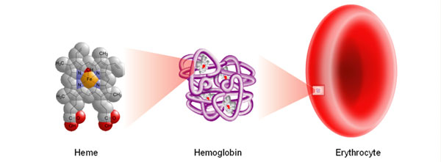

Heme Containing Protein in Hemoglobin

(http://www.sigmaaldrich.com/life-science/metabolomics/enzyme-explorer/learning-center/plasma-blood-protein/hemoglobin-heme-products.html)

Heme-containing enzymes, such as cytochromes, play an important role in mitochondrial electron transport, which is required for cellular energy production. The electrons are transferred by interconverting from Fe⁺³ to Fe⁺². The cytochromes provide electrons during the synthesis of ATP, which stores energy in the cell.

Some heme-containing enzymes serve as antioxidants. As an example, some peroxidases are heme-containing enzymes that protect cells against the accumulation of hydrogen peroxide. They catalyze a reaction that converts hydrogen peroxide to water and oxygen.

The non-heme, iron-dependent enzyme ribonucleotide reductase catalyzes the synthesis of deoxyribonucleotides used for DNA replication. It is also essential to the repair of damaged DNA.

Metabolism of iron in the body

Iron is recycled in the body, which conserves the iron in the body. A little over 60% of the iron in the body is located in hemoglobin; about 25% is stored in the liver, spleen and heart; and 15% is in muscle myoglobin and in a variety of iron-containing enzymes. Let’s look at the metabolism of iron and its cycle.

The first step in the metabolism of iron is its absorption, which occurs in the stomach. The amount of iron absorbed is low; generally between 5 and 35%, depending on the person and the type of iron ingested. Iron enters the stomach from the esophagus, where the stomach acid converts all the iron to Fe⁺³ (ferric ions). The iron is then absorbed in the duodenum, a portion of the small intestine.

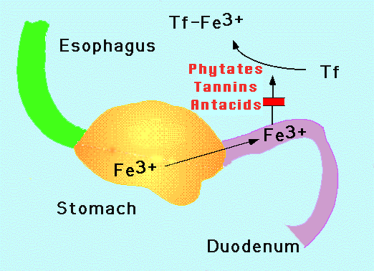
Once iron is absorbed it is carried (transported) by a protein called transferrin (Tf). Each molecule of transferrin can carry two atoms of iron. When working normally, transferrin binds to iron, and transports it to all tissues, vital organs, and bone marrow, so that normal metabolism, DNA synthesis, and red blood cell production can take place. Recently scientists have discovered that transferrin does not work completely alone in the transport of iron. Ceruloplasmin a major copper-containing protein in plasma is also involved in iron transport. Iron needs adequate amounts of copper to reach some of its intended destinations, such as the brain.
Iron absorbed in the duodenum
and carried by transferrin.

(http://sickle.bwh.harvard.edu/iron_absorption.html)

(http://www.irondisorders.org/absorption/)

Since iron is necessary for growth, development, normal cellular functions and the synthesis of hormones, it is important for us to maintain an adequate supply of iron. The metabolism of iron is tightly regulated. The body regulates the transport of iron to the bones for the production of red blood cells, to the liver and other tissues for storage, and to the muscles for the production of myoglobin. The equilibrium of iron in the body is regulated by the hormone hepcidin. Hepcidin prevents the absorption of iron across the gut mucosa and reduces the release of iron from the liver and other storage sites. When iron levels are low there is very little hepcidin produced, allowing for absorption of iron from the diet and the release of iron from the body stores. When the body has sufficient iron, the body produces more hepcidin to prevent additional absorption and release of iron.

To help maintain a balance of iron in the body, it is stored in a protein called ferritin, which is made throughout the body. It is a large molecule with a large capacity for iron. It can hold over 4000 atoms of iron. Ferritin stores iron in the insoluble form primarily in the liver, spleen and bone marrow. The amount of ferritin in blood serum correlates well with the total body iron stores, so serum ferritin is a convenient laboratory test to estimate the amount of iron in the body.

The body excretes very little iron once it is absorbed. The major loss of iron is from bleeding, menstruation and pregnancy. Some iron is lost due to normal exfoliation of cells from the skin, genitourinary tract and gastrointestinal tract. These losses (1mg/day) are minor, compared with bleeding. Excessive menstrual blood loss is the most common cause of iron deficiency in women.

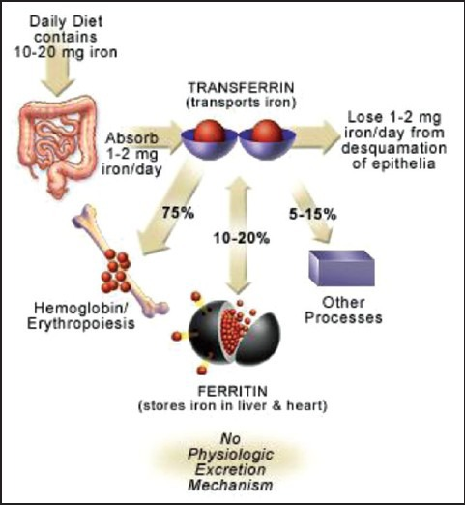

Schematic diagram of the iron cycle

(https://www.ncbi.nlm.nih.gov/pmc/articles/PMC3999603/)

Dietary requirements and sources of iron

The amount of iron needed daily depends on your age, sex and diet. Newborns receive their iron requirement by the little iron contained in human milk. Since their bodies are growing rapidly, infants and children between 6 months and 6 years of age need from 7–11 mg/day of iron. During the adolescent years, the body’s need for iron is also high, this time due to growth spurts. Menstruating and pregnant women also need high levels of iron intake. The values in the Recommended Dietary Allowances table below were established by the Food and Nutrition Board at the Institute of Medicine at the National Academies (formally the National Academy of Sciences). It should be noted that this table is for non-vegetarians. The requirements for vegetarians that do not eat meat, fish or seafood are about twice that given in the table, since the body does not absorb the non-heme iron found in plants as well as the heme iron in animal products.

Recommended Dietary Allowances (RDAs) for Iron

Age | Male | Female | Pregnancy | Lactation
Birth to  6 months | 0.27 mg* | 0.27 mg*
7–12 months | 11 mg | 11 mg
1–3 years | 7 mg | 7 mg
4–8 years | 10 mg | 10 mg
9–13 years | 8 mg | 8 mg
14–18 years | 11 mg | 15 mg | 27 mg | 10 mg
19–50 years | 8 mg | 18 mg | 27 mg | 9 mg
51+ years | 8 mg | 8 mg

* Adequate Intake (AI) (established when evidence is insufficient to develop an RDA; intake at this level is assumed to ensure nutritional adequacy.)

(https://ods.od.nih.gov/factsheets/Iron-HealthProfessional/#en5)

Iron is available from food sources, as well as from iron supplements. Dietary iron is available in two forms: heme and non-heme.

The richest sources of heme iron in the diet include lean meat and seafood. Dietary sources of non-heme iron include nuts, beans, vegetables, and fortified grain products. In the United States, about half of dietary iron comes from bread, cereal, and other grain products. Breast milk contains highly bioavailable iron but in amounts that are not sufficient to meet the needs of infants older than 4 to 6 months.

Heme iron has higher bioavailability than non-heme iron, and other dietary components have less effect on the bioavailability of heme than non-heme iron. The bioavailability of iron is approximately 14% to 18% from mixed diets that include substantial amounts of meat, seafood, and vitamin C (ascorbic acid, which enhances the bioavailability of non-heme iron) and 5% to 12% from vegetarian diets.

(https://ods.od.nih.gov/factsheets/Iron-HealthProfessional/#en5)

Some of the common food items that are high in iron are given below. A more extensive list of foods and their iron content can be found at http://apjcn.nhri.org.tw/server/info/books-phds/books/foodfacts/html/data/data5e.html.

Food | Milligrams  per serving |  | Percent  DV*
Breakfast cereals, fortified with 100% of the DV for iron,  1 serving |  | 18 |  | 100
Oysters, eastern, cooked with moist heat, 3 ounces |  | 8 |  | 44
White beans, canned, 1 cup |  | 8 |  | 44
Chocolate, dark, 45%–69% cacao solids, 3 ounces |  | 7 |  | 39
Beef liver, pan fried, 3 ounces |  | 5 |  | 28
Lentils, boiled and drained, ½ cup |  | 3 |  | 17
Spinach, boiled and drained, ½ cup |  | 3 |  | 17
Tofu, firm, ½ cup |  | 3 |  | 17
Kidney beans, canned, ½ cup |  | 2 |  | 11
Sardines, Atlantic, canned in oil, drained solids with bone, 3 ounces |  | 2 |  | 11
Chickpeas, boiled and drained, ½ cup |  | 2 |  | 11
Tomatoes, canned, stewed, ½ cup |  | 2 |  | 11
Beef, braised bottom round, trimmed to 1/8" fat, 3 ounces |  | 2 |  | 11
Potato, baked, flesh and skin, 1 medium potato |  | 2 |  | 11
Cashew nuts, oil roasted, 1 ounce (18 nuts) |  | 2 |  | 11
Green peas, boiled, ½ cup |  | 1 |  | 6
Chicken, roasted, meat and skin, 3 ounces |  | 1 |  | 6
Rice, white, long grain, enriched, parboiled, drained, ½ cup |  | 1 |  | 6
Bread, whole wheat, 1 slice |  | 1 |  | 6
Bread, white, 1 slice |  | 1 |  | 6
Raisins, seedless, ¼ cup |  | 1 |  | 6
Spaghetti, whole wheat, cooked, 1 cup |  | 1 |  | 6
Tuna, light, canned in water, 3 ounces |  | 1 |  | 6
Turkey, roasted, breast meat and skin, 3 ounces |  | 1 |  | 6
Nuts, pistachio, dry roasted, 1 ounce (49 nuts) |  | 1 |  | 6
Broccoli, boiled and drained, ½ cup |  | 1 |  | 6
Egg, hard boiled, 1 large |  | 1 |  | 6
Rice, brown, long or medium grain, cooked, 1 cup |  | 1 |  | 6

* DV = Daily Value. DVs were developed by the U.S. Food and Drug Administration (FDA) to help consumers compare the nutrient contents of products within the context of a total diet. The DV for iron is 18 mg for adults and children age 4 and older. Foods providing 20% or more of the DV are considered to be high sources of a nutrient.

Iron Content in Various Foods

(https://ods.od.nih.gov/factsheets/Iron-HealthProfessional/#en5)

When people do not get enough iron from their diet, iron supplements may be recommended, which generally provide the daily value of 18 mg. Some iron supplements may provide more iron, even up to 65 mg/day. The iron in the supplements generally contain ferrous [(Fe⁺²] and ferric [Fe⁺³] ion salts. Examples of these are ferrous sulfate [FeSO₄], ferrous gluconate [Fe(C₆H₁₂O₇)₂], and ferric sulfate [Fe₂(SO₄)₃]. The ferrous iron salts are more soluble than the ferric iron salts, so they tend to be absorbed by the body more readily.

Factors that affect iron absorption

A number of factors influence the absorption of iron in the body. They can be classified as enhancers, inhibitors, or competitors. Ascorbic acid (vitamin C) increases the absorption of iron in two ways. It reduces iron(III) to iron(II), so the iron is more soluble. It also serves as a weak chelator (a substance whose molecules can form several bonds to a single metal atom); this helps the metal enter the duodenum. Ascorbic acid tends to counteract the negative effects of the iron absorption inhibitors. Citrates also act as weak chelators to facilitate the absorption of iron. Amino acids, such as those found in meat, fish and poultry, have been shown to enhance the absorption of non-heme iron.

The absorption of iron is inhibited by phytates, polyphenols, calcium, and egg and milk proteins. Phytates are found in nuts, edible seeds, beans, legumes and grains. They are the principle storage form for phosphorus in plant tissues. The phytates chelate with non-heme iron in such a way as to prevent absorption of the iron. Polyphenols are found in vegetables, fruit, legumes, tea, coffee and wine. Tannic acid is an example of a polyphenol. Polyphenols bind with non-heme iron, forming a non-transportable complex that cannot enter the blood stream. It is excreted with the feces. Calcium, which is found in milk, yogurt, and cheeses, inhibits the absorption of both heme and non-heme iron. The mechanism for this is not fully understood. Egg and milk proteins bind with non-heme iron and thereby reduce its ability to be absorbed.

Several metals share the absorption pathway used by iron and as a result act as competitors with iron. These metals include lead, cobalt, strontium, manganese and zinc.

Lead is a particularly pernicious element to iron metabolism. Lead is taken up by the iron absorption machinery, and secondarily blocks iron through competitive inhibition. Further, lead interferes with a number of important iron-dependent metabolic steps such as heme biosynthesis. This multifaceted attack has particularly dire consequences in children, were [sic] lead not only produces anemia, but can impair cognitive development.

(http://sickle.bwh.harvard.edu/iron_absorption.html)

Iron deficiency

Iron deficiency occurs when there is too little iron in the body. It is the most common nutrient deficiency and cause of anemia (a condition that develops when your blood lacks enough healthy red blood cells or hemoglobin) in the world. Iron deficiency progresses through several stages:
- Storage iron depletion (mild deficiency): Iron stores in the body are depleted, but the functional iron supply is still normal. The serum ferritin concentrations and levels of iron in bone marrow decrease.
- Early functional iron deficiency (marginal deficiency): This occurs before anemia. The supply of functional iron to tissues including the bone marrow is inadequate. This impairs the production of red blood cells; however, hemoglobin levels usually are within a normal range.
- Iron deficient anemia: The actual definition of this condition is the point at which individual hemoglobin concentrations fall two standard deviations below the mean distribution for hemoglobin in a healthy population of the same gender, age and living at the same altitude (at higher altitudes there is less oxygen absorbed by hemoglobin). At this level (the two standard deviations below the mean), there is inadequate iron to support normal red cell production. The red blood cells are smaller than normal and the levels of hemoglobin decline. As a result the red blood cells are paler than normal.

Most of the symptoms associated with iron deficiency is a result of anemia. The symptoms caused by anemia include chronic fatigue, weakness, dizziness, rapid heart rate, palpitations, shortness of breath when doing simple tasks, pica (the desired to chew on ice or other non-food items), and gastrointestinal disturbances. It may also cause impaired cognitive function, immune function and body temperature regulation. Even mild and moderate deficiency conditions can be associated with functional impairments affecting cognitive development, immunity functions, and work capacity. Iron deficiency in infants or children can result in psychomotor and cognitive abnormalities, which can lead to learning disabilities if left untreated. Anemia during pregnancy can result is the risk of sepsis, maternal mortality, perinatal mortality and low birth weight.

The cause of iron deficiency can fall into one of two broad categories. Iron deficiency can be a result of the increased need for iron or a decrease in the intake or absorption of iron. The increased need for iron occurs when rapid growth is occurring. Neonates, infants, children under the age of six, early adolescents, and pregnant women fall into this category. Chronic bleeding or acute blood loss also increases the need for iron. Those that may be at risk for iron deficiency due to blood loss include girls and women that have heavy menstruation, pregnant women, frequent blood donors and people that undergo surgery or have an accident.

Decreased intake or absorption can occur due to certain diets. Diets that do not include heme iron, such as vegetarian and vegan diets, potentially have less iron absorbed since non-heme iron is absorbed less efficiently. Those that consume large quantities of foods that interfere with the absorption of iron, such as dairy products, coffee, tea or eggs, may suffer from iron deficiency. Certain disease conditions can also limit iron absorption. Celiac disease is an example. For people with celiac disease, the consumption of food with gluten causes an immune system response that damages the intestinal mucosa. This prevents the absorption of iron and can result in anemia. Inflammatory bowel diseases, such as Crohn’s disease, impairs the intestinal absorption of iron and causes blood loss from ulcerated mucosa.

Iron toxicity and overload

Too much iron in the body can cause severe problems. Normally very little free ion circulates in the bloodstream, since it is bound to proteins like transferrin. Iron toxicity can increase the levels of free iron in the body where is acts as a pro-oxidant (opposite of an antioxidant) and can potentially cause damage to cells. Acute iron poisoning occurs when a person, frequently a child, swallows a large number of pills containing iron. Single doses as low as 10–20 mg/kg may cause adverse symptoms that include gastric upset, nausea, abdominal pain, vomiting, dehydration and faintness. Doses higher than 40 mg/kg require medical attention, for such overdoses can lead to multisystem organ failure, coma, convulsions and even death.

Iron overload is caused by a gradual buildup of too much iron in the body. This occurs when there is deregulation of intestinal iron absorption, since the body cannot excrete excess iron. Excess iron increases the risk of liver disease, heart attack, osteoporosis, and hypothyroidism. Iron overload is usually caused by an inherited disease, the most common of which is hemochromatosis. The treatment for iron overload is phlebotomy (blood removal) or the routine donation of blood, if the patient’s hemoglobin is sufficient. An alternative treatment is iron-chelation. Individuals with iron overload are also advised to avoid iron-rich foods and vitamin C.

Polyphenols

Polyphenols comprise a large class of chemical compounds found in plants, including vegetables, fruits, and cereals. They are secondary metabolites of plants and are generally involved in the defense against ultraviolet radiation, aggression by pathogens, and attack by insects. They give plants their color. In foods they may contribute to bitterness, astringency, color, flavor, and odor. There are more than 8000 polyphenolic compounds that have been identified. Many of them serve as antioxidants that help protect cells from damage from free radicals. Some polyphenols are also known to have anti-inflammatory properties. Because of these properties, diets rich in polyphenols provide significant protection against the development and progression of many chronic pathological conditions, including cancer, diabetes, cardio-vascular problems and aging.

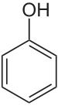
Polyphenols are characterized by the presence of many phenol units per molecule. A phenol unit (shown at right) is composed of a six member aromatic hydrocarbon ring with a hydroxyl group (–OH).

Structure of phenol

(http://foodwatch.com.au/blog/super-foods/item/top-100-polyphenols-what-are-they-and-why-are-they-important.html)

The number of rings and the atoms attached to them differ with each phenolic structure. Based on the structures of the phenolic molecules that comprise the polyphenols, they are classified into four categories: phenolic acids, flavonoids, stilbenes and lignans.

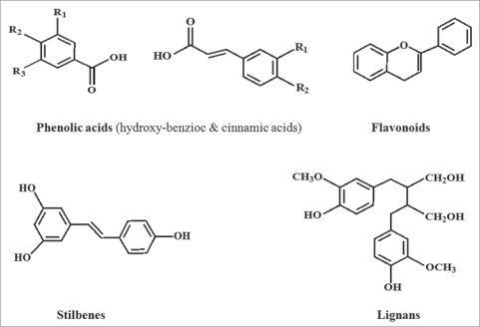

Classes of polyphenols

(https://www.ncbi.nlm.nih.gov/pmc/articles/PMC2835915/)

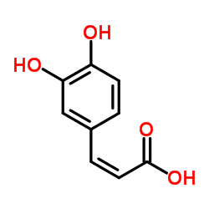
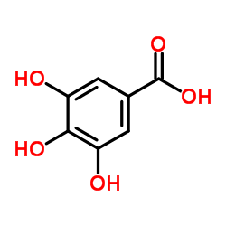
Phenolic acids are divided into two classes: hydroxybenzoic acids and hydroxycinnamic acids. Both are derived from non-phenolic molecules, benzoic acid and cinnamic acid. Hydroxybenzoic acid content in plants is generally low. One such hydroxybenzoic acid is gallic acid (3,4,5-trihydroxybenzoic acid), shown at near right, found in tea. Hydroxycinnamic acids are more common and are found in all parts of fruits and vegetables. One of the most common hydroxycinnamic acids is caffeic acid (3,4-dihydroxycinnamic acid), shown at far right. Caffeic acid is found in most vegetables and fruits, but the richest sources are coffee, carrots, blueberries, cranberries and blackberries.
Caffeic acid

(http://www.chemspider.com/Chemical-Structure.1266077.html)
Gallic acid

(http://www.chemspider.com/Chemical-Structure.361.html)

Flavonoids are the most studied group of polyphenols. They are both antioxidant and anti-inflammatory agents. They are found in a wide variety of plant-based foods including vegetables, fruits, legumes, and in red wine and green tea. Many flavonoids are responsible for the colors of flowers, fruits and leaves. They all have a common basic structure consisting of two aromatic rings bonded together by three carbon atoms that form an oxygenated heterocycle. There are six subclasses of flavonoids: flavonols, flavanones, flavanols, flavones, anthocyanins, and isoflavones.

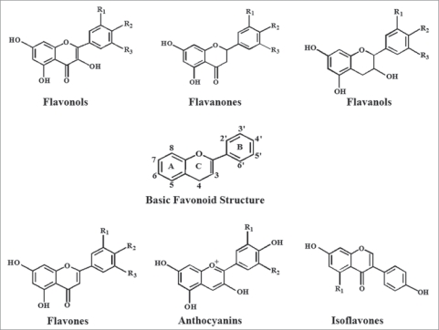

Classes of Flavonoids

(https://www.ncbi.nlm.nih.gov/pmc/articles/PMC2835915/)

Stilbenes represent a small group, and their occurrence in human diets is rare.
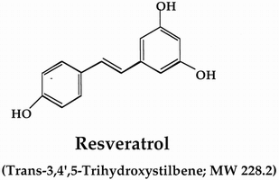
They contain two phenyl units connected by a two carbon methylene bridge (examples shown below). In plants they act as an antifungal agents and are produced only in response to infection or injury. The most common stilbene is resveratrol (below, right), which is found in grape skins and therefore also found in red wine.
(https://www.mdidea.com/products/herbextract/resveratrol/data05.html)
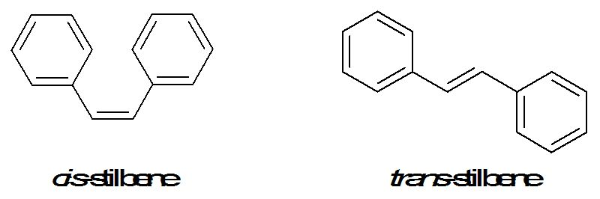
cis-stilbene trans-stilbene
(http://www.intechopen.com/books/biodegradation-life-of-science/phenolic-extractives-and-natural-resistance-of-wood)

Lignans are diphenolic compounds. They are found in seeds like flax, legumes, cereals, grains, fruits, algae, and certain vegetables. Many serve as antioxidants.
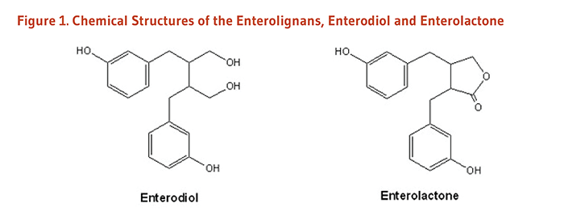
Examples of Lignans

(http://lpi.oregonstate.edu/mic/dietary-factors/phytochemicals/lignans)

Oxidation states

Oxidation states, also known as oxidation numbers, are a means used by chemists to keep track of how many electrons an atom has. The oxidation state of an atom is the charge it would have if its bonds were completely ionic. In a covalently bonded species, the oxidation state is the charge the atom would possess if the shared electrons were completely transferred to the more electronegative atom. Electron pairs shared by the atoms of the same element, such as in hydrogen gas (H₂), are divided equally and have an oxidation state of zero. Consider the molecule HCl and its Lewis structure. In HCl, chlorine is more electronegative atom, so the shared electrons would be assigned to it. This gives chlorine eight valence electrons—one more than the neutral atom—so it has an oxidation state of -1. Hydrogen has no valence electrons—one less than the neutral atom—giving it an oxidation state of +1.
+1 –1

H Cl

In a binary compound, the element that is more electronegative will have a negative charge, while the less electronegative atom will have a positive charge.

It is too time consuming to assign oxidation states by counting electrons, so a set of rules makes this process easier. The general rules are:
- The oxidation state is zero for any element in its free state (when it is not combined with a different element).
- Atoms in monatomic (i.e., single atom) ions have an oxidation number equal to their charge.
- Fluorine always has an oxidation state of –1 in its compounds. The other halogens have oxidation states of –1, unless they are combined with a more electronegative halogen or oxygen.
- Hydrogen has an oxidation number of +1 except when it is in metal hydrides, such as NaH, LiH, etc. Then hydrogen’s oxidation state is –1.
- The oxidation state of oxygen is –2 except for peroxides, like H₂O₂, and Na₂O₂, in which the oxidation state for O is –1.
- The sum of the oxidation states of all the atoms in a molecule or ion is equal to the overall charge on the species.

References
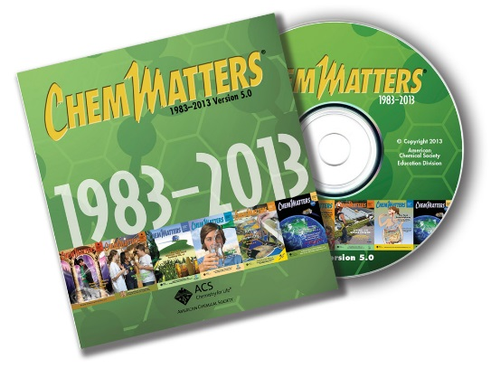
(non-Web-based information sources)
The references below can be found on the ChemMatters 30-year DVD, which includes all articles
published from the magazine’s inception in October 1983 through April 2013; all available Teacher’s Guides, beginning February 1990; and 12 ChemMatters videos. The DVD is available from the American Chemical Society for $42 (or $135 for a site/school license) at this site: http://ww.acs.org/chemmatters. Click on the “Teacher’s Guide” tab to the left, directly under the “ChemMatters Online" logo and, on the new page, click on “Get the past 30 Years of ChemMatters on DVD!” (the icon on the right of the screen).

Selected articles and the complete set of
Teacher’s Guides for all issues from the past three
years are available free online at the same Web site, above. Click on the “Issues” tab just below the logo, “ChemMatters Online”.
30 Years of ChemMatters !
Available Now!

“Iron for Breakfast” describes the iron found in cereals. It also discusses the oxidation states of iron and how the body uses iron.
(Schmidt, K. Iron for Breakfast. ChemMatters, 1994, 12 (3) pp 13–15)

The various colors of blood in different animals is investigated and explained by its chemical makeup in this article.
(Lutz, D. The Many Colors of Blood. ChemMatters, 2010, 28 (1), pp 5–7)

Web Sites for Additional Information
(Web-based information sources)
Iron, the element

This site provides a variety of information about iron. It includes physical and chemical properties, history of iron, the uses and sources of iron, and a video on iron. (http://www.rsc.org/periodic-table/element/26/iron)

Interesting facts about iron as well as some history of the use of iron can be found here: http://www.livescience.com/29263-iron.html.

This site has not only chemical and physical properties of iron but also has a basic video about iron as an element. (http://www.elementalmatter.info/iron-properties.htm)

The process of extracting iron from it ore and the production of steel is described at this site. It also describes various type of iron and steel. (http://www.chemguide.co.uk/inorganic/extraction/iron.html)

Iron in the body

This Oregon State University site provides an extensive, easily understood explanation about iron in the body. It includes detailed information on the function of iron in the body, the sources of iron, iron deficiency and iron overload. (http://lpi.oregonstate.edu/mic/minerals/iron)

“Review on Iron and its Importance for Human Health” is an extensive article that includes many references and interesting diagrams. The article includes information on the metabolism of iron, its bioavailability, human requirements for iron, and causes and consequences of iron deficiency and anemia. (https://www.ncbi.nlm.nih.gov/pmc/articles/PMC3999603/)

The Iron Disorders Institute website provides concise information on such topics as the need for iron, iron absorption, recommended daily allowance for iron and iron level tests. (http://www.irondisorders.org/our-need-for-iron/)

Iron absorption is the topic of this short article by the same name. It provides a good explanation of iron absorption and its mechanism. (http://sickle.bwh.harvard.edu/iron_absorption.html)

An explanation of iron toxicity and iron overload, as well at the consequences of each, can be found here: https://authoritynutrition.com/why-too-much-iron-is-harmful/.

At this site, the “Nutrients and Dietary Energy Calculator” will quickly determine the amount of various nutrients, including iron, a person needs. (https://www.nrv.gov.au/node/add/nutrients-energy-calc)

Polyphenols

At this site there is a concise article, “Polyphenols - What They Are, and Why You Need Them”, discussing what polyphenols are, the various types of polyphenols, their role in plants and humans, and their benefits. There is also a short video describing polyphenols. (http://articles.mercola.com/sites/articles/archive/2015/12/14/polyphenols-benefits.aspx)

“Plant Polyphenols as Dietary Antioxidants in Human Health and Disease” is an extensive article about polyphenols. It includes information about their structure, occurrence, bioavailability, and benefits. It includes many references and graphics as well. (https://www.ncbi.nlm.nih.gov/pmc/articles/PMC2835915/)

A short explanation of polyphenols and a description of some of their health benefits are described here: http://www.globalhealingcenter.com/natural-health/what-are-polyphenols/.

Oxidation states

At this Khan Academy site, titled “Oxidation Numbers”, oxidation states (numbers) are clearly explained, rules are given and examples are provided. (https://www.khanacademy.org/science/chemistry/chemical-reactions-stoichiome/types-of-chemical-reactions/a/oxidation-number)

Rules for assigning oxidation states, an extensive list of examples and practice problems can be found at this University of Waterloo site: http://www.science.uwaterloo.ca/~cchieh/cact/c123/oxidstat.html.

A Khan Academy video, “Oxidation state trends in periodic table”
(8:37), can be found at this site. It examines the periodic trends in oxidation states. (https://www.khanacademy.org/science/chemistry/oxidation-reduction/redox-oxidation-reduction/v/oxidation-state-trends-in-periodic-table)

This site provides a simple game, “Oxidation Numbers”, for students to practice assigning oxidation states to various elements in compounds. (https://www.quia.com/pop/31191.html?AP_rand=1756072931)

