Activity Sheet Answers
Chapter 6, Lesson 8
pH and Color Change

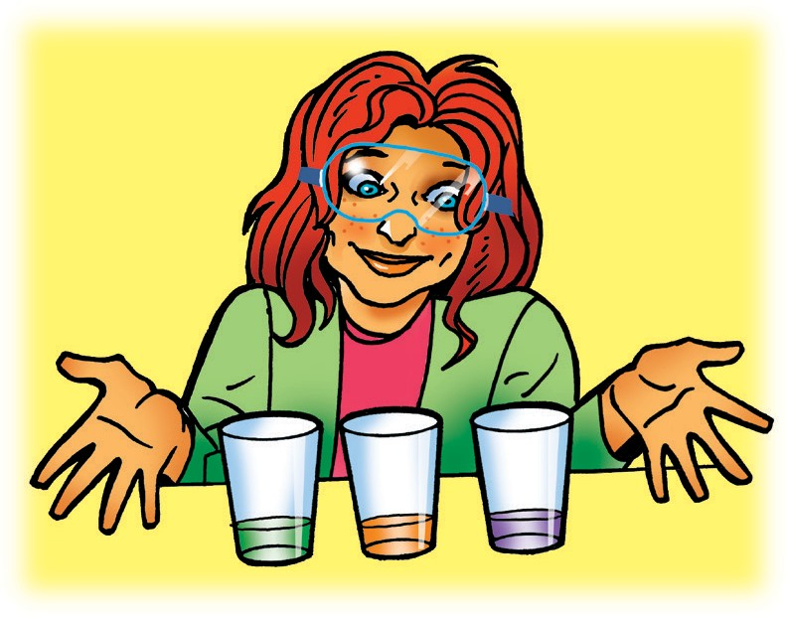
DEMONSTRATION
- What does the change in color of the indicator solution tell you about the substance your teacher placed in each cup?
Since the green solution turned reddish in one cup, there must have been an acid in that cup. Since the green solution turned purple in the other cup, there must have been a base in that cup.

ACTIVITY

- How does the color of the indicator solution change as the citric acid solution becomes more concentrated?
As the citric acid solution becomes more concentrated, the color of the indicator solution goes from green to yellow, to orange, and to red.

- How does the number on the pH scale change as the concentration of citric acid solution increases?
As the concentration of the citric acid increases, the solution becomes more acidic so the number on the pH scale decreases.

- How does the color of the indicator solution change as the sodium carbonate solution becomes more concentrated?
As the sodium carbonate solution becomes more concentrated, the color of the indicator solution goes from green to blue-green, to blue, to purple.

- How does the number on the pH scale change as the concentration of base increases?
As the concentration of sodium carbonate increases, the solution becomes more basic so the number on the pH increases.

- In this activity, you did not add any citric acid solution or sodium carbonate solution to the first well in each spot plate. What is the purpose of leaving the first well green?
The purpose of leaving the first well green is to have a color to compare the other colors to see how much they changed.

EXPLAIN IT WITH ATOMS AND MOLECULES

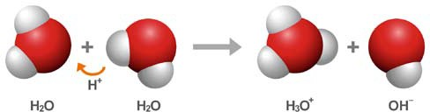
- The chemical formula for water is H₂O. Sometimes two water molecules can bump into each other and form the ions H₃O⁺ and OH⁻.
- What is happening in the chemical equation above?
When the two water molecules bump into each other, a proton from a hydrogen atom in one water molecule is attracted to and switches over to the other water molecule.
- Why is one ion positive and the other ion negative?
Since a proton has a positive charge, the molecule that gained the proton is a positively charged ion and the water molecule that lost the proton now is a negatively charged ion.

- The pH scale is a measure of the concentration of H₃O⁺ ions in a solution. In the chart, use the words increases, decreases, or stays the same to describe how the concentration of H₃O⁺ ions changes as different substances are added to water.

How does the concentration of H₃O⁺ ions change as each substance is added to water?
Type of substance | Concentration of H₃O⁺ ions
Acid | Increases
Base | Decreases
Neutral | Stays the same

TAKE IT FURTHER
- What did you observe as you slowly poured your acid and base solutions into the indicator solution?
As the acid is poured in, the solution goes from green to reddish. As the base is poured into the acidic solution, the color changes from reddish back toward the neutral green.

