Activity Sheet Name Chapter 6, Lesson 4
Temperature and the Rate of a Chemical Reaction Date

DEMONSTRATION
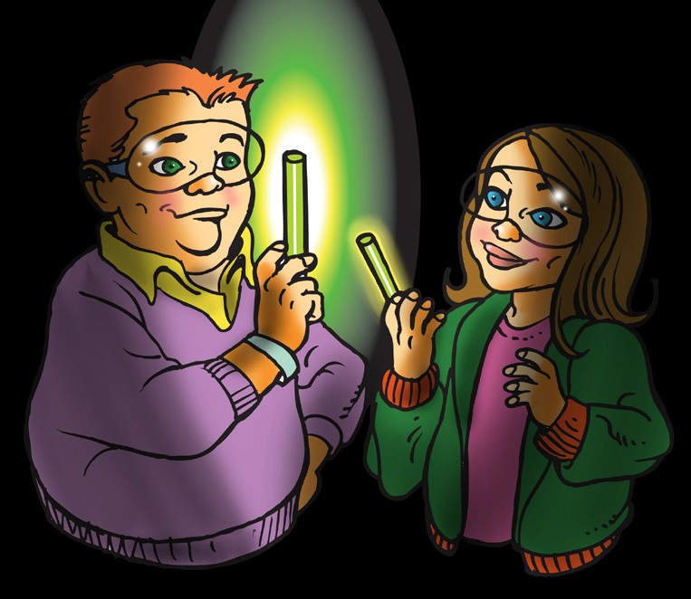
- Your teacher warmed one glow stick and cooled another. Once the light sticks were started, there was a noticeable difference in their brightness.

- How can you tell whether the chemical reaction is happening faster or slower in each glow stick?

- Some people place glow sticks in the freezer to make them last longer. Why do you think this works?

- Do you think that starting with warmer reactants in other reactions increases the rate of those chemical reactions?

Why or why not?

ACTIVITY

Question to Investigate
Does the temperature of the reactants affect the rate of the chemical reaction?

Materials for Each Group
- Baking soda
- Calcium chloride
- Water
- Graduated cylinder
- Balance or measuring spoon (½ teaspoon)
- 4 small plastic cups
- 2 plastic deli-style containers
- Hot water (about 50 °C)
- Cold water (0–5 °C)
- Masking tape
- Pen

Procedure

Make the Baking Soda Solution
  - Use masking tape and a pen to label 2 small plastic cups baking soda solution, and 2 small plastic cups calcium chloride solution.
  - Use a graduated cylinder to add 20 mL of water to one of the baking soda solution cups.
  - Add 2 g (about ½ teaspoon) of baking soda to the water in its labeled cup. Swirl until as much of the baking soda dissolves as possible. (Some undissolved baking soda may remain in the bottom of the cup.)
  - Pour half of your baking soda solution into the other baking soda solution cup.

Make the calcium chloride solution
  - Use a graduated cylinder to add 20 mL of water to one of the calcium chloride solution cups.
  - Add 2 g (about ½ teaspoon) of calcium chloride to the water in its labeled cup. Swirl until the calcium chloride dissolves.
  - Pour half of your calcium chloride solution into the other calcium chloride solution cup.

Heat and Cool the Solutions
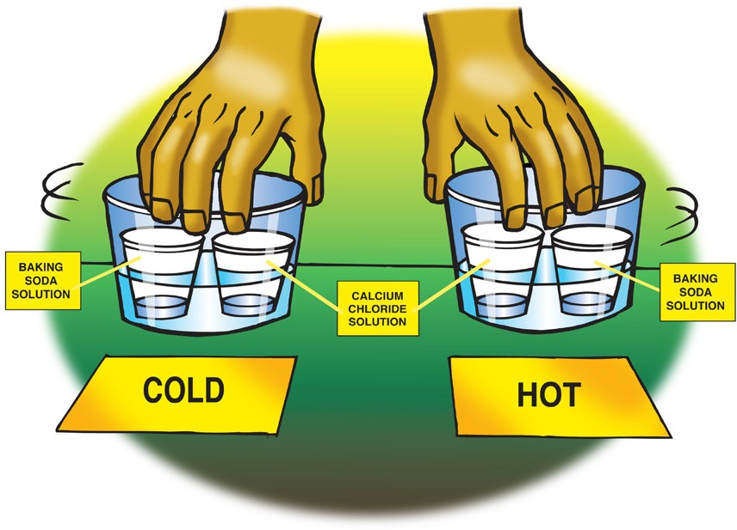
  - Pour hot water into one plastic container and cold water into the other until each is about ¼ filled. The water should not be very deep. These are your hot and cold water baths.
  - Place and hold one cup of baking soda solution and one cup of calcium chloride solution in the hot water. Gently swirl the cups in the water for about 30 seconds to heat up the solutions.
  - Your partner should place and hold one cup of baking soda solution and one cup of calcium chloride solution in the cold water.
Gently swirl the cups in the water for about 30 seconds to cool the solutions.

Combine the solutions
  - At the same time, you and your partner should combine the two warm solutions with each other, and the two cold solutions with each other.

EXPLAIN IT WITH ATOMS & MOLECULES
- Does the temperature of the reactants affect the rate of the chemical reaction?

How do you know?

- On the molecular level, why do you think the warm solutions react faster than the cold solutions?

TAKE IT FURTHER
- You saw a video showing the ammonium dichromate volcano. Heat from a burning wick starts the reaction, but why does the reaction continue?

