**Chapter 6, Lesson 3: Forming a Precipitate**

***Key Concepts***

* The ions or molecules in two solutions can react to form a solid.
* A solid formed from two solutions is called a *precipitate*.

***Summary***

Students will combine two clear colorless solutions (baking soda solution and calcium chloride solution) and see the formation of a solid and a gas. Students will analyze the chemical equation for the reaction and see that all atoms in the reactants end up in the products. They will make the connection between the chemical equation and the real substances and see that the solid and gas produced in the actual reaction are also in the products of the equation.

***Objective***

Students will be able to explain that for a chemical reaction to take place, the reactants interact, bonds between certain atoms in the reactants are broken, the atoms rearrange, and new bonds between the atoms are formed to make the products. Students will also be able to explain that this definition applies to the production of a solid called a *precipitate*.

***Evaluation***

The activity sheet will serve as the “Evaluate” component of each 5-E lesson plan. The activity sheets are formative assessments of student progress and understanding. A more formal summative assessment is included at the end of each chapter.

***Safety***

Be sure you and the students wear properly fitting goggles. If you do the demonstration with copper II sulfate solution, ammonia, and hydrogen peroxide at the end of the lesson, pour the resulting solution and precipitate in a cup or beaker and allow it to evaporate. Put the small amount of solid in a paper towel and dispose in the trash or use a disposal method required by local regulations. Sodium carbonate may irritate skin. Wash hands after the activity. Magnesium sulfate dust can irritate respiratory tract.

Follow all safety precautions regarding use, storage, and disposal of copper II sulfate and sodium carbonate.

***Materials for the Demonstrations***

* Sodium carbonate
* Epsom salt (magnesium sulfate)
* 2 clear plastic cups
* Test tube
* Water
* Copper II sulfate
* Household ammonia
* Hydrogen peroxide (3%)
* Graduated cylinder
* 2 droppers

***Materials for Each Group***

* Baking soda
* Calcium chloride
* Water
* Graduated cylinder
* Measuring spoon (½ teaspoon) or balance
* 2 clear plastic cups
* Masking tape
* Pen

# ENGAGE

## Do a demonstration by combining two clear colorless solutions that produce a white solid and introduce the term *precipitate*.

**Materials for the Demonstration**

* + Magnesium sulfate (Epsom salt)
  + Sodium carbonate
  + Water
  + 2 clear plastic cups
  + 1 tablespoon
  + 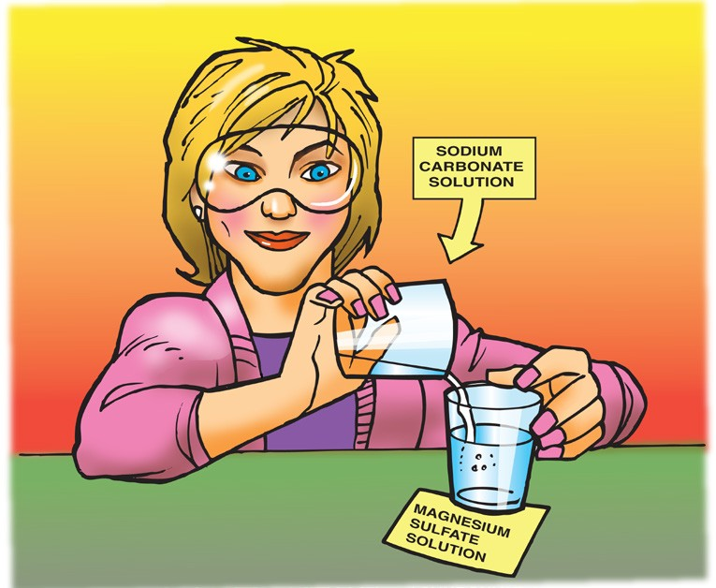1 teaspoon

## Teacher Preparation

* + Pour 100 mL of water in one clear plastic cup and add 10 g (about 1 tablespoon) of magnesium sulfate. Stir until the solution is clear.
  + Pour 50 mL of water in another clear plastic cup and add 5 g (about 1 teaspoon) of sodium carbonate. Stir until the solution is clear.

## Procedure

1. Hold up the two clear colorless solutions and slowly pour the smaller amount into the larger.

## Expected Results

Particles of a white solid will form.

Ask students:

## Would you consider adding a sodium carbonate solution to a magnesium sulfate solution a chemical reaction?

Yes.

## Why or why not?

Combining the two clear colorless liquids is a chemical change because a different solid substance is formed.

Tell students that a precipitate is an insoluble solid that forms when two solutions are combined and react chemically. Insoluble means that the solid will not dissolve.

## Give Each Student an Activity Sheet.

Students will record their observations and answer questions about the activity on the activity sheet. The *Explain It with Atoms & Molecules* and *Take It Further* sections of the activity sheet will either be completed as a class, in groups, or individually, depending on your instructions. Look at the teacher version of the activity sheet to find the questions and answers.

# EXPLORE

## 2. Have students combine two liquids to observe another precipitate.

**Question to Investigate**

How do you know when a precipitate is formed in a chemical reaction?

## Materials for Each Group

* + Baking soda
  + Calcium chloride
  + Water
  + Graduated cylinder
  + Measuring spoon (½ teaspoon) or balance
  + 2 clear plastic cups
  + Masking tape
  + Pen

***Note****: If you would like students to practice using a balance to weigh grams, have them weigh two grams each of baking soda and calcium chloride.*

## Procedure

1. Use masking tape and a pen to label 2 plastic cups

*baking soda solution* and *calcium chloride solution*.

1. Use a graduated cylinder to add 20 mL of water to each cup.
2. Add 2 g (about ½ teaspoon) of calcium chloride to the water in its labeled cup. Swirl until as much of the calcium chloride dissolves as possible.
3. Add 2 g (about ½ teaspoon) of baking soda to the water in its labeled cup. Swirl until as much of the baking soda dissolves as possible. There may be some undissolved baking soda remaining in the bottom of the cup.
4. Carefully pour the baking soda solution into the calcium chloride solution. Try not to pour in any undissolved baking soda. Observe.

## Expected Results

Bubbling and a white precipitate appear.

## Discuss student observations.

Ask students:

## What did you observe when you mixed the baking soda solution and the calcium chloride solution?

The solutions bubbled and little white particles of solid formed.

## Did you observe a precipitate?

Yes. The white particles appeared after the two solutions were combined.

## Do you think this was a chemical reaction? Yes. Why?

The two substances that were combined were liquids and the substances that were produced were a solid and a gas. These products seem to be different from the reactants.

# EXPLAIN

## Discuss the products produced in this chemical reaction.

Remind students that in the chemical reactions they have seen so far, certain atoms in the reactant molecules unbond from one another and then rearrange and rebond in different ways to form the products. They saw that the same type and number of atoms were in the reactants as were in the products.

**Project the image *Calcium Chloride and Sodium Bicarbonate*.**

[www.acs.org/middleschoolchemistry/simulations/chapter6/lesson3.html](http://www.acs.org/middleschoolchemistry/simulations/chapter6/lesson3.html)

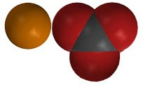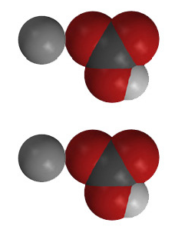

+

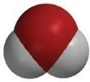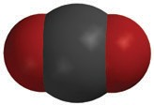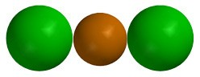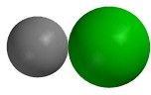

+

+

+

**CaCl2**

calcium chloride

**2NaHCO3**

sodium bicarbonate

**CaCO3**

calcium carbonate

**2NaCl**

sodium chloride

**H2O**

water

**CO2**

carbon dioxide

Ask students:

## What products of the reaction do you recognize?

Students should recognize sodium chloride (NaCl), water (H2O), and carbon dioxide (CO2).

## Look at the product side of the chemical equation. What gas is produced in the chemical reaction?

Carbon dioxide gas.

## What do you think is the precipitate?

The salt and water are clear and colorless as a solution, so the precipitate must be CaCO3, which is calcium carbonate. Tell students that calcium carbonate is ordinary chalk.

## How many of each type of atom is on the reactant side of the equation?

1 calcium atom, 2 chlorine atoms, 2 sodium atoms, 2 hydrogen atoms, 2 carbon atoms, and 6 oxygen atoms.

* **How many of each type of atom is on the product side of the chemical equation?**

1 calcium atom, 2 chlorine atoms, 2 sodium atoms, 2 hydrogen atoms, 2 carbon atoms, and 6 oxygen atoms.

## Is this a balanced chemical equation? If so, how do you know?

## Yes. The same type and number of atoms are in the reactants and products.

Make sure students see that every type of atom on the left side of the equation is also on the right. Also be sure that they see that there is an equal number of each type on both sides of the equation.

# EXPLORE

1. **Separate the products to show that the precipitate is a solid.**

**Ask students:**

* + **How do you think we could separate the precipitate from the other products?**

Put everything in a filter and let the liquid run through.

**Question to Investigate**

Can you separate the calcium carbonate from the rest of the products?

## Materials for Each Group

* Coffee filter or paper towel
* Tall clear plastic cup

## Procedure

1. 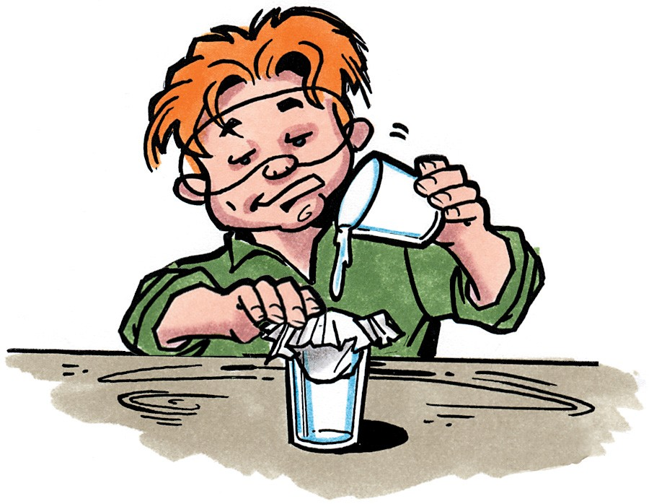Use a large enough coffee filter (or paper towel) so that you can push it about ⅓ of the way into the cup and still have enough left to hold it around the outside of the cup.
2. While holding the coffee filter in place, pour the products into the center of the coffee filter.
3. Allow the liquid to drip through the filter. This may take 5 – 10 minutes.
4. Set the precipitate aside and allow the water to evaporate.

## Expected results

A white solid will remain in the coffee filter. After the water evaporates, the calcium carbonate will be a white powder.

***Note****: If you’d like to separate the sodium chloride from the water that flowed through the filter, pour the liquid into a clean empty cup and allow the water to evaporate for a few days. As the water evaporates, students will begin to see cubic-shaped salt crystals forming in the solution. Eventually, only salt crystals will remain in the cup.*

Ask students:

## What is the solid white substance on the paper?

Calcium carbonate (chalk).

* **Is filtering out the calcium carbonate and allowing the water to evaporate a chemical change or a physical change?**

Physical change.

* **Why?**

These substances were already present in the water, so no new chemicals are made.

## What evidence was there that a chemical reaction occurred when you combined baking soda solution and calcium chloride solution?

A gas and a white solid were formed.

1. **Confirm that a chemical reaction took place.**

Ask students:

* **How could we compare the precipitate to the reactants to be sure that the precipitate is actually different from both of them?**

Do a solubility test on all three substances.

## Question to Investigate

Is the solubility of the precipitate different than the solubility of baking soda and calcium chloride?

## Ask students:

**How should we set up the solubility test?**

* **Should we use the same amount of each substance?**

Yes

## Should we use the same amount of water?

Yes

## Materials for Each Group

* Dry precipitate on paper towel
* Balance
* 3 small plastic cups
* Graduated cylinder
* ¼ teaspoon
* Popsicle stick (optional)
* Calcium chloride
* Baking soda
* Water

## Procedure

1. Label 3 cups sodium bicarbonate, calcium chloride, and precipitate.
2. Use a spoon or popsicle stick to scrape the precipitate into a pile.
3. Scoop up the precipitate into a ¼ teaspoon until it is as full as possible. Place the ¼ teaspoon of precipitate into its labeled cup.
4. 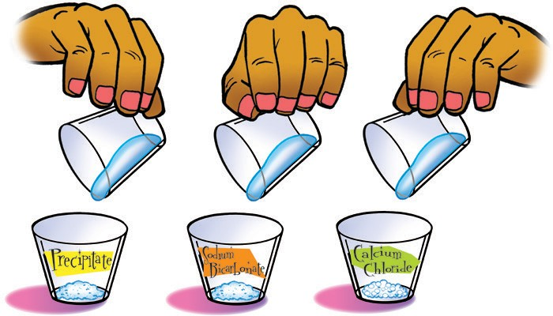Place ¼ teaspoon of sodium bicarbonate and calcium chloride into their labeled cups.
5. Add 25 mL of water to each cup and gently swirl until the solids dissolve as much as possible. Look to see the amount of solid that remains undissolved in each cup.

## Expected results

The sodium bicarbonate and calcium chloride dissolve but the precipitate does not.

Since the precipitate does not dissolve like either of the reactants, it must be a different substance than the reactants. Therefore, a chemical reaction must have occurred.

# EXTEND

## Do a demonstration to show students another example of a precipitate and a color change.

## Tell students that you will show them another reaction that forms a precipitate and a little something extra.

## Materials for the Demonstration

* Copper II sulfate
* Household ammonia
* Hydrogen peroxide (3%)
* Water
* Graduated cylinder
* Test tube
* 2 droppers
* 1 clear plastic cup (empty)

***Note****: The copper compound is called “copper II” because copper can make different types of ions. It can lose one electron and be just Cu+ or it can lose two electrons and be Cu 2+. This type of copper ion is called copper II. The “sulfate” in copper II sulfate is also an ion. This ion is made up of more than one atom. It is one of the polyatomic ions discussed in Chapter 4, Lesson 3. The sulfate ion is made up of a sulfur atom bonded to four oxygen atoms and is treated as one ion (SO42−).*

## Teacher Preparation

Make a copper II sulfate solution by adding 5 g of copper II sulfate to 50 mL of water.

## Procedure

1. Pour 15–20 mL of copper II sulfate solution into a test tube so it is about ½ full.
2. Add about 10–20 drops of ammonia.
3. Add about 10–20 drops of hydrogen peroxide.

## Expected Results

After adding the ammonia, a whitish precipitate will form at the top of the copper II sulfate solution. As more ammonia is added, the color on top of the liquid will change to a deeper darker blue. As the hydrogen peroxide is added, the dark blue area at the top of the solution will turn dark green and a dark precipitate will form.

***Note****: The details of the chemical reactions that produce the different precipitates and different color changes are complicated. The main idea for students is that atoms or groups of atoms in the reactants rearranged and bonded in different ways to form different substances in the products.*

Let students know that when they see the production of a gas, a precipitate, or a color change, that this is evidence that a chemical reaction has taken place.

Ask students:

## How can you tell that something new was made when the copper II sulfate and ammonia reacted?

A precipitate was produced.

## How can you tell that something new was made when these substances reacted with hydrogen peroxide?

The color change and other precipitate are evidence of another chemical reaction.

## In-Class or At-Home Project.

Have students use objects such as gum drops, beads, M&Ms, Legos, or other small objects to represent the atoms in two of the three reactions they have explored so far. Students can tape or glue the objects to poster board and write down the chemical formula for the reactants and products.

**CH4**

methane

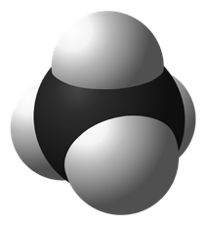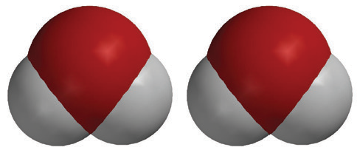

**2O2**

oxygen

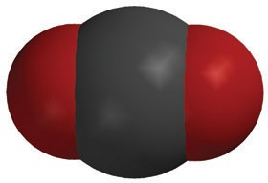

**CO2**

carbon dioxide

**2H2O**

water

+

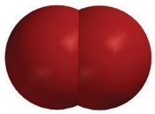

+

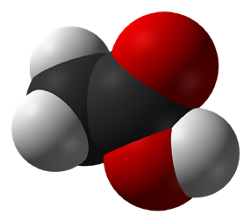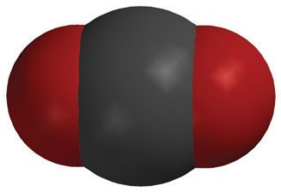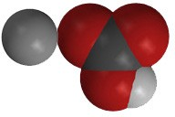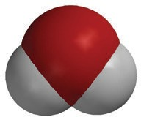

+

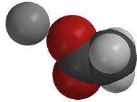

+

+

**C2H4O2**

acetic acid

**NaHCO3**

sodium bicarbonate

**NaC2H3O2**

sodium acetate

**H2O**

water

**CO2**

carbon dioxide



+



+

+

+

**CaCl2**

calcium chloride

**2NaHCO3**

sodium bicarbonate

**CaCO3**

calcium carbonate

**2NaCl**

sodium chloride

**H2O**

water

**CO2**

carbon dioxide