Activity Sheet Answers
Chapter 6, Lesson 3
Forming a Precipitate

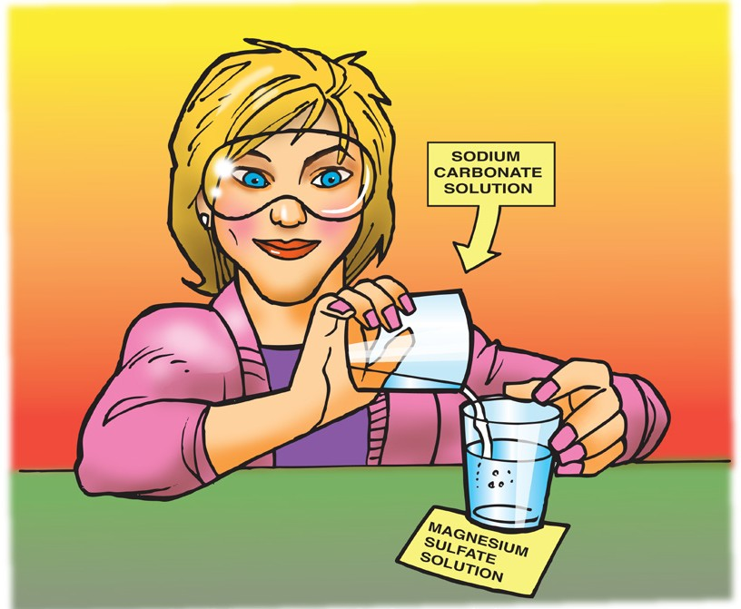
DEMONSTRATION
- Your teacher combined two clear colorless solutions. One was a sodium carbonate solution and the other was a magnesium sulfate solution. Do you think a chemical reaction occurred when these two substances were combined? Why or why not?
When sodium carbonate solution was mixed with a magnesium sulfate solution a chemical reaction took place because a solid was formed from two liquids.

- What is a precipitate?
A precipitate is a solid that is formed when two liquids are mixed together and the solid does not dissolve.

ACTIVITY
- What do you observe when you combine baking soda solution and calcium chloride solution?
When a baking soda solution is combined with a calcium chloride solution, there is bubbling and white particles appear in the mixture.

- How do you know that a chemical reaction occurs when you combine baking soda solution and calcium chloride solution?
When a baking soda solution is mixed with a calcium chloride solution, you can tell that a chemical reaction takes place because a gas and a precipitate are produced.

EXPLAIN IT WITH ATOMS & MOLECULES
- Look at the chemical equation for the reaction between calcium chloride and sodium bicarbonate and answer the following questions.
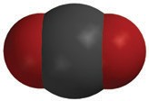
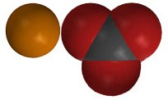
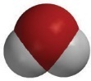
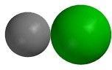
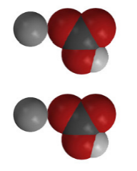
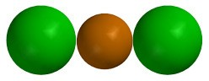
CO2
carbon dioxide
H2O
water
CaCO3
calcium carbonate
2NaCl
sodium chloride
2NaHCO₃
sodium bicarbonate
+
+
+
+
CaCl2
calcium chloride

What gas is produced in the chemical reaction?
The gas produced is carbon dioxide
What do you think is the precipitate?
The precipitate is calcium carbonate
How many of each type of atom appears on each side of the chemical equation?
Atom | Reactant side | Product side
Calcium | 1 | 1
Chlorine | 2 | 2
Sodium | 2 | 2
Hydrogen | 2 | 2
Oxygen | 6 | 6
Carbon | 2 | 2

ACTIVITY
- Is filtering the calcium carbonate and allowing the water to evaporate a chemical change or a physical change? Why?
Filtering the calcium carbonate and allowing the water to evaporate from it are physical changes and not chemical changes. The filtering and the evaporation both leave calcium carbonate which does not become a different substance.

TAKE IT FURTHER
Your teacher added drops of ammonia to copper II sulfate solution.

- How can you tell that something new was made when the copper II sulfate and ammonia reacted?
When the drops of ammonia were added to the copper II sulfate solution, there was a color change and a precipitate was formed.

- How can you tell that something new was made when these substances reacted with hydrogen peroxide?
When the hydrogen peroxide was added, the color changed and a different precipitate seemed to form.

