**Activity Sheet Name Chapter 6, Lesson 10**

**Carbon Dioxide Can Make a Solution Acidic Date**

# DEMONSTRATION

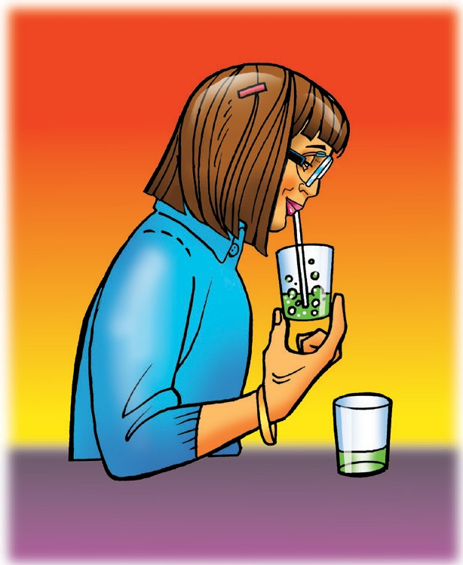

1. **Your teacher blew through a straw into a universal indicator solution until it changed color.**

**Did the indicator solution become acidic or basic?**

1. **What chemical from your teacher’s breath caused the indicator to change color?**

# ACTIVITY

## Question to Investigate

Will carbon dioxide from carbonated water change the pH of an indicator solution?

## Materials for Each Group

* + Universal indicator solution in a plastic cup
  + Water
  + Carbonated water in a wide clear plastic cup
  + 1 wide, clear, plastic cup
  + 2 taller, clear, plastic cups
  + Graduated cylinder
  + Universal Indicator pH Color Chart

## Procedure

1. 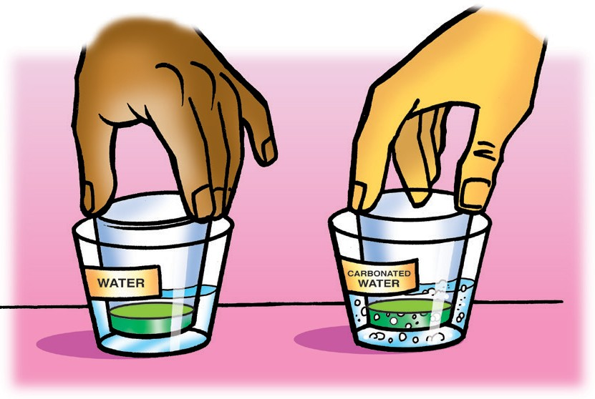Measure 30 mL of universal indicator solution and divide it evenly into two small clear plastic cups.
2. Add 25 mL of water to a wide plastic cup and 25 mL of carbonated water to another wide cup.
3. Stand the small cups with indicator solution in the liquid in the wider cups as shown.
4. 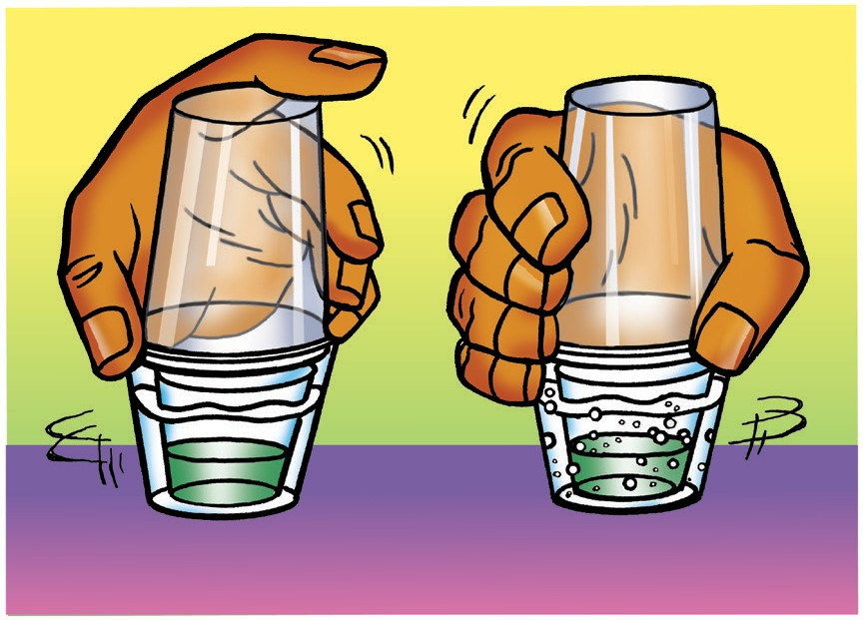Turn the two tall cups upside down and place them over the two wider cups.
5. While holding the top and bottom cups to keep them together, gently swirl both sets of cups. Watch the color of the indicator in both cups to see if there is any change.
6. Compare the color of the indicator to the pH Color Chart to find out whether the solution is acidic, neutral, or basic.

|  |  |
| --- | --- |
| **Describe the color of the indicator solution in each set of cups** | |
| **Carbonated Water** | **Water** |
|  |  |

1. **What does the color of the indicator solution tell you about the pH of each solution? Is it acidic, neutral, or basic?**
2. **The carbonated water and water should not have splashed into the indicator solutions. Why did the indicator solution change color in one set of cups?**

# ACTIVITY

## Question to Investigate

Will carbon dioxide gas produced in the baking soda and vinegar reaction change the pH of an indicator solution?

## Materials for Each Group

* + Universal indicator solution in cup
  + pH color chart
  + Water
  + Baking soda in wide clear plastic cup
  + Vinegar in cup
  + 2 small, clear, plastic cups
  + 1 wide, clear, plastic cups
  + 2 taller, clear, plastic cups
  + Graduated cylinder

## Procedure

1. 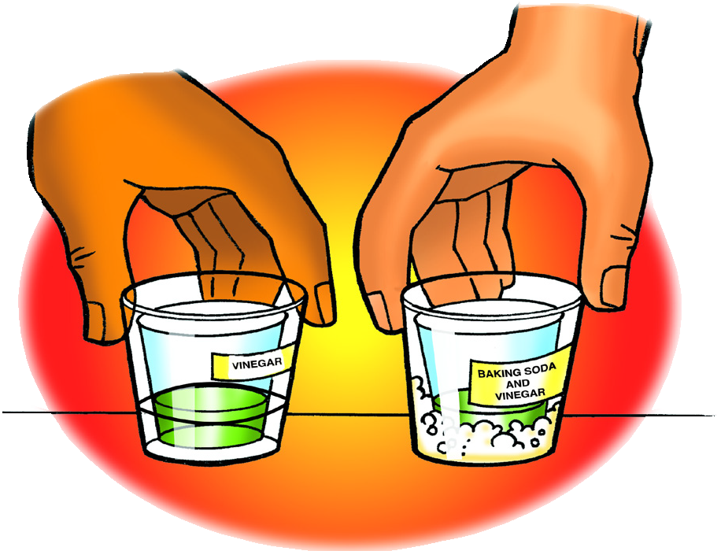Measure 30 mL of universal indicator solution and pour it into a clean, small, plastic cup.
2. Pour half the indicator solution into another small cup so that you have two equal samples.
3. Pour the vinegar on top of the baking soda in one of the wide, clear, plastic cups. The other wide, clear, plastic cup should be empty.
4. Stand the small cups with indicator solution in both of the wider cups as shown.
5. Turn the two tall cups upside down and place them over the two wider cups.
6. While holding the top and bottom cups to keep them together, gently swirl both sets of cups. Watch the color of the indicator in both cups to see if there is any change.
7. Compare the color of the indicator to the pH Color Chart to find out whether the solution is acidic, neutral, or basic.

|  |  |
| --- | --- |
| **Describe the color of the indicator solution in each set of cups** | |
| **Reacting baking soda and vinegar** | **Just Vinegar** |
|  |  |

**5. What does the color of the indicator solution tell you about the pH of each solution? Is it acidic, neutral, or basic?**

1. **Why did one set of cups only have vinegar in the bottom, while the other had vinegar and baking soda?**
2. **The baking soda and vinegar should not have splashed into their indicator solutions. Why did the indicator solution change color in one set of cups?**

# EXPLAIN IT WITH ATOMS & MOLECULES

1. **Water and carbon dioxide gas react to produce carbonic acid. As more carbon dioxide is released into the atmosphere, why is that a problem for our oceans?**

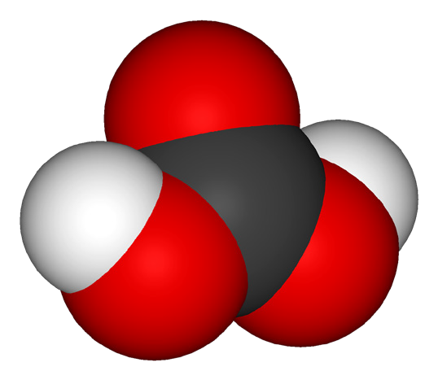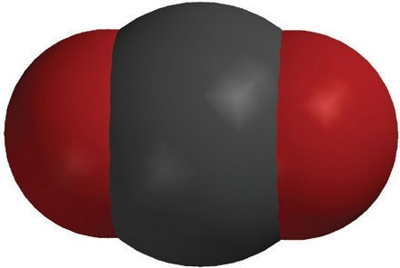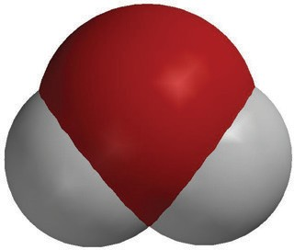

+

**H2O**

water

**H2CO3**

carbonic acid

**CO2**

carbon dioxide

# TAKE IT FURTHER

## Question to Investigate

How does the pH of the solution change during a chemical reaction between the ingredients in an Alka-Seltzer tablet in water?

## Materials for Each Group

* Universal indicator solution in cup
* Water
* Alka-Seltzer tablet
* Graduated cylinder
* Snack-sized zip-closing plastic bag

## Procedure

* 1. 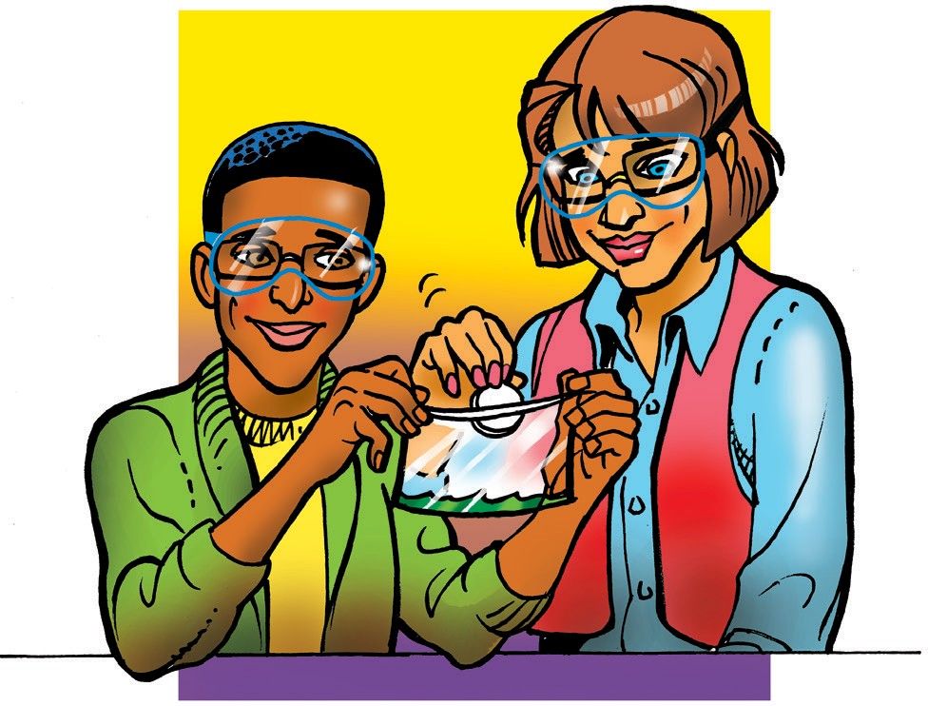Add 20 mL of universal indicator solution to a snack-sized zip-closing plastic bag.
  2. Seal the bag.

**9. What do you think caused the bag to inflate?**

**10. Fill in the chart to show whether the indicator solution was acidic, basic, or neutral.**

|  |  |
| --- | --- |
| **What do the color changes tell you about the pH**  **of the indicator solution during the chemical reaction?** | |
| Beginning |  |
| Middle |  |
| End |  |

**11. Why do you think the indicator solution turned green at the end of the reaction?**