Activity Sheet Answers
Chapter 6, Lesson 10
Carbon Dioxide Can Make a Solution Acidic

DEMONSTRATION
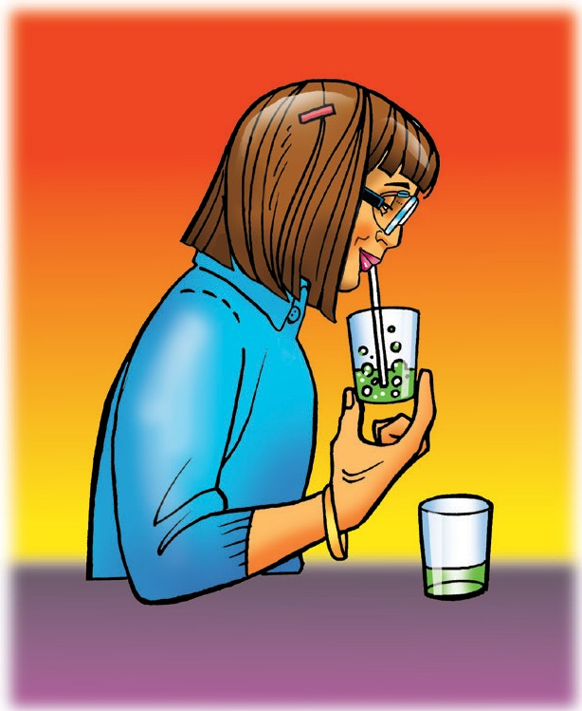
- Did the indicator solution become acidic or basic?
When breath is blown into the indicator solution, the solution turns slightly acidic.
- What chemical from your teacher’s breath caused the indicator to change color?
Carbon dioxide (CO₂) gas in breath caused the indicator solution to become acidic.

ACTIVITY
- What does the color of the indicator solution tell you about the pH of each solution? Is it acidic, neutral, or basic?
The universal indicator solution exposed to carbonated water is greenish-yellow. This means that the indicator solution is slightly acidic.

- The carbonated water and water should not have splashed into the indicator solutions. Why did the indicator solution change color in one set of cups?
The indicator solution became slightly acidic and changed color because carbon dioxide (CO₂) gas reacted with water in the solution and formed carbonic acid.

ACTIVITY
- What does the color of the indicator solution tell you about the pH of each solution? Is it acidic, neutral, or basic?
The universal indicator solution exposed to the vinegar and baking soda reaction turns yellow. This means that the indicator solution is acidic. The indicator solution in the cup without the reaction stays green so it is neutral.
- Why did one set of cups only have vinegar in the bottom, while the other had vinegar and baking soda?
The set of cups with just the indicator solution is a control. It is used to compare the color of the indicator solution in the other cups to see if and how much it changed.

- The baking soda and vinegar should not have splashed into their indicator solutions. Why did the indicator solution change color in one set of cups?
The reaction between baking soda and vinegar produces carbon dioxide (CO₂) gas. The gas reacts with the water and forms carbonic acid. This acid causes the color change in the indicator.

EXPLAIN IT WITH ATOMS & MOLECULES
- Water and carbon dioxide gas react to produce carbonic acid. As more carbon dioxide is released into the atmosphere, why is that a problem for our oceans?
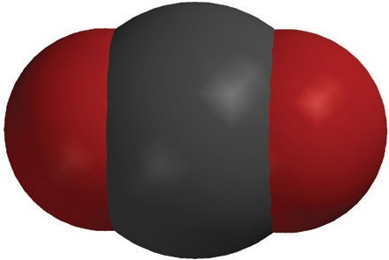
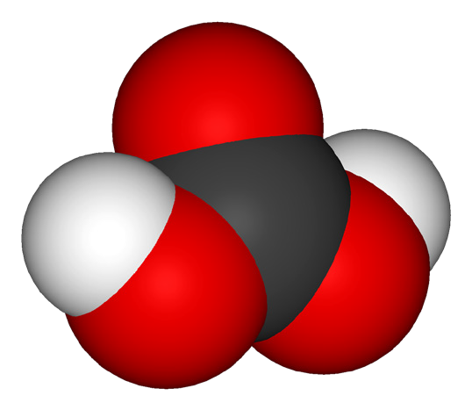
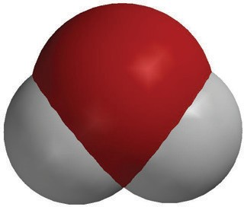
H₂O
water
CO₂
carbon dioxide
+

H₂CO₃
carbonic acid

When raindrops fall through the air, carbon dioxide in the air reacts with the water and makes carbonic acid which makes rain water slightly acidic. This goes into the ocean water and makes it more acidic.

TAKE IT FURTHER
- What do you think caused the bag to inflate?
Since an Alka-Seltzer tablet is made of citric acid and sodium bicarbonate (baking soda) they react to form carbon dioxide gas (CO₂) which inflates the bag.

- Fill in the chart to show whether the indicator solution was acidic, basic, or neutral.

What do the color changes tell you about the pH
of the indicator solution during the chemical reaction?
Beginning | Red (Acidic)
Middle | Orange-yellow (Less acidic)
End | Green (Neutral)

- Why do you think the indicator solution turned green at the end of the reaction?
The solution turned green because the acid (citric acid) and the base (sodium bicarbonate) neutralized each other.

