**Activity Sheet Name Chapter 6, Lesson 1**

**What is a Chemical Reaction? Date**

# DEMONSTRATION

1. **Your teacher lit a candle and told you that this was a chemical reaction. What are the *reactants* in this chemical reaction?**
2. **What are the *products* in this chemical reaction?**
3. 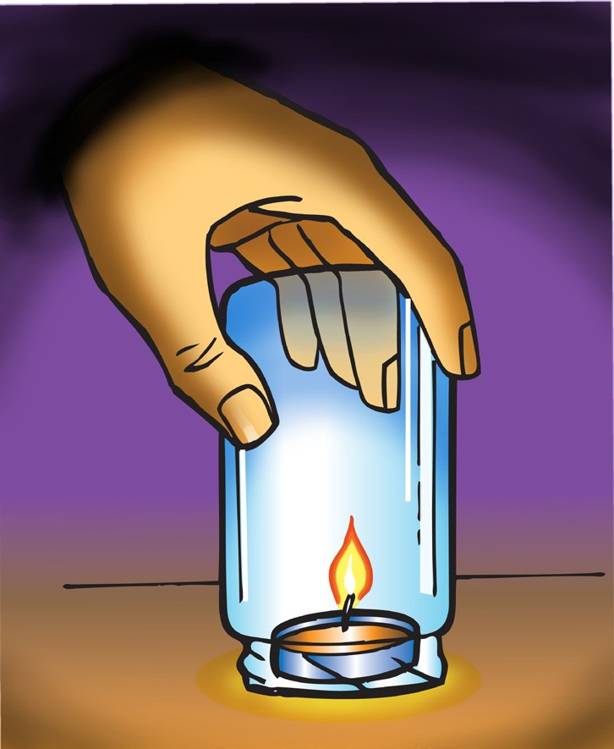**Why did the flame go out when your teacher put a jar over the candle?**
4. **Where do the atoms come from that make the carbon dioxide and the water on the right side of the equation?**

**CH4**

methane

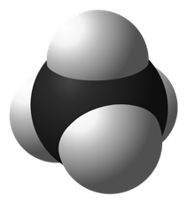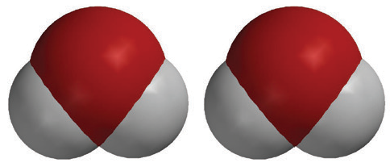

**2O2**

oxygen

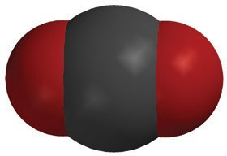

**CO2**

carbon dioxide

**2H2O**

water

+

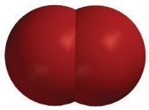

+



# ACTIVITY

## Question to Investigate

Where do the atoms in the products of a chemical reaction come from?

## Materials for Each Student

* + Atom model cut-outs (carbon, oxygen, and hydrogen)
  + Sheet of colored paper or construction paper
  + Colored pencils
  + Scissors
  + Glue or tape

## Procedure

### Prepare the Atoms

1. Color the carbon atoms black, the oxygen atoms red, and leave the hydrogen atoms white.
2. Use scissors to carefully cut out the atoms.

### Build the Reactants

1. On a sheet of paper, place the atoms together to make the molecules of the reactants on the left side of the chemical equation for the combustion of methane.
2. Write the chemical formula under each molecule of the reactants. Also draw a plus sign (+) sign between the reactants.

### Build the products

1. Draw an arrow after the second oxygen molecule to show that a chemical reaction is taking place.
2. Rearrange the atoms in the reactants to make the molecules in the products on the right side of the arrow.
3. Write the chemical formula under each molecule of the products. Also draw a + sign between the products.

Tell students that in a chemical reaction, the atoms in the reactants come apart, rearrange, and make new bonds to form the products.

### Represent the chemical equation

1. Use your remaining atoms to make the reactants again to represent the chemical reaction as a complete chemical equation.
2. Glue or tape the atoms to the paper to make a more permanent chemical equation of the combustion of methane.

# EXPLAIN IT WITH ATOMS & MOLECULES

In a chemical equation, like the one below, you will notice that there are regular-sized numbers in front of some of the molecules and small numbers after certain atoms within a molecule. The little number is called the *subscript* and tells how many of a certain type of *atom* are in a molecule. The bigger number is called the *coefficient* and tells how many of a particular type of *molecule* there are.

If there is a coefficient in front of the molecule and a subscript after an atom, multiply the coefficient and the subscript to get the number of atoms. For example, in the products of the chemical reaction there are two water molecules, or 2H2O. The coefficient means that there are two molecules of water. The subscript means that each water molecule has two hydrogen atoms. Since each water molecule has 2 hydrogen atoms and there are two water molecules, there must be (2 × 2) = 4 hydrogen atoms.

**CH4**

methane



**2O2**

oxygen



**CO2**

carbon dioxide

**2H2O**

water

+



+



**5. Count the number of atoms on each side of the equation below and write this in the chart.**

|  |  |  |
| --- | --- | --- |
| **CH4 + 2O2 CO2 + 2H2O** | | |
| **Atom** | **Reactant side** | **Product side** |
| Carbon |  |  |
| Hydrogen |  |  |
| Oxygen |  |  |

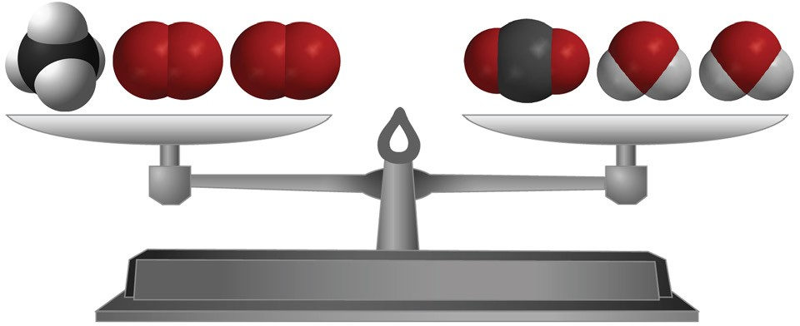**6. Are atoms created or destroyed in a chemical reaction?**

**How do you know?**

**7. In a physical change, like changing state from a solid to a liquid, the sub- stance itself doesn’t really change. How is a chemical change different from a physical change?**

# TAKE IT FURTHER

Molecules made up of only carbon and hydrogen are called *hydrocarbons*. The candle and the hydrocarbons listed below react with oxygen in a chemical reaction called *combustion*.

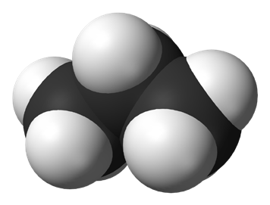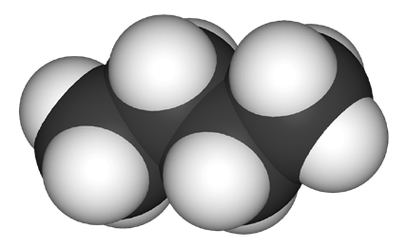

**CH4**

methane

**C3H8**

propane

**C4H10**

butane

Fuel in gas stoves in many home kitchens

Fuel in outdoor gas grills

Fuel in disposable lighters

**8. Count the number of carbon, hydrogen, and oxygen atoms in the reactants and products of each equation to see if the equation is balanced. Record the number of each type of atom in each chart.**

Combustion of Propane C3H8 + O2  3CO2 + 4H20

|  |  |  |
| --- | --- | --- |
| **C3H8 + 5O2** | | **3CO2 + 4H2O** |
| **Atom** | **Reactant side** | **Product side** |
| Carbon |  |  |
| Hydrogen |  |  |
| Oxygen |  |  |

Combustion of Butane

2C4H10 + 13O2 8CO2 + 10H2O

|  |  |  |
| --- | --- | --- |
| **2C4H10 + 13O2** | | **8CO2 + 10H2O** |
| **Atom** | **Reactant side** | **Product side** |
| Carbon |  |  |
| Hydrogen |  |  |
| Oxygen |  |  |

