Activity Sheet Name Chapter 5, Lesson 8
Can Gases Dissolve in Water? Date

DEMONSTRATION
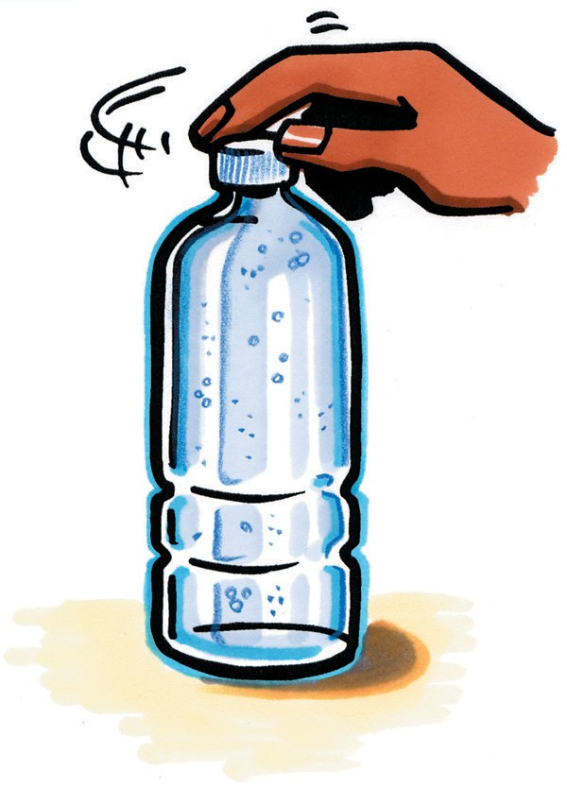
- What gas is inside the bubbles you saw when your teacher opened a bottle of carbonated water?

- Where was this gas before the bottle was opened?

EXPLAIN IT WITH ATOMS & MOLECULES
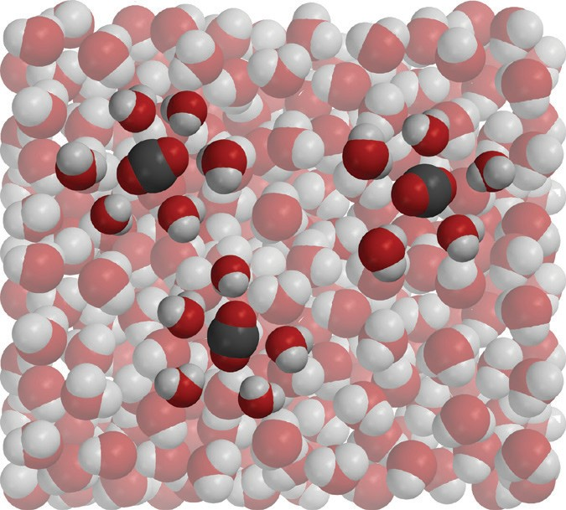
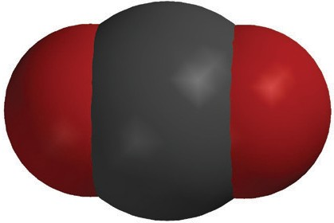
+
_
_
+

- Why does carbon dioxide dissolve in water?

- Why does carbon dioxide gas come out of solution (opposite of dissolving) so easily?

ACTIVITY

Question to Investigate
How can you make carbon dioxide gas come out of solution?

Materials for Each Group
  - Club soda in clear plastic cup
  - 2 clear plastic cups
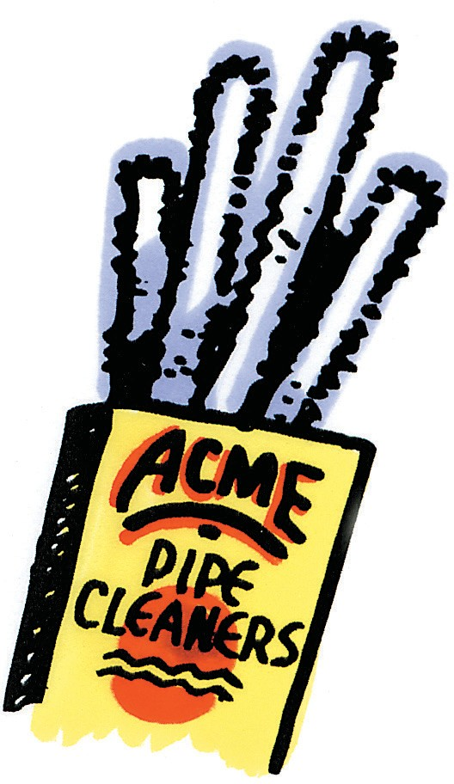
  - M&M
  - Pipe cleaner

Procedure
- Evenly divide the club soda among the 3 clear plastic cups. Push two of these cups aside to use later.
- Place a pipe cleaner in the soda and observe.
- Place an M&M in the soda and observe.

- What was it about the pipe cleaner and M&M that caused bubbles to form?

- While drinking soda pop with a straw, you may have noticed that bubbles form on the outside of the straw. Now that you have done this activity, why do you think these bubbles form on the straw?

ACTIVITY

Question to Investigate
Does carbon dioxide stay dissolved better in water that is warmed or water that is cooled?

Materials for Each Group
  - Carbonated water in 2 clear plastic cups
  - Hot water (about 50 °C)
  - Cold water (about 5 °C)
  - 2 deli containers (that cups easily fit in)

Procedure
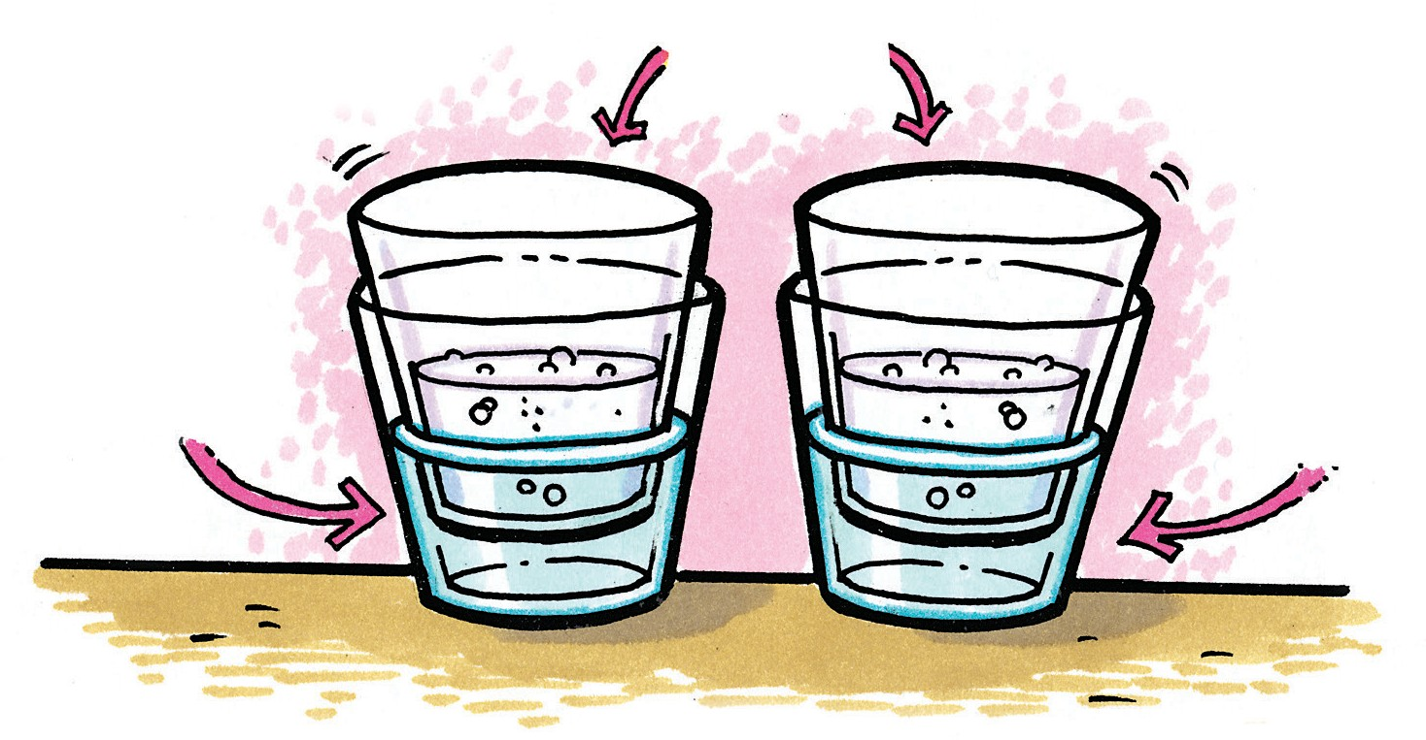
- Get the two cups of carbonated water that you moved aside earlier.
- Fill one empty deli container about ⅓ of the way with ice cold water and another about ⅓ of the way with hot tap water.
- Place each of the cups of carbonated water into the cold and hot water, as shown.
- Watch the surface of the soda in each cup of carbonated water.

- Does carbon dioxide stay dissolved better in hot water or in cold water?

How do you know?

- Based on what you observed in this experiment, why do you think people store soda pop in the refrigerator after the bottle has been opened?

EXPLAIN IT WITH ATOMS & MOLECULES
- Why does warming carbonated water make it easier for carbon dioxide to come out of solution?

- Look at the graph showing the solubility of carbon dioxide in water to answer the following questions.
Carbon dioxide solubility in water
0.35

0.3

0.25

0.2

0.15

0.1

0.05

0
0
10
20
30
40
50
60
Temperature (C)

a. As the temperature increases, is carbon dioxide more soluble in water or less soluble in water?

b. Does this graph match or not match your observations? Explain.

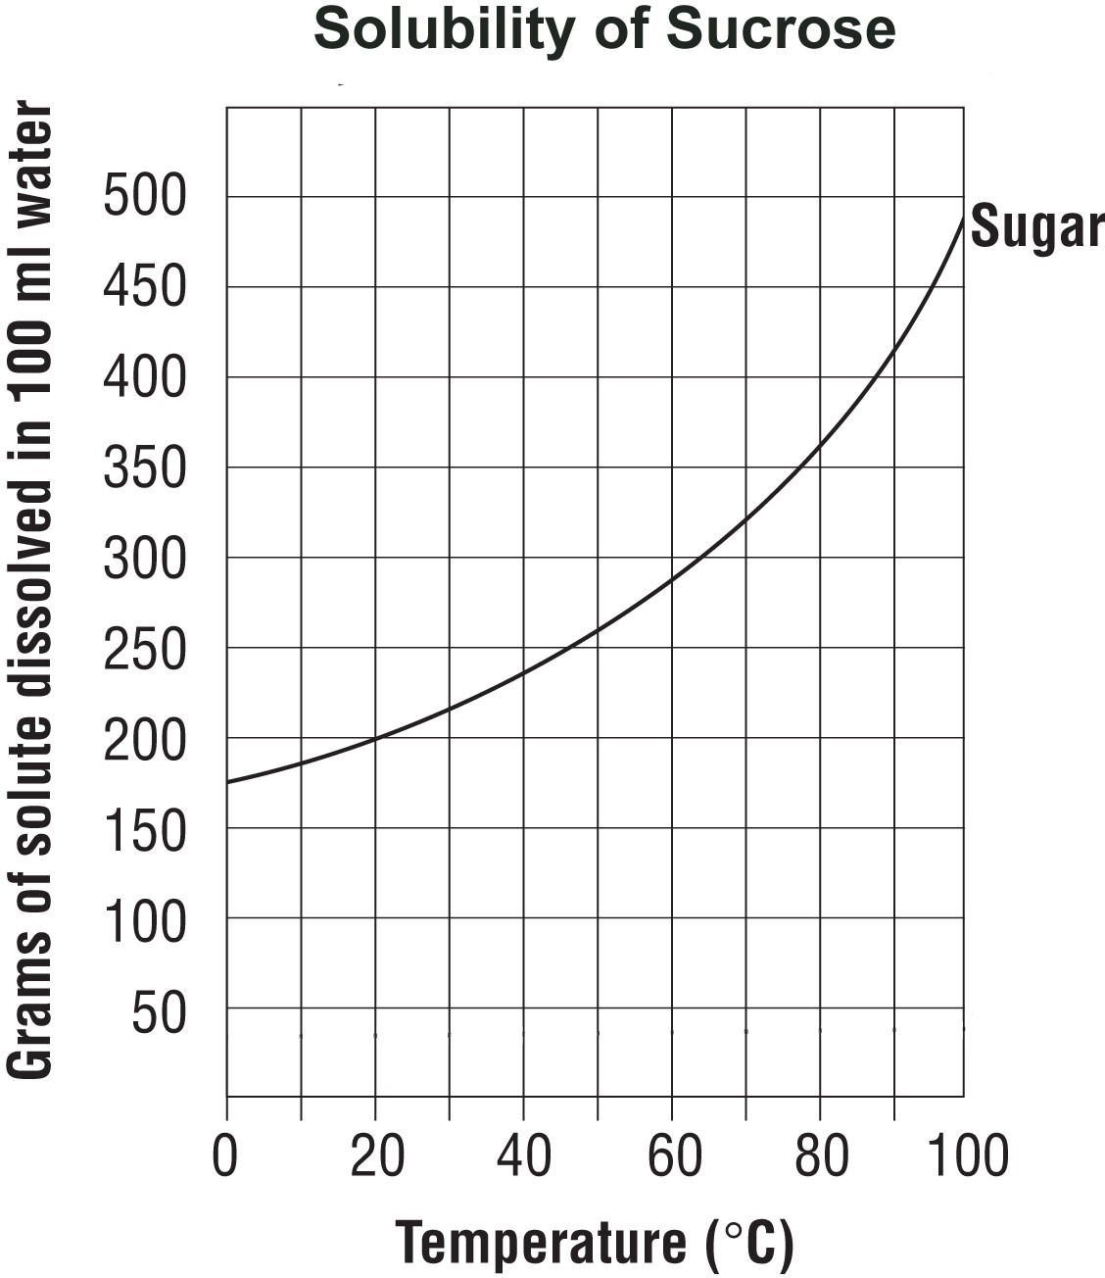
- What do the graphs below tell you about the solubility of carbon dioxide compared to sucrose, as temperature increases?
Carbon dioxide solubility in water
0.35

0.3

0.25

0.2

0.15

0.1

0.05

0
0
10
20
30
40
50
60
Temperature (C)

TAKE IT FURTHER
- During a long hot summer, you may notice fish gulping air at the surface of a pond. Why do you think the fish come to the surface like this, instead of breathing dissolved oxygen in the water the way that they normally do?

- Coal-burning power plants heat water to turn turbines to make electricity. After using the water, it is cooled and then returned to the river or lake it came from. Why is it important to cool the water before returning it to the river?

- What causes the fantastic “fountain” when a roll of Mentos mints is dropped in a bottle of Diet Coke?

