Activity Sheet Name Chapter 5, Lesson 6
Does Temperature Affect Dissolving? Date

INTRODUCTION

- Does the temperature of water affect the amount of coating that dissolves from an M&M? Talk with your group and design an experiment to find out.

List three variables and how you will control them.

What is the only variable that should be changed?

ACTIVITY

Question to Investigate
Does the temperature of water affect the amount of coating that dissolves from an M&M?

Materials for Each Group
- 3 same-colored M&Ms
- 3 clear plastic cups
- 1 sheet of white paper
- Room temperature water
- Hot water (about 50 °C)
- Cold water (about 5 °C)

Procedure
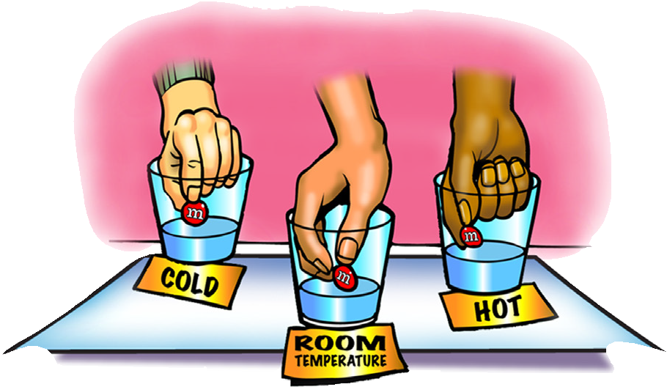
  - Pour cold, room temperature, and hot water into the cups so that the water is deep enough to cover an M&M.
  - Place the three cups on the white paper. Write cold, room temp, and hot near its cup.
  - With the help of your partners, place a same-colored M&M in the center of each cup at the same time. Observe for about 1 minute.

- Does the temperature of the water affect the amount of coating that dissolves from an M&M?

How do you know?

EXPLAIN IT WITH ATOMS & MOLECULES
- What are the differences in the way water molecules move in cold, room temperature, and hot water?

- On the molecular level, why do you think sugar dissolves better in hot water than in cold water?

- Why do you think there is a greater difference in the amount of dissolving between the hot and room temperature water than between the room temperature and cold water?

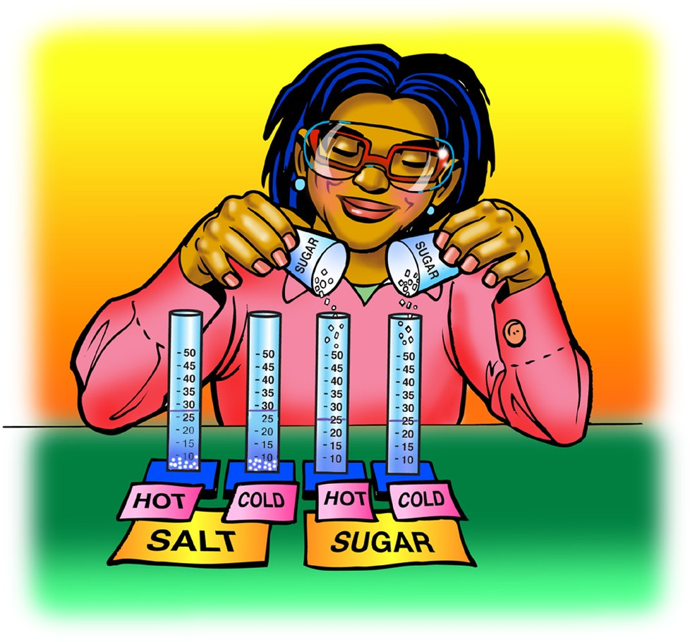
DEMONSTRATION
- Your teacher showed you a demonstration comparing the amount of salt that can dissolve in hot and cold water and the amount of sugar that can dissolve in hot and cold water. Just like in your M&M experiment, much more sugar dissolved in hot water.
Does much more salt dissolve in hot water than in cold?

How do you know?

- The following data table and graph compare how much sugar and salt can dissolve in water over the temperature range 0 °C to 100 °C. Use the table and graph to answer the following questions.
Solubility of sodium chloride and sucrose
Measured in grams of solute dissolved in 100 mL of water
Temperature °C | 0 | 20 | 40 | 60 | 80 | 100
Sodium chloride | 35.5 | 36 | 36.5 | 37.5 | 38 | 39
Sucrose | 179 | 204 | 241 | 288 | 363 | 487

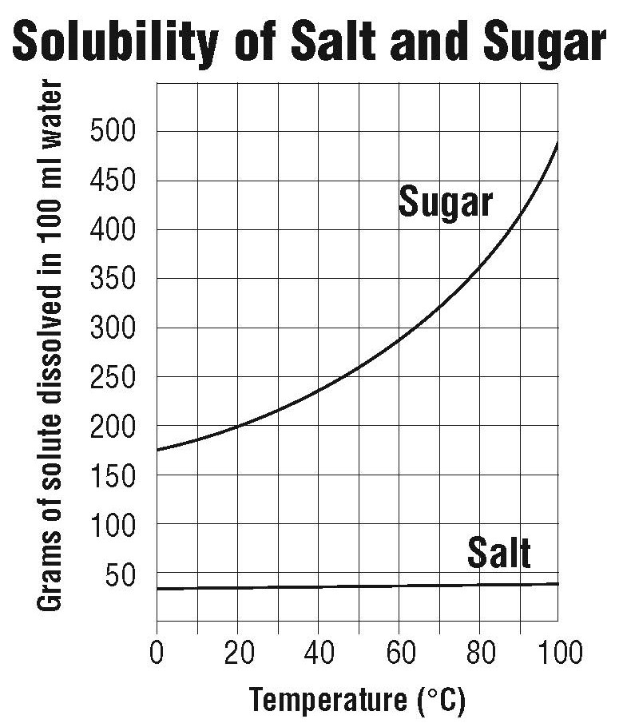

The activity showed that temperature affects the dissolving of sugar more than it affects the dissolving of salt. Explain how the graph shows this.

How much sugar dissolves in 100 mL of water at 50 °C?

How much salt dissolves in 100 mL of water at 50 °C?

TAKE IT FURTHER
- Potassium chloride is a salt substitute sold in grocery stores for people who should limit their intake of table salt (sodium chloride). Use the data table to plot the solubility curve for potassium chloride on the graph below. Then use the graph to answer the following questions.

The solubility of potassium chloride
Measured in grams of solute dissolved in 100 mL of water
Temperature °C | 0 | 20 | 40 | 60 | 80 | 100
Potassium chloride | 28 | 33 | 38 | 44 | 50 | 55

At what temperature would you say that the solubility of sodium chloride and potassium chloride are about the same?

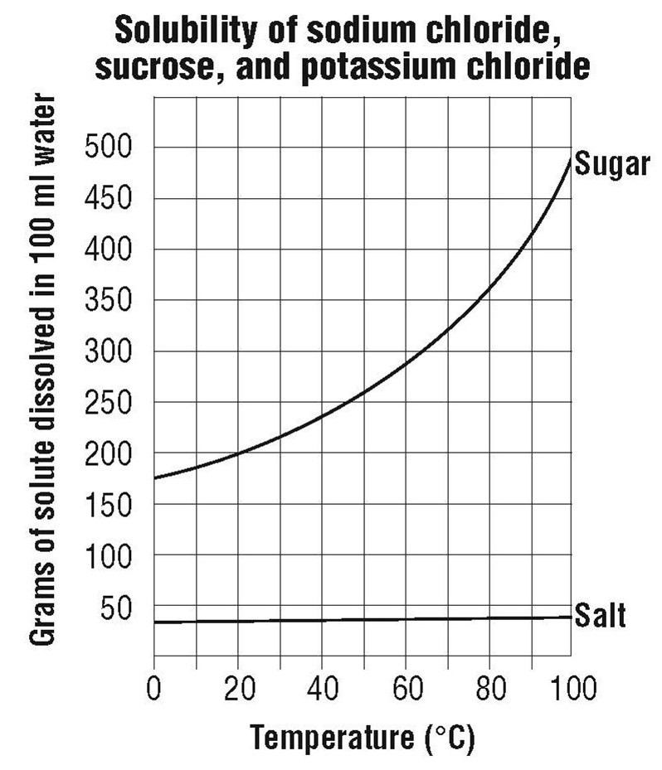

At 0 °C, which substance is the least soluble?

At 0 °C, which substance is the most soluble?

