Chapter 5, Lesson 5—Using Dissolving to Identify an Unknown
Key Concepts
- Different substances are made from different atoms, ions, or molecules, which interact with water in different ways.
- Since dissolving depends on the interaction between water and the substance being dissolved, each substance has a characteristic solubility.
Summary
Students will observe a solubility test between salt and sugar. They will then be presented with four known crystals and an unknown. Based on the solubility demonstration, the class will design a solubility test to discover the identity of the unknown.
Objective
Students will be able to identify and control variables when designing a solubility test. Students will be able to explain why different substances dissolve to different extents in water.
Evaluation
The activity sheet will serve as the “Evaluate” component of each 5-E lesson plan. The activity sheets are formative assessments of student progress and understanding. A more formal summative assessment is included at the end of each chapter.
Safety
Be sure you and the students wear properly fitting goggles.

Materials for the Demonstrations
- Gram balance
- Simple balance
- Graduated cylinder
- Water
- 4 clear plastic cups
- 2 small plastic cups
- Salt
- Sugar
- Cereal balls (Kix work well)
- Zip-closing plastic bag (quart-size, storage-grade)

Materials for Each Group
- Salt (sodium chloride)
- Epsom salt (magnesium sulfate)
- MSG (monosodium glutamate)
- Sugar (sucrose)
- Coarse kosher salt (sodium chloride)
- Water
- Black construction paper
- Masking tape
- Pen or permanent marker
Materials for Each Group (cont’d)
- Magnifier
- Gram balance
- 5 small plastic cups
- 5 clear plastic cups
- Graduated cylinder
- Paper towel

ENGAGE

Do a demonstration to show that different substances have different solubilities.
Tell students that in this demonstration, you will pour salt and sugar into water to find out which dissolves better. In order to make this test fair, you will use the same amount (mass) of salt and sugar, the same amount of water at the same temperature, and you will swirl each in the same way for the same length of time.

Question to Investigate
Which dissolves in water better, salt or sugar?

Materials for the Demonstration
    - Balance that measures in grams
    - Graduated cylinder
    - Water
    - 2 clear plastic cups
    - 2 small plastic cups
    - Salt
    - Sugar

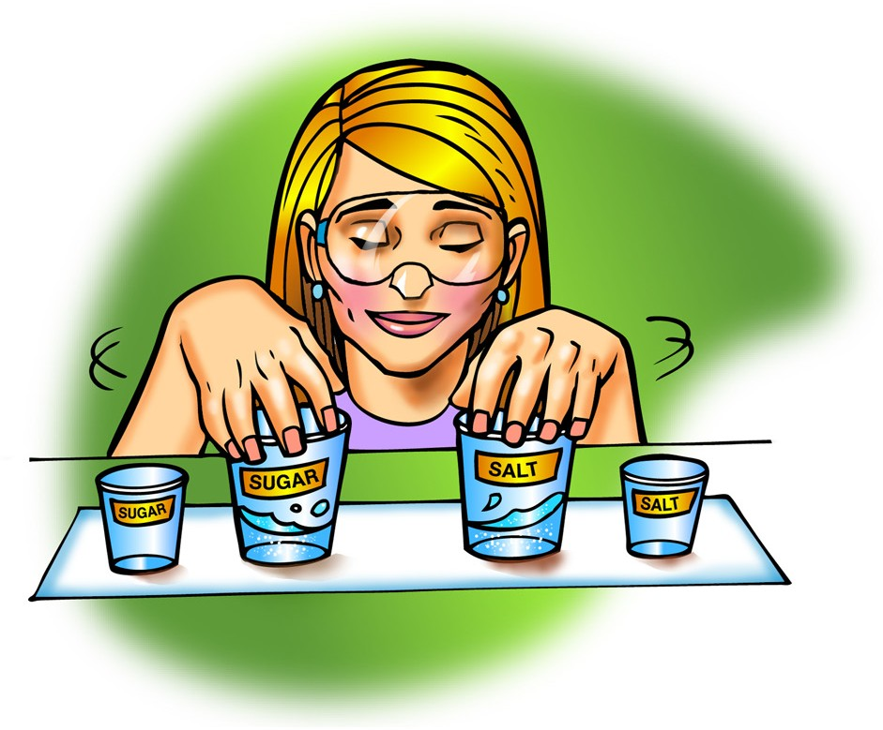
Teacher Preparation
    - Label 1 clear plastic cup and 1 small cup Salt.
    - Label the other clear plastic cup and another small cup Sugar.
    - Measure 5 grams of salt and 5 grams of sugar and place them in the pair of small, labeled cups.
    - Pour 5 mL of room temperature water into the pair of larger empty cups.

Procedure
- At the same time, pour the salt and sugar into the water in the corresponding cups. Swirl each cup at the same time and in the same way for about 20 seconds.
- Walk around the room to show students the amount of salt and sugar left in the bottom of each cup. If you have an overhead projector, place the cups on the projector so that the entire class can compare what is left undissolved in each cup. Ask students whether one substance seems to dissolve better than the other.
- Swirl again for 20 seconds and observe. Then swirl for 20 more seconds and have students make their final observations.
- Slowly and carefully pour the solution from each cup back into its empty labeled cup. Try not to let any undissolved crystal go into these cups. Show students the cups so that they can compare the amount of undissolved crystal remaining.

Expected Results
Much more sugar will dissolve than salt. There will be more undissolved salt than sugar left in the cups.
Note: Solubility is normally measured by the number of grams of a substance that dissolves in a certain volume of water at a given temperature. The previous
demonstration uses this conventional way to measure solubility. Another approach could be to compare the number of molecules or ions of each substance that dissolves in water. This would require a way to “count” the molecules or ions in each substance.
Read more about counting molecules or ions in Teacher Background.

Discuss the results of the demonstration and introduce the idea that each substance has its own characteristic solubility.
Ask students:

Was more salt or sugar left in the bottom of the cup?
There was more salt left undissolved in the bottom of the cup.

Which dissolved better, salt or sugar?
Because there was little to no sugar in the bottom of the cup, more of it must have dissolved in the water.

Do you think we would get similar results if we tried dissolving salt and sugar again?
We probably would get similar results because the amount of salt or sugar that dissolves has something to do with how each substance interacts with water.

How well a substance dissolves in water is called its solubility. Would you expect different substances to have the same or different solubility?
Each substance is made up of its own kind of molecules that will interact with water differently. Different substances should have different solubilities.
Tell students that they will compare the solubility of four different household crystals— salt (sodium chloride), Epsom salt (magnesium sulfate), MSG (monosodium glutamate), and sugar (sucrose). Explain that they will also test an unknown crystal that is chemically the same as one of the other crystals. Because it is chemically the same, it should have the same solubility as one of the crystals they will test. By the end of the activity, students should be able to identify the unknown.

Give each student an activity sheet.
Students will record their observations and answer questions about the activity on the activity sheet. The Explain It with Atoms & Molecules and Take It Further sections of the activity sheet will either be completed as a class, in groups, or individually, depending on your instructions. Look at the teacher version of the activity sheet to find the questions and answers.

EXPLORE
  - Have students try to identify the unknown based on appearance.
Let students know that before doing a solubility test, they will look closely at the crystals to see if they might be able to get some clues about the identity of the unknown by appearance alone. Have students follow the procedure below and record their observations about the crystals on the activity sheet. Let students know that they can look at the crystals and touch them, but they should not taste them.

Question to Investigate
Can you identify the unknown crystal by the way it looks?

Materials for Each Group
- Black construction paper
- Masking tape
- Pen or permanent marker
- 5 small plastic cups
- Salt
- Epsom salt
- MSG
- Sugar
- Unknown (Coarse kosher salt)
- Magnifier

Teacher Preparation
- Label the 5 small plastic cups Salt, Epsom salt, MSG, Sugar, and Unknown.
- Add at least two teaspoons of each crystal to its labeled cup.

Procedure
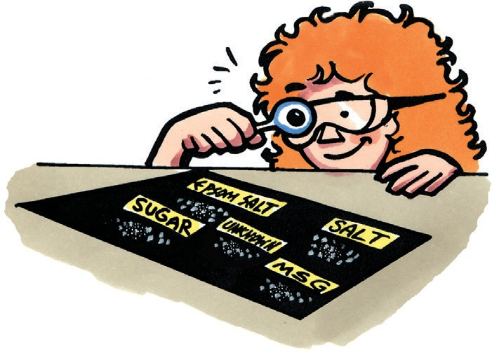
- Use masking tape and a pen to label four corners of a piece of black construction paper Sugar, Salt, Epsom salt, and MSG. Label the center Unknown.
- Place small samples of Epsom salt, table salt, sugar, MSG, and the unknown on the labeled areas of the construction paper.
- Use a magnifier to look carefully at each type of crystal.

Expected Results
All of the crystals are white, but some are more transparent or opaque than others. Each type of crystal is also a different size and shape.

  - Discuss student observations and have groups plan how they might conduct a solubility test to identify the unknown.
Ask students:

What do you notice about each crystal? Include any similarities or differences you notice among them.
Students should describe physical properties such as the size, shape, color and texture. They should also describe whether the crystals are shiny, dull, transparent, or opaque.

Can you identify the unknown yet?
Students should not have enough evidence to correctly identify the unknown at this point. Don’t tell students yet that the unknown is coarse kosher salt. They will discover this by the end of this lesson.

Explain that looking at the crystals is not enough to identify the unknown. But a solubility test will provide useful information, if it controls variables well. Ask students to think about how they might conduct a solubility test on salt, Epsom salt, MSG, sugar, and the unknown. Have students work in groups to discuss their ideas and record a simple plan on their activity sheet.

  - Have student groups share their ideas for a solubility test and consider how each plan controls variables.
As each group presents their plans, have the class identify how each solubility test controls variables. All groups will likely suggest that they use the same volume of water at the same temperature in the same type of containers, and the same amount of each crystal. But there may be some disagreement in how to measure the same amount of each crystal. Some students may suggest they use the same volume of each crystal while others may suggest the same mass of each crystal. If no one suggests using mass, explain that in the demonstration, you used an equal mass of salt and sugar—5 g of each.
Ask students:

Is it better to use the same volume (like a teaspoon or 5 mL) or the same mass (like 5 g) of each crystal? Why?
Tell students that you will do a demonstration that will help them see whether they should use a volume or mass measure so that they can dissolve the same amount of each crystal in water.

  - Do a demonstration to show that mass is better than volume in measuring equal amounts for a solubility test.
Question to Investigate
Is it better to measure the same volume or same mass of each crystal when conducting a solubility test to identify an unknown?

Materials for the Demonstration
- 2 clear plastic cups
- Cereal balls (Kix work well)
- Zip-closing plastic bag (quart-size storage-grade)
- Balance

Teacher Preparation
Fill two clear plastic cups completely with cereal balls. Both cups should be identical and contain the same amount of cereal balls. Test these cups on a balance to make sure that these cups have the same mass.

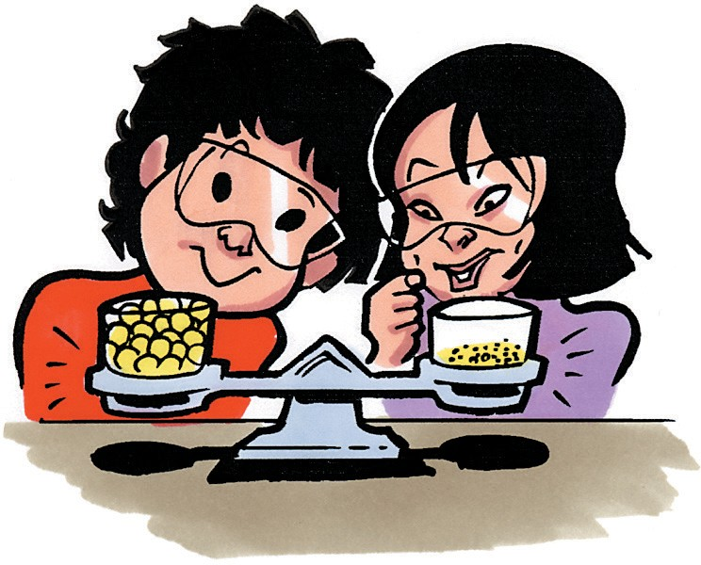
Procedure
- Hold the cups filled with cereal up so that students can see that both have about the same amount of cereal in them.
- Place the cups in the center of each end of a simple balance to prove to your students that both contain the same amount of cereal.

Ask students to make a prediction:

I am going to crush the cereal balls in one cup. Do you expect the height of cereal in this cup to be higher, lower, or the same as in the other cup?
Students will probably say that the crushed cereal will not take up as much room in the cup.

- Pour the cereal from one of the cups into a storage-grade, zip-closing plastic bag. Get as much air out as possible and seal the bag.
- Place the bag on the ground, and crush the cereal thoroughly with your foot. Once the cereal is pulverized, open the bag, and pour the crushed cereal back into the cup.

Ask students:

Which cup contains more cereal?
Students will realize that both cups contain the same amount of cereal, but some may have an urge to say that the cup with the cereal balls contains more cereal.

Was any cereal added or removed from either cup?
Point out that even though the crushed cereal takes up less space, it is still the same amount of matter (cereal) as was in the cup before it was crushed.
  - How could you prove that these two cups contain the same amount of matter?
Students should suggest placing the cups on a balance as you did before.

- Place the cups on opposite ends of a balance to prove that the mass of cereal in each cup is the same.

Expected Results
Even though the volume of cereal balls is greater than the volume of crushed cereal balls, the cups will balance on the scale.

Relate student observations in the demonstration to the five crystals they will dissolve in water.
Tell students to imagine that the large cereal balls represent large crystals and the crushed cereal represents small crystals. Explain that the size and shape of the crystals may be different, but the balance shows that their mass is the same. Remind students that mass is a measure of the amount of matter. Because the large and small crystals (cereal) have the same mass, both cups contain the same amount of matter. Conclude that, in order to measure equal amounts, it is better to measure the mass of substances than the volume.

Ask students:

In the solubility test you will do, you will need to measure equal amounts of the five crystals. How will you measure equal amounts?
After this demonstration, students should realize that measuring mass for a solubility test is better than measuring by volume.

Based on what students observed when they looked closely at the different crystals along with evidence from the demonstration, they should realize that different crystals have a slightly different size or shape. This will cause them to pack differently in the spoon so that more granules of one will be in the spoon than the other.

Note: The following explanation may be too difficult for students but is included here for you to think about and discuss with students if you think it is appropriate. Even if salt and sugar granules were exactly the same size and shape and packed exactly the same way in a spoon, it still would not be a good idea to use a teaspoon to measure equal amounts for a solubility test. Here’s why: Salt is about 25% more dense than sugar. Therefore, a teaspoon of salt weighs more than a teaspoon of sugar by almost 25%. Your dissolving test would not be accurate because you would be starting out with a larger mass of salt than sugar.

Have students weigh five grams of each of the crystals for the solubility test.
Materials for Each Group
- Gram balance
- 5 small plastic cups
- 5 clear plastic cups
- Masking tape and pen or permanent marker
- Salt
- Epsom salt
- MSG
- Sugar
- Unknown (coarse kosher salt)
- Water

Procedure
- Use masking tape and a pen to label the 5 small plastic cups Salt, Epsom salt, MSG, Sugar, and Unknown.
- Label the 5 larger clear plastic cups the same way.
- Weigh 5 g of each crystal and place each in its small labeled cup.

If you do not have enough time, you can stop here and have students store the crystals and conduct the test another day. If you do have time to conduct the test, the procedure follows.

Have students dissolve the four known crystals and the unknown in room temperature water.
The amount of water used in the procedure is specific and should be used because it gives clear results. Swirling the crystals in water is a good way of mixing them to help them dissolve. Lead the class so that all groups pour their crystal samples into the water at the same time. Also tell students when to swirl the water and crystals and when to stop and observe. There will be three 20-second intervals.

Question to Investigate
Can you identify an unknown using a solubility test?

Materials for Each Group
- Graduated cylinder
- 5 g each of salt, Epsom salt, MSG, sugar, and unknown (coarse kosher salt)
- 5 clear plastic cups
- Water

Procedure
- Use a graduated cylinder to add 5 mL of room temperature water to each empty clear plastic cup.
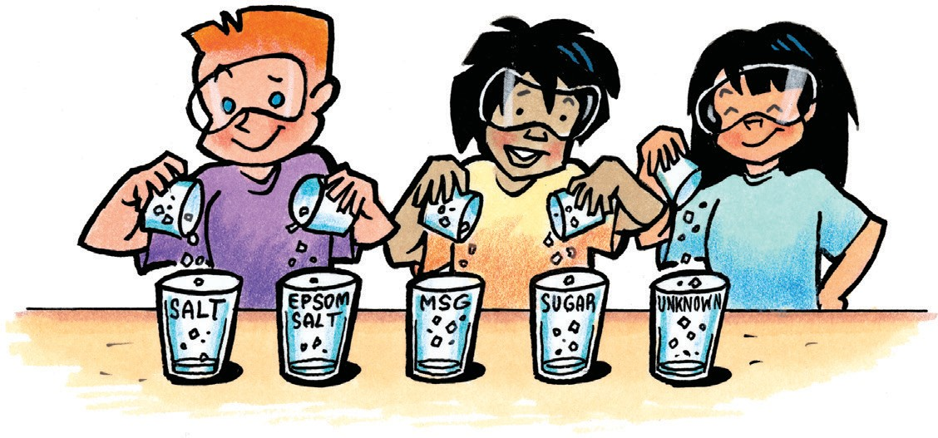
- Match up each pair of labeled cups so that each cup of crystal is near its corresponding cup of water.
- When your teacher tells you to, work with your lab partners to pour the weighed amount of each crystal into its cup of water at the same time.
- With the help of your lab partners, swirl each cup at the same time and in the same way for about 20 seconds and observe. Swirl again for another 20 seconds and observe. Swirl again for the last 20 seconds and make your final observations.
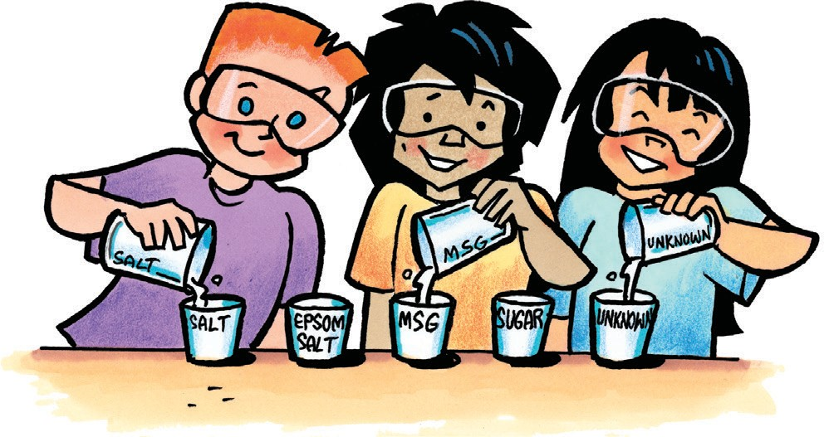
- Slowly and carefully pour the solution from each cup back into its small empty cup. Try not to let any undissolved crystal go into the small cup. Compare the amount of crystal remaining in each clear plastic cup.

Expected Results
Results may vary. However, sugar should dissolve the most, followed by Epsom salt. MSG should appear to dissolve a bit more than salt and the unknown. The salt and the unknown should appear to dissolve to a similar degree.

Discuss student observations and the possible identity of the unknown.

Ask students:
  - Are there any crystals that you could rule out as probably not the unknown?
Based on their observations, students are most likely to eliminate sugar and Epsom salt as the unknown.

Which cup or cups seem to have about the same amount of crystal left undissolved as the unknown?
The unknown, salt, and MSG appear to have similar amounts of crystal that did not dissolve.

What do you think is the identity of the unknown?
Students might conclude that the unknown is salt, but in some cases might think it could also be MSG.

What evidence do you have to support your conclusion?
Students should cite the amount of crystal left behind in each cup as evidence that the unknown is either salt or MSG.

If someone in the class had a very different conclusion and had very different observations, what do you think may have led to these differences?
Students should mention possible errors in weighing the crystals, in measuring the amount of water used, stirring in a different way, or accidentally pouring the crystals into the wrong cups.

Tell students that their test showed that different substances have different solubilities. In fact, solubility is a characteristic property of a substance. Explain to students that this type of solubility test can help eliminate some of the crystals but may not be accurate enough to identify the unknown. Since they may have some doubt about the identity of the unknown, students will do a recrystallization test with the crystal solutions made during the solubility test.

Have students conduct another test to confirm the identity of the unknown.
Explain to students that they might be able to get more clues about the identity of the unknown if they allow the solutions of the dissolved crystals to recrystallize. Allowing the substances to recrystallize from their solutions might show similarities and differences that were not as easily seen in the original crystals.

Materials notes: The recrystallization test should be done immediately after the solubility test with the solutions made during the solubility test. Students will reuse the large clear plastic cups and solutions from the dissolving part of the activity, according to the procedure.

Question to Investigate
Will the crystals that form when the solutions evaporate help identify the unknown?

Materials for Each Group
- Five solutions made in the activity, each in a small plastic cup
- 5 clear plastic cups from the activity
- Magnifier
- Water
- Paper towel

Procedure
- Rinse each large, clear plastic cup with water to remove any remaining crystal. Dry each with a paper towel.
- Carefully pour the solution from each small cup into its corresponding large, clear plastic cup.
- Allow the solutions to sit overnight.
- The next day, use a magnifier to carefully observe the crystals from both the top and bottom of the cup.

Expected Results
Salt and the unknown look very similar. Epsom salt, MSG, and sugar look different from each other and different from salt and the unknown. The sugar may not have recrystallized yet but given more time it will form crystals.

Ask students:

Describe the crystals in each cup. What do you think is the identity of the unknown?
Students should discuss the shape and size of the different crystals and notice that both salt and the unknown look very similar.

Tell students that the unknown is coarse kosher salt. It is chemically the same as regular salt, but the process for making ordinary table salt and kosher salt is different and this is why they look different.

EXPLAIN

Show molecular models of salt, Epsom salt, sugar, and MSG.
Project the image All Four Crystals.
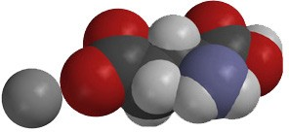
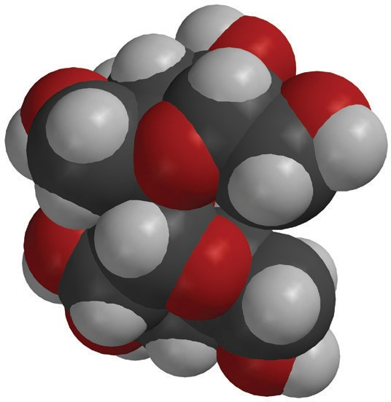
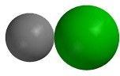
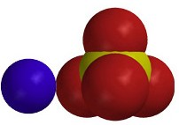
www.acs.org/middleschoolchemistry/simulations/chapter5/lesson5.html
Sodium chloride
Monosodium glutamate

Magnesium sulfate
Sucrose

Explain that because these substances are made up of different atoms and ions bonded together differently, they interact with water differently, giving them each their own characteristic solubility.

Salt
Remind students that sodium chloride is an ionic compound. There is a positive sodium ion (Na⁺) and a negative chloride ion (Cl–). Polar water interacts with these oppositely charged ions to dissolve the salt.

Epsom salt
Tell students that Epsom salt is an ionic compound. There is a positive magnesium ion (Mg²⁺) and a negative sulfate ion (SO^{2–}). Polar water interacts with these oppositely charged ions to dissolve the Epsom salt.

MSG
MSG is made of a positive sodium ion (Na⁺) and a negative glutamate ion, which has the molecular formula (C₅H₈NO–). Polar water interacts with these oppositely charged ions to dissolve the MSG.

Sugar
Sucrose is not an ionic compound. Sucrose has many O–H bonds, which give it positive and negative polar areas. These areas attract other sucrose molecules and hold them together in a crystal. These polar areas interact with water and cause entire sucrose molecules to separate from one another and dissolve.

EXTEND

Help students review the similarities and differences in the way salt and sugar dissolve in water.
Tell students that depending on the substance being dissolved, ions are separated from each other, or molecules are separated from each other. Salt and sugar are common examples of dissolving both types of solids.

Project the image Water Dissolves Salt.
www.acs.org/middleschoolchemistry/simulations/chapter5/lesson5.html
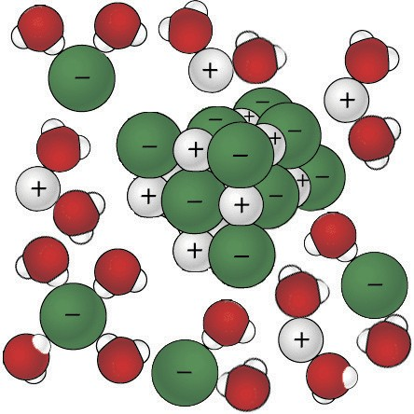
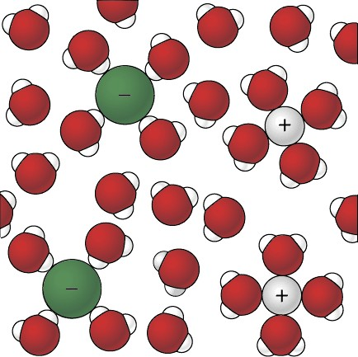
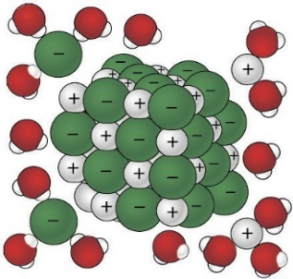
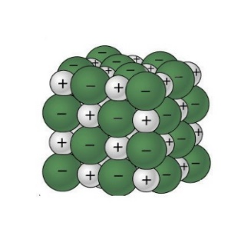

Ask students:

When salt dissolves, why are water molecules attracted to the sodium and chloride ions?
Sodium chloride is an ionic compound with a positive sodium ion (Na⁺) and a negative chloride ion (Cl–). Polar water interacts with these oppositely charged ions to get it to dissolve.
Project the image Water Dissolves Sugar.
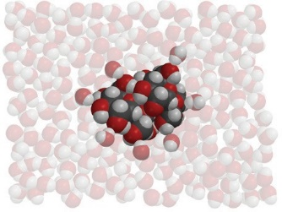
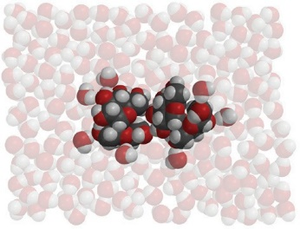
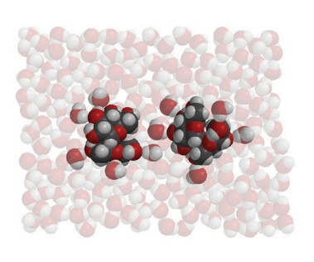
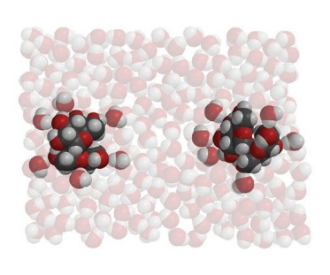
www.acs.org/middleschoolchemistry/simulations/chapter5/lesson5.html

Ask students:
  - When sugar dissolves, why are water molecules attracted to sucrose molecules?
Sucrose has many O–H bonds, which give it positive and negative polar areas. These areas attract other sucrose molecules and hold them together in a crystal. These polar areas interact with water and cause entire sucrose molecules to separate from one another and dissolve.

What are the similarities and differences between water dissolving salt and water dissolving sugar?
The sodium and chloride ions separate from one another and become surrounded by water molecules as they dissolve. Entire sucrose molecules separate from other sucrose molecules. The covalent bonds holding the atoms in the sucrose molecule do not come apart.

