Activity Sheet Name Chapter 5, Lesson 4
Why Does Water Dissolve Sugar? Date

INTRODUCTION

Question to Investigate
What happens to the sugar and color coating of an M&M when it is placed in water?

Materials
- Clear plastic cup
- Water
- M&M
- White paper
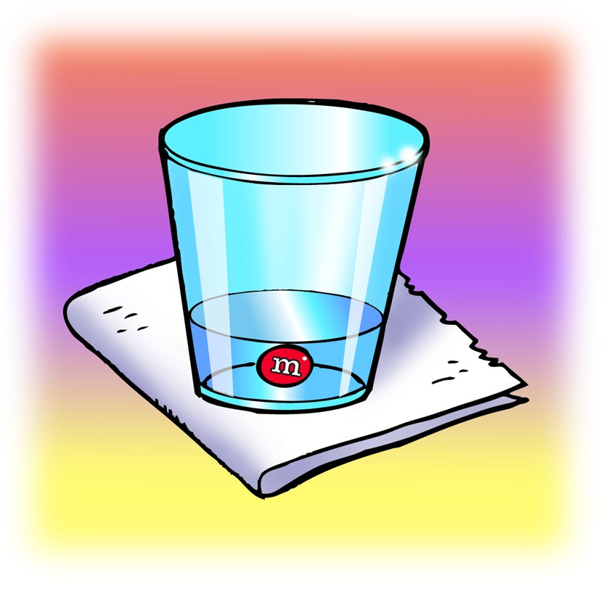

Procedure
- Pour enough room temperature water into a clear plastic cup so that the water is deep enough to completely cover an M&M and place this cup on a piece of white paper.
- Once the water has settled, place 1 M&M in the center of the cup. Be careful to keep the
water and M&M as still as possible. Observe for about 1 minute.

- What happens to the sugar and color coating when an M&M is placed in water?

- Knowing what you do about the polarity of water, why do you think water dissolves sugar?

EXPLAIN IT WITH ATOMS & MOLECULES
- Sucrose makes up the sugar we commonly use. The chemical formula for sucrose is C₁₂H₂₂O₁₁. What do these letters and numbers mean?

- What do the + and – signs around certain parts of the sucrose molecule mean?

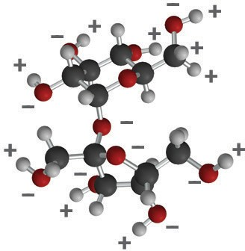
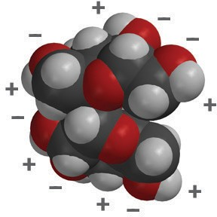
Sucrose ball-and-stick model
Sucrose space-filling model

- Look at the pictures below and describe what happens when water dissolves sucrose. Be sure to discuss the polarity of both water and sucrose.

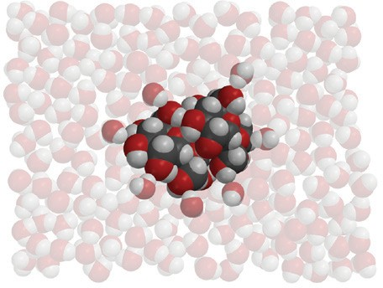
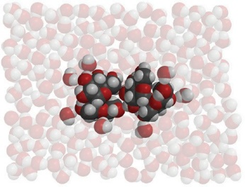
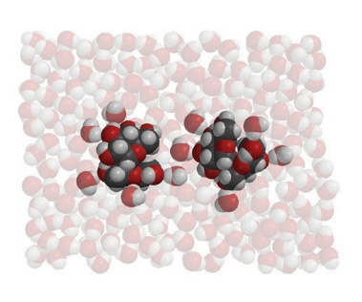
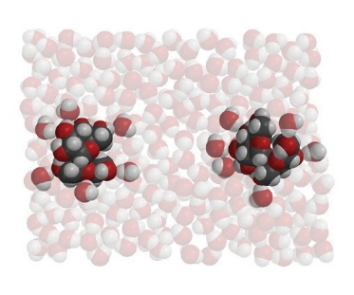

ACTIVITY

Question to Investigate
Is water, alcohol, or oil better at dissolving the color and sugar coating from an M&M?

Materials
  - 3 M&M’s (same color)
  - Water
  - Mineral oil
  - Isopropyl alcohol (70%)
  - 3 clear plastic cups
  - White paper

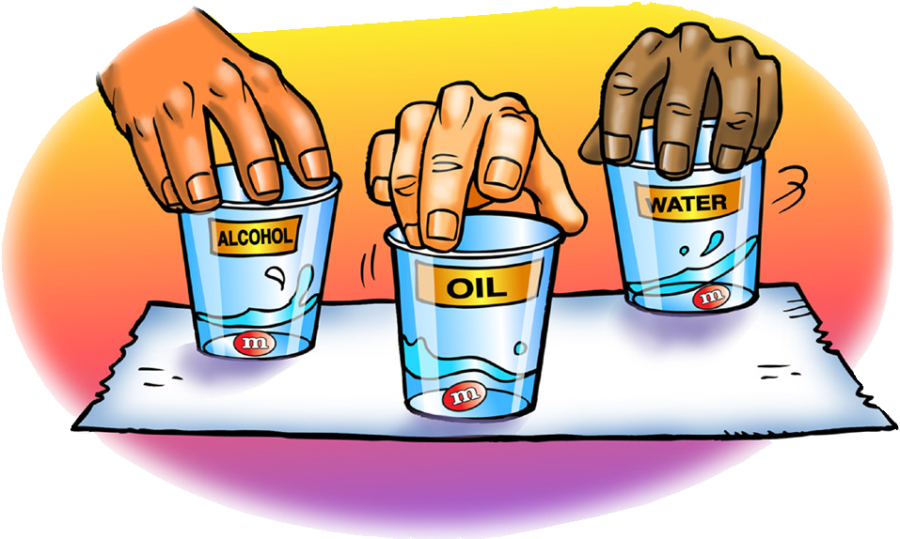
Procedure
- Label 3 cups Water, Alcohol, and Oil. Add 15 mL of water, alcohol, and mineral oil to their labeled cups.
- Place the three cups on a white sheet of paper.
- At the same time, add 1 M&M to each liquid. Then gently swirl the liquid and M&M in each cup for about 30 seconds.

- Draw a line from the solvent to the description to show how well each solvent dissolves the sugar and color coating of an M&M.
Water doesn’t dissolve the sugar and color at all.

Isopropyl alcohol dissolves the sugar and color very well.

Mineral oil dissolves a small amount of the sugar and color.

EXPLAIN IT WITH ATOMS & MOLECULES

The polarity of a solvent and how well sucrose dissolves in it
Solvent | How polar is the solvent?  nonpolar / slightly polar / very polar | How does the polarity of the solvent affect how well sucrose dissolves in it?
Water
Isopropyl alcohol
Oil

TAKE IT FURTHER
- Citric acid occurs naturally in fruits like oranges, lemons, and limes. It is dissolved in the water within the fruit and contributes to the fruit’s sour taste. When it isn’t dissolved in water, citric acid molecules are attracted to other citric acid molecules within a crystal.

The chemical formula for citric acid is C₆H₈O₇ and it is very soluble in water.
Why do you think citric acid is so soluble in water?

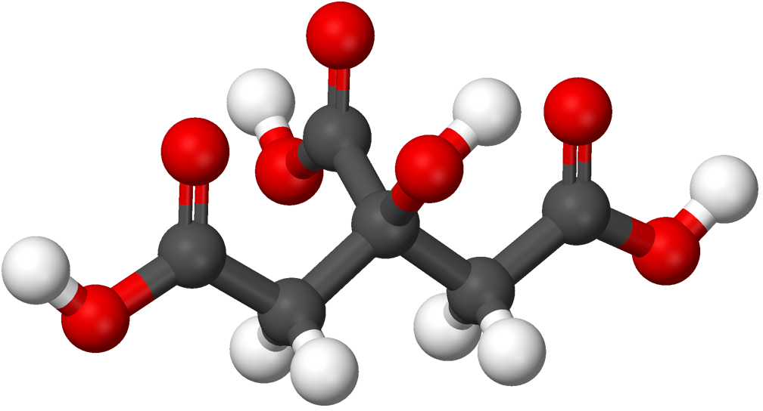
Ball-and-stick model of a citric acid molecule

