Chapter 4, Lesson 5: Energy Levels, Electrons, and Ionic Bonding
Key Concepts
- The attractions between the protons and electrons of atoms can cause an electron to move completely from one atom to the other.
- When an atom loses or gains an electron, it is called an ion.
- The atom that loses an electron becomes a positive ion.
- The atom that gains an electron becomes a negative ion.
- A positive and negative ion attract each other and form an ionic bond.

Summary
Students will look at animations and make drawings of the ionic bonding of sodium chloride (NaCl). Students will see that both ionic and covalent bonding start with the attractions of protons and electrons between different atoms. But in ionic bonding, electrons are transferred from one atom to the other and not shared like in covalent bonding. Students will use Styrofoam balls to make models of the ionic bonding in sodium chloride (salt).

Objective
Students will be able to explain the process of the formation of ions and ionic bonds.

Evaluation
The activity sheet will serve as the “Evaluate” component of each 5-E lesson plan. The activity sheets are formative assessments of student progress and understanding. A more formal summative assessment is included at the end of each chapter.

Safety
Be sure you and the students wear properly fitting goggles.

Materials for Each Group
- Black paper
- Salt
- Cup with salt from evaporated saltwater
- Magnifier
- Permanent marker

Materials for Each Student
- 2 small Styrofoam spheres
- 2 large Styrofoam spheres
- 2 toothpicks

Note: In an ionically bonded substance such as NaCl, the smallest ratio of positive and negative ions bonded together is called a “formula unit” rather than a “molecule.” Technically speaking, the term “molecule” refers to two or more atoms that are bonded together covalently, not ionically. For simplicity, you might want to use the term “molecule” for both covalently and ionically bonded substances.

ENGAGE

Show a video of sodium metal reacting with chlorine gas.
Project the video Sodium and chlorine react.
www.acs.org/middleschoolchemistry/simulations/chapter4/lesson5.html
Before starting the video, tell students that chlorine is a greenish poisonous gas and sodium is a shiny, soft, and very reactive metal. But when they react, they form sodium chloride (table salt). Tell students that in the video, the drop of water helps expose the atoms at the surface of the sodium so that they can react with the chlorine. The formation of the salt crystals releases a lot of energy.

Note: If students ask if the salt they eat is made this way in salt factories, the answer is no. The salt on Earth was produced billions of years ago but probably not from pure chlorine gas and sodium metal. These days, we get salt from mining it from a mineral called halite or from evaporating sea water.

EXPLAIN

Show an animation to introduce the process of ionic bonding.
Project the animation Ionic bond in sodium chloride.
www.acs.org/middleschoolchemistry/simulations/chapter4/lesson5.html
Remind students that in covalent bonding, atoms share electrons. But there is another type of bonding where atoms don’t share, but instead either take or give up electrons. This is called ionic bonding. This animation shows a very simplified model of how sodium and chloride ions are formed.

Note: In order to simplify the model of ionic bonding, a single atom of sodium and chlorine are shown. In reality, the chlorine atom would be bonded to another chlorine atom as part of the gas Cl₂. The sodium atom would be one of billions of trillions of sodium atoms bonded together as a solid. The combination of these substances is a complex reaction between the atoms of the two substances. The animation shows single separated atoms to illustrate the idea of how ions and ionic bonds are formed.

Explain what happens during the animation.
Tell students that the attraction of the protons in the sodium and chlorine for the other atom’s electrons brings the atoms closer together. Chlorine has a stronger attraction for electrons than sodium (shown by the thicker arrow). At some point during this process, an electron from the sodium is transferred to the chlorine. The sodium loses an electron and the chlorine gains an electron.

Tell students that when an atom gains or loses an electron, it becomes an ion.
- Sodium loses an electron, leaving it with 11 protons, but only 10 electrons. Since it has 1 more proton than electrons, sodium has a charge of +1, making it a positive ion.
- Chlorine gains an electron, leaving it with 17 protons and 18 electrons. Since it has 1 more electron than protons, chlorine has a charge of –1, making it a negative ion.
- When ions form, atoms gain or lose electrons until their outer energy level is full.
  - For example, when sodium loses its one outer electron from the third energy level, the second level becomes the new outer energy level and is full. Since these electrons are closer to the nucleus, they are more tightly held and will not leave.
  - When chlorine gains an electron, its third energy level becomes full. An additional electron cannot join, because it would need to come in at the fourth energy level. This far from the nucleus, the electron would not feel enough attraction from the protons to be stable.
  - Then the positive sodium ion and negative chloride ion attract each other and form an ionic bond. The ions are more stable when they are bonded than they were as individual atoms.

Have students describe the process of ionic bonding in sodium chloride on their activity sheet.
Give each student an activity sheet.
Have students write a short caption under each picture to describe the process of covalent bonding and answer the first three questions. The rest of the activity sheet will either be completed as a class, in groups, or individually depending on your instructions.
Project the image Ionic bond in sodium chloride.
www.acs.org/middleschoolchemistry/simulations/chapter4/lesson5.html

Review with students the process of ionic bonding covered in the animation.
Help students write a short caption beside each picture to describe the process of ionic bonding in sodium and chloride ions.
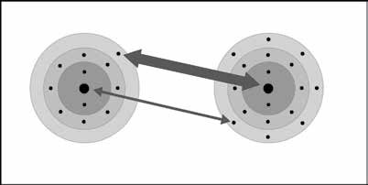
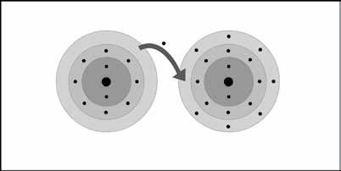
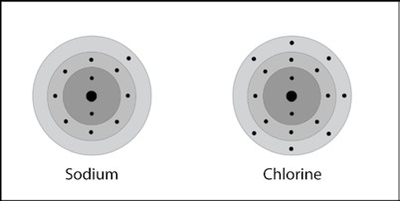
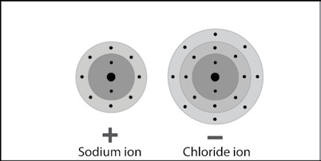
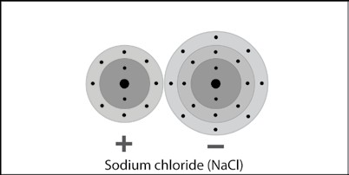
Sodium and chlorine atoms are near each other.

The protons of the two atoms attract the electrons of the other atom. The thicker arrow shows that chlorine has a stronger attraction for electrons than sodium has.

During the interactions between the atoms, the electron in sodium’s outer energy level is transferred to the outer energy level of the chlorine atom.

Since sodium lost an electron, it has 11 protons, but only 10 electrons. This makes sodium a positive ion with a charge of +1.

Since chlorine gained an electron it has 17 protons and 18 electrons. This makes chloride a negative ion with a charge of –1.

The positive sodium ion and negative chloride ion attract one another. They make an ionic bond and form the ionic compound NaCl.

4. Show students a model of a sodium chloride crystal and have them identify the ions.
Project the image Sodium chloride crystal.
www.acs.org/middleschoolchemistry/simulations/chapter4/lesson5.html
Review with students the process of ionic bonding covered in the animation so that students will understand why the sodium ions are positive and the chloride ions are negative. Remind students that the scale of any model of atoms, ions, or molecules is enormous compared to the actual size. In a single grain of salt there are billions of trillions of sodium and chloride ions.

Ask students:

What ion is the larger ball with the negative charge?
The chlorine ion.

What made it negative?
It gained an electron.

What is the ion with the positive charge?
The sodium ion.

What made it positive?
It lost an electron.

EXPLORE

5. Have students observe actual sodium chloride crystals and relate their shape to the molecular model.
This two-part activity will help students see the relationship between the arrangement of ions in a model of a sodium chloride crystal and the cubic shape of real sodium chloride crystals.

Question to investigate:

Why are salt crystals cube-shaped?

Teacher preparation
The day before the lesson, dissolve about 10 grams of salt in 50 ml of water. Use Petri dishes or use scissors to cut down 5 or 6 clear plastic cups to make shallow plastic dishes. Pour enough saltwater to just cover the bottom of each dish (1 for each group). Leave the dishes overnight to evaporate so that new salt crystals will be produced.

Materials for each group
  - Black paper
  - Salt
  - Cup with salt from evaporated saltwater
  - Magnifier
  - Permanent marker

Materials for each student
  - 2 small Styrofoam spheres
  - 2 large Styrofoam spheres
  - 2 toothpicks

Procedure, Part 1
Observe sodium chloride crystals.
- Place a few grains of salt on a piece of black paper. Use your magnifier to look closely at the salt.
- Use your magnifier to look at the salt crystals in the cup.

Project the image Cubic sodium chloride.
www.acs.org/middleschoolchemistry/simulations/chapter4/lesson5.html
The image shows both a magnified view of ordinary table salt and a model of the sodium and chloride ions that make up a salt crystal.
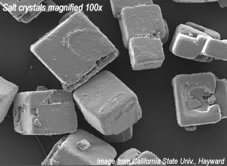
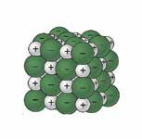

Project the animation Sodium chloride.
www.acs.org/middleschoolchemistry/simulations/chapter4/lesson5.html
The green spheres represent negatively charged chloride ions and the gray spheres represent positively charged sodium ions.

Ask students:

What do the photograph, molecular model, and your observations of real salt crystals tell you about the structure of salt?
In each case, the salt seems to be shaped like a cube.

Have students build a 3-dimensional model of sodium chloride.
Each student will make 1 unit of sodium chloride. Students in each group will put their sodium chloride units together.
You can help the groups combine their structures into a class model of a sodium chloride crystal.

Procedure, Part 2
Make NaCl units.
  - Use the marker to put a “–” on the large spheres which represent chloride ions.
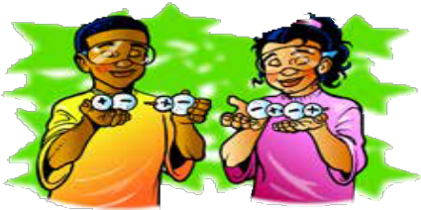
  - Use the marker to put a “+” on the small spheres, which represent sodium ions.
  - Break two toothpicks in half. Use one of the half-toothpicks to connect the centers of the small and large ions together to make a unit of sodium chloride (NaCl). Do the same thing with the other small and large spheres.
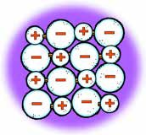
  - Use another half-toothpick to connect the two NaCl units in a straight line as shown.

Put NaCl ions together to make one layer of ions.
  - Contribute your line of ions to your group and arrange them to make a 4×4 square of ions.
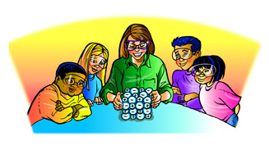
  - Use half-toothpicks to attach the ends of each line to hold the ions together. You only need to place toothpicks in the balls at the end of each line.

Build a class sodium chloride crystal.
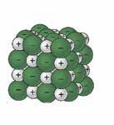
  - Give your group’s layer of ions to your teacher. Your teacher will stack these to build a model of a sodium chloride crystal.
Point out that anywhere you look on the crystal, a sodium ion
and a chloride ion are always surrounded by the oppositely charged ion. These opposite charges hold the ions together in a crystal.

Ask students

Based on the way sodium and chloride ions bond together, why are salt crystals shaped like cubes?
The size and arrangement of the ions forms a cube on the molecular level. Since the pattern repeats over and over again in the same way, the shape stays the same even when the crystal becomes the normal size that we can see.

EXTEND

Show students how calcium and chlorine atoms bond to form the ionic compound calcium chloride.
Tell students that there is another common substance called calcium chloride (CaCl₂). It is the salt that is used on icy sidewalks and roads. Explain that when calcium and chlorine react, they produce ions, like sodium and chlorine, but the calcium ion is different from the sodium ion.

Ask students:

What ions do you think CaCl₂ is made of?
One calcium ion and two chloride ions.

Project the animation Calcium chloride Ionic Bond.
www.acs.org/middleschoolchemistry/simulations/chapter4/lesson5.html
Point out that the calcium loses two electrons, becoming a +2 ion. Each of the two chlorine atoms gains one of these electrons, making them each a –1 ion. Help students realize that 1 calcium ion bonds with 2 chloride ions to form calcium chloride (CaCl₂), which is neutral.

Some atoms gain or lose more than 1 electron. Calcium loses 2 electrons when it becomes an ion. When ions come together to form an ionic bond, they always join in numbers that exactly cancel out the positive and negative charge.

Project the image Calcium chloride Ionic Bond .
www.acs.org/middleschoolchemistry/simulations/chapter4/lesson5.html
Review with students the process of ionic bonding covered in the animation.

Have students write a short caption beneath each picture to describe the process of ionic bonding in sodium and chloride ions.

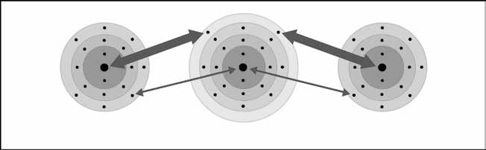
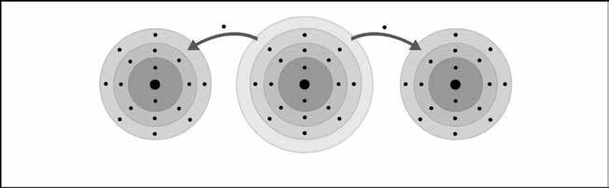
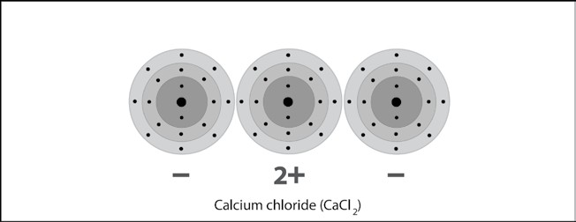
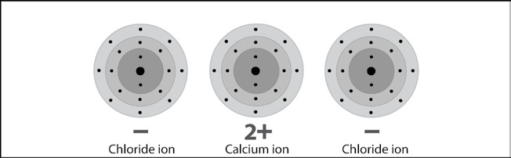
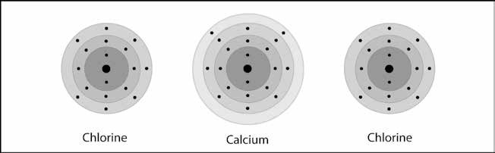
The protons of the calcium atom attract the electrons from the chlorine atom. The protons of the two chlorine atoms attract the electrons from the calcium atom more strongly as shown by the thicker arrows.

During the interactions between the atoms, the two electrons in calcium’s outer energy level are transferred to the outer energy level of each of the chlorine atoms.

Since calcium lost two electrons, it has 20 protons, but only 18 electrons. This makes calcium a positive ion with a charge of 2+.

Since each chlorine atom gained an electron, they each have 17 protons and 18 electrons. This makes each chloride a negative ion with a charge of –1.

Oppositely charged ions attract each other, forming an ionic bond. The bonded ions are more stable than the individual atoms were.
One calcium atom and two chlorine atoms are near each other.

