Activity Sheet Answers
Chapter 4, Lesson 5
Energy Levels, Electrons, and Ionic Bonding

EXPLAIN IT WITH ATOMS & MOLECULES
- What is the basic difference between covalent and ionic bonding?
In covalent bonding, each atom attracts the other atom’s electrons and electrons from each atom end up being shared by both atoms. In ionic bonding, the attractions are less balanced, and electrons are attracted by one atom significantly more than another. One or more electrons ends up being transferred to the atom with the stronger attraction. This creates a positive and a negative ion which attract and form an ionic bond.

- Write a short caption beside each picture to describe the process of ionic bonding.

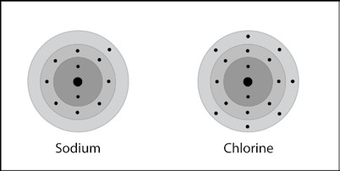
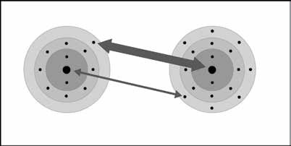
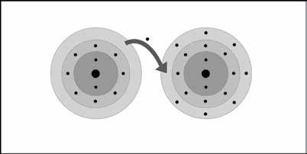
Sodium and chlorine atoms are near each other.
The chlorine attracts an electron from the sodium more strongly than the sodium attracts an electron from the chlorine.
An electron is transferred from the sodium to the chlorine.

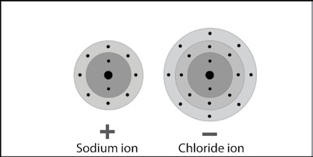
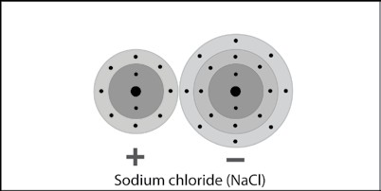
Since the sodium loses and electron, it has one more proton than electrons and becomes a positive ion. Since the chlorine gains an electron, it has one more electron than protons and becomes a negative ion.
The oppositely charged ions attract and form an ionic bond to make sodium chloride.

ACTIVITY
- Knowing what you do about sodium and chloride ions, why are salt crystals cube-shaped?
Salt crystals are cube-shaped because the sodium and chloride ions bond together in an alternating pattern in three dimensions.

TAKE IT FURTHER
- Write a short caption beneath each picture below and on the next page to describe the process of ionic bonding. The first one is done for you below.

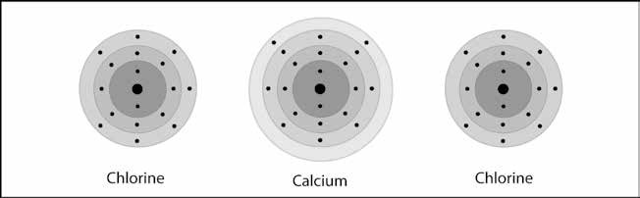
One calcium and two chlorine atoms are near each other.

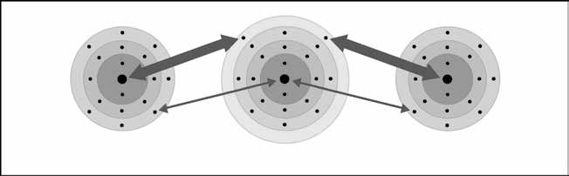

Each chlorine atom attracts an electron from the calcium more strongly than the calcium attracts the electron from the chlorine.

Each chlorine atom receives an electron donated from calcium. This forms three ions.

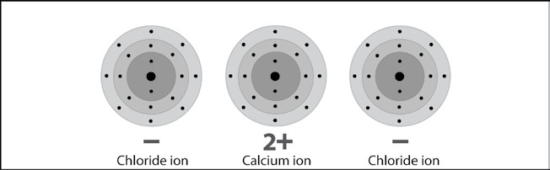

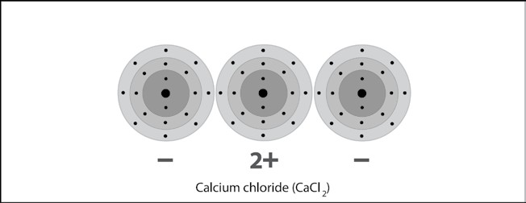
The positive and negative ions attract each other and form an ionic bond to make calcium chloride.
Since each chlorine atom gains an electron each becomes a negatively charged chloride ion. Since the calcium atom loses two electrons it becomes a +2 calcium ion.

