Activity Sheet Answers
Chapter 4, Lesson 4
Energy Levels, Electrons, and Covalent Bonding

EXPLAIN IT WITH ATOMS & MOLECULES
- Write a short caption under each picture to describe the process of covalent bonding.
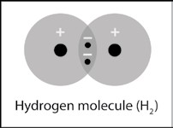
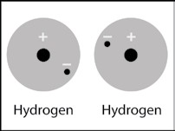
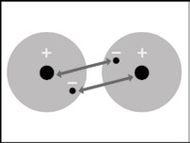
Two hydrogen atoms are near each other.
TT The electron from each hydrogen atom feels an attraction from the proton in the other atom.

The attractions bring the two hydrogen atoms together and the electrons are shared by both atoms making a covalent bond.

- What are two conditions atoms must have to form covalent bonds with one another?
There has to be strong enough attraction by the protons in each atom for the electrons in the other atom. And there must be room for the electrons on the outer energy level of both atoms.
- Why is a hydrogen molecule (H₂) more stable than two individual hydrogen atoms?
The electrons form a covalent bond which means that each electron can be near two protons instead of just 1. In a covalent bond, the electrons are shared between the two atoms.

- Why can’t a third hydrogen atom join the H₂ molecule to make H₃?
A hydrogen molecule (H₂) is made up of two hydrogen atoms sharing two electrons on the first energy level. If another hydrogen atom comes along, the electron from that hydrogen atom cannot be shared on the first energy level because there is no room. It would have to be further away from the nucleus and would not feel a strong enough attraction. Also, the electrons in the H₂ molecule would not feel a strong enough attraction to that one proton to move further away from the two protons they are attracted to.

- Write a short caption beside each picture to describe the process of covalent bonding.
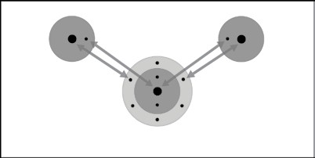
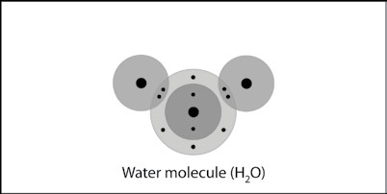
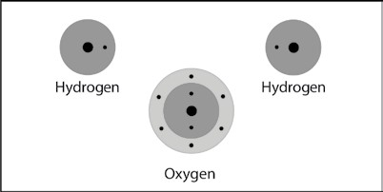
Two hydrogen atoms and one oxygen atom are near each other.
The electrons in each hydrogen atom feel the attraction of the protons in the oxygen atom.

And the electrons on the outer energy level of oxygen feel the attraction for the proton from hydrogen.
The attractions bring the atoms together in a covalent bond.

- Why can’t a third hydrogen atom join the water molecule (H₂0) to make H₃O?
If another hydrogen atom comes along, the electron from that hydrogen atom cannot be shared on the second energy level of oxygen because there is no room. It would have to be further away from the nucleus and would not feel a strong enough attraction. Also, the electrons already in the H₂O molecule would not feel a strong enough attraction to that one proton to move further away from the protons they are already attracted to.

ACTIVITY

- What were the bubbles made out of in this activity?
The bubbles that formed in the solution were Hydrogen gas (H₂) and Oxygen gas (O₂).

- Why was there more hydrogen gas produced than oxygen gas?
HINT: Look back at the drawings showing the number of hydrogen and oxygen atoms that bond to form a water molecule.
More hydrogen gas was produced because each water molecule contains more hydrogen than it does oxygen. In one water molecule, there are two hydrogen atoms, while there is only one oxygen atom.

TAKE IT FURTHER

- Briefly describe the process of covalent bonding between two oxygen atoms to make an oxygen molecule. Be sure to mention attractions between electrons and protons and the number of electrons in the outer energy level for the atoms in the final molecule.
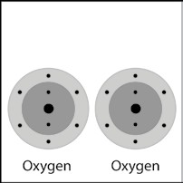
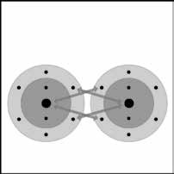
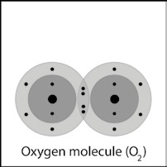
Each oxygen atom has 6 electrons in its outer energy level.
Electrons from each oxygen atom feel an attraction from protons in the other atom.

The attractions bring the two oxygen atoms together to make a double covalent bond which forms an oxygen molecule from the two oxygen atoms.

- Briefly describe the process of covalent bonding between the carbon and the four hydrogen atoms to make a methane molecule. Be sure to mention attractions between electrons and protons and the number of electrons in the outer energy level for the atoms in the final molecule.

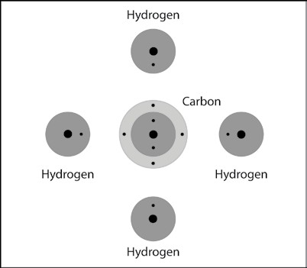
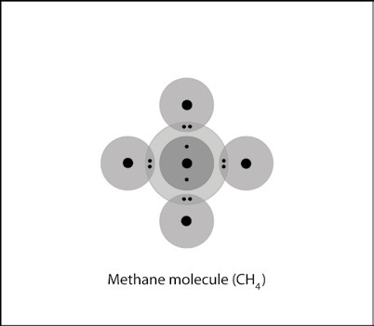
Initially, each Hydrogen atom has a single outermost electron, while the carbon atom has four outermost electrons.

Electrons within the hydrogen atoms and the central carbon atom feel an attraction from protons in the other atom.

The attractions bring the atoms together to form four covalent bonds. Each hydrogen atom now has 2 electrons in its outer energy level, while the carbon atom has 8 electrons in its outer energy level.

- Briefly describe the process of covalent bonding between the carbon and the two oxygen atoms to make a carbon dioxide molecule. This molecule has two double bonds. Be sure to mention attractions between electrons and protons and the number of electrons in the outer energy level for the atoms in the final molecule.
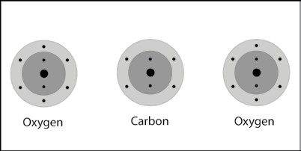
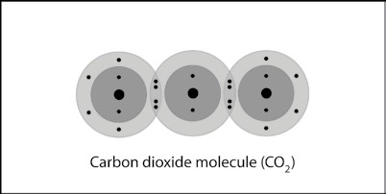
Initially, each oxygen atom has 6 outermost electrons, while the carbon atom has four outermost electrons.

Electrons within the oxygen atoms and the carbon atom feel an attraction from protons in the other atom.

The attractions bring the atoms together to form two double covalent bonds. Each atom now has 8 electrons in its outer energy level.

