Test Bank - Chapter 4
The questions in the test bank cover the concepts from the lessons in Chapter 4. Select questions from any of the categories that match the content you covered with students. The types of questions include multiple choice, true/false, fill-in-the-blank, and short answer.

Multiple Choice

- Protons are located in the nucleus of the atom. A proton has
  - No charge
  - A negative charge
  - A positive and a negative charge
  - A positive charge

- Neutrons are in the nucleus of the atom. A neutron has
  - A positive charge
  - No charge
  - A negative charge
  - Twice as much positive charge as a proton

- An electron is in a region outside the nucleus. An electron
  - Is larger than a proton and has no charge
  - Has less mass than a proton and has a negative charge
  - Is smaller than a proton and has no charge
  - Has a positive charge

- A hydrogen atom is made up of one proton and one electron. The proton and electron stay near each other because
  - Positive and negative charges repel
  - Positive and positive charges repel
  - Positive and negative charges attract
  - Two negatives make a positive

- The atomic number of an atom is
  - The mass of the atom
  - The number of protons added to the number of neutrons
  - The number of protons in the atom’s nucleus
  - Negatively charged

- The atoms of the same element can have different isotopes. An isotope of an atom
  - Is an atom with a different number of protons
  - Is an atom with a different number of neutrons
  - Is an atom with a different number of electrons
  - Has a different atomic number

- The atomic mass of an element is
  - The average mass of all the isotopes of that element
  - A measure of the density of that element
  - The mass of the most common isotope of that element
  - The number of protons and electrons in the atoms of the element

- An element and an atom are different but related because
  - A particular element is made up of many different types of atoms
  - A molecule is the same as an atom
  - An element is made up of all the same type of atom
  - An element is smaller than an atom

- The periodic table shows that a carbon atom has six protons. This means that a carbon atom also has
  - Six electrons
  - Six neutrons
  - More protons than electrons
  - An atomic mass that equals six

- The atomic number of nitrogen is 7. The atomic mass is 14.01. This means that
  - All nitrogen atoms have exactly 7 neutrons.
  - A small percentage of nitrogen atoms have fewer than 7 neutrons
  - A small percentage of nitrogen atoms have more than 7 neutrons
  - Some nitrogen atoms have fewer than 7 electrons

- Electrons are in regions around the nucleus called energy levels. The first energy level
  - Is furthest from the nucleus
  - Is closest to the nucleus
  - Holds the most electrons
  - Needs more than two electrons to fill it up

- Neon has 10 protons and 10 electrons. The electrons fill the energy levels in Neon like this:
  - 2 in the first, 2 in the second, and 6 in the third
  - 4 in the first, 4 in the second, and 2 in the third
  - 2 in the first, 4 in the second, and 4 in the third
  - 2 in the first, and 8 in the second

- The atoms in a column of the periodic table all have
  - The same abbreviation
  - The same number of energy levels
  - The same number of electrons
  - The same number of electrons in the outer energy level

- In the process of covalent bonding, atoms share electrons. This means that
  - Electrons from each atom are attracted to the nucleus of both atoms
  - Protons and neutrons attract
  - Atoms lose electrons and become ions
  - Atoms gain electrons and become ions

- In the process of ionic bonding
  - Both atoms gain electrons
  - One atom gains one or more electrons and the other loses the same number
  - Atoms switch protons
  - Both atoms lose electrons

- In the process of ionic bonding, ions come together because
  - Opposite charges repel
  - Positive and negative ions attract
  - Salt is magnetic
  - Like charges attract each other

Chapter 4
Multiple Choice Answers

- d  - b  - b  - c  - c  - b  - a  - c  - a | - c  - b  - d  - d  - a  - b  - b

True/False and Fill-in-the-blank

True or false?
Electrons are found in the nucleus of an atom. False

True or false?
Neutrons and electrons are attracted to one another. False

The atomic number of an atom is equal to the number of _____ in the atom’s
. protons, nucleus
Different atoms of the same element can have a different number of . neutrons The electrons of an atom are located in regions around the nucleus called _______.
energy levels

True or false?
The first energy level of atom is closest to the nucleus. True

True or false?
In a covalent bond, electrons are shared between two atoms. True

The electrons on the outermost energy level of an atom are called ___ electrons. valence

True or false?
In an ionic bond, electrons are shared between two atoms. False When an atom loses an electron, it forms a ion. positive When an atom gains an electron, it forms a ion. negative
True or false?
It is possible to have double covalent bond. True

Short Answer

What are the three common subatomic particles? Where are they found within an atom? What charge do they have?
The three common particles are protons, neutrons and electrons. Protons and neutrons are found in the atom’s nucleus and electrons are in regions outside the nucleus. Protons have a positive charge, electrons have a negative charge, and neutrons have no charge.

When you charged a strip of plastic by rubbing it through your fingers or on cloth, you transferred electrons onto the plastic strip. Using the terms “electrons” and “protons”, and “negative” and “positive”, explain why the strip was attracted to your fingers or the cloth you rubbed it on.
If electrons were transferred to the plastic, the plastic has extra electrons and becomes negative, since electrons are negative. If my fingers lost electrons, they would have more protons than electrons and become positive. Positive and negative attract.

When you rub a balloon on your hair, electrons are transferred from your hair onto the balloon. Using the terms “electrons” and “protons”, and “negative” and “positive”, explain why a rubbed balloon is attracted to and sticks to a wall even though you didn’t rub the balloon on the wall.
Since the balloon has extra electrons from being rubbed on your hair, the balloon is negatively charged. When you bring it over to the wall, the negative balloon repels the negative electrons in the wall and leaves an area of positive charge. The negative balloon is then attracted to the positive wall.

Why can atoms of the same element have slightly different atomic masses?
Atoms of the same element all have the same number of protons but they can have different numbers of neutrons. This is why different atoms of the same element can have different atomic masses.

What is the difference between the atomic number and atomic mass of an element in the periodic table?
The atomic number is the number of protons in the nucleus of the atoms in that element. The atomic mass is the average mass of the different isotopes of that element.

If you know the atomic number of an element in the periodic table, do you also know the number of neutrons in any atom of that element? Explain.
No, because different atoms of the same element can have different numbers of neutrons. These are called isotopes.

Magnesium’s atomic number is 12. Magnesium’s atomic mass is 24.30. If all magnesium atoms had 12 neutrons, its atomic mass would be about 24.00. If all magnesium atoms had 13 neutrons, its atomic mass would be about 25.00. Explain why the atomic mass of magnesium is between 24 and 25.
It is because some magnesium atoms have 12 neutrons and some have 13 neutrons. These are different isotopes of magnesium. The atomic mass is the average of these different isotopes so it is a number between 24 and 25.

What are the “energy levels” of an atom?
The energy levels of an atom are the regions around the nucleus where electrons are likely to be found. The different energy levels hold a different number of electrons.

What is special about valence electrons?
Valence electrons are the electrons that are in the outermost energy level of the atom. These are the electrons that are involved in bonding.

If you know that an atom has 6 electrons on the second energy level and no electrons on the third energy level, explain how you know that this atom must be oxygen.
The atom must have 8 electrons because it has 2 electrons in the first energy level and 6 in the second. An atom with 8 electrons in the periodic table also has 8 protons. An atom with 8 protons has an atomic number of 8, and that is oxygen.

Look at the elements in a vertical column (group) in the energy level models shown. What do you notice about the number of electrons in the outermost energy level (valence electrons)? What does this tell you about how the atoms in a group react?
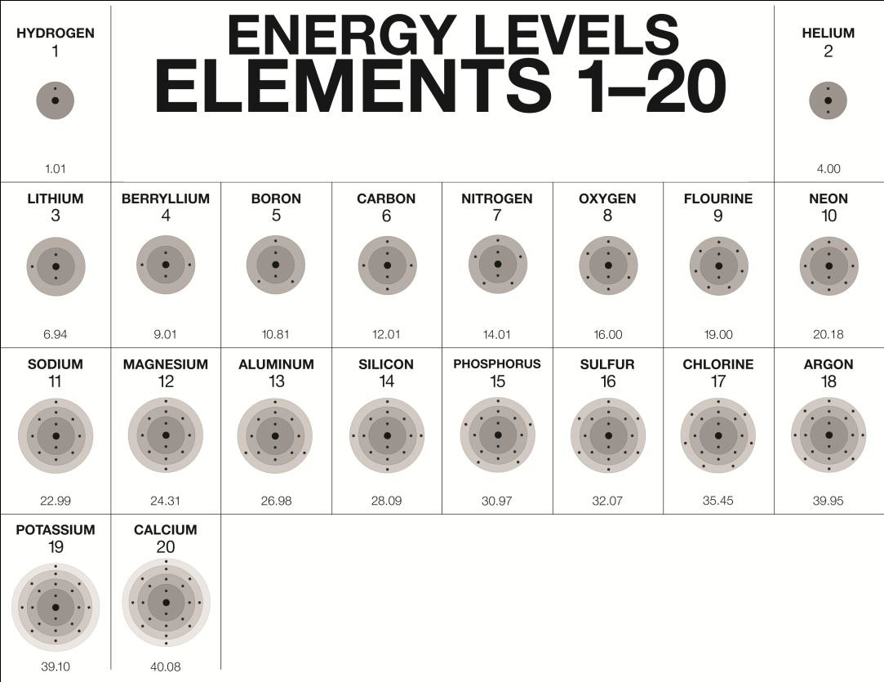
The atoms in a group have the same number of valence electrons. These electrons are involved in chemical reactions, so atoms with the same number of valence electrons tend to react in similar ways.

What does it mean for two atoms to be covalently bonded?
Atoms covalently bond when electrons from each atom are attracted to the other atom’s nucleus but are also attracted to the nucleus of their own atom. These attractions bring the atoms together and the electrons end up being attracted to both nuclei and are shared between them.

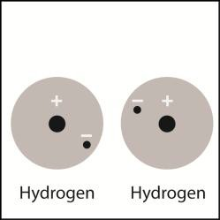
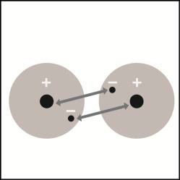
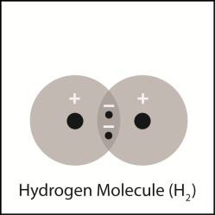
Use the illustrations to explain what causes two hydrogen atoms to come together to form the covalently bonded hydrogen molecule (H₂).

The electron in each atom is attracted to its own proton (not shown by an arrow) and is also attracted to the proton in the other atom (shown by arrows). These attractions bring the atoms together.

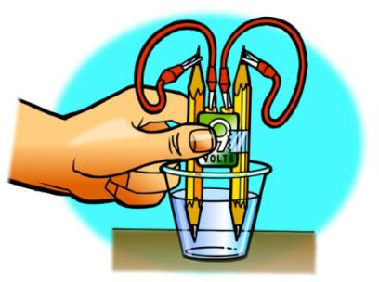
If you put an electric current through water, the electricity can cause the covalently boded oxygen and the hydrogen atoms to come apart. This process releases oxygen gas (O₂) and hydrogen gas (H₂). Think about the formula for water (H₂O) and explain why this process produces more hydrogen gas than oxygen gas.

Since the formula for water is H₂O, there are twice as many hydrogen atoms as oxygen atoms in a sample of water. If the water molecules are broken up to make hydrogen gas (H₂) and oxygen gas (O₂) there are twice as many hydrogen atoms so there should be twice as much H₂ gas as O₂ gas.

What is an ion and how is it formed?
An ion is an atom that has gained or lost one or more electrons. An ion is formed when one atom has a stronger attraction for electrons than the other atom which causes one or more electrons to be transferred to the atom with the stronger attraction.

Assume that two atoms interact and become ions. Explain why the atom that loses an electron becomes a positively charged ion, and the atom that gains an electron becomes a negatively charged ion.
Since atoms start with the same number of protons as electrons, an atom that loses an electron will have one extra proton and be positive. The atom that gained the electron will have one extra electron and be negative.

How is ionic bonding different than covalent bonding?
In an ionic bond, electrons have been lost by one atom and gained by the other. The atom that loses the electron becomes positively charged and the atom that gains an electron becomes negatively charged. The positive and negative ions attract and bond. In covalent bonding, the electrons are not gained or lost – they are shared between the atoms.

Use the series of pictures below to explain what happens between sodium (Na) and chlorine (Cl) atoms to make an ionic bond to form sodium chloride (NaCl).
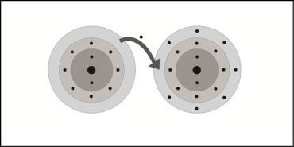
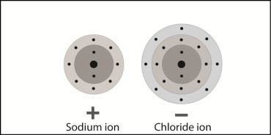
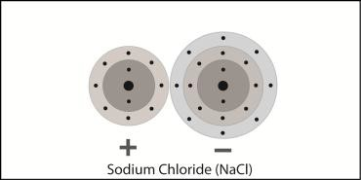
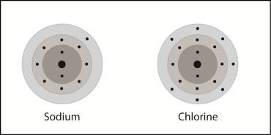
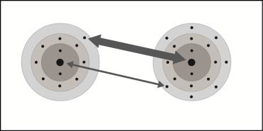

Chlorine’s attraction for an electron in sodium is stronger than sodium’s attraction for an electron in chlorine. An electron is transferred to chlorine which makes chlorine a negative ion. Since sodium lost an electron, it becomes a positive ion. Positive and negative ions attract and form an ionic bond.

