Activity Sheet Name Chapter 3, Lesson 5
Density: Sink and Float for Liquids Date

DEMONSTRATION

- Your teacher showed you one candle floating in water and another identical candle sinking in alcohol.
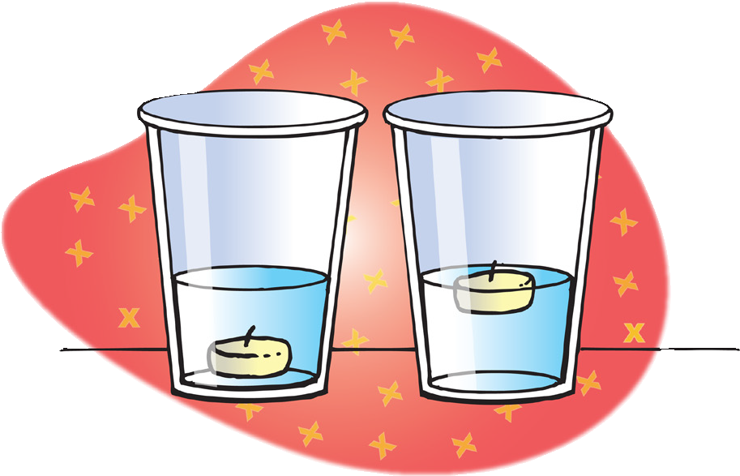
Do water and alcohol have the same or different densities?

Which liquid is more dense?

How do you know?

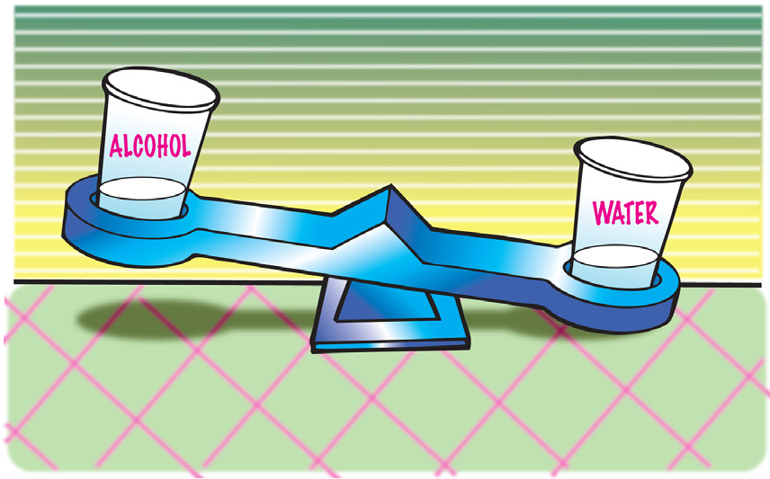
- Your teacher placed equal volumes of water and alcohol on a balance.

Explain how this demonstration proves that water is more dense than alcohol. Be sure to mention both volume and mass.

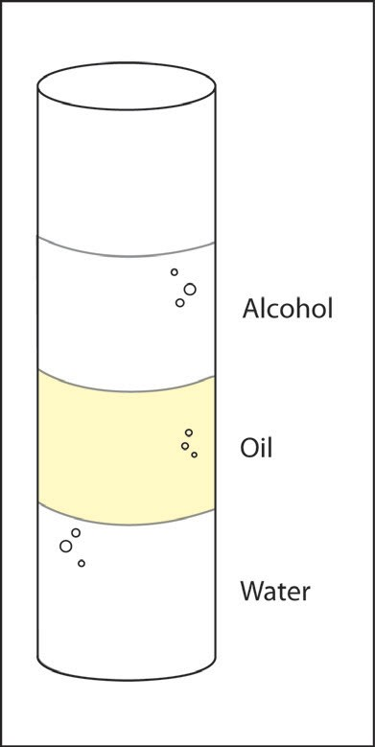

- Your teacher showed you a graduated cylinder with alcohol, oil, and water.

Why does the alcohol float on the oil?

Why does the water sink in the oil?

ACTIVITY

Question to investigate
Why does water sink in oil, and alcohol float in oil?

Materials for each group
- Water
- Vegetable oil
- Isopropyl alcohol
- Graduated cylinder
- Balance that measures in grams

Procedure
  - Find the mass of an empty graduated cylinder. Record the mass in grams in the chart on the activity sheet.
  - Pour 20 mL of water into the graduated cylinder. Try to be as accurate as possible by checking that the meniscus is right at the 20-mL mark.
  - Weigh the graduated cylinder with the water in it. Record the mass in grams.
  - Find the mass of only the water by subtracting the mass of the empty graduated cylinder. Record the mass of 20 mL of water in the chart.
  - Use the mass and volume of the water to calculate density. Record the density in g/cm³ in the chart.
  - Follow steps 2–5 for alcohol and then oil. Be sure to measure the oil last because it does not rinse easily from the graduated cylinder.

 | Water | Alcohol | Oil
Mass of graduated cylinder + liquid (g)
Mass of empty graduated cylinder (g)
Mass of liquid (g)
Density of liquid (g/cm³)

- How do the densities you calculated explain why water sinks in oil and alcohol floats on oil?

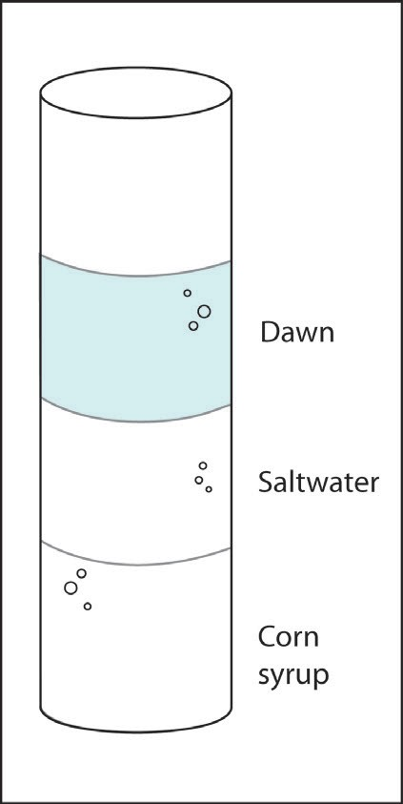
- Look at the layered liquids in the illustration. Write most, least, or in-between in the chart below to describe the density of each liquid.

Liquid | Density
Dawn
Saltwater
Corn syrup

EXPLAIN IT WITH ATOMS & MOLECULES

- Water molecules are smaller and have less mass than alcohol and oil molecules. Explain why water is more dense than alcohol and oil.

TAKE IT FURTHER
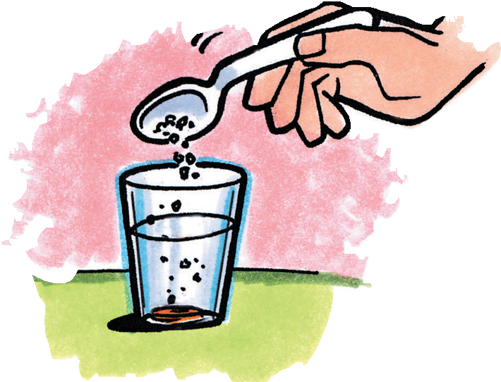
- A carrot slice sinks in water and floats in saltwater.

Is the carrot more dense or less dense than water?

Is the carrot more dense or less dense than saltwater?

- Does adding salt change the density of the water?

How do you know?

- What would you expect if you placed equal volumes of water and saltwater on opposite ends of a balance?

- Adding salt to water increases both its mass and volume; which do you think it increases more, the mass of the water or the volume? Explain Why.

