Chapter 3, Lesson 2:
Finding Volume—The Water Displacement Method
Key Concepts
- A submerged object displaces a volume of liquid equal to the volume of the object.
- One milliliter (1 mL) of water has a volume of 1 cubic centimeter (1 cm³).
- Different atoms have different sizes and masses.
- Atoms on the periodic table are arranged in order according to the number of protons in the nucleus.
- Even though an atom may be smaller than another atom, it might have more mass.
- The mass of atoms, their size, and how they are arranged determine the density of a substance.
- Density equals the mass of the object divided by its volume; D = m/v.
- Objects with the same mass but different volume have different densities.
Summary
Students use the water displacement method to find the volume of different rods that all have the same mass. They calculate the density of each rod and use the characteristic density of each material to identify all five rods. Then students consider the relationship between the mass, size, and arrangement of atoms to explain why different rods have different densities. Students will be briefly introduced to the periodic table.
Objective
Students will be able to explain that materials have characteristic densities because of the different mass, size, and arrangement of their atoms. Students will be able to use the volume displacement method to find the volume of an object.
Evaluation
The activity sheet will serve as the “Evaluate” component of each 5-E lesson plan. The activity sheets are formative assessments of student progress and understanding. A more formal summative assessment is included at the end of each chapter.
Safety
Make sure you and your students wear properly fitting goggles.
Materials for Each Group
- Set of 5 different rods that all have the same mass
- Graduated cylinder, 100 mL
- Water in a cup
- Calculator

Notes about the materials:
For this lesson you will need a set of five solid rods, each with the same mass, same diameter, but a different volume. Each rod is made of a different material. There are several versions of these rods available from different suppliers. This activity uses the Equal Mass Kit from Flinn Scientific but can be adapted to any set of equal mass rods. Since there are only five samples in the Equal Mass kit, you may need two kits so that each group can work with a sample.
This chart will help you identify each rod. Do not reveal this information to the students. They will discover the identity of each rod and the inverse relationship between the density and the length of each rod later in this lesson.
Sample | Material | Approximate density (g/cm³) | Relative length
Smallest metal | Brass | 7.5 | shortest  longest
Shiny gray metal | Aluminum | 3.0
Dark gray | PVC | 1.4
Tall off-white | Nylon | 1.1
Tallest white | Polyethylene | 0.94

ENGAGE

Show students five rods that have the same mass but different volumes.
Show students the five rods and explain that they all have the same mass. Then hold up the longest, middle-sized, and shortest rods and remind students that they have the same mass.
Ask students to make a prediction:

Which rod is the most dense? Least dense? In between?
Students may reason that since the mass of each rod is the same, the volume of each rod must have something to do with its density. Some may go so far as to say that the rod with the smallest volume must have the highest density, because the same mass is packed into the smallest volume. Or that the rod with the largest volume must have the lowest density, because the same mass is spread out over the largest volume.
Tell students that like the cubes in the previous activity, they will need to know the volume and mass of each of the samples. They will also calculate the density of each sample and use this value to figure out which material each rod is made from which material.

Show an animation and demonstrate how to measure volume using the water displacement method.
Project the animation Water Displacement. www.acs.org/middleschoolchemistry/simulations/chapter3/lesson2.html
Play the animation as you demonstrate the water displacement method using a cup of water, a graduated cylinder, and a rod, the way students will do in the activity. Use the dark gray plastic sample so that students can see it better.

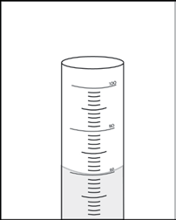
Volume
- Demonstrate what students will do by pouring water from a cup into a 100-mL graduated cylinder until it reaches a height that will cover the sample. This is the “initial water level.”
- Tell students that the surface of water in a tube may not be completely flat. Instead, the surface may curve in a shallow U-shape called the meniscus. When measuring, read the line just at the bottom of the meniscus.
- Tilt the graduated cylinder and slowly slide the sample into the water. Hold the graduated cylinder upright. Record the level of the water. Point out that this is the “final water level.”

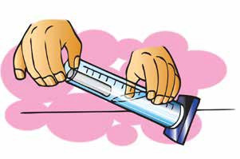

- Tell students that you want to find out how much the water level changed. Subtract the initial water level from the final water level to find the volume of the rod.
  - Volume of sample = final water level – initial water level

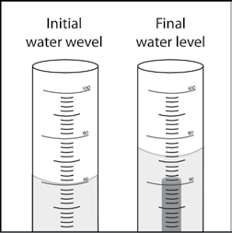

Students may be confused that the unit for volume in the graduated cylinder is milliliters (mL), when in the previous lesson students calculated volume in cubic centimeters (cm³). Explain to students that 1 ml is the same as 1 cm³. Click on the oval-shaped button on the first screen of the animation marked “1 mL = 1 cm³.”
Ask students:

When you place a sample in the water, why does the water level go up?
The volume that the rod takes up pushes or displaces the water. The only place for the water to go is up. The amount or volume of water displaced is equal to the volume of the sample.

Is the volume of the sample equal to the final water level?
No. Students should realize that the volume of the rod is not equal to the level of the water in the graduated cylinder. Instead, the volume of the rod equals the amount that the water went up in the graduated cylinder (the amount displaced). To find the amount of water displaced, students should subtract the initial level of the water (60 mL) from the final level of the water.
- What units should you use when you record the volume of the sample? Because they will be using the volume to calculate density, students should record the volume of the sample in cm³.

Mass
Student groups will not need to measure the mass of the rods. The mass of each rod is the same, 15 grams, and is given in their chart on the activity sheet. They will need to measure the volume of each of the five different rods and calculate their densities. Students will use their values for density to identify each rod.

Density
Demonstrate how to calculate density (D = m/v) by dividing the mass by the volume. Point out that that the answer will be in grams per cubic centimeter (g/cm³).

Give one activity sheet to each student.
Students will record their observations and answer questions about the activity on the activity sheet. The Explain It with Atoms and Molecules and Take It Further sections of the activity sheet will either be completed as a class, in groups, or individually, depending on your instructions. Look at the teacher version of the activity sheet to find the questions and answers.
Give students time to answer questions 1–5 on the activity sheet before starting the activity.

EXPLORE

Have students calculate the density of five different rods and use the characteristic property of density to correctly identify them.
Note: The densities for the three plastics are similar, so students need to be very
careful when measuring their volume using the water displacement method. Also, it is difficult to measure the volume of the smallest rod. Give students a hint that it is between 1.5 and 2.0 mL.

Question to investigate
Can you use density to identify all five rods?

Materials for each group
  - Set of five different rods that all have the same mass
  - Graduated cylinder, 100 mL
  - Water in a cup
  - Calculator

Teacher preparation
  - Use a permanent marker to mark the five rods with letters A, B, C, D, and E. Keep track of which letter corresponds to which sample without letting students know. If you are using two or more sets of rods, be sure to mark each sample of the same material with the same letter.
  - After a group finds the volume of a sample, they should then pass that sample to another group until all groups have found the volume of all five rods.
  - For the longest sample, which floats, students can use a pencil to gently push the sample just beneath the surface of the water to measure its full volume.

Procedure

Volume
- Pour enough water from your cup into the graduated cylinder to reach a height that will cover the sample. Read and record the volume.
- Slightly tilt the graduated cylinder and carefully place the sample into the water.
- Place the graduated cylinder upright on the table and look at the level of the water.
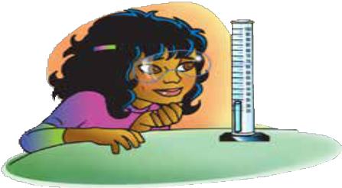
If the sample floats, use a pencil to gently push the top of the sample just under the surface of the water. Record the number of milliliters for this final water level.
- Find the amount of water displaced by subtracting the initial level of the water from the final level. This volume equals the volume of the cylinder in cm³.
- Record this volume in the chart on the activity sheet.
- Remove the sample by pouring the water back into your cup and taking the sample out of your graduated cylinder.

Density
- Calculate the density using the formula D = m/v. Record the density in (g/cm³).
Sample | Initial water level (mL) | Final water level (mL) | Volume of the rods (cm³) | Mass (g) | Density (g/cm³)
A |  |  |  | 15.0
B |  |  |  | 15.0
C |  |  |  | 15.0
D |  |  |  | 15.0
E |  |  |  | 15.0
- Trade samples with other groups until you have measured the volume and calculated the density of all five samples.

Identify the samples
- Compare the values for density you calculated to the values in the chart. Then write the letter name for each sample in the chart.

Note: The densities students calculate may not be exactly the same as the given densities in the chart. As students are working, check their values for volume to be sure that they are using the difference between the final and initial water levels, not just the final level.

Material | Approximate density (g/cm³) | Sample (Letters A–E)
Brass | 8.8
Aluminum | 2.7
PVC | 1.4
Nylon | 1.2
Polyethylene | 0.94

Discuss whether students’ values for density support their predictions from the beginning of the lesson.
Discuss student values for density for each of the samples. Point out that different groups may have different values for density, but that most of the values are close to the values in the chart.
Ask students:

Each group measured the volume of the same samples. What are some reasons that groups might have different values for density?
Students should realize that small inaccuracies in measuring volume can account for differences in density values. Another reason is that the graduated cylinder, itself, is not perfect. So there is always some uncertainty in measuring.
Remind students that in the beginning of the lesson they made a prediction about the density of the small, medium, and long sample. Students should have predicted that the longest cylinder has the lowest density, the shortest cylinder has the highest density, and the middle is somewhere in between.

Ask students:

Was your prediction about the density of these three samples correct?
Have students look at their chart with the values for mass, volume, and density for each cylinder. Have them look for a relationship between the volume and the density. Students should realize that the shortest cylinder has the greatest density and the longest cylinder has the lowest density.
  - Is it fair to say that if two samples have the same mass that the one with the larger volume will have a lower density?
Yes.
Why?
Because the samples have the same mass, their volumes will give you an idea about their densities according to the equation D = m/v. If a larger number for volume is in the denominator, the density will be lower.
  - Is it fair to say that the one with the smaller volume will have a higher density?
Yes.
Why?
If a smaller number for volume is in the denominator, the density will be higher.

EXPLAIN

Have students look at the size and mass of atoms to help explain why each sample has a different density.
Project the image Atomic Size and Mass.
www.acs.org/middleschoolchemistry/simulations/chapter3/lesson2.html

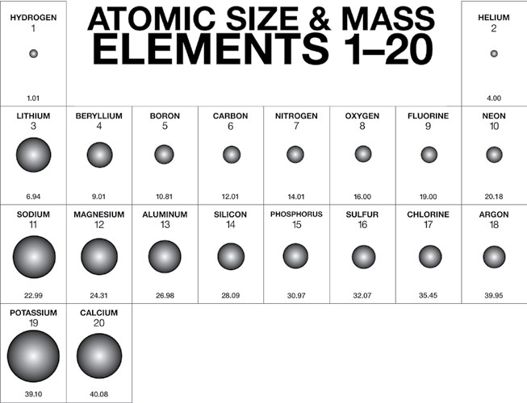
Tell students that this chart is based on the periodic table of the elements but that it only includes the first 20 elements out of 118. A representation of an atom for each element is shown. For each element, the atomic number is above the atom and the atomic mass is below. This chart is special because it shows both the size and mass of atoms compared to other atoms.

Note: Students may want to know more about why atoms have different atomic numbers and different sizes. These questions will be covered in later chapters but you can tell them that the atomic number is the number of protons in the center or nucleus of the atom. Each element has a certain number of protons in its atoms, so each element has a different atomic number. The difference in size is a little harder to explain. Atoms have positively charged protons in the nucleus and negatively charged electrons moving around the nucleus. It’s really the space the electrons occupy that makes up most of the size of the atom. As the number of protons in the atom increases, both its mass and the strength of its positive charge increases. This extra positive charge pulls electrons closer to the nucleus, making the atom smaller. The atoms get bigger again in the next row because more electrons are added in a space (energy level) further from the nucleus.
Let students know that they will learn more about the periodic table and atoms in Chapter 4. For now, all students need to focus on is the size and mass of the atoms.

Tell students that the difference in density between the small, medium, and large samples that they measured can be explained based on the atoms and molecules they are made from.

Project the image Polyethylene (longest rod).
www.acs.org/middleschoolchemistry/simulations/chapter3/lesson2.html
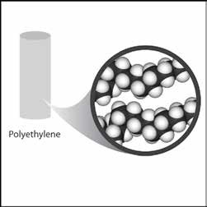
Polyethylene is made of long molecules of only carbon and hydrogen atoms. In the Atomic Size and Mass chart, the mass of carbon is pretty low, and the mass of hydrogen is the lowest of all the atoms. These low masses help explain why polyethylene has a low density. Another reason is that these long, skinny molecules are loosely packed together.

Project the image Polyvinyl Chloride (medium-length rod).
www.acs.org/middleschoolchemistry/simulations/chapter3/lesson2.html

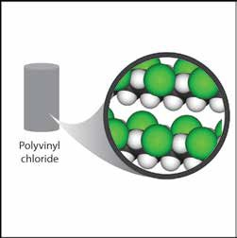
Polyvinyl chloride is made up of carbon, hydrogen, and chlorine atoms. If you compare polyvinyl chloride to polyethylene, you will notice that there are chlorine atoms in some places where there are hydrogen atoms in the polyethylene. In the chart, chlorine has a large mass for its size. This helps make polyvinyl chloride more dense than polyethylene. The density of different plastics is usually caused by the different atoms that can be connected to the carbon–hydrogen chains. If they are heavy atoms for their size, the plastic tends to be more dense; if they are light for their size, the plastic tends to be less dense.

Project the image Brass (shortest rod).
www.acs.org/middleschoolchemistry/simulations/chapter3/lesson2.html
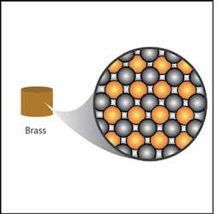
Brass is a combination of copper and zinc atoms. Copper and zinc come up later in the periodic table, so they are not shown in the chart, but they are both heavy for their size. The atoms are also packed very closely together. For these reasons, brass is more dense than either polyethylene or polyvinyl chloride.

EXTEND

Discuss the density of calcium compared to the density of sulfur.
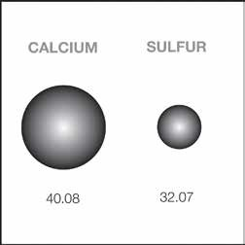
Have students refer to the illustration of Calcium and Sulfur on their activity sheets. Explain that a calcium atom is both bigger and heavier than a sulfur atom. But a piece of solid sulfur is more dense than a solid piece of calcium. The density of sulfur is about 2 g/cm³ and the density of calcium is about 1.5 g/cm³.

Ask students:

Based on what you know about the size, mass, and arrangement of atoms, explain why a sample of sulfur is more dense than a sample of calcium.
Even though a sulfur atom has less mass than a calcium atom, many more sulfur atoms can pack together in a certain amount of space. This gives sulfur more mass per volume than calcium, making it more dense.

