Activity Sheet Answers
Chapter 3, Lesson 2
Finding Volume—The Water Displacement Method

DEMONSTRATION

- Predict the densities of each sample by writing a phrase from the box on the line next to each sample.
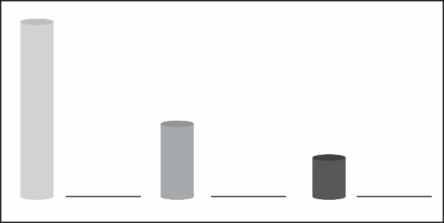
Least dense
Medium dense
Most dense

- Explain why you think each rod is either the most, medium, or least dense.
If all the masses are the same, then the largest rod must have the lowest density. Since D=m/v, the larger the value for Volume in the denominator of the equation, the smaller the calculated value of Density will be.
Conversely, the smallest rod must be the densest because its value for volume is the smallest. With a small value for V in the denominator, the value for density goes up. So the smallest rod must be most dense. By the same logic, the medium sized rod should be somewhere between the smallest and largest rod in overall density.
Looking at it a different way, if you have two different objects, one clearly larger in volume than the other, but you know they have the same mass, the only way that can be possible is if the small volume object is more dense than the larger volume object.

- Look at the illustrations showing the water level in a graduated cylinder before and after a sample is submerged in water. What does this difference in water level tell you about the sample?
The difference in water level, or the volume of water that is displaced, is equal to the volume of the sample. In this case, the volume of the sample in the picture is roughly 12 cm³.
How much would the water level rise if you submerged a cube with a volume of 1 cm³ in a graduated cylinder filled with 40 mL of water?
If a cube with a volume of 1cm³ were placed in a graduated cylinder with an initial volume of 40 mL, the water level would rise 1mL, up to a final volume of 41 mL.

- What is the density of the sample described below? Be sure to write the units in g/cm³.
- Water level rose from 60 mL to 85 mL
- Mass = 50 g
To calculate density, use the equation D=m/v. The volume of the sample is equal to the volume of water displaced, which is 85 – 60, or 25 mL. Substituting values into the equation for Density gives D=50/25, or 2 cm³.

ACTIVITY
- On the first page of this activity sheet, you made a prediction about the density of a small, medium, and long rod. Based on your calculations for density in your chart, were your predictions correct? If a short rod and a long rod have the same mass, explain why the short one will be more dense than the long one.
Answers will vary by student. A shorter rod must be more dense than a longer rod of the same mass because the mass is in a smaller volume. Since density is mass per unit volume, having the same mass in a smaller volume makes the smaller rod more dense.

EXPLAIN IT WITH ATOMS & MOLECULES

- Polyethylene is made of carbon and hydrogen atoms. Polyvinyl chloride is also made of carbon and hydrogen atoms, but also has chlorine atoms.

Look at the size and mass of these atoms in the chart to explain why polyvinyl chloride is more dense than polyethylene.
Polyvinyl chloride is denser than polyethylene because it contains atoms of chlorine which have a large mass for their size. The long molecule chains are also closer together in polyvinyl chloride than they are in polyethylene, contributing to its greater density.

- Brass is made of copper and zinc atoms. These atoms are pretty heavy for their size, but they are also packed together differently than the molecules of the plastics. How does the way these atoms pack together help make the brass more dense than the plastics?
The way that copper and zinc atoms are packed closely together in brass makes it denser than the plastics because it means that there is more mass in a given volume of space, which is the definition of density.

- Based on the Atomic Size and Mass chart, a calcium atom is both bigger
and heavier than a sulfur atom. But a piece of solid sulfur is more dense than a solid piece of calcium. In fact, sulfur is about 2 g/cm³, and calcium is about
1.5 g/cm³.

Based on what you know about the size, mass, and arrangement of atoms, explain why a sample of sulfur is more dense than a sample of calcium.
Although sulfur atoms are less massive than calcium atoms, a sample of sulfur is denser than a sample of calcium. This is because the sulfur atoms are small and able to pack closely together. This enables sulfur to concentrate more mass into a unit of volume than calcium.

