Activity Sheet Name Chapter 2, Lesson 5
Changing State—Melting Date

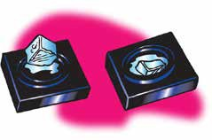
DEMONSTRATION

- You watched a piece of ice melt. Where do you think the energy came from to melt the ice?

- What do you think happened to the speed of the molecules in the ice when it was heated?

ACTIVITY

Work with your group to design a way to make ice melt faster. You will need to show that your method really does make ice melt faster, so be sure to use a control.

- Write down the steps in your procedure under “Procedure” below. Check with your teacher before conducting your experiment.

Question to investigate:
Will make ice melt faster?

Procedure

- Does your method make ice melt faster?

How do you know?

EXPLAIN IT WITH ATOMS AND MOLECULES

- Write a caption underneath each picture to explain how the motion and arrangement of the water molecules changes as ice melts.

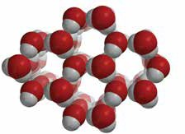
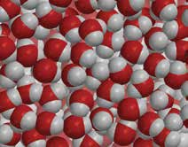

- Look at the diagram below representing the motion and arrangement of the molecules of a substance (not water) when it is a solid, a liquid, and a gas. Write the name of the state change that takes place on each curved arrow.

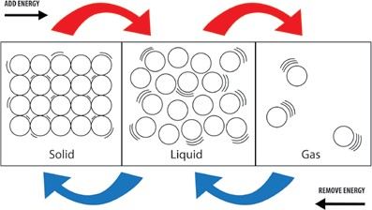

- The following diagram uses the space-filling model of water to represent the arrangement of water molecules when it is a solid, liquid, and a gas.
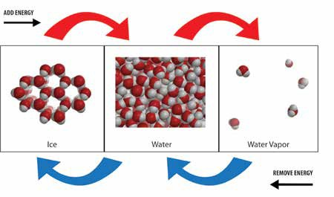

a. How are the state changes of water similar to the state changes in most other substances?

b. How are state changes of water different from the state changes in most other substances?

TAKE IT FURTHER

- Do regular ice and dry ice melt in the same way?

How do you know?

- You saw that the dry ice sublimates very quickly in water. Why does it sublimate even faster in hot water?

