Activity Sheet Name Chapter 2, Lesson 3
Changing State—Condensation Date

DEMONSTRATION

- Your teacher showed you two cups of water with ice in them. One cup was in a bag with as much air taken out as possible. The other cup was left out in the air. After a few minutes, water was on the outside of the cup left in the air. Much less water was on the outside of the cup in the bag.
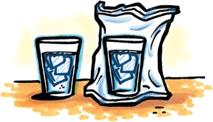
Why do you think the cup that is exposed to more air has water on the outside of it?

- Condensation happens when water molecules in the air slow down so much that their attractions overcome their speed. This makes them join together, forming liquid water.

List two common examples of condensation.

ACTIVITY

Question to investigate
What happens when water vapor condenses?

Materials for each group
  - 1 short wide-rimmed clear plastic cup
  - 1 tall smaller-rimmed clear plastic cup
  - Hot water (about 50 °C)
  - Magnifier

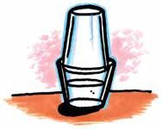
Procedure
- Fill a wide clear plastic cup about 2/3 full of hot tap water. Place the tall cup upside down inside the rim of the bottom cup as shown.
- Watch the cups for 1–2 minutes.
- Use a magnifier to look at the sides and top of the top cup.
- Take the top cup off and feel the inside surface.

WHAT DID YOU OBSERVE?
3. After a couple of minutes, what did you observe on the inside of the top cup?

4. How could the tiny drops of water get to the inside of the top cup? Use ideas about evaporation and condensation in your explanation.

ACTIVITY

Question to investigate
Does making water vapor colder increase the rate of condensation?

Materials for each group
  - 2 short wide-rimmed clear plastic cups
  - 2 tall smaller-rimmed clear plastic cups
  - Hot water
  - Magnifier
  - Ice

Procedure
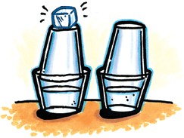
- Fill two wide clear plastic cups about 2/3 full of hot tap water.
- Quickly place the taller cups upside down inside the rim of each cup of water, as shown.
- Place a piece of ice on top of one of the cups.
- Wait 2–3 minutes.
- Remove the ice and use a paper towel to dry the top of the cup where the ice may have melted a bit.
- Use a magnifier to examine the tops of the two upper cups.

WHAT DID YOU OBSERVE?
5. Does cooling water vapor increase the rate of condensation?

What evidence do you have from the activity to support your answer?

EXPLAIN IT WITH ATOMS & MOLECULES
6. The animation showed water molecules as a gas condensing to form liquid water on the inside of the top cup. Since the water molecules were all separated as a gas, why did they come together to form a liquid?

7. Why do you think the cup with the ice has bigger drops of water on the inside than the cup without ice?

TAKE IT FURTHER

Fogging up a cold window

8. When you breathe on a cold window in the winter, the window gets tiny droplets of moisture on it or “fogs up.” Using what you know about condensation, explain why you think the cold window gets foggy. (Hint: There is water vapor in your breath.)

Warm breath in cold air

9. When you breathe out in the winter, you see “smoke,” which is really tiny droplets of liquid water. Using what you know about condensation, explain why you think this happens.

Evaporation and condensation in the water cycle

One common place you see the results of condensation is in the weather. Water vapor in the air (humidity), clouds, and rain are all the result of evaporation and condensation.
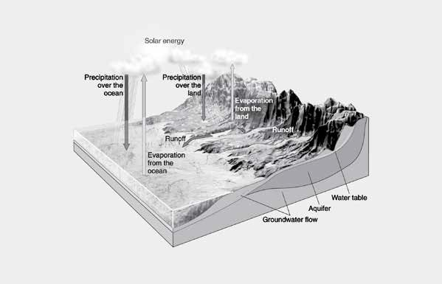

10. Using what you know about evaporation and condensation, explain what causes rain.

TAKE IT FURTHER (continued)

Question to investigate
Why do damp things dry more quickly on a windy day?

Materials
  - 2 pieces of brown paper towel
  - Water
  - Dropper

Procedure
- Place one drop of water on two pieces of brown paper towel.
- Have your partner hold one while paper while you swing the other one through the air.
- After about 30 seconds compare the paper towels to see if you can see any difference in how wet or dry the papers are.
- Repeat step 3 until you notice a difference between the wet spots on the paper towel.

11. Why does moving air over a wet surface make it dry more quickly?
Hint: your answer should mention both evaporation and condensation.

TAKE IT FURTHER (continued)

Question to investigate
If colored water evaporates and condenses, will there be any color in the water that is produced?

Materials for each group
  - 1 short wide-rimmed clear plastic cup
  - 1 tall smaller-rimmed clear plastic cup
  - Hot water
  - Food coloring
  - Ice cube
  - White napkin or paper towel

Procedure
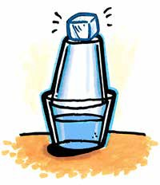
- Add hot tap water to a wide clear plastic cup until it is about 2/3 full.
- Add 1 drop of food coloring and stir until the water is completely colored.
- Turn another clear plastic cup upside down on the cup of hot water as shown. Place an ice cube on the top cup to make condensation happen faster.
- Wait 1–3 minutes for water vapor to condense to liquid water on the inside surface of the top cup.
- Use a white paper towel to wipe the inside of the cup to check for any color.

12. Is there any color in the water that forms on the inside of the top cup?

13. If you were stranded on an island and only had saltwater, how could you make water to drink?

