Activity Sheet Name Chapter 1, Lesson 5
Air, It’s Really There Date

DEMONSTRATION – BASKETBALL AND COMPRESSED GAS
The demonstrations with the basketball and the can of compressed air were meant to show something about gases and matter. Matter is anything that has mass and takes up space.
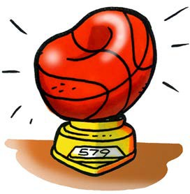
- Think about the demonstration with the deflated and inflated basketball. The basketball weighed more after it was inflated with air than when it was deflated. How does this show that gas is matter?

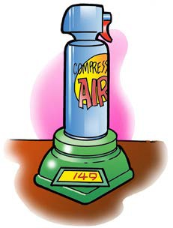
- Think about the demonstration with the can of compressed gas. The can weighed less after some gas was shot out of the can. How does this show that gas is matter?

EXPLAIN IT WITH ATOMS & MOLECULES
You saw an animation of gas molecules inside a balloon.

- What did you notice about the molecules of a gas?
  - Do the molecules of a gas have strong or weak attractions?

  - Are the molecules of a gas randomly or orderly arranged?

  - When the molecules of a gas hit each other, do they normally stick together or bounce off?

ACTIVITY

Question to investigate
How do heating and cooling affect a gas?

Materials for each group
- 2 clear plastic cups
- 8-oz plastic bottle
- Detergent solution in cup
- Hot water
- Cold water
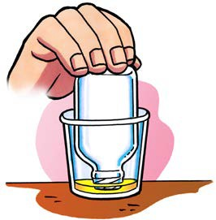

Procedure

- Warming the air inside the bottle
  - Pour hot water into an empty cup until it is about ½-full.
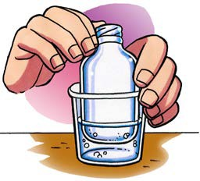
  - Turn the bottle over and dip the opening of the bottle into the detergent to get a film of detergent covering the rim.
  - While holding the bottle, slowly push the bottom of the bottle down into the hot water.

- Cooling the air inside the bottle
- Pour cold water into another cup until it is about ½-full.
- If there is still a bubble on the bottle, slowly push the bottom of the bottle down into the cold water.
- If a bubble is not still on the bottle, make another bubble by dipping the opening into detergent and then pushing the bottom of the bottle into hot water again.
- While holding the bottle, slowly push the bottom of the bottle down into the cold water.

WHAT DID YOU OBSERVE?

- What happened to the film of detergent solution when you placed the bottle in hot water?

- What happened to the bubble when you placed the bottle in cold water?

EXPLAIN IT WITH ATOMS & MOLECULES
You saw an animation showing the air molecules inside a bottle when it is placed in hot and cold water. Think of the animation and use the drawing below as a reference to answer the questions at the top of the next page.
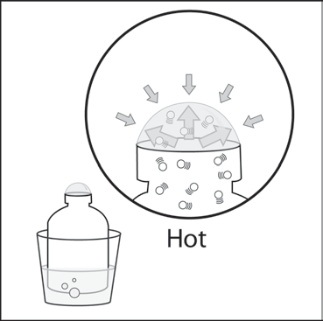
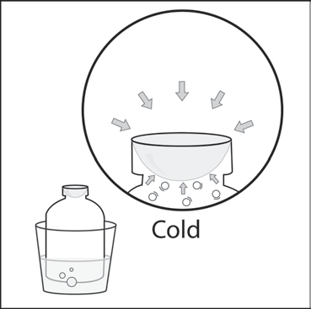

- What caused the bubble to form when you placed the bottle in hot water? Be sure to write about the speed of the molecules inside the bubble and the force on the bubble from the outside air.

- Why did the bubble get smaller when you placed the bottle in cold water? Be sure to write about the speed of the molecules inside the bubble and the force on the bubble from the outside air.

You saw an animation about the molecules in solids, liquids, and gases.

- Draw circles to represent the molecules in a solid, liquid, and gas. Because all three different substances are all at the same temperature, draw the same number of motion lines near the circles for each substance. Under each box, write about the arrangement and motion of the molecules and the attractions the molecules have for one another.

Solid

Liquid

Gas

TAKE IT FURTHER

- Imagine that you work at a party store during the summer. You are going to ride home with the owner of the store whose car has been sitting in the hot sun all day long. The owner tells you that you can take home a big bunch of balloons but advises you to not blow the balloons up all of the way. Explain why the owner’s advice is wise. Be sure to discuss how heating affects the motion of the molecules in a gas.

