Activity Sheet Answers
Chapter 1, Lesson 4
Moving Molecules in a Solid

EXPLAIN IT WITH ATOMS & MOLECULES

- How is the motion of the atoms in solid metal different from the motion of the molecules in liquid water?
The atoms in solid metal vibrate back and forth but do not move past one another like the water molecules in liquid water.

- What is it about atoms and molecules in liquids and solids that keeps them close to one another even though they are moving?
The atoms or molecules that make up liquids and solids are kept near each other by the attraction between molecules or the attraction between atoms.

DEMONSTRATION

- At room temperature the metal ball fits through the ring. What happened when your teacher tried to push the heated ball through the ring?
When the ball was heated it did not fit through the ring.

- What happened to the atoms in the heated metal ball so that it didn’t fit through the ring?
Heating makes the atoms in the metal move faster. The extra speed of the atoms competes with their attractions for one another and causes them to move slightly further apart. Since the atoms move further apart, the size (volume) of the metal ball increases a little and will not fit through the ring.

- After the ball was cooled by putting it in the water, why do you think it fit through the ring again?
Cooling makes the atoms in the metal move more slowly. When they move more slowly, their attractions for one another are able to bring them slightly closer together. Since the atoms come closer together, the size (volume) of the metal ball decreases a little and will fit through the ring again.

EXPLAIN IT WITH ATOMS & MOLECULES

- Draw a model of the atoms in the metal ball at room temperature and after it has been heated. Use circles and motion lines to show the speed and spacing of the atoms in the room temperature ball. Include captions like “atoms faster and further apart” or “atoms slower and closer together” to describe your drawings
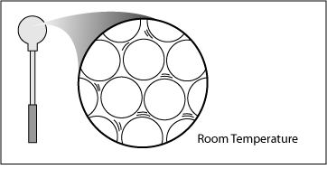
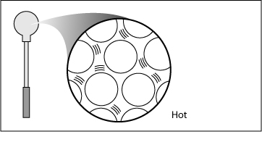
Atoms slower and closer together
Atoms faster and further apart

TAKE IT FURTHER

- Knowing what you do about how solids act when they are heated and cooled, why do you think they put flexible connections in the road on a bridge?
If it gets cold enough, the bridge shrinks or contracts a little. If it gets hot enough, the bridge grows or expands a little. The flexible material allows the road to shrink a little in the cold or expand a little in the heat without weakening or cracking the road material.

