Activity Sheet Answers
Chapter 1, Lesson 3
The Ups and Downs of Thermometers

WHAT DID YOU OBSERVE?

- Based on what you know about the way molecules move in hot liquids, explain why the liquid in the thermometer goes up when heated.
The liquid in the thermometer goes up when the thermometer is heated because heating makes the alcohol molecules of the liquid move faster. The extra speed of the molecules competes with their attraction for one another and causes them to move slightly further apart. Since the molecules move further apart, the same amount of alcohol takes up more room in the thin tube of the thermometer. The liquid has nowhere else to go but up.

- Based on what you know about the way molecules move in cold liquids, explain why the liquid in the thermometer goes down when cooled.
The liquid in the thermometer goes down when the thermometer is cooled because cooling makes the alcohol molecules of the liquid move more slowly. When they move more slowly, their attractions for one another are able to bring them slightly closer together. Since the molecules come closer together, the same amount of alcohol takes up less room in the thin tube of the thermometer and goes down.

- Why do you think the tube that contains the red liquid is so thin?
The tube in the thermometer that contains the red liquid is very thin so that it is easier to see the liquid move up and down. Since the volume of the liquid only increases or decreases a small amount when heated or cooled, it would be harder to see these changes if the tube was wider.

- What do you think is the purpose of the larger outer tube?
The purpose of the outer wider tube on the thermometer is to protect the thinner inner tube. Another purpose might be to magnify the line that the red liquid makes so it is easier to see.

EXPLAIN IT WITH ATOMS & MOLECULES

- Based on what you know about the motion of molecules in a liquid and what you saw in the animations, draw circles to represent alcohol molecules in the liquid in the thermometer. Try to show the difference in distance between the molecules when the liquid is hot and cold. Use motion lines to represent their movement (fast or slow).

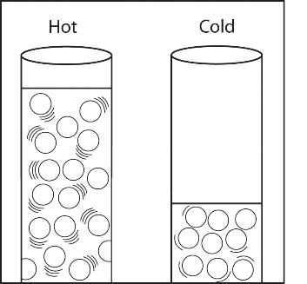
The circles representing molecules should be farther apart and have more motion lines in the tube in hot water. The circles should be closer together and have fewer motion lines in the tube in cold water.

TAKE IT FURTHER

- Imagine that you have two thermometers that are identical in every way, except one has alcohol and the other has mercury inside. Each thermometer is placed in hot water that is 100 °C. The levels of the alcohol and mercury are shown in the picture.
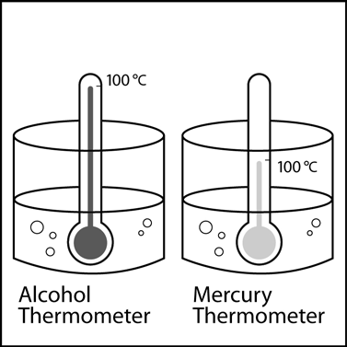

Why do you think the liquids in the thermometers are at different levels even though they are in water that is the same temperature?
The alcohol and the mercury thermometers go up by different amounts because the molecules that make up alcohol and the atoms that make up mercury are different. Since they are different, their attractions are different and the way they respond to heating and cooling are different. So even though they both go up and down when heated and cooled, they do it by different amounts.

