

**December 2016/January 2017 Teacher's Guide for**

***The Flint Water Crisis: What’s Really Going On?***

**Table of Contents**

About the Guide 2

Student Questions 3

Answers to Student Questions 5

Anticipation Guide 6

Reading Strategies 7

Connections to Chemistry Concepts 10

Possible Student Misconceptions 10

Anticipating Student Questions 11

Activities 12

References 14

Web Sites for Additional Information 15

Background Information 18

# About the Guide

Teacher’s Guide team leader William Bleam and editors Pamela Diaz, Regis Goode, Diane Krone, Steve Long and Barbara Sitzman created the Teacher’s Guide article material.

E-mail: [bbleam@verizon.net](mailto:bbleam@verizon.net)

Susan Cooper prepared the anticipation and reading guides.

Patrice Pages, *ChemMatters* editor, coordinated production and prepared the Microsoft Word and PDF versions of the Teacher’s Guide.

E-mail: [chemmatters@acs.org](mailto:chemmatters@acs.org)

Articles from past issues of *ChemMatters* and related Teacher’s Guides can be accessed from a DVD that is available from the American Chemical Society for $42. The DVD contains the entire 30-year publication of *ChemMatters* issues, from February 1983 to April 2013, along with all the related Teacher’s Guides since they were first created with the February 1990 issue of *ChemMatters*.

The DVD also includes Article, Title, and Keyword Indexes that cover all issues from February 1983 to April 2013. A search function (similar to a Google search of keywords) is also available on the DVD.

The *ChemMatters* DVD can be purchased by calling 1-800-227-5558. Purchase information can also be found online at <http://tinyurl.com/o37s9x2>.

# Student Questions

**The Flint Water Crisis: What’s Really Going On?**

* 1. Why was the Sewage Department of the Karegnondi Water Authority not ready to deliver water to Flint?
  2. List the two (2) problems that were noticed almost immediately after the Flint River became the water source.
  3. How is a trihalomethane molecule different from a methane molecule?
  4. How do trihalomethanes get into drinking water?
  5. Why did the Romans use lead for water pipes?
  6. List the three metals mentioned in the article that are used to make water pipes.
  7. What happens when lead metal is oxidized?
  8. What is one method used to prevent lead pipes from leaching lead ions into the drinking water?
  9. Explain chemically what happens to the lead(II) carbonate (PbCO3) protective layer when the pH is too low.
  10. What was the reason given for the Flint River water having a high chloride ion (Cl–) concentration?
  11. How can iron (Fe) affect the chlorine (Cl2) concentration, and why is that a problem?
  12. Name four other cities that have recently reported high levels of lead in their drinking water.

# Answers to Student Questions

**(taken from the article)**

**The Flint Water Crisis: What’s Really Going On?**

* + 1. **Why was the Sewage Department of the Karegnondi Water Authority not ready to deliver water to Flint?**

*The Karegnondi Water Authority could not supply water to Flint because they were in the process of building a new pipeline to bring water from Lake Huron.*

* + 1. **List the two (2) problems that were noticed almost immediately after the Flint River became the water source.**

*The two problems noticed almost immediately were:*

1. *foul smell,*
2. *discolored water,*
   * 1. **How is a trihalomethane molecule different from a methane molecule?**

*In a trihalomethane molecule, three of the hydrogen atoms are replaced with halogen atoms (group 17).*

* + 1. **How do trihalomethanes get into drinking water?**

*Trihalomethanes are produced when chlorine, which is used to disinfect drinking water, reacts with organic material such as algae, leaves and weeds.*

* + 1. **Why did the Romans use lead for water pipes?**

*The Romans used lead because it was durable and malleable.*

* + 1. **List the three metals mentioned in the article that are used to make water pipes.**

*The metals that have been used for water pipes are lead, copper, and iron.*

* + 1. **What happens when lead metal is oxidized?**

*When lead metal is oxidized, it loses electrons and forms lead(II) ions (Pb2+), which dissolve in the water. The equation for this reaction is Pb 🡪 Pb2+ + 2e –*

* + 1. **What is one method used to prevent lead pipes from leaching lead ions into the drinking water?**

*One method to prevent lead pipes from leaching ions is to add phosphate (PO43–) ions to the water. They react with the lead, forming solid lead(II) phosphate, Pb3(PO4)2, which forms a crust on the pipes and acts as a protective coating.*

* + 1. **Explain chemically what happens to the lead(II) carbonate (PbCO3) protective layer when the pH is too low.**

*The lead(II) carbonate layer decreases. Lead(II) carbonate dissolves to a very small extent. When the pH is low the excess hydrogen ions react with the carbonate ions and produce carbon dioxide and water. Removing carbonate ions causes more lead(II) carbonate to dissolve and the layer rapidly decreases.*

*PbCO3 (s) ⇌ Pb2+ (aq) + CO32– (aq)*

*CO3 2–(aq) + H+ (aq) 🡪 H2O (l) + CO2 (g)*

* + 1. **What was the reason given for the Flint River water having a high chloride ion (Cl–) concentration?**

*The chloride ions in Flint River water come from the road salt used to de-ice the slippery roads. They enter the river as run-off from the roads.*

* + 1. **How can iron (Fe) affect the chlorine (Cl2) concentration, and why is that a problem?**

*Iron can reduce chlorine to chloride ions. This decreases the amount of chlorine dissolved in the water. Chlorine is added to water sources to eliminate pathogens in the water. Without the chlorine, the water-borne pathogens can survive and cause diseases.*

* + 1. **Name four other cities that have recently reported high levels of lead in their drinking water.**

*Cities that have recently had high levels of lead include: Washington D.C.; Durham, N.C.; Greenville, N.C.; and Jacksonville, Miss.*

# Anticipation Guide

Anticipation guides help engage students by activating prior knowledge and stimulating student interest before reading. If class time permits, discuss students’ responses to each statement before reading each article. As they read, students should look for evidence supporting or refuting their initial responses.

**Directions:**  *Before reading*, in the first column, write “A” or “D,” indicating your agreement or disagreement with each statement. As you read, compare your opinions with information from the article. In the space under each statement, cite information from the article that supports or refutes your original ideas.

|  |  |  |
| --- | --- | --- |
| **Me** | **Text** | **Statement** |
|  |  | 1. The problem with water in Flint was first noticed by residents in the 1990s. |
|  |  | 1. Prior to the public announcement of a problem with the water in Flint, General Motors stopped using the water in its Flint car plant because of fear of corrosion. |
|  |  | 1. Trihalomethanes contain carbon and halogens. |
|  |  | 1. Lead has been used in plumbing since Roman times because it is durable and malleable. |
|  |  | 1. Prior to 2014, lead (II) phosphate formed a protective layer in the pipes in Flint. |
|  |  | 1. The lead level in tap water is measured in ppm (parts per million). |
|  |  | 1. The Flint water plants try to keep the pH of the water around 7. |
|  |  | 1. Phosphate ions added to water combine with lead to form a protective coating inside water pipes. |
|  |  | 1. Chloride ions eliminate waterborne pathogens similar to elemental chlorine. |
|  |  | 1. More than 30 years ago, the use of lead water pipes in new construction was banned by the U. S Congress. |

# Reading Strategies

These graphic organizers are provided to help students locate and analyze information from the articles. Student understanding will be enhanced when they explore and evaluate the information themselves, with input from the teacher if students are struggling. Encourage students to use their own words and avoid copying entire sentences from the articles. The use of bullets helps them do this. If you use these reading and writing strategies to evaluate student performance, you may want to develop a grading rubric such as the one below.

|  |  |  |
| --- | --- | --- |
| **Score** | **Description** | **Evidence** |
| 4 | Excellent | Complete; details provided; demonstrates deep understanding. |
| 3 | Good | Complete; few details provided; demonstrates some understanding. |
| 2 | Fair | Incomplete; few details provided; some misconceptions evident. |
| 1 | Poor | Very incomplete; no details provided; many misconceptions evident. |
| 0 | Not acceptable | So incomplete that no judgment can be made about student understanding |

***Teaching Strategies:***

1. Links to **Common Core Standards for Reading**:

* ELA-Literacy.RST.9-10.1:Cite specific textual evidence to support analysis of science and technical texts, attending to the precise details of explanations or descriptions.
* ELA-Literacy.RST.9-10.5: Analyze the structure of the relationships among concepts in a text, including relationships among key terms (e.g., force, friction, reaction force, energy).
* ELA-Literacy.RST.11-12.1:Cite specific textual evidence to support analysis of science and technical texts, attending to important distinctions the author makes and to any gaps or inconsistencies in the account.
* ELA-Literacy.RST.11-12.4: Determine the meaning of symbols, key terms, and other domain-specific words and phrases as they are used in a specific scientific or technical context relevant to grades 11-12 texts and topics.

1. Links to **Common Core Standards for Writing**:

* ELA-Literacy.WHST.9-10.2F: Provide a concluding statement or section that follows from and supports the information or explanation presented (e.g., articulating implications or the significance of the topic).
* ELA-Literacy.WHST.11-12.1E: Provide a concluding statement or section that follows from or supports the argument presented.

1. **Vocabulary** and **concepts** that are reinforced in this issue:

* Chemical reactions
* Redox reactions
* Solubility
* Equilibrium
* Le Chatelier’s Principle
* Vitrification
* Hydrogen bonding
* Molecular structures
* Personal and community health
* Rare-earth metals
* Endothermic and exothermic reactions
* Conservation of energy

1. Some of the articles in this issue provide opportunities for students to consider how understanding chemistry can help them make informed choices as citizens and consumers.
2. Engagement suggestions:

* Prior to giving students the article “The Flint Water Crisis: What’s Really Going On?” use a Think-Pair-Share to find out what students already know about the Flint water crisis. During reading, students will reflect on what they thought and how the evidence from the article supports their original ideas (or not).
* Avoid telling students the title of the article, “No Smartphones, No TV, No Computers: Life without Rare-Earth Metals.” Instead, ask them where in their everyday lives they would find rare-earth metals and why they are used. After a short class discussion, give them the article to read.

1. To help students engage with the text, ask students which article **engaged** them most and why, or what **questions** they still have about the articles. The Background Information in the *ChemMatters* Teacher’s Guide has suggestions for further research and activities.

**Directions**: As you read, complete the graphic organizer below to describe the chemistry involved in causing and correcting the Flint water crisis.

|  |  |  |
| --- | --- | --- |
| **Causes of the Flint water crisis** | | |
|  | **How did it get in the water?** | **Why is it a concern?** |
| **Trihalomethanes** |  |  |
| **Lead** |  |  |

|  |  |  |
| --- | --- | --- |
| **Correcting the problems** | | |
|  | **What can (or should) be done?** | **What are some drawbacks to the possible solution(s)?** |
| **Preventing lead contamination** |  |  |
| **High levels of chloride ions** |  |  |
| **Effect of pH** |  |  |
| **Chlorine treatment** |  |  |

**Summary:** On the bottom or back of this paper, write a tweet (140 characters or less) describing how to protect your town from lead contamination in the drinking water.

# Connections to Chemistry Concepts

**(for correlation to course curriculum)**

1. **Organic Chemistry**—Structures of THMs provided in the Dingle article would serve as an excellent extension to the discussion of organic molecules and the reactions they undergo. Students could be asked to compare the structure of methane to a trihalomethane.
2. **Concentration**—When teaching concentration units, this article could be used to introduce the concept of parts per million and explain it is a common concentration unit used when measuring trace quantities. It could be compared to percent by mass concentrations.
3. **Oxidation-reduction reaction**—When teaching oxidation-reduction reactions, this would serve as a prime example of how the process is a part of our everyday life. Students could be asked to describe the oxidation of the iron pipes using chemical equations.
4. **Solubility rules and precipitation**—Students should be able to predict that lead carbonate and lead phosphate would be insoluble and form a precipitate by using their solubility rules.
5. **pH**—As a lesson in an acid-base unit, teachers could use the article to emphasize that a low pH means that it is an acid and contains more hydrogen ions, which affects the corrosion of the pipes.
6. **Le Châtelier’s Principle**—This is an excellent article to help students grasp the importance of Le Châtelier’s principle as a real world example as they study equilibrium. Students could be asked to describe the shift in the lead carbonate equilibrium as the pH changes. They could also be asked to suggest factors that would shift the equilibrium so the lead carbonate coating is preserved.

# Possible Student Misconceptions

**(to aid teacher in addressing misconceptions)**

1. **“Bottled water is pure water.”** *Bottled water is not pure water. Pure water would only contain molecules of H2O. Pure water can be produced, but it is expensive to make and to keep pure. As soon as the pure water comes in contact with air, it will dissolve oxygen and nitrogen. Dissolved gases give a water a pleasing taste. Trace minerals found in water are important for chemical reactions in our body. Other compounds are added to our water to make is safer and healthier (e.g., chlorine is added to disinfect it and fluoride is added to prevent tooth decay).*
2. **“Adding chlorine to drinking water is dangerous because it forms trihalomethanes.”** *OK, this one isn’t really a misconception, because chlorine* ***can*** *react with organic material in water to form trihalomethanes and it does pose some potential health hazards. However, the greatest threat of danger in drinking water is the presences of harmful water-borne pathogens. One of the best methods for destroying these bacteria is chlorination. Chlorination not only destroys these disease causing agents, it travels with the water through the pipes to our taps, killing bacteria all the way. Other disinfection methods, such as the use of ozone or ultraviolet light, tend to work for only a short period of time while in the water treatment plant.*
3. **“Bottled water is better than tap water.”** *Bottled water can be more convenient, and some prefer its taste to tap water, but there is no reason to think that it is better for you. Tap water is regulated by the Environmental Protection Agency (EPA) and is routinely tested. Municipalities are required to report the results of these tests. Bottled water is regulated by the Food and Drug Administration (FDA), but manufacturers are not required to report to the consumers where the water comes from or how it is treated or what it might contain. Many brands of bottled water use municipal water (tap water). Some producers of bottled water use springs as their water source which may contain impurities you may not want to consume. Such an example is:*

… Fiji Water, a popular and overpriced brand, even among already overpriced bottled water. In 2007, they ran a series of magazine ads claiming, “The Label Says Fiji Because It’s Not Bottled in Cleveland.” The city government of Cleveland was not amused and hired specialists to run tests on the city’s water versus Fiji’s. The results showed that Fiji water contains 6.3 micrograms of arsenic — which is poisonous to humans — per liter. Cleveland’s city water supply is arsenic-free and infinitely cheaper.

(<http://www.kstatecollegian.com/2012/09/20/3-myths-and-misconceptions-about-water-debunked/>)

# Anticipating Student Questions

**(answers to questions students might ask in class)**

1. **“How do I know if my tap water has lead in it?”** *According to the Center for Disease Control and Prevention:*

The only way to know whether your tap water contains lead is to have it tested. You cannot see, taste, or smell lead in drinking water. Therefore, you must ask your water provider whether your water has lead in it. For homes served by public water systems, data on lead in tap water may be available on the Internet from your local water authority. If your water provider does not post this information, you should call and find out.

(<https://www.cdc.gov/nceh/lead/tips/water.htm>)

1. **“Why is fluoride added to drinking water?”** *Fluoride is known to help prevent tooth decay by strengthening the enamel. Since, in most areas of the country, fluoride is not a common mineral in diets, it is added to water.*
2. **“What is hard water?”** *Hard water is defined as water containing large quantities of calcium and magnesium ions. It is generally formed when water runs through limestone, chalk or other mineral deposits containing calcium or magnesium. The water dissolves some of these ions. Hard water interferes with the cleansing action of soap. It also tends to form limescale (calcium or magnesium carbonates) in hot water heaters. Hard water is inconvenient and can reduce the lifetime of equipment such as boilers and water heaters. It does have some health benefits. Humans need calcium and magnesium in their diet, and drinking hard water does contribute small amounts of these minerals to our dietary needs.*
3. **“How much water do humans need on a daily basis?”** *It is important to remember that everybody’s needs are going to be a little different. Our daily water needs are obtained predominantly by drinking but to a lesser extent by eating water containing food. It is recommended that we consume between 1.5 and 2.0 liters of water per day. It is important to note that anything containing water, such as tea and coffee, counts towards our daily requirement. Our total daily need for water is 2.5 liters. Between drinking water containing fluids and the water containing food this amount will be adequate for most people.*

# Activities

**Labs and Demos**

1. **Wet lab to simulate the water purification process:** This lab, “Water Filtration”, uses “swamp” water (water with dirt or mud added) and goes through the basic process of purification used in many municipal water treatment plants. It includes aeration, coagulation, sedimentation and filtration in the purification process. This is a very simple lab to execute. (<https://www3.epa.gov/safewater/kids/pdfs/activity_grades_4-8_waterfiltration.pdf>)
2. **Wet lab, which is a little more involved, simulates the purification of waste water:** The “Foul Water Lab” is adapted from the textbook *Chemistry in the Community*. Three different processes are used: oil/water separation, sand and gravel filtration and charcoal adsorption and filtration. This procedure includes a nice follow-up that includes questions, calculations, and data analysis. (<http://ralston-web.jeffco.k12.co.us/ralston/html/science/chemistry/Labs/Foul%20Water%20Lab.pdf>)  
   The original version of this lab can be found in the *Chemistry in the Community* textbook, published by the American Chemical Society. *Chemistry in the Community 6th edition*, W. H. Freeman and Company/BFW: New York, 2011; pp 479–482.
3. **Water contamination demonstration:** This demonstration takes about 10 minutes. In a simple manner, it simulates how easily water becomes contaminated and relates it to drinking water standards. It includes suggestions for a follow-up discussion. (<http://serc.carleton.edu/introgeo/demonstrations/examples/watercontamination.html>)
4. **Series of demonstrations and wet labs that explores equilibrium and Le Châtelier’s Principle:** “All Things Being Equal” provides objectives, and detailed instructions for the teacher, as well as student procedure, preparation time, expected results, and questions with suggested answers.

(<https://www.nsta.org/highschool/connections/201210AllThingsBeingEqualTeachersGuide.pdf>)

**Simulations**

1. **Water sources and its purification:** This simulation explains where most municipalities get drinking water. It then goes through the typical process of water purification. It does provide an interactive quiz at the end and a comparison of bottled water to tap water. (<http://techalive.mtu.edu/meec/module03/index.htm>)
2. **Lead entering drinking water:** “Flint’s Water Crisis Explained in 3 GIFs”, produced by *Time*, illustrates graphically the difference between the Detroit water and the Flint River water. (<http://time.com/4191864/flint-water-crisis-lead-contaminated-michigan/>)
3. **The actual chemistry of lead entering the water system:** “Corrosive Chemistry: How Lead Ended Up in Flint's Drinking Water” is a one minute simulation produced by *Scientific American*. (<https://www.scientificamerican.com/video/corrosive-chemistry-how-lead-ended-up-in-flint-s-drinking-water1/>)
4. **pH:** This PHET simulation, “pH Scale”, tests the pH of various common materials. It provides molecular views of the relative numbers of hydroxide ions and hydronium ions in solution. It also looks at the effect of dilution on pH. (<https://phet.colorado.edu/en/simulation/ph-scale>)

**Media**

1. **The water purification process:** “Water and You: The Water Treatment Process” (4:19) is a clever video showing and explaining the water treatment process. (<https://www.youtube.com/watch?v=KMP9-49I1U4>)
2. **Flint water crisis:** The CNN news report “Here’s How Flint’s River Crisis Happened” (4:28) explains the events that lead to the crisis in Flint. (<http://www.cnn.com/videos/us/2016/01/21/flint-michigan-water-crisis-ganim-dnt-ac.cnn>)
3. **The explanation of flocculation:** This Massachusetts Institute of Technology video, “Flocculation” (5:34), provides an excellent explanation of flocculation. It includes both demonstrations of flocculation of actual water samples as well as explaining the process with molecular view drawings. (<https://www.youtube.com/watch?v=5uuQ77vAV_U>)
4. **Chemical and physical properties of lead:** This video (8:08) from *Periodic Videos* by the University of Nottingham not only gives the properties of lead but also provides a wide range of interesting facts about lead. It includes information about lead used by the Romans as well as being used as lead pipes. (<http://www.periodicvideos.com/videos/082.htm>)
5. **Lead poisoning:** The *How Stuff Works* video “Lead—A Sweet Tasting Poison” (1:32) provides a short but informative description of the effects of lead poisoning. (<https://www.youtube.com/watch?v=EGac6S0NLXk>)
6. **Oxidation-reduction reactions:** There are two videos on redox reactions; one is useful for an introductory lesson while the other is very detailed and better for advanced students.
7. “Redox Reactions: Crash Course Chemistry #10” (11:12) is a video that would be good as an introductory lesson. It is fast moving and involves humor, while providing accurate information. (<https://www.youtube.com/watch?v=lQ6FBA1HM3s>)
8. “Oxidation and Reduction” (11:03) is the first in a series on redox reactions produced by the Kahn Academy. This video provides a sophisticated explanation of the oxidation/reduction process. It is done using symbols and drawings to explain the exchange of electrons. This video and the rest in the series can be found at <https://www.khanacademy.org/science/chemistry/oxidation-reduction/redox-oxidation-reduction/v/introduction-to-oxidation-and-reduction>.
9. **Le Châtelier’s Principle:** Both videos below explain equilibrium and Le Châtelier”s Principle. One is short and is good as an introduction to the concepts. The other video is detailed and the first in a series on equilibrium.
10. “Le Châtelier’s Principle” (7:00) is a video good as an introduction. It provides an excellent explanation using pictures of equilibrium systems, symbols and molecular models. At the end of the video, a real life application of the principle is provided. (<https://www.youtube.com/watch?v=PciV_Wuh9V8>)
11. “Le Châtelier’s Principle” (14:42) by the Kahn Academy is a detailed video that gives an in-depth explanation of the principle. It presents the explanation in terms of symbols and molecular models. It is the first in a series on factors that affect equilibrium. (<https://www.khanacademy.org/science/chemistry/chemical-equilibrium/factors-that-affect-chemical-equilibrium/v/le-chatelier-s-principle>)

**Lessons and Lesson Plans**

1. **A series of lessons on drinking water:** This site, created by the EPA, includes activities on water pollution, building models of aquifers, and the availability of ground water. It also has suggestions for games dealing with drinking water. (<https://www3.epa.gov/safewater/kids/teachers_9-12.html>)
2. **Water—at elementary, middle and high school levels:** These lesson are aligned with national standards and produced by Open Square Foundation. They include individual lesson plans, as well as a unit plan that includes cross-curriculum suggestions for the study of water and the global water crisis. (<http://water.org/news/lesson-plans/> )
3. **Oxidation-reduction reactions:** At this site, a lesson plan for the teaching of redox reactions is provided. It includes a PowerPoint and activity sheets that can be downloaded. It states the objectives, prior knowledge necessary, and guiding questions. It also provides suggestions for methods for teaching this lesson. (<http://www.cpalms.org/Public/PreviewResourceLesson/Preview/156068>)

**Projects and Extension Activities**

1. **A debate or town meeting dealing with a water crisis:** The EPA has a design for a town meeting that looks at an industry coming to town that could potentially threaten the water supply. The description for this debate can be found at <https://www3.epa.gov/safewater/kids/pdfs/activity_grades_9-12_proposedtankfarm.pdf>.
2. **Student research project on waterborne diseases:** Students could research various waterborne diseases such as cholera, typhoid, dysentery, amoebiasis, shigellosis, giardia, and legionnaire’s disease. They could research the cause, how it affects the body, the seriousness, how it is transmitted, and the cure.
3. **Students write a position paper:** Students could research the pros and cons of bottled water vs tap water. From their research they would write a positon paper explaining why one is better than the other, citing facts to support their position.
4. **Students could debate chlorination:** Students could research the pros and cons of using chlorine or chlorine-containing products for disinfecting drinking water. A class debate or risk-benefit analysis could then be held to argue each point.

# References

**The references below can be found on the *ChemMatters* 30-year DVD, which includes all articles   
published from the magazine’s inception in October 1983 through April 2013; all available Teacher’s Guides, beginning February 1990; and 12 *ChemMatters* videos. The DVD is available from the American Chemical Society for $42 (or $135 for a site/school license) at this site:** [**http://ww.acs.org/chemmatters**](http://www.acs.org/chemmatters)**. Click on the “Teacher’s Guide” tab to the left, directly under the “*ChemMatters Online"* logo and, on the new page, click on “Get the past 30 Years of *ChemMatters* on DVD!” (the icon on the right of the screen).**

**Selected articles and the complete set of   
Teacher’s Guides for all issues from the past three   
years are available free online at the same Web site, above. Click on the “Issues” tab just below the logo, *“ChemMatters Online”*.**

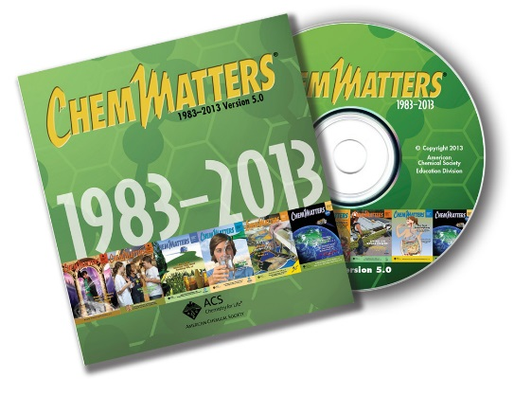

***30* Years of *ChemMatters !***

Available Now!

**(non-Web-based information sources)**

This article discusses lead poisoning, as well as some of the uses of lead. (Gough, M. Lead Poisoning. *ChemMatters*, 1983, *1* (4), pp 4–7)

An excellent explanation of Le Châtelier’s Principle can be found in this classic article: Davenport, D. When Push Comes to Shove: Disturbing the Equilibrium. *ChemMatters*, 1985, *3* (1), pp 14–15.

Michael McClure writes an article about the mysterious death of several cows, which were poisoned by lead. In the article he explains the process for analyzing lead. (McClure, M. Mystery Matters: The Cattle Killer. *ChemMatters*, 1986, *4* (3), pp. 13–15)

An older article on wastewater treatment can be found in the issue given below. It   
does have some interesting graphics. (Garber, C. Wastewater. *ChemMatters*, 1992, *10* (2),   
pp 12–15)

The lead poisoning of Beethoven is described in this article: Withgott, J. Mystery Matters: Lead—Beethoven’s Heavy Metal Ailment. *ChemMatters,* 2001, *19* (3), pp14–15.

Information about lead, its history, uses, and health effects are described here: Brownlee, C. Bling Zinger: The Lead Content of Jewelry. *ChemMatters*, 2006, *24* (2), pp 11–14.

The Teacher’s Guide for April 2006 article above provides additional information on lead poisoning and its symptoms.

This article describe the process used to treat waste water. (Haines, G. Is this Water Recycled Waste? *ChemMatters*, 2011, *29* (1), pp 8–10)

The Teacher’s Guide for the February 2011 article above contains additional information on water purification, filtration and EPA water standards.

# Web Sites for Additional Information

**(Web-based information sources)**

The Center for Disease Control and Prevention provides basic information about municipal water treatment. It includes a clear graphic of the process. In addition, it does describe what types of treatments that can be done in the house. (<http://www.cdc.gov/healthywater/drinking/public/water_treatment.html>)

This site provides a more detailed description of municipal water treatment. (<http://www.lenntech.com/applications/drinking/purification/drinking-water-preparation.htm>)

The USGS describes the various processes that are used in wastewater treatment in a short, concise manner. (<http://water.usgs.gov/edu/wwvisit.html>)

A more detailed discussion of wastewater treatment can be found at <http://www.science.uwaterloo.ca/~cchieh/cact/applychem/watertreatment.html>.

At this EPA educational site the history of water treatment is described in a one-page fact sheet. (<https://nepis.epa.gov/Exe/tiff2png.cgi/P1002SMN.PNG?-r+105+-g+15+D%3A%5CZYFILES%5CINDEX%20DATA%5C00THRU05%5CTIFF%5C00001267%5CP1002SMN.TIF>)

**Flint River and the water crisis**

This article by the Flint Water Study explains some of the problems with the Flint River water: <http://flintwaterstudy.org/tag/drinking-water/>.

This *C&EN* article, “How Lead Ended up in Flint’s Tap Water”, describes the Flint River crisis. This is the article that was cited in the *ChemMatters* article. (<http://cen.acs.org/articles/94/i7/Lead-Ended-Flints-Tap-Water.html>)

This *New York* Times article describes the investigation by Marc Edwards to determine the problems with the Flint water. (<http://www.nytimes.com/2016/08/21/magazine/flints-water-crisis-and-the-troublemaker-scientist.html?_r=1>)

A timeline of the events that occurred in the Flint water crisis can be found here: <http://www.msnbc.com/msnbc/flint-water-crisis-timeline>.

Another article that is well written discusses the pollution in the Flint River. It can be found at this site: <http://www.theverge.com/2016/2/26/11117022/flint-michigan-water-crisis-lead-pollution-history>.

An infographic about the Flint River crisis was created by Compound Interest and can be found at <http://www.compoundchem.com/2016/01/25/flint-water/>.

**Lead**

Interesting facts about lead and its uses can be found at this site: <http://www.livescience.com/39304-facts-about-lead.html>.

Some basic physical and chemical properties of lead can be found at <http://www.chemicool.com/elements/lead.html>.

Information about lead can be found in this article. It includes information about its history, properties, occurrences, extraction, and health effects. (<http://www.chemistryexplained.com/elements/L-P/Lead.html>)

The occurrence and the effects of lead in drinking water are described in this article: <http://www.water-research.net/index.php/lead>.

**Trihalomethanes**

A short basic article that explains what trihalomethanes are, how they are formed, and their health effects can be found at <http://www.nesc.wvu.edu/ndwc/articles/qanda/otsp99_q_a.pdf>.

This article gives more details about the health effects of trihalomethanes: <http://des.nh.gov/organization/commissioner/pip/factsheets/ard/documents/ard-ehp-13.pdf>.

At this site trihalomethanes are described and discussed in relationship to the Flint water crisis: <http://www.waterandhealth.org/tthm-drinking-water-flint-michigan-story-lesson/>.

This blog describes disinfection byproducts found in drinking water. It includes information on their history, toxicity, and how they are regulated. (<https://www.hydroviv.com/blogs/water-smarts/disinfection-byproducts-in-drinking-water-toxicity-history-and-policy>)

**Oxidation, reduction and corrosion**

Concise definitions of oxidation, reduction, oxidation numbers and redox reactions are given at this site. (<http://www.chemteam.info/Redox/Meaning-of-Redox.html>)

This site describes redox reactions. It provides instructions and examples for balancing redox reactions. It also has a quiz the students could use to test themselves. (<http://chp090.chemistry.wustl.edu/~coursedev/Online%20tutorials/Redox.htm>)

This site gives rules for assigning oxidation numbers and provides examples for assigning oxidation numbers to compounds. It also gives examples for recognizing redox reactions. (<http://chem.libretexts.org/Core/Analytical_Chemistry/Electrochemistry/Redox_Chemistry/Oxidation-Reduction_Reactions>)

At this site, the corrosion of drinking water pipes is described. It includes information on the health effects of the corrosion and the factors that contribute to the corrosion. (<http://soiltesting.tamu.edu/publications/E-616.pdf>)

This Center for Disease Control and Prevention article describes the causes of water pipe corrosion. (<http://www.cdc.gov/fluoridation/factsheets/engineering/corrosion.htm>)

This article provides information about the causes for corrosion of the pipes in Flint, Michigan. It describes the mistakes made in Flint, the science of the corrosion and the economics of the situation. (<http://theconversation.com/the-science-behind-the-flint-water-crisis-corrosion-of-pipes-erosion-of-trust-53776>)

**pH**

A concise explanation of pH, and acids and bases can be found at <http://www.sciencebuddies.org/science-fair-projects/project_ideas/Chem_AcidsBasespHScale.shtml>**.**

A more detailed discussion of pH can be found at this site. It also describes the values of pH and provides examples of the pH of common materials. (<http://hyperphysics.phy-astr.gsu.edu/hbase/chemical/ph.html>)

At this USGS site, pH is described in terms of water properties. It describes the measurement of pH and the effect of pH on water quality. Included in the article is a map of the pH of natural waters in the United States. (<http://water.usgs.gov/edu/ph.html>)

**Le Châtelier’s Principle**

This article gives a clear definition of the Le Châtelier’s Principle and provides an explanation of how concentration, pressure and temperature affect equilibrium. There is a short quiz at the end to test understanding. (<http://www.chemguide.co.uk/physical/equilibria/lechatelier.html>)

At this site, the effects of Le Châtelier’s Principle are described by using calculations. There is an example problem for students to try at the end of the article. (<http://chemed.chem.purdue.edu/genchem/topicreview/bp/ch16/lechat.html#top>)

A detailed explanation of equilibrium and Le Châtelier’s Principle can be found at this site. It includes clear examples and links to videos, additional information, and quizzes. (<http://www.chem1.com/acad/webtext/chemeq/Eq-02.html>)

# Background Information

**(teacher information)**

**History of drinking water treatment**

Today we assume that the city-supplied tap water is safe. We feel we can drink the water without contracting a waterborne disease or becoming ill. We assume the water has gone through some purification and disinfection processes. In history, this is a relatively new phenomenon.

Civilizations have generally been established around sources of water, so the importance of water for drinking and other uses has long been understood; however, the quality of the water was not understood or appreciated. The treatment of water in these early times was focused only on the aesthetic qualities. They wanted to improve the smell, the taste and the color of the water that was used.

This ancient Egyptian clarifying device was found pictured on the wall of the tomb of Amenophis II at Thebes. The inscription was carved in 1450 B.C.

[*http://www.buffalowater.org/Quality/Treatment/WaterTreatmentHistory*](http://www.buffalowater.org/Quality/Treatment/WaterTreatmentHistory)

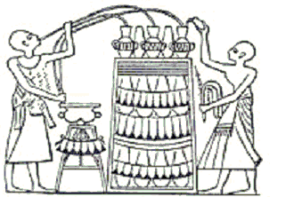

As early as 2000 BC, the writings of the Sanskrit and Greeks recommended water treatment methods. They knew that heating the water might purify it. They also used sand and gravel filtration, as well as leaving water in the sun and straining it. By 1500 BC, the Egyptians discovered the concept of coagulation. They used alum to cause suspended particles to settle out. Pictures of this process were found on the tombs of Amenophis II and Ramses II (see illustration at right).

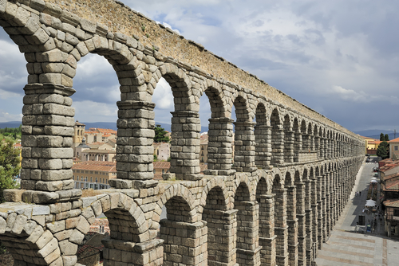The Greek scientist Hippocrates believed that, if water smelled and tasted clean, it was good for the body. He invented the process of sieving water and created the first bag filter, which trapped sediments that caused bad odors and color. During 300–200 BC, the Romans built the first aqueducts, which supplied Rome with one million cubic meters of water daily.

*Roman aqueducts*

[*http://www.kidsdiscover.com/quick-reads/roman-aqueducts-dawn-plumbing/*](http://www.kidsdiscover.com/quick-reads/roman-aqueducts-dawn-plumbing/)

During the Middle Ages, also called the Dark Ages (500-1500 AD), there was a lack of scientific innovations and experimentation, so water treatment and its importance was ignored. In 1627, Sir Francis Bacon experimented with a type of sand filtration to remove salt from seawater. His experiments were not successful, but his work did revive an interest in the treatment of water. In the 1670s, Anton van Leeuwenhoek created the first microscope with lenses that he ground and polished to increase the magnification. His invention allowed him to be the first to observe microorganisms in water. By the 1700s, water filters made from wool, sponge and charcoal were commonly used to remove particles.

Slow sand filtration was being used regularly in Europe by the 1800s. In 1804, Robert Thom designed the first municipal water treatment plant in Scotland. It was based on slow sand filtration and initially the water was distributed from the plant to customers by horse and cart. Within three years they installed water pipes. Dr. John Snow proved that cholera was spread through water in 1855. He determined that cholera epidemics were less severe where water went through slow sand filtration. Dr. Snow used chlorine to purify the water, which began the use of water disinfectants. During the late 1880s, Louis Pasteur described a “germ theory” of disease in which microscopic organisms could transmit disease through materials like water.

As a result of this flurry of research, by the late 19th and early 20th century, the focus regarding water quality centered on disease causing organisms. At this point, people realized that turbidity was not just an aesthetic problem, because the suspended particles held pathogens. America started building water treatment plants with large sand filters. It was found that coagulation and sedimentation techniques improved the filtration. This did reduce the incidence of typhoid and cholera epidemics.

Chlorine was used as the primary disinfectant for the first time in the United States in Jersey City, New Jersey in 1908. Other disinfectants, such as ozone, were in use in Europe. The first federal regulation of drinking water occurred in 1914, when the U.S. Public Health Service established standards for the quality of drinking water. This only applied to water systems that provided water to interstate carriers such as trains. It wasn’t until the 1940s that the drinking water standards applied to municipal water systems. By the early 1970s, public health concerns not only involved pathogens, but people began to worry about industrial and agricultural chemicals that were found in the water supply. For example, in 1972, 36 chemicals were found in treated water taken from a treatment plant whose water supply was the Mississippi River. This inspired new legislation. The Clean Water Act of 1972 requires industrial plants to improve their waste procedures and limit the effect of contaminants on freshwater sources. The Safe Drinking Water Act of 1974 regulates public water systems, and it was adopted by all 50 states. This act was amended in 1986 and 1996. It is administered by the U.S. Environmental Protection Agency’s (EPA) Office of Ground Water and Drinking Water. The act specifies the contaminants that must be closely monitored in water. If the contaminants exceed the maximum contaminant levels allowed by the federal government, they must be reported to the residents.

It is believed that water treatment is one of the most significant public health advancements of the 20th century.

**Water treatment process**

Drinking water in the United States is some of the safest in the world. In the U.S., drinking water generally comes either from surface water (rivers, lakes or streams) or from groundwater. Municipal water systems must treat the water to make it safe for us to drink and for other human uses. Today there are common steps that most municipalities use: screening, coagulation and flocculation, sedimentation, filtration, and disinfection.

**Screening** is the first step in the process of cleaning water for drinking. Surface water contains large objects such as sticks, leaves, trash and fish that can clog the water treatment system. Large screens cover the water intake pipes and prevent the debris from entering the plant. These screens need to be cleaned periodically so they do not slow the intake of the water.

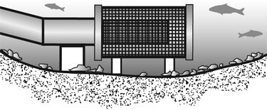

*Water treatment screening process*

*(*[*http://www.tru.ca/trades/programs/water/watersafe/info-operators/water-treatment.html*](http://www.tru.ca/trades/programs/water/watersafe/info-operators/water-treatment.html)*)*

Small particles are able to pass through the screen and are frequently too small to settle out and, as a result, make the water look cloudy, forming a colloid. At this point, **coagulation and flocculation** are used to remove these small particles. The suspended particles are neutral but are polar and have the negative charge on the outside. Since the suspended particles have the same negative charge on the surface they repel each other. To destabilize the colloids, chemicals called coagulants are added. These chemicals are generally higher-valence cationic salts of Al+3 or Fe+3. (See diagram below.) The most commonly used substance is a solution of aluminum sulfate, Al2(SO4)3 (alum).

Al2(SO4)3•12 H2O (s) 🡪 Al3+ (aq) + 3 SO42– (aq) + 12 H2O (l)

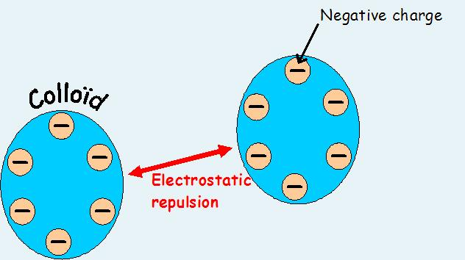 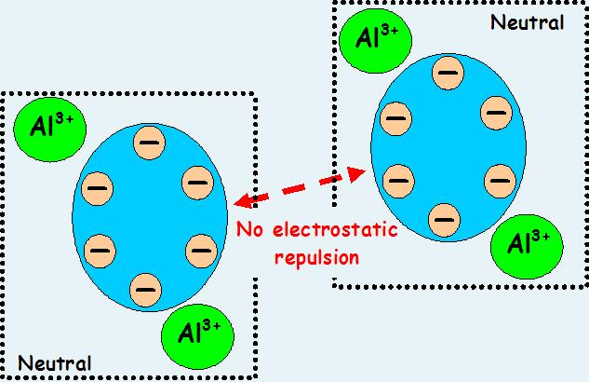

*The treatment of colloidal particles in tap water*

*(*[*http://www.thewatertreatments.com/wastewater-sewage-treatment/coagulation-types/*](http://www.thewatertreatments.com/wastewater-sewage-treatment/coagulation-types/)*)*

The coagulant is mixed rapidly in the colloidal water. The salts react with the suspended particles and form a precipitate. As the precipitates form, they trap impurities. Some of these particles are large enough to settle out.

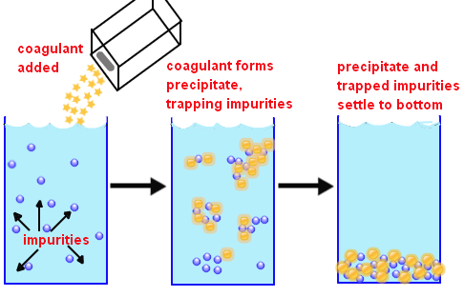

*(*[*http://chemistry.tutorvista.com/physical-chemistry/flocculation.html*](http://chemistry.tutorvista.com/physical-chemistry/flocculation.html)*)*

In order to remove more of the suspended particles, the water is mixed slowly, causing more particles to stick together, forming larger clumps called flocs. This process is called flocculation.

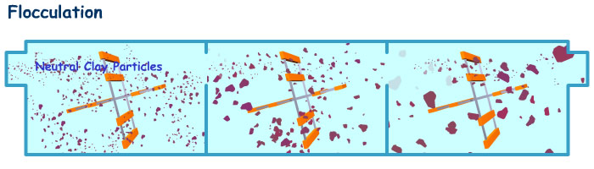

*(*[*https://jzcacayuran.wordpress.com/2015/07/*](https://jzcacayuran.wordpress.com/2015/07/)*)*

**Sedimentation** is the next step in the water treatment process. From the flocculation tank, the water flows to the sedimentation basin, which is deep. Here, the clumps of floc are allowed to settle to the bottom, leaving relatively clear water on top.

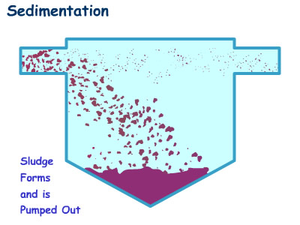

*(*[*https://jzcacayuran.wordpress.com/2015/07/*](https://jzcacayuran.wordpress.com/2015/07/)*)*

The water that leaves the sedimentation basin then goes through **filtration.** It will pass through filters of varying compositions, such as sand, gravel, and charcoal that will remove microscopic particles and microorganisms. Charcoal adsorption (the process in which one substance is attached to the surface of another substance) is used when the water contains dissolved organic compounds such as herbicides or industrial waste products. These can affect the taste and color of the drinking water as well as pose a health threat.

The final step in the process is generally **disinfection**. In many water supplies, the greatest risks to health are disease-causing bacteria, viruses, and parasites. Various chemical methods are used to kill these before the water enters the distribution system. Those most commonly used are chlorine, chlorine dioxide, chloramine, ozone and ultra-violet irradiation.

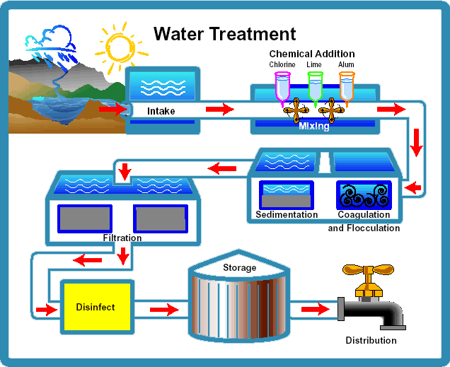

*(*[*https://www.ecwa.org/treatmentprocess*](https://www.ecwa.org/treatmentprocess)*)*

It should be noted that each water treatment plant is different, but each plant generally has each of the processes described above. There are other treatments that maybe involved in the treatment of water. The following table provides information on some of these.

|  |  |  |
| --- | --- | --- |
| **Treatment** | **Chemicals or Process Used** | **Purpose** |
| pH Adjustment | CaO and NaOH | Increases the pH, making the water more basic to help prevent corrosion |
| Fluoride | Fluorides (F–)  (1 part per million) | Protects teeth from decay for those  who drink the water |
| Aeration | Spray water into the air | Removes odors and improves taste |
| Corrosive Inhibitors |  |  |
| 1. Passive | Oxidizing ions  like chromate, nitrite and nitrate | Shifts the corrosion potential |
| 1. Cathodic | Compounds of arsenic  and antimony | Makes the recombination and discharge  of hydrogen more difficult |
| 1. Organic | Urea, amines, ascorbic acid | Protects the metal by forming a  hydrophobic film on the metal surface |
| 1. Precipitation inducers | Silicates and phosphates | Causes the formation of  precipitates on the surface of the metal |

**Wastewater Treatment Process**

Once water is used, it must be returned to the fresh water supply. Wastewater comes from the toilet, bathing, washing dishes and clothes. The water from these sources may contain contaminants that are harmful both to humans and to the environment. Municipal wastewater facilities remove these harmful products before the water is returned to rivers, lakes or streams. The process most facilities use are described below.

1. **Screening**

The first stage requires screening to remove large objects such as rags, diapers, bottle tops, and newspaper. This protects the main sewage pumps and other equipment. This garbage is sent to landfills. At this point, the sewage is sent to a grit chamber, which removes cinders and sand that get washed into the sewer.

1. **Primary Settling**

After the first stage, the wastewater contains organic and inorganic matter and suspended solids. The sewage flows into a sedimentation tank where the flow of water is slowed. This allows the heavier solids to settle to the bottom of the tank, while the lighter materials float. The solids at the bottom are called raw primary biosolids (formerly called sludge). The bottom of the tanks have large scrapers which continuously scrape the floor of the tank and push the biosolids towards the center where they are removed and further treated to be used as fertilizer or sent to a landfill. The floating trash, which is generally grease, scum and plastic material, is skimmed off the top.

1. **Aeration**

The sewage then flows into an aeration tank. Here it is mixed with air and sludge (from step 4, below) that stimulates the growth of oxygen-using bacteria. It is allowed to remain in this tank for several hours. The bacteria breaks down the organic matter into harmless substances.

1. **Final Settling**

The wastewater flows to the final settling tanks. The heavy particles and other solids settle out to the bottom, forming secondary sludge. Most of the sludge is aerated, chlorinated, dried and sent either to a landfill or incinerator. Some of the sludge is reused by sending it back to the aeration tank.

1. **Disinfection**

At this point the water may still contain disease causing organisms. The wastewater is most commonly treated with chlorine, which will kill the harmful bacteria and reduce odor. Some municipalities use ultraviolent light or ozone to disinfect the water. The wastewater is then released into a local waterway.

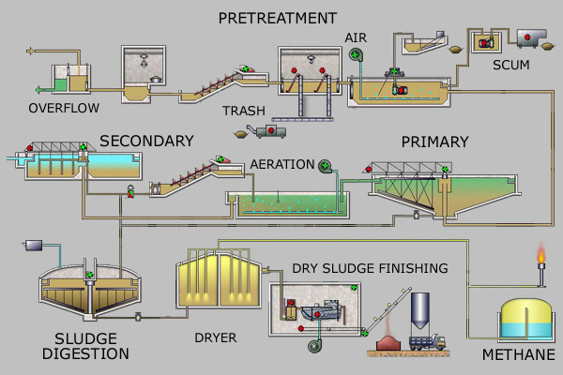

*The steps in sewage treatment*

*(*[*https://en.wikipedia.org/wiki/Sewage_treatment*](https://en.wikipedia.org/wiki/Sewage_treatment)*)*

**More on** **Flint River**

The Flint Water Crisis was the result of poor decisions made by the local and state government, but it is also the result of the pollution of the Flint River over the past century. The more polluted a water source is, the more treatment that is required to make the water safe to drink. Due to pollution, it is more difficult to treat water from the Flint River than from Lake Huron, where Flint received water from 1974 to 2014. The Flint River is polluted from four sources; natural biological waste, treated industrial and human waste, untreated waste intentionally or accidentally dumped into the river, and contaminants washed into the river. In addition, the temperature of the Flint River is warmer than Lake Huron. These all result in higher levels of bacteria, organic matter and dissolved contaminants.

Flint, like many cities, did not worry about the pollution of its river until recently. The earliest industrial waste dumped into the Flint River came from lumber mills in the 1830s. A natural development from the lumber industry was the addition of paper mills and chemical processing plants. As Flint grew, the industries grew and soon they began making carriages and then automobiles. All of which were dumping their wastes into the Flint River. As early as 1893, Flint began getting its city drinking water from the Flint River. By the 1930s, they noticed that the fish in the river began to disappear. Research by the University Of Michigan Institute Of Fisheries Research determined pollution had lowered oxygen levels in the river, suffocating the fish. By the 1940s, there were discussions about the pollution in the river—but nothing was done.

After World War II, Flint became a booming city of 200,000 people. By 1955 it was reported that the Flint River would not be able to support the city’s needs. At that time, new regulations required businesses and industries to treat and dilute their waste with city water before releasing it into the river. This would require even more water from the Flint River. Flint switched to water processed by Detroit in 1967. The main motivation for the switch, which was pushed by General Motors executives, was to save money and guarantee enough water for the needs of the city. City officials were worried about the capacity of the river and whether it could provide enough drinking water and water for the industries. The quality of the water was not a concern.

Switching to water supplied by Detroit did not improve the quality of the Flint River. With the passage of the Clean Water Act in 1972, the Flint River showed some improvement upstream from Flint, but downstream there were significant toxins. They included raw sewage from Flint’s wastewater plant containing fecal coliform bacteria, and phenol from GM plants. Fertilizers in rural area also polluted the river. Road salt raised the rivers chloride levels making the water more corrosive.

*Pollution in the Flint River*

*(*[*http://icastinayak.com/tag/fly-fishing-flint-river-michigan/*](http://icastinayak.com/tag/fly-fishing-flint-river-michigan/)*)*

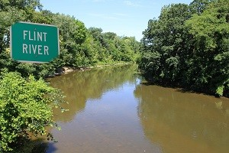

Today, environmental regulations keep companies from dumping waste into the river; however, illegal and accidental dumping continue. Flint city continues to discharge untreated sewage into the river during heavy rains, snowmelts and power outages. Although GM closed its plants in Flint in 2004, the waste left behind still leaches into the river and groundwater. The mistreatment of the Flint River certainly has contributed to the crisis in Flint.

**Lead’s role in the crisis**

Lead is one of a few elements that has been known since ancient times. The oldest example of lead is a small statue found in Egypt believed to be made during the First Dynasty in about 3400 BC. The use of lead was mentioned in ancient writings from India, as well as in the Bible. Romans widely used lead for pipes, writing tablets, coins, pots and pans. In fact, scientists believe that many Romans may have become sick from cooking food and boiling wine in lead pots.

It is believed that the word *lead* is derived from the Celtic word “luaide”, meaning reddish, because of the reddish color of “red lead”, which is lead tetroxide. The symbol Pb is derived from the Latin term *plumbum*, which is believed to be derived from the Latin word for waterworks. This is where the term plumber comes from.

Lead is a lustrous bluish-white metal when freshly cut. When exposed to air, it tarnishes and turns a gray color. This serves as a protective coating. Lead is very soft, highly malleable, ductile, and a poor conductor of electricity (compared to other metals). It is a moderately active metal. It will slowly dissolve in water and cold acids. It is rarely found free in nature and generally found in ores such as galena, PbS (lead sulfide); anglesite, PbSO4 (lead(II) sulfate); and cerussite, PbCO3 (lead(II) carbonate). Lead makes up only 0.0013% of the Earth’s crust, but is not generally considered rare, since it is easily mined and refined. Elemental lead was most commonly obtained historically by roasting galena in hot air. Today most elemental lead is obtained by recycling. Lead is produced around the world, with Australia, China, the United States, Peru, Canada, Mexico and Sweden being the largest producers.

*Galena, PbS*

*(*[*http://www.mine-engineer.com/mining/mineral/galena.htm*](http://www.mine-engineer.com/mining/mineral/galena.htm)*)*

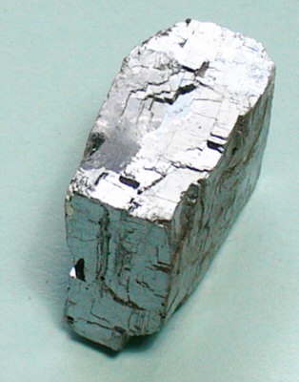

In recent history, lead and lead compounds have been used for many applications. Lead has been used in gasoline, paint, ceramics, pipes and plumbing, solders, batteries, ammunition, and cosmetics. Today, many products that once contained lead no longer use it. This is to reduce the amount of lead that gets into the environment and reduce its toxic effects. The majority of lead today is used in lead-acid batteries for automobiles. The other common applications of lead used today include coloring agents for ceramics, radiation shields, and glass used for computer and television screens.

**Health effects of lead**

No level of lead is safe, and lead fills no essential function in the body. The injuries caused by lead poisoning tend to be permanent, and the effects can last years or a lifetime. Chelation therapy can remove lead from the body, but the effects remain. The degree of exposure to lead depends on the concentration of lead, the route of exposure (air, water or food), and the current medical condition and age of the person. Fetuses, infants, and young children are particularly at risk to lead poisoning since their bodies are growing quickly, which facilitates the bioaccumulation of lead.

When lead enters the body it initially goes into the blood. It is then distributed throughout the body. Most of the lead is then stored in the soft tissue, bones and teeth. Only about 1% remains in the blood. The lead stored in the bones and teeth remains there indefinitely unless it is released back into the blood during a time of stress. When lead is present in the body, especially when present in high concentrations, it tends to compete with magnesium ions, Mg2+, calcium ions, Ca2+, and iron ions, Fe2+. When lead ions, which are also divalent, replace these ions in enzymes, they render the enzymes ineffective. This potentially affects every organ of the body. Lead ions and calcium ions react in similar ways under similar conditions. As a result, lead is absorbed into the bones, replacing calcium. This is a problem for young children who are building bones for, as lead is deposited instead of calcium, stunted growth results. Lead affects enzymes as described by Michael McClure, below.

Lead is believed to inactivate some enzymes by reacting with sulfhydryl groups in the proteins in enzymes.

Lead ions in solution react readily with sulfur, as illustrated by their reaction with hydrogen sulfide to form insoluble lead sulfide.

Pb2+ + H2S 🡪 PbS + 2H+

Enzymes consist of long chains of amino acids (represented below as AA), some of which contain sulfhydryl (-SH) groups. Possibly, lead binds to the sulfur of these groups, thus disrupting the enzymes and damaging nerves and vital organs.



(McClure, M. Mystery Matters: The Cattle Killer. *ChemMatters,* 1986, *4* (3), p 15)

High levels of lead in infants and young children can result in convulsions, major neurological damage, organ failure, coma, and even death. Moderate to low levels of lead can result in behavior and learning problems, such as Attention Deficit Hyperactivity Disorder (ADHD), lower IQ, developmental delays, slowed growth, hearing problems, and anemia.

Pregnant women also are at particular risk with lead poisoning. During pregnancy calcium is normally released from the mother’s bones to help form the bones of the fetus. If lead is present in the bones it is also released. This is especially true when the woman is deficient in calcium. The lead can cross the placental barrier, exposing the fetus to lead. This results in reduced growth of the fetus, premature births, and still-births.

In adults, lead poses a wide range of serious effects. These include the disruption of the biosynthesis of hemoglobin, which results in anemia; increased blood pressure; kidney damage; disruption of the nervous system; brain damage; and reproductive problems.

**Trihalomethanes**

Trihalomethanes were first identified in drinking water in the 1970s. Chlorine and chlorine-containing compounds are added to drinking water to destroy microbial pathogens that could make consumers sick or even kill them. Trihalomethanes (THMs) form when the chlorine or chlorine-containing disinfectants react with organic matter in the water. The organic matter, also referred to as precursors, include such material as algae, weeds, decaying leaves and decomposing animals. The Environmental Protection Agency (EPA) survey shows that THMs are present in most chlorinated water supplies. They are odorless and tasteless. The production of THMs depends on the amount and type of organic matter, the temperature, the pH, the concentration of chlorine, and the contact time of the chlorine with the organic matter.

The most common trihalomethane compounds are dibromochloromethane (CHBr2Cl); tribromomethane (CHBr3), also called bromoform (see below); trichloromethane (CHCl3), also called chloroform; and bromodichloromethane (CHBrCl2). The sum of these four is referred to as Total Trihalomethanes (TTHMs).

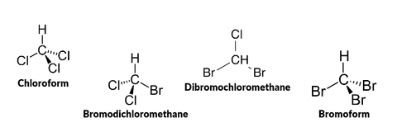

*Structural formulas of the trihalomethane compounds*

*(*[*https://www.hydroviv.com/blogs/water-smarts/disinfection-byproducts-in-drinking-water-toxicity-history-and-policy*](https://www.hydroviv.com/blogs/water-smarts/disinfection-byproducts-in-drinking-water-toxicity-history-and-policy)*)*

The formation of trihalomethanes may occur through many different reaction mechanisms. One of the most widely discussed is the haloform reaction (see below). This involves the stepwise chlorine substitution of the enolate form of a methyl ketone. The resulting trichloroacetyl compound undergoes base hydrolysis liberating chloroform and a carboxylic acid.

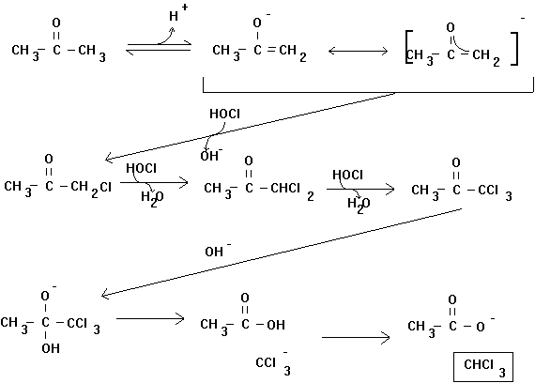

(<http://www.ecs.umass.edu/cee/reckhow/courses/572/572bk4/572BK4.html>)

Trihalomethanes pose a variety of health risks. They can cause injury to the liver, kidney, central nervous system, and they can increase the risk of bladder and colon cancer. Chloroform, (the most common THM), dibromochloromethane and bromoform have been named as substances that will likely cause cancer, based on animal studies. Bromodichloromethane has been identified as a mutagen, which alters DNA. Higher concentrations of trihalomethanes may cause reproductive problems, birth defects, and still births. It should be noted that the health risks from THMs in drinking water are small compared to the risk of potentially deadly infectious diseases if the water is not disinfected with chlorine.

**Oxidation, reduction and corrosion**

The oxidation-reduction reaction, also known as a redox reaction, is a type of reaction in which the acceptance of one or more electrons (reduction) by a material is matched with the donation of one or more electrons (oxidation) by another, usually different, material. Zinc metal typically loses two electrons and produces zinc ions, as in the reaction below.

Zn 🡪 Zn2+ + 2e–

Zinc is said to be oxidized because it loses electrons as it forms ions. Reduction occurs when a reactant gains one or more electrons. In the reaction below, copper (II) ions gain electrons, producing copper metal; copper ions are said to be reduced.

Cu2+ + 2e– 🡪 Cu

Electrons cannot be gained by one substance unless they are lost by another, so oxidation and reduction always occur together. The reaction between the zinc metal and copper ions would look like this:

Zn + Cu2+ 🡪 Zn2+ + Cu

An oxidizing agent is the substance that accepts the electrons from the substance that is oxidized. The oxidizing agent is thus the substance that is reduced. Likewise, the reducing agent is the substance that donates the electrons to the substance that is reduced, and it (the oxidizing agent) is the substance that is oxidized. This can be confusing, but the definition of the term “agent” may help. According to the Oxford Dictionary, an agent is “a person or thing that takes an active role or produces a specified effect.” (<https://en.oxforddictionaries.com/definition/agent>).

In other words, an agent facilitates the effect (e.g., a travel agent helps a person plan and arrange a trip, and a sports agent helps the athlete find the best team and negotiate the best deal). So, the oxidizing agent produces or facilitates the oxidation.

One of the many mnemonics for remembering the definitions of oxidation and reduction is the saying, “LEO the lion says GER”:

LEO = Loss of Electrons is Oxidation

GER = Gain of Electrons is Reduction

The corrosion process is an oxidation/reduction reaction that converts metals to metal ions. The most familiar example of corrosion is the rusting of iron. The green coating called patina that forms on bronze statues is another type of corrosion. The green color is caused by the formation of copper ions. Corrosion is a complex reaction, but it can be understood if it is considered an electrochemical process.

An electrochemical cell consists of two cells called half-cells. Each half-cell contains a metal electrode and an electrolyte. The half-cell where oxidation occurs is called the anode, and the one in which reduction occurs is called the cathode. The electrons naturally flow from the anode to the cathode, creating an electrical current. Corrosion can then be explained as follows:

The metal being corroded acts as the anode; the metal is oxidized, forming metal ions and free electrons. The free electrons reduce the oxygen, often times forming hydroxide, and providing a complimentary cathodic reaction. The dissolution of the metal at the anode has two possible outcomes; the metal ions can go into solution, becoming hydrated, or the metal ions can form a solid compound that collects on the surface. In the former case, further oxidation of the metal ions can occur and an open pit can form. In the latter case, a protective barrier may be formed and the collection of solid metal ions will inhibit further corrosion.

(<http://chem.libretexts.org/Core/Analytical_Chemistry/Electrochemistry/Case_Studies/Corrosion/Corrosion_Basics>)

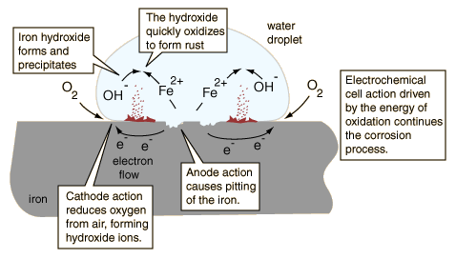

*An illustration of the corrosion (rusting) of iron*

<http://hyperphysics.phy-astr.gsu.edu/hbase/chemical/corrosion.html>

The following equations describe the reactions discussed in the diagram above.

At the anode:

Fe (s) ⟶ Fe2+ (aq) + 2 e−

At the cathode:

O2 (g) + 2 H2O (l) + 4 e− ⟶ 4 OH– (aq)

In the water droplet above, the iron(II) ions and the hydroxide ions combine to form a   
 precipitate:

Fe2+ (aq) + 2 OH− (aq) ⟶ Fe(OH)2 (s)

The precipitate quickly oxidizes to form rust (Fe2O3):

4 Fe(OH)2 (s) + O2(g) ⟶ 2 Fe2O3•2 H2O (s) + 2 H2O (l)

The corrosion of pipes used to distribute drinking water can cause problems, such as: contributing toxic metals to the drinking water; staining laundry, sinks and tubs; and creating a poor taste. The metal water pipes are made of a variety of metals including iron, copper, galvanized steel and lead. There are many factors that affect the rate of corrosion in these water pipes. They include the pH of the water, the concentration of oxygen dissolved in the water, the chemical composition of the water, the temperature of the water, and the velocity and pressure of the water in the pipes.

Water that is slightly basic, with a pH of around 8, is less corrosive, while slightly acidic water, with a pH less than 6.5, will be very corrosive. Water exposed to air dissolves oxygen. Oxygen is an oxidizing agent that causes the metal pipes to be oxidized, and the result is corrosion, adding metal ions in the water. The chemical composition of the water (a mixture) may have varying effects on the corrosion of the plumbing.

When minerals dissolve in the water, they separate into ions that conduct electricity and support the electrochemical process of corrosion. Certain minerals such as calcium or magnesium ions will react with carbonate ions in the water to form a protective coating on the pipe, reducing corrosion. Like all chemical reactions, corrosion is more rapid at higher temperatures, so warm or hot water increases the rate of corrosion. Thus, corrosion is more prevalent in hot water lines. With a high pressure and flow rate, the natural protective coating that form on pipes can be eroded, exposing the bare metal. This results in a higher rate of corrosion when the protective coating is removed.

**Effects of pH**

The degree of acidity of a substance is determined by measuring its pH. The pH range commonly goes from 0 to 14 and a neutral substance has a pH of 7. Substances with a pH of less than 7 are acidic and greater than 7 are basic.

A small number of water molecules dissociate into hydrogen ions (H+) and hydroxide ions (OH–). In pure water the number of H+ and OH– ions are equal and the pH is 7. pH is really a measurement of hydrogen ions, H+, and is believed to stand for the “power of hydrogen”. As stated by the United States Environmental Protection Agency (EPA):

pH is an expression of hydrogen ion concentration in water. Specifically, pH is the negative logarithm of hydrogen ion (H+) concentration (mol/L) in an aqueous solution:

pH = –log10 (H+)

The term is used to indicate the degree of basicity or acidity of a solution ranked on a scale of 0 to 14, with pH 7 being neutral. As the concentration of H+ ions in solution increases, acidity increases and pH gets lower, below 7. When pH is above 7, the solution is basic. Because pH is a logarithmic function, one unit change in pH (e.g., from 7 to 6) indicates a 10x change in hydrogen ion concentration in that solution.

(<https://www3.epa.gov/caddis/ssr_ph_int.html>)

The range of the pH scale is shown in the table below, with specific examples of substances at each pH level.

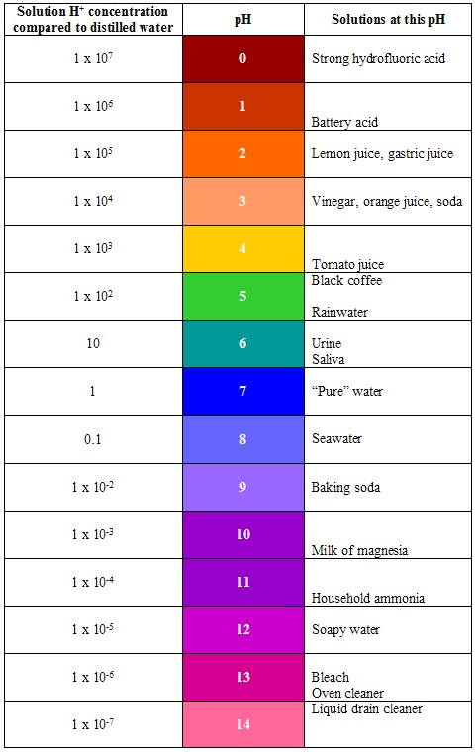

*The pH scale, including materials that exhibit the individual pH levels*

*(*[*http://www.austincc.edu/biocr/1406/labm/ex3/prelab_3_3.htm*](http://www.austincc.edu/biocr/1406/labm/ex3/prelab_3_3.htm)*)*

**Le Châtelier’s Principle**

Le Châtelier’s principle is also known as the equilibrium principle. In chemistry a dynamic equilibrium occurs when the tendency of the reactants to form products is balanced by the tendency of the products to form reactants. This occurs when the rate of the forward reaction is equal to the rate of the reverse reaction. The composition of a system at equilibrium can change if certain conditions change. How these changes influence a chemical reaction at equilibrium was first described by Henri Louis Le Châtelier in 1884. Le Châtelier’s principle can be stated as: Any change (also called a stress) in a chemical reaction at equilibrium causes the reaction to proceed in the direction that reduces the effect of the change. Stresses, changes in concentration, pressure/volume and temperature, all cause a reaction to proceed in the direction that reduces the impact of the change.

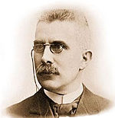

*Henri Louis Le Châtelier*

*(*[*https://en.wikipedia.org/wiki/Henry_Louis_Le_Ch%C3%A2telier*](https://en.wikipedia.org/wiki/Henry_Louis_Le_Ch%C3%A2telier)*)*

The increase in the concentration of a reactant or product causes the reaction to proceed in the direction that consumes the added substance. Likewise the decrease in the concentration of a reactant or product causes the reaction to proceed in the direction that produces more of the missing substance. For example in the reaction

2 SO3 (g) ↔ 2 SO2 (g) + O2 (g)

if the concentration of SO3 is increased the equilibrium will favor the forward reaction which consumes the SO3 and produces more SO2 and O2.

Any change in pressure or volume of an equilibrium system is only significant when gases are involved. Remember that pressure is a result of gas molecules colliding with the walls of the container and with each other. The more gas molecules in the container, the higher the pressure. If the pressure on the equilibrium system is increased, the reaction will shift in such a direction to counteract the change. Therefore, the position of equilibrium will move in the direction that will decrease the number of molecules (moles) of gas, thus reducing the pressure.

Using the same equation as above, if the pressure on the entire equilibrium system is increased, the reaction will shift to make fewer moles of gas, so that there are fewer molecular collisions, thus reducing pressure. Since there are two moles of gas on the reactant side and three moles of gas on the products side, the reaction will proceed to the left, producing more SO3, but consuming more of the “products”. If pressure in a gaseous equilibrium system is decreased, the system will proceed in the direction that would produce more moles of gas, thus increasing the pressure.

In order to apply Le Châtelier’s principle during a change in temperature, it is necessary to know whether the reaction is endothermic (absorbs heat) or exothermic (releases heat). Heat can be considered a “product” in an exothermic reaction and a “reactant” in an endothermic reaction. If we look at the SO3 decomposition reaction again it is necessary to know that it is endothermic (because more energy is consumed to break the two S–O bonds than is produced in making the one O–O bond). So we can now consider the reaction as:

Heat + 2 SO3 (g) ↔ 2 SO2 (g) + O2 (g)

Suppose the system is at equilibrium, and then the temperature is increased. According to Le Châtelier’s principle, the reaction will proceed in the direction to counteract this change. Because the reaction in endothermic (heat is a reactant), a shift to the right (forward direction) will use up some of the excess heat (added as a stress), and more SO2 and O2 will be produced as a result.