April/May 2017 Teacher's Guide

for

Growing Green on the Red Planet

Table of Contents

About the Guide 2
Student Questions 3
Answers to Student Questions 5
Anticipation Guide 6
Reading Strategies 7
Connections to Chemistry Concepts 10
Possible Student Misconceptions 10
Anticipating Student Questions 11
Activities 12
References 15
Web Sites for Additional Information 16

BACKGROUND INFORMATION:
About the Guide 19
Background Information 20
References 36
Web Sites for Additional Information 37

About the Guide

Teacher’s Guide team leader William Bleam and editors Pamela Diaz, Regis Goode, Diane Krone, Steve Long and Barbara Sitzman created the Teacher’s Guide article material.
E-mail: bbleam@verizon.net

Susan Cooper prepared the anticipation and reading guides.

Patrice Pages, ChemMatters editor, coordinated production and prepared the Microsoft Word and PDF versions of the Teacher’s Guide.
E-mail: chemmatters@acs.org

Articles from past issues of ChemMatters and related Teacher’s Guides can be accessed from a DVD that is available from the American Chemical Society for $42. The DVD contains the entire 30-year publication of ChemMatters issues, from February 1983 to April 2013, along with all the related Teacher’s Guides since they were first created with the February 1990 issue of ChemMatters.

The DVD also includes Article, Title, and Keyword Indexes that cover all issues from February 1983 to April 2013. A search function (similar to a Google search of keywords) is also available on the DVD.

The ChemMatters DVD can be purchased by calling 1-800-227-5558. Purchase information can also be found online at http://tinyurl.com/o37s9x2.

Student Questions

Growing Green on the Red Planet

  - What does Mark Watney need in order to survive on Mars until NASA sends a rescue mission?

  - What type of scientist is Mark Watney?

  - Name three places on Earth that have been used to study Mars.

  - According to this article, why is Mars much colder than Earth?

  - Why is it necessary to regulate the use of manure as fertilizer on Earth?

  - Describe the chemical reaction that is involved in photosynthesis.

  - Nitrogen, phosphorus and potassium are primary nutrients for plants. What is the purpose of each of these nutrients?

  - Describe the difference between macronutrients and micronutrients.

  - How does the gravity on Mars compare to that on Earth?

  - List the three factors cited in the article that would make it difficult to grow plants on Mars.

  - What are the sources of oxygen and hydrogen that Mark Watney used to make water on Mars?

Answers to Student Questions
(taken from the article)
Growing Green on the Red Planet

    - What does Mark Watney need in order to survive on Mars until NASA sends a rescue mission?
Mark Watney will need food and water to survive on Mars.
    - What type of scientist is Mark Watney?
Mark Watney is a botanist.
    - Name three places on Earth that have been used to study Mars.
The three places on Earth used to study Mars are:
- Antarctica
- Hawaii
- South America
    - According to this article, why is Mars much colder than Earth?
Mars is much colder that Earth mainly because it is farther away from the sun than is Earth.
    - Why is it necessary to regulate the use of manure as fertilizer on Earth?
It is necessary for U.S. environmental agencies to regulate the use of manure to prevent the spread of viruses and bacteria that could contaminate the crops.
    - Describe the chemical reaction that is involved in photosynthesis.
Water and carbon dioxide react to produce oxygen and sugars in photosynthesis.
6 H₂O + 6 CO₂ 6 O₂ + C₆H₁₂O₆
    - Nitrogen, phosphorus and potassium are primary nutrients for plants. What is the purpose of each of these nutrients?
Nitrogen is an important element in chlorophyll, which is needed for photosynthesis.
Phosphorus is a component in the chemical reactions that involve photosynthesis.
Potassium is involved in the opening and closing of the pores in leaves and stems, which allows the uptake of carbon dioxide and water.
    - Describe the difference between macronutrients and micronutrients.
Macronutrients, such as nitrogen, phosphorus, potassium, calcium, magnesium and sulfur, are needed in large quantities for plant life. Micronutrients, which include iron, manganese, zinc, copper, boron, molybdenum, and chlorine, are important for plant growth but are only need in small quantities.
    - How does the gravity on Mars compare to that on Earth?
The gravity on Mars is 38% that of Earth’s.
    - List the three factors cited in the article that would make it difficult to grow plants on Mars.
Factors that would make it difficult to grow plants on Mars include:
- extreme cold temperatures
- sunlight hitting Mars is much less that what Earth gets
- Mars’s atmosphere is not as thick as Earth’s
    - What are the sources of oxygen and hydrogen that Mark Watney used to make water on Mars?
Mark Watney obtained the oxygen from the oxygenator, which produced oxygen from the atmospheric carbon dioxide. He produced hydrogen by dissociating hydrazine, N₂H₄, which was the propellant for the rocket.

Anticipation Guide
Anticipation guides help to engage students by activating prior knowledge and stimulating students’ interest before reading. If class time permits, discuss students’ responses to each statement before reading each article. As they read, students should look for evidence supporting or refuting their initial responses.

Directions: Before reading, in the first column, write “A” or “D,” indicating your agreement or disagreement with each statement. As you read, compare your opinions with information from the article. In the space under each statement, cite information from the article that supports or refutes your original ideas.

Me | Text | Statement
 |  | - Research shows that Martian soil cannot be used to grow plants.
 |  | - Next to Earth, Mars appears to be the most habitable planet in our solar system.
 |  | - The atmosphere of Mars is about 50% carbon dioxide.
 |  | - All of the macronutrients required for plant life are nonmetals.
 |  | - Micronutrients are usually supplied to plants through fertilizers.
 |  | - Organic waste (manure) is very good for fertilizing soil.
 |  | - The chemistry in Weir’s book The Martian is plausible.
 |  | - Volcanic soil in Hawaii is similar to Martian soil.
 |  | - Watering plants on Mars could require less water than on the Earth.
 |  | - Hydrazine is a rocket propellant containing only nitrogen and hydrogen.

Reading Strategies
These graphic organizers are provided to help students locate and analyze information from the articles. Students’ understanding will be enhanced when they explore and evaluate the information themselves, with input from the teacher if students are struggling. Encourage students to use their own words and avoid copying entire sentences from the articles. The use of bullets helps them do this. If you use these reading strategies to evaluate student performance, you may want to develop a grading rubric such as the one below.

Score | Description | Evidence
4 | Excellent | Complete; details provided; demonstrates deep understanding.
3 | Good | Complete; few details provided; demonstrates some understanding.
2 | Fair | Incomplete; few details provided; some misconceptions evident.
1 | Poor | Very incomplete; no details provided; many misconceptions evident.
0 | Not acceptable | So incomplete that no judgment can be made about student understanding

Teaching Strategies:

- Links to Common Core Standards for Reading:
  - ELA-Literacy.RST.9-10.1: Cite specific textual evidence to support analysis of science and technical texts, attending to the precise details of explanations or descriptions.
  - ELA-Literacy.RST.9-10.5: Analyze the structure of the relationships among concepts in a text, including relationships among key terms (e.g., force, friction, reaction force, energy).
  - ELA-Literacy.RST.11-12.1: Cite specific textual evidence to support analysis of science and technical texts, attending to important distinctions the author makes and to any gaps or inconsistencies in the account.
  - ELA-Literacy.RST.11-12.4: Determine the meaning of symbols, key terms, and other domain-specific words and phrases as they are used in a specific scientific or technical context relevant to grades 11-12 texts and topics.

- Links to Common Core Standards for Writing:
  - ELA-Literacy.WHST.9-10.2F: Provide a concluding statement or section that follows from and supports the information or explanation presented (e.g., articulating implications or the significance of the topic).
  - ELA-Literacy.WHST.11-12.1E: Provide a concluding statement or section that follows from or supports the argument presented.

- Vocabulary and concepts that are reinforced in this issue:

  - Chemical reactions
  - Macro- and micronutrients
  - Personal and community health
  - Proteins
  - Structural formulas
  - Biochemistry
  - Consumer choices
  - Recycling

- Some of the articles in this issue provide opportunities for students to consider how understanding chemistry can help them in their personal lives.

- Consider asking students to read “Open for Discussion” on page 4 to extend the information in “Growing Green on the Red Planet” on pages 5-7.

- The infographic on page 19 provides more information to support the article “Espresso, Café Latte, Cappuccino…A Complex Brew” on pages 10-12.

- To help students engage with the text, ask students which article engaged them most and why, or what questions they still have about the articles.

- You might also ask them how information in the articles might affect their health and/or consumer choices. Also ask them if they have questions about some of the issues discussed in the articles.

- The Background Information in the ChemMatters Teachers Guide has suggestions for further research and activities.

Directions: As you read, complete the graphic organizer below to describe the chemistry of growing plants on Mars.

 | What chemicals are needed? | How can they be obtained on Mars?
Atmosphere
Soil
Water

Summary: On the bottom or back of this paper, write a short email (about 3 sentences) to a friend who wants to know whether the chemistry in The Martian is a good indicator of how future scientists can grow food on Mars.

Connections to Chemistry Concepts
(for correlation to course curriculum)
- Descriptive chemistry—This article could be used to discuss the characteristics and importance of several elements, especially those important to plant growth.
- Limiting reagent—The discussion of macronutrients and micronutrients can be used as an example of a limiting reagent.
- Energy conversion—This article serves as an example of the conversion of light energy from the sun to chemical energy in the plants.
- Light energy, wavelength and activation energy—As you discuss the relationship between light energy and wavelength you can use the information in this Teacher’s Guide to cite the pigments in plants and their colors as an example of how absorbed light determines the color of the pigment. You could also relate the light energy absorbed by plants as the activation energy in the photosynthesis process.
- Synthesis and decomposition reactions—The decomposition of hydrazine to produce hydrogen, and then the synthesis of water from the hydrogen provides real life practical examples of these reaction types.
- Oxidation-reduction reactions—The production of oxygen from carbon dioxide, the decomposition of hydrazine to form nitrogen and oxygen, the synthesis of water from hydrogen and oxygen, and photosynthesis are all excellent examples of redox reactions mentioned in the article
- Greenhouse effect—While studying the greenhouse effect, you could discuss how the thin Martian atmosphere affects the daily and seasonal temperatures on Mars.

Possible Student Misconceptions
(to aid teacher in addressing misconceptions)
- “The dust storms on Mars have strong, destructive winds like in the movie, The Martian.” Dust storms do exist and can last for long periods of time on Mars. The atmosphere on Mars is only 1% of that on Earth. Since the atmosphere is so thin, even a strong wind would have little force, since the force is a function of velocity and atmospheric density. In the strongest storm you would feel a breeze but it wouldn’t be able to knock a person over. The wind would be strong enough to fly a kite, but not much else.
- “The Martian atmosphere is thinner than Earth’s, so it should allow much more sunlight to penetrate to the surface of the planet to make it warmer.” That might be true during the daytime when the sun’s rays hit the planet, but the thin atmosphere of Mars also does not hold in nearly as much of the sun’s energy at night as Earth’s atmosphere does.
- “With an atmosphere of 95% carbon dioxide, plants should really flourish on Mars.” Unfortunately, even though its atmosphere is 95% carbon dioxide, the atmosphere on Mars is only about 1% as concentrated as the atmosphere on Earth. That means there won’t be enough carbon dioxide on Mars to sustain plants outdoors (never mind the cold temperatures), unless we concentrate the atmosphere in some way.
- “Organic fertilizers are better.” The plant doesn’t care where the nutrients come from. Organic fertilizers do release their nutrients to the soil more slowly, since they are bound in complicated organic compounds and require microbial activity to release them. The concentration of nutrients in organic fertilizer is generally lower, requiring the use of more fertilizer. Organic fertilizers do improve the soil by adding organic material. There are certainly advantages and disadvantages to using organic fertilizers.

Anticipating Student Questions
(answers to questions students might ask in class)
- “Is it safe to use human feces as fertilizer?” The use of untreated human feces as fertilizer can be risky, since it can carry disease-causing pathogens. When human waste is treated by the municipal treatment plant it is then referred to as “biosolids”. It is treated to ensure that there are no pathogens or other hazardous materials. Once treated and tested the biosolids are safe to use as fertilizers for crops.
- “Don’t manures stink?” Treated manures (biosolids) do have their own distinctive odor, depending on the treatment process. Some have a slight musty ammonia odor, while others have a much stronger odor that people would not find pleasant. The odor is primarily caused by compounds containing sulfur and ammonia which are nutrients for plant.
- “Is it really possible to send a manned mission to Mars?” NASA has a goal to have a manned mission to Mars by 2030. They believe it will take international cooperation and private industry support.

“We are farther down the path to sending humans to Mars than at any point in NASA's history," Bolden [NASA administrator and astronaut] said during an event at NASA Headquarters in Washington, D.C. that detailed NASA's manned Mars plans.

"We have a lot of work to do to get humans to Mars, but we'll get there," Bolden said.

Some of this work includes developing a capsule called Orion and the Space Launch System (SLS) megarocket to help get astronauts to deep-space destinations. Orion and the SLS are scheduled to fly together for the first time, on an unmanned test flight, in 2018, with a manned flight to take place in 2021.

Newman [NASA deputy administrator] cited the fact that astronauts recently grew (and ate) lettuce on the International Space Station, as part of an experiment designed to better understand the production of food crops away from Earth.

Furthermore, two crewmembers on the orbiting lab — NASA astronaut Scott Kelly and cosmonaut Mikhail Kornienko — are halfway through an unprecedented yearlong mission that is characterizing the psychological and physiological effects of long-duration spaceflight. Such work should inform planning for crewed Red Planet missions, which could take astronauts away from Earth for 500 days or more, NASA officials have said.

Newman also mentioned the Mars Oxygen ISRU Experiment (MOXIE), one of seven science instruments that NASA's next Mars rover will carry toward the Red Planet when it blasts off in 2020.

MOXIE will pull carbon dioxide from the thin Martian atmosphere and turn it into pure oxygen and carbon monoxide, demonstrating technology that could keep settlers alive on the Red Planet — and help them blast off the surface when it's time to go home. (Oxygen can be used as an oxidizer, helping to burn rocket fuel.)
.
"We're going to make oxygen on another planet — the first time ever to make oxygen on another planet," Newman said. "These experiments — they're real, they're here."

Such work is being done in service of an epic and monumental goal.

(http://www.space.com/30580-nasa-manned-mars-mission-reality.html)

As of a news release on February 24, 2017, NASA is actually completing a feasibility study of putting two astronauts aboard the Space Launch System (SLS) for its initial flight in late 2018. A new report on this new study can be found at: http://www.cbsnews.com/news/nasa-studies-adding-crew-to-super-rocket-test-flight/.

Activities
Labs and demos

- A lab to determine the contents of a fertilizer: The “Fertilizer Components” laboratory activity is a basic qualitative analysis lab that tests for nitrates, phosphates, sulfates, ammonium ions, iron(III) ions, and potassium ions. This lab procedure can be found in the textbook Chemistry in the Community. (American Chemical Society Chemistry in the Community, 6th ed., W. H. Freeman and Company/BFW: New York, 2012; pp 507–512)
It can also be found online at https://books.google.com/books?id=wYtpGEbAB1cC&pg=PA412&lpg=PA412&dq=Chemistry+in+the+Community+Fertilizer+Components&source=bl&ots=eb3_69Imss&sig=6l6wTpWF-uGxq3fS2piVxL4IM4U&hl=en&sa=X&ved=0ahUKEwiLmOvUhJ_SAhXFbiYKHQe-Az8Q6AEIGjAA#v=onepage&q=Chemistry%20in%20the%20Community%20Fertilizer%20Components&f=false.
- A laboratory activity to analyze phosphates in fertilizer: “Analysis of Phosphorus in Plant Food” quantitatively determines the amount of phosphorus in a fertilizer. This lab would be good for an advanced chemistry class, for the students are to determine the calculations they will need to perform in order to determine the mass percent of P₂O₅ in the fertilizer. (https://www.emich.edu/chemistry/genchemlab/documents/10-phosphorus.pdf)
- A simple student lab for the electrolysis of water: “Electrolysis of Water Experiment” uses common household materials. This is written for a sixth grade class but could easily be adapted for high school students. (https://www.education.com/science-fair/article/water-electrolysis/)
A similar version of the lab that is geared for high school students can be found on the American Association of Chemistry Teachers Web site for those who are members: https://teachchemistry.org/classroom-resources/electrolysis-of-water.
- A demonstration for the electrolysis of water: “Electrolysis of Water” provides teacher instructions for demonstrating the electrolysis of water using the Hoffman apparatus, as well as an alternative procedure using a Petri dish. A reference to a video for both procedures is also included. (https://projects.ncsu.edu/project/chemistrydemos/Electrochem/Electrolysis%20of%20Water.pdf)

Simulations

- Simulation of the rate of photosynthesis: “Measuring the Rate of Photosynthesis of Elodea” provides an opportunity for students to collect data on the rate of photosynthesis versus the amount of light. (https://www.reading.ac.uk/virtualexperiments/ves/preloader-photosynthesis-full.html)
- Simulation of photosynthesis: “Illuminating Photosynthesis” is a series of simulations produced by NOVA. The first simulation, “The Cycle” shows the process of photosynthesis at the macroscale; sunlight striking the plant, watering the plant and the plant producing oxygen. The second simulation, “Atomic Shuffle”, illustrates photosynthesis on the molecular level. (http://www.pbs.org/wgbh/nova/nature/photosynthesis.html)
- Greenhouse Effect simulation: This PhET simulation, “The Greenhouse Effect”, allows students to explore the relationship between various greenhouse gases, their concentrations, photons and temperature. There are many teacher submitted activities associated with this simulation. (https://phet.colorado.edu/en/simulation/greenhouse)
- Simulation of the electrolysis of water: The “SEPUP Electrolysis Simulation” demonstrates the process at the molecular level. It provides an explanation of the processes occurring at the anode and the cathode. The animation may be stopped and started as needed. (http://www.sepuplhs.org/high/hydrogen/electrolysis_sim.html)

Media

Videos

- Mars: “Magnificent Mars: 10 Years of Mars Reconnaissance Orbiter” is a short video (2:20) produced by NASA Jet Propulsion Laboratory. It shows spectacular pictures taken from the Mars Reconnaissance Orbiter. (https://www.youtube.com/watch?v=bdHkgtLgcSY)
- The color of Mars: “Is Mars Really Red?” is a short animated video (1:00) produced by NASA that explains the red color of Mars. (http://mars.nasa.gov/multimedia/videos/?v=29)
- Explanation of the use of manure: “Treated Human Waste as Fertilizer” is a video (7:43) that investigates the use of human waste as fertilizer. The video shows the process of treating and testing the human waste from Los Angeles. The process turns the human waste into biosolids, which are then applied to fields to grow crops. (https://www.youtube.com/watch?v=9HPCW5020SU)
- Photosynthesis: This Khan video, “Photosynthesis” (13:37), provides an overview of the process of photosynthesis. There are other Khan videos that go into more detail that can be found at the same site: https://www.khanacademy.org/science/biology/photosynthesis-in-plants/introduction-to-stages-of-photosynthesis/v/photosynthesis.
- Photosynthesis using graphics: “Photosynthesis: Crash Course Biology #8” is a video (13:14) that provides an explanation of photosynthesis. The presenter is energetic and his explanation is interspersed with excellent graphics that demonstrate the photosynthesis process. (https://www.youtube.com/watch?v=sQK3Yr4Sc_k)
- Reaction of hydrogen and oxygen: This video, “Hydrogen and Oxygen Gas Reaction” (2:57), provides an explanation of the reaction to produce water. It shows the explosive nature of the reaction. (https://www.youtube.com/watch?v=RudCaJB_Xx4)

Lessons and lesson plans

- Series of lessons on soil science: From the Ground Up: The Science of Soil, produced by Discovery Education, is a series of six lessons dealing with soil, plants, and the chemistry associated with them. Each lesson provides objectives, teacher background, detailed instructions and a PowerPoint presentation. The titles of the lessons are: “In Search of Essential Nutrients”, “Properties of Soil”, “Plant Soil Interactions”, “Plant Soil Deficiencies”, “Fertilizers and the Environment”, and “Nourishing the Planet in the 21st Century”. (http://www.thescienceofsoil.com/teacher-resources)
- Series of activities dealing with the chemistry of fertilizers: The Chemistry of Fertilizers is a series of activities designed for high school chemistry classes. It provides an overview of the unit, objectives, time requirements, and materials needed for each lesson. Additional resources are also provided. (http://archives.lessoncorner.com/e4defd9f8135458f3.pdf)

Projects and extension activities

- A research project dealing with NASA’s technologies: Students could be assigned to research and report about the technologies that NASA is developing and compare them to those in the movie The Martian. Some of the technologies the students could research and compare to the movie might include: developing the habitat, growing plants in space, recovering water, generating oxygen and creating land rovers, to name a few. An article that could be used to initiate the research can be found at https://www.nasa.gov/feature/nine-real-nasa-technologies-in-the-martian.
- Scientific analysis of a science fiction movie: Students could be assigned to watch a science fiction movie to identify the science presented in the movie. They would then research and report on the validity and feasibility of the science presented in the movie. Some movies that could be used for this include 2001: A Space Odyssey, Apollo 13, The Right Stuff, Andromeda Strain, and the Star Wars movies.
- A home experiment to compare fertilizers: At home, students could perform an experiment to determine whether inorganic or organic fertilizers are most effective for growing plants. A description of such a project can be found at https://www.education.com/science-fair/article/plant-grow-chemical-organic-no-fertilizer/.
- Debate on the use of fertilizers: The use of various types of fertilizers can be controversial. Students could spend time researching the pros and cons of various types of fertilizers. The debate could center over whether organic (manure) or inorganic (synthetic) fertilizers are better.

References
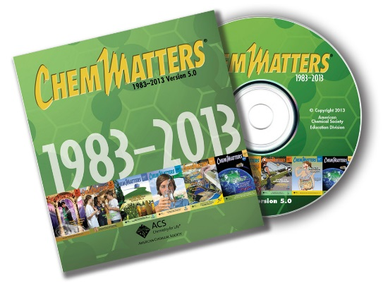
(non-Web-based information sources)
The references below can be found on the ChemMatters 30-year DVD, which includes all articles
published from the magazine’s inception in October 1983 through April 2013; all available Teacher’s Guides, beginning February 1990; and 12 ChemMatters videos. The DVD is available from the American Chemical Society for $42 (or $135 for a site/school license) at this site: http://ww.acs.org/chemmatters. Click on the “Teacher’s Guide” tab to the left, directly under the “ChemMatters Online" logo and, on the new page, click on “Get the past 30 Years of ChemMatters on DVD!” (the icon on the right of the screen).

Selected articles and the complete set of
Teacher’s Guides for all issues from the past three
years are available free online at the same Web site, above. Click on the “Issues” tab just below the logo, “ChemMatters Online”.
30 Years of ChemMatters !
Available Now!

The article “Life on Mars” describes the purpose and the experiments performed by the Viking 1 and Viking 2 spacecraft that landed on Mars in 1976. One of the purposes of the landers was to determine if there was life on Mars. The experiments describe the theory behind them, what they detected and the analysis of the results. (Scott, D. Life on Mars. ChemMatters, 1994, 12 (4), pp 10–13)

The exploration of Mars by the Pathfinder spacecraft and its robotic rover, Sojourner, are described in this article. The soil of Mars was examined, and it was determined that it has many similarities to the soil on Earth. The article explains the methods used to analyze the Martian soil and rocks. (Stone, C. Clues from a Far Planet. ChemMatters, 1998, 16 (2), pp 7–9.)

This article describes the purpose of the Mars Science Laboratory that was sent to Mars in 2010. The purpose of this mission was to search for carbon. In the article, the various methods to detect carbon are explained. (Bleacher, L. Follow the Carbon. Follow the What? ChemMatters, 2008, 26 (1) pp 16–19.)

The importance of nitrogen in fertilizer is described in this article. It includes a good explanation of the nitrogen cycle. The use of manure and some advantages of organic farming are described. The hazards of excess nitrogen in the environment is also explored. (Nolte, B. Nitrogen From Fertilizers: Too Much of a Good Thing. ChemMatters, 28 (2), pp 5–7.)

The Teacher’s Guide for the April 2010 ChemMatters fertilizer article above provides more information on nitrogen, its compounds and its pollution. It also contains the sources for a nitrogen cycle activity as well as a simulation on the nitrogen cycle.

Web Sites for Additional Information
(Web-based information sources)
Mars

This NASA site has a graphic comparison of Mars and Earth. (http://mars.nasa.gov/allaboutmars/facts/#infographic)

This is a short article produced by National Geographic and NASA about Mars, its water and its landscape. In addition, there are nice graphics of Mars, its moons and its relationship to our solar system. (http://science.nationalgeographic.com/science/space/solar-system/mars-article/)

At this site you will find a more detailed article about Mars. It includes information about the size, orbit, composition, moons, atmosphere and climate of Mars. There are also several imbedded videos in the article dealing with Mars. (http://www.universetoday.com/14701/mars/)

Another extensive article about Mars, it composition, atmosphere, and climate can be found at http://www.space.com/47-mars-the-red-planet-fourth-planet-from-the-sun.html.

Plant growth and nutrients

The basic needs of plants are briefly discussed at this site: http://www.aces.uiuc.edu/vista/html_pubs/hydro/require.html.

This is an extensive article about the nutrient requirements for plants. It provides information on the role each nutrient plays. (http://www.ncagr.gov/agronomi/pdffiles/essnutr.pdf)

More information about plant nutrients can be found at this site. The information at this site is a little more concise and given in a bulleted format. (http://www.ncagr.gov/cyber/kidswrld/plant/nutrient.htm)

This article provides a comparison between inorganic and organic fertilizer. It provides the comparison in a chart, as well as providing a discussion on the history, cost, and supply of nutrients. (http://www.diffen.com/difference/Chemical_Fertilizer_vs_Organic_Fertilizer)

At this site, a graphic comparison of organic and inorganic fertilizers can be found. (http://www.majordifferences.com/2013/10/difference-between-organic-manures-and.html#.WK3oNzsrJPZ)

Photosynthesis

A basic explanation of photosynthesis is given at this site. It includes a discussion of the cellular components essential for photosynthesis, as well as the photosynthetic process. (http://www.livescience.com/51720-photosynthesis.html)

This article on photosynthesis includes illustrations that help in the understanding of the process. (http://www.nature.com/scitable/topicpage/photosynthetic-cells-14025371)

A study guide on photosynthesis for students can be found at this site. It provides a review of the processes involved, study questions, and a photosynthesis quiz. (http://chemistry.about.com/od/lecturenotesl3/a/photosynthesis.htm)

The Khan tutorial on the introduction of photosynthesis can be found at this site. The explanation of photosynthesis includes graphics to aid in student understanding. More tutorials on the specific processes involved in photosynthesis can be accessed from this site as well. (https://www.khanacademy.org/science/biology/photosynthesis-in-plants/introduction-to-stages-of-photosynthesis/a/intro-to-photosynthesis)

Oxygen generation in space

This short NASA article discusses the Mars Oxygen ISRU Experiment (MOXIE), which will be on the Mars Rover in 2020 and will make oxygen from carbon dioxide. It includes a schematic of how it will work. (http://mars.nasa.gov/mars2020/mission/instruments/moxie/for-scientists/)

This article explains the scientific process that MOXIE will use to generate oxygen on Mars. (http://ssed.gsfc.nasa.gov/IPM/PDF/1134.pdf)

A technical paper on the production of oxygen using solid oxide electrolysis is found at this site. It explains the process as well as the experimentation that has occurred to test the process. (http://citeseerx.ist.psu.edu/viewdoc/download?doi=10.1.1.194.6749&rep=rep1&type=pdf)

At this site, the production of oxygen on the International Space Station is discussed and explained. (http://science.howstuffworks.com/oxygen-made-aboard-spacecraft.htm)

Hydrazine

At this site, information on hydrazine, as well as sources for the information, can be found: https://pubchem.ncbi.nlm.nih.gov/compound/hydrazine#section=Synonyms.

A discussion of the hydrazine and its uses can be found at https://eic.rsc.org/magnificent-molecules/hydrazine/2000023.article.

This article on hydrazine provides a little information on how it is produced and some of its uses. The uses described include: as a reducing agent, as a precursor for organic synthesis and blowing agents, and as a rocket thruster fuel. (http://www.chm.bris.ac.uk/motm/hydrazine/hydrazineh.htm)

April/May 2017 Teacher's Guide

Background Information

for

Growing Green on the Red Planet

Table of Contents

About the Guide 20
Background Information 21
References 37
Web Sites for Additional Information 38

About the Guide

Teacher’s Guide team leader William Bleam and editors Pamela Diaz, Regis Goode, Diane Krone, Steve Long and Barbara Sitzman created the Teacher’s Guide article material.
E-mail: bbleam@verizon.net

Susan Cooper prepared the anticipation and reading guides.

Patrice Pages, ChemMatters editor, coordinated production and prepared the Microsoft Word and PDF versions of the Teacher’s Guide.
E-mail: chemmatters@acs.org

Articles from past issues of ChemMatters and related Teacher’s Guides can be accessed from a DVD that is available from the American Chemical Society for $42. The DVD contains the entire 30-year publication of ChemMatters issues, from February 1983 to April 2013, along with all the related Teacher’s Guides since they were first created with the February 1990 issue of ChemMatters.

The DVD also includes Article, Title, and Keyword Indexes that cover all issues from February 1983 to April 2013. A search function (similar to a Google search of keywords) is also available on the DVD.

The ChemMatters DVD can be purchased by calling 1-800-227-5558. Purchase information can also be found online at http://tinyurl.com/o37s9x2.

Background Information
(teacher information)
Mars—the planet

History

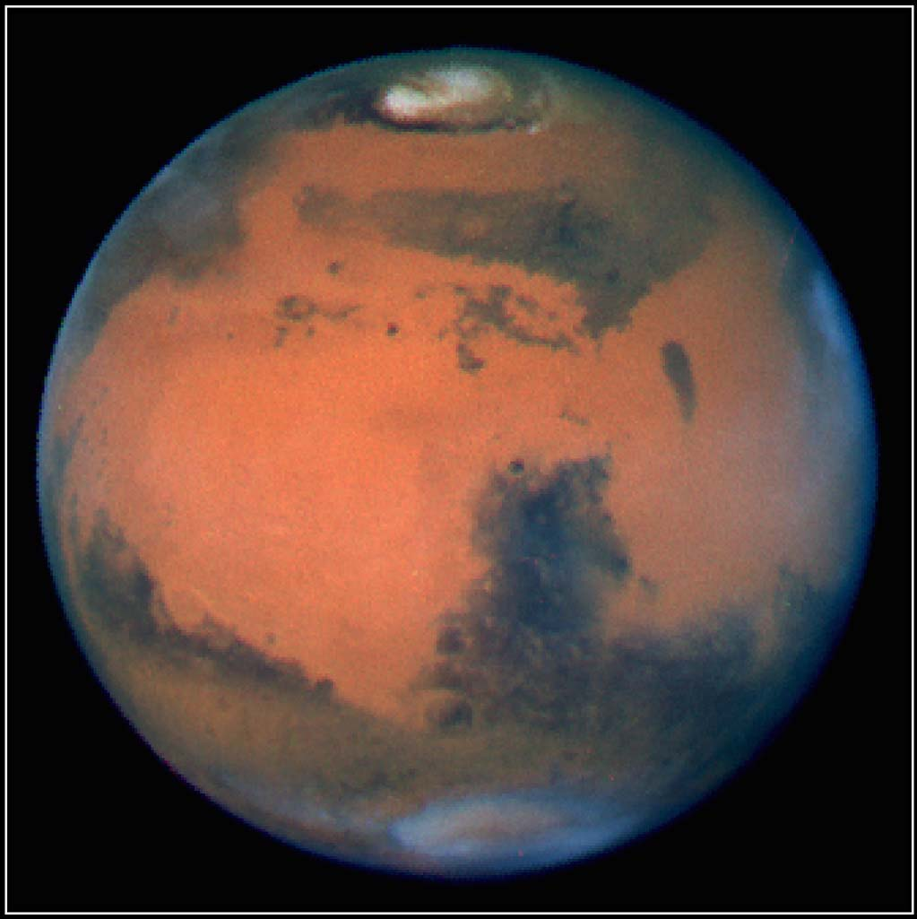
Mars is the fourth planet in our solar system. It was named by the Romans after their god of war, because of its red, blood-like color. The Egyptians named it “Her Desher” meaning “the red one.” Mars is the most studied planet after Earth.
Mars, 4th planet from the sun

(http://nssdc.gsfc.nasa.gov/image/planetary/mars/hst_mars_opp_9709a.jpg)

The first recorded reference of Mars was made in 1534 BCE by Egyptian astronomers who described it as a wandering object in the night sky. They described that the planet appeared as a star but moved differently than other stars. It would slow down and even reverse its course, and then return to the original course. Astronomers of the Neo-Babylonian Empire (626 BCE–539 BCE) regularly recorded the positions of the planets. They detailed Mars’s orbital period and its passage through the zodiac. By the 5th–4th century BCE, the Greeks made additional observations on Mars’s behavior, which helped them better understand its position in the solar system.

The first to observe Mars with a telescope was Galileo Galilei in 1610. His goal was to determine if Mars exhibited phases as the Moon does. Galileo did note that Mars’s angular size did seem to decrease. Mars’s phases were observed by a Polish astronomer, Johannes Hevelius, in 1645. In 1659, the first map of Mars that displayed terrain features was produced by Christiaan Huygens, a Dutch astronomer. He also determined that the rotation period of the planet was about 24 hours. Domenico Cassini, an Italian astronomer, improved on Huygens’s measurement and determined that the rotation was closer to 24 hours and 40 minutes. Cassini also observed a fuzzy white cap at Mars’s north pole in 1672, which for the next 300 years people assumed was either snow or ice. We now refer to them as the polar ice caps.

By the 20th century, improvements in the resolution of telescopes made it possible to see surface features on Mars. One of the features researchers saw a network of long, straight canals. This led to the hypothesis that the canals were an indication of a civilization that used them to move water from the poles to the dry center of the planet. Other researchers argued that there could not be canals with water because the surface temperatures on Mars were too cold. The controversy concerning the canals was not settled until spacecraft arrived near Mars and revealed that Mars was a barren world with no signs of life or civilization.

The following information gathered from various NASA documents provides an overview of the history of some of the spacecraft studying Mars.

DATE | SPACECRAFT | RESULTS
1964 | Mariner 4 (orbiter) | Sent images of Moon-like, cratered terrain. Measured atmospheric pressure and daytime temperatures.
1969 | Mariner 6 and 7 (orbiters) | Sent images of equator and south pole which showed the surface to be very different from that of the moon.
1971 | Mariner 9 (orbiter) | Mapped 80% of Mars, discovering volcanoes and canyons.
1976 | Viking 1 and 2 (orbiter and lander) | First successful landing on Mars. Took close-up pictures and carried out biological experiments to look for possible signs of life.
1996 | Mars Pathfinder (lander and small robotic wheeled rover) | Rover was named Sojourner. Took and returned more than 17,000 images. Performed chemical analyses of rocks and soils. Collected extensive data on wind and weather factors.
1997 | Mars Global Surveyor (orbiter) | Studied entire Martian surface, atmosphere and interior over period of several years.
2001 | Mars Odyssey (orbiter) | Discovered vast amounts of water ice buried below the surface in the polar regions.
2003 | Spirit and Opportunity (rovers) | The Mars Exploration Rover Mission launched and landed the two rovers on opposite sides of Mars. Both found evidence that water once flowed on the planet.
2006 | Mars Reconnaissance Orbiter (orbiter) | The goal for this orbiter was to search for evidence that water persisted on the surface of Mars for a long period of time. It has confirmed that liquid water flows on today’s Mars. This orbiter continues today (2017) to send back pictures and data.
2008 | Phoenix (lander) | It landed near the northern pole. Scientists designed it to study the history of water and search for complex organic molecules in the soil. It confirmed water ice, observed falling snow, found perchlorate in rocks.
2012 | Curiosity (rover) | The rover is part of the Mars Science Laboratory Mission. Its main scientific goals are to help determine whether Mars could have ever supported life, determine the role of water, and study the climate and geology of Mars. It is still operating today (2017).
2014 | MAVEN (Mars Atmosphere and Volatile Evolution Mission) (probe) | It was design to study the Martian atmosphere and determine how the planet’s water and atmosphere were lost over time.

Composition and geology

Mars is the second smallest planet, next to Mercury. It is a rocky body about one half the size of Earth. Although Mars is half the diameter of Earth, it has the same amount of dry land. The planet’s red color is due to iron-rich minerals. The iron minerals oxidize or rust, causing the soil to look red. Martian soil is rich in minerals containing silicon, oxygen, iron, magnesium, sodium, potassium and chlorine. The soil is slightly alkaline, with a pH of about 7.7. The crust is largely basalt, an igneous rock, which is also common in the crusts of Earth and the Moon. Basalt is rich in magnesium oxide, MgO, and calcium oxide, CaO, and low in silicon dioxide, SiO₂. Some crustal rock may be a form of andesite, another igneous rock, which has more silicon dioxide than basalt.

There is no global magnetic field in Mars, yet Mars Global Surveyor orbiter found areas of the Martian crust in the southern hemisphere that are about ten times more strongly magnetized than anything measured on Earth. This provides an indication that an ancient magnetic field once existed on Mars.

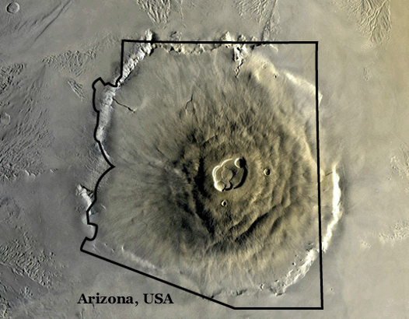
Mars has the highest mountain and the deepest, longest valley in the solar system. Olympus Mons, once a volcano, is 16 miles (25 kilometers) high, which is about three times as tall as Mt. Everest.
Olympus Mons compared to
the state of Arizona

(https://mars.jpl.nasa.gov/gallery/atlas/olympus-mons.html)
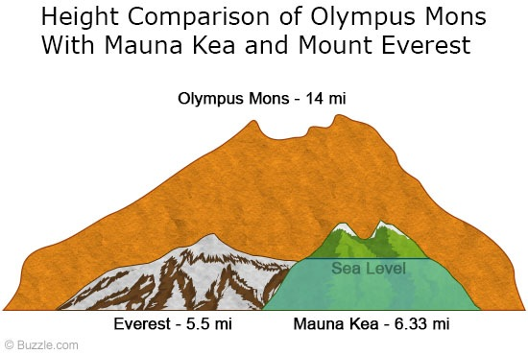
(http://www.buzzle.com/articles/facts-about-olympus-mons-a-large-shield-volcano-on-mars.html)

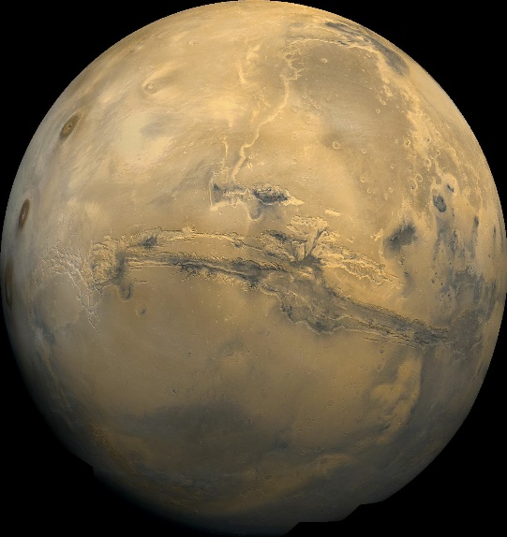
The Valles Marineris system of valleys is 6 miles (10 kilometers) deep in spots and runs east-west for roughly 2500 miles (4000 kilometers). These mountains that were once volcanoes are believed to have been active 2–3 billion years ago. Channels, valleys, and gullies exist all over the Mars surface. They suggest that liquid water might have flowed across the planet’s surface at one time. Scientists believe that Mars experienced a giant flood over 3.5 billion years ago; however, they do not know where the flood water came from, how long it lasted, or where it went.
Valles Marineris

(https://www.nasa.gov/multimedia/imagegallery/image_feature_83.html)

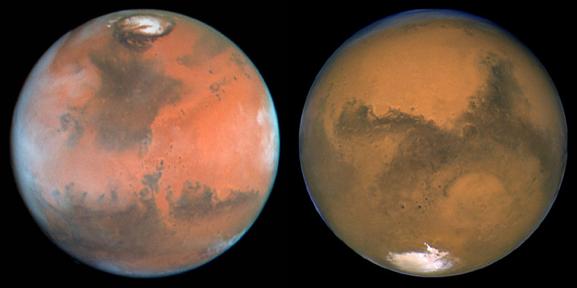
At the poles of Mars are vast deposits of finely layered stacks of (water) ice and solid carbon dioxide (dry ice), which extend from the pole to about 80 degrees latitude. There is a polar ice cap all year long, which grows in the winter and shrinks in the summer. The permanent northern polar ice cap is mostly water, while the one in the south is predominantly carbon dioxide ice, with some water ice. At times the northern permanent cap is 10 times larger than the southern cap. Scientists have no explanation for the differences at this time.
Polar ice caps on Mars

(http://www.windows2universe.org/mars/places/mars_poles_image_gallery.html)

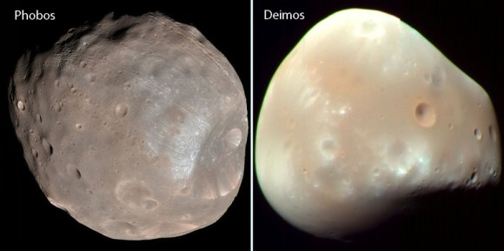
Mars has two moons, Phobos and Deimos. They are named after the sons of the Greek god of war. Phobos means “fear” and Deimos means “rout”. These moons are composed of carbon-rich rock, mixed with ice covered in dust and loose rocks. They are small compared to the Earth’s moon. They are potato shaped because they have too little mass for gravity to make them spherical. Although it is uncertain how these moons were “born”, it is strongly believed that they may have been asteroids captured by Mars’s gravitational pull. Phobos is gradually getting closer to Mars each century and will eventually either crash into Mars or break up to form a ring of debris around the planet.
Moons of Mars—Phobos and Deimos

(http://www.universetoday.com/14701/mars/)

Atmosphere and Climate of Mars

Mars has a very thin atmosphere. The atmospheric pressure varies between 0.4 and 0.87 kilopascals, which is equivalent to about 1% of Earth’s atmospheric pressure at sea level. The composition of the Mars atmosphere consists of 95% carbon dioxide, CO₂; 2.7% nitrogen, N₂; 1.6% argon, Ar; 0.13% oxygen, O₂; and 0.08% carbon monoxide, CO. Because the atmosphere is predominantly carbon dioxide, the Martian atmospheric pressure changes with the season. During the summer, the CO₂ sublimes from the polar ice caps enough to increase the pressure. The pressure falls in the winter when the CO₂ refreezes as snow (dry ice). The atmosphere is dusty and contains particulates that measure about 1.5 micrometers in diameter. This gives the sky a brownish-red color from the surface of the Mars.

At one time Mars had a much thicker atmosphere. Scientists did not know if the atmosphere was lost to space or absorbed by the planet, until NASA’s MAVEN orbiter arrived. From the data it collected scientists determined that the atmosphere was lost to space over four billion years ago. The stripping of the atmosphere continues today at a much slower rate. The loss of the atmosphere is due to solar winds, composed of mainly protons and electrons from the sun, which produce an electric field that accelerates ions in the upper Martian atmosphere to an escape velocity. The strong magnetic field on Earth prevents this from happening here.

Mars once had a strong magnetic field--like Earth does now--produced by a dynamo effect from its interior heat. But as the smaller planet cooled, Mars lost its magnetic field sometime around 4.2 billion years ago, scientists say. During the next several hundred million years, the Sun’s powerful solar wind stripped particles away from the unprotected Martian atmosphere at a rate 100 to 1,000 times greater than that of today.

(https://arstechnica.com/science/2015/11/how-mars-lost-its-atmosphere-and-became-a-cold-dry-world/)

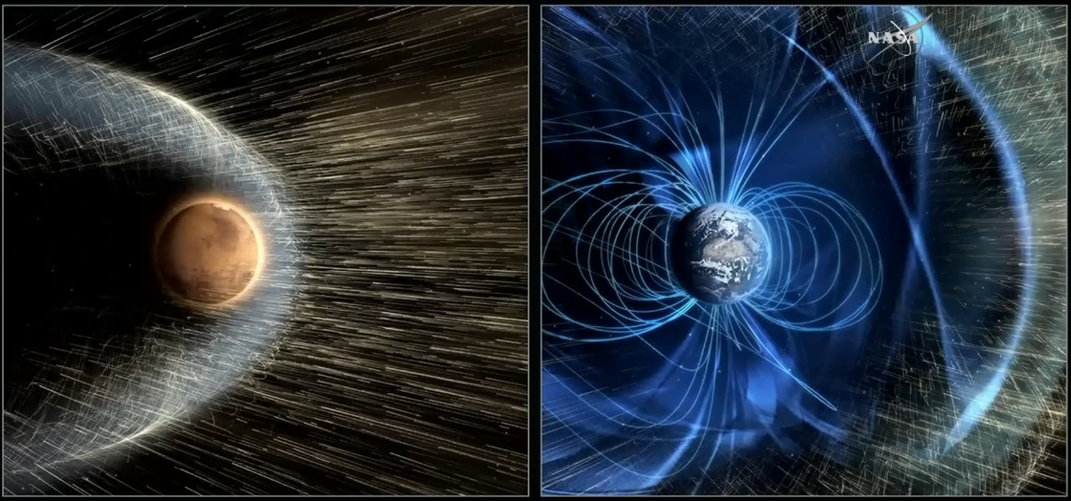

Without a strong magnetic field like Earth, Mars is laid bare due to solar winds.

(https://arstechnica.com/science/2015/11/how-mars-lost-its-atmosphere-and-became-a-cold-dry-world/)

Mars is much colder than Earth, due to its thin atmosphere and its greater distance from the sun. Mars does experience seasons, much like Earth, due to the tilt of its rotational axis. Because of its slightly elliptical orbit around the sun, the length of the seasons on Mars vary. The average temperature is about –80 ºF (–60 ºC); however, there is a wide range of temperatures on the planet. Near the poles during the winter, the temperature can drop to
–195 ºF (–125 ºC). During the summer near the Martian equator, the temperature can reach
95 ºF (35 ºC). These temperatures currently prevent liquid water existing on the Martian surface for any length of time.

Mars experiences dust storms that are the largest in the solar system; these can blanket the entire planet and last for months. During the warmer season, the sun heats up the atmosphere and causes small convection currents that lift dust into the atmosphere. The airborne dust particles absorb sunlight and heat up the atmosphere further, which causes more wind, lifting more dust into the air. This cycle continues and creates tornado-like dust storms.

The table below compares the characteristics of Mars to those of Earth.

 | Mars | Earth
Atmosphere (composition) | Carbon dioxide (95.32%)  Nitrogen (2.7%)  Argon (1.6%)  Water vapor (0.03%)  Nitric oxide (0.01%) | Nitrogen (77%)  Oxygen (21%)  Argon (1%)  Carbon dioxide (0.038%)
Atmosphere (pressure) | 7.5 millibars (average) | 1013 millibars (at sea level)
Deepest canyon | Valles Marineris  7 km (4.35 miles) deep  4000 km (2485 miles) wide | Grand Canyon  1.8 km (1.1 miles) deep  400 km (248.5 miles) long
Distance from the sun (average) | 227,936,637 kilometers (142,633,260 miles) | 149,597,891 kilometers  (92,955,820 miles)
Equatorial radius | 3,397 kilometers (2,111 miles) | 6,378 kilometers (3,963 miles)
Gravity | 0.375 that of Earth | 2.66 times that of Mars
Largest volcano | Olympus Mons  26 kilometers (16 miles) high  602 kilometers (374 miles) in diameter | Mauna Loa (Hawaii)  10.1 kilometers (6.3 miles) high  121 kilometers (75 miles) in diameter
Length of day (time required to make a full rotation on its axis) | 24 hours 37 minutes | Just slightly under 24 hours
Length of year (time required to make a complete orbit of the sun) | 687 Earth days | 365 days
Polar caps | Covered with a mixture of carbon dioxide ice and water ice | Permanently covered with water ice
Surface temperature (average) | –81 ºF (–63 ºC) | 57 ºF (14 ºC)
Tilt of axis | 25 degrees | 23.45 degrees
# of satellites | 2 (Phobos and Deimos) | 1 (Moon)

(http://phoenix.lpl.arizona.edu/mars111.php)

Plant growth and nutrients

Many factors affect the growth of a plant, and each kind of plant has its own needs and requirements. All plants do require certain basic environmental factors in their environment. If any one factor is less than ideal, it will become a limiting factor in the plant’s growth. The basic environmental factors are: light, temperature, water, pH, and nutrients.

The energy source for plants is sunlight. There are three principle characteristics of light that affect plant growth. The quantity of light, which is the intensity or concentration of sunlight, is the first factor. The intensity varies with the season. During the summer it is at its maximum and it is at a minimum in winter. The more sunlight a plant receives, the more photosynthesis occurs and the more food the plant produces. The quality of light is another characteristic. This refers to the color or the wavelength reaching the plant surface. Red and blue light increase plant growth the most. Green light is mostly reflected, which is why plants look green, so it has little effect on plant growth. The third factor is the duration or photoperiod of the light. The photoperiod relates to the amount of time the plant is exposed to sunlight, and it triggers flowering. Actually, it is not the length of daylight, but the length of uninterrupted dark periods that is critical.

Temperature affects plant growth. Plants grow best within an optimum range of temperatures. For some species the optimum range maybe wide, while for others it is narrow. The temperature must allow the plant to carry on life-sustaining chemical reactions. Plants experience abnormal growth and reduced production when the temperatures are either too high or too low. Warm season vegetables and most flowers grow best when the temperatures are between 60 ºF (15 ºC) and 80 ºF (27 ºC). Cool season vegetables, like spinach and lettuce, grow best between 50 ºF (10 ºC) and 70 ºF (21 ºC).

Water is essential for plant growth, even though different plants have different needs. Some plants tolerate drought, some need winter rains, and others need a consistent supply of moisture to grow well. Water is a primary component in photosynthesis. It also plays a critical role as a solvent for minerals moving into a plant. Water maintains the firmness of tissue, referred to as turgor pressure. The turgor pressure regulates the opening and closing of the stomata, which regulates the plants respiration. Water pressure helps the roots move through the soil.

The pH of the soil and water affect the ability of plant roots to take up certain nutrients. Most plants grow best in soils that have a relatively neutral pH (pH = 7). Some plant such as azaleas and blueberries thrive in slightly acidic soil (pH=6). The solubility of trace elements is controlled by pH and only soluble nutrients can be used by the plant. For instance, iron is not soluble when the pH is high (basic) and iron deficiencies are often present in high pH soils even when the soil contains plenty of iron.

There are sixteen elements that are important to plant’s growth and survival. They can be divided into two categories; non-mineral nutrients and mineral nutrients. The non-mineral nutrients are carbon, hydrogen and oxygen and are obtained from the air and water. Carbon dioxide and water are converted to sugars by photosynthesis. Since these elements come from the air and water there is little that can be controlled by farmers and gardeners. The remaining 13 essential elements, which are the mineral nutrients, are taken up from the soil and can be grouped into three categories: primary macronutrients, secondary macronutrients and micronutrients.

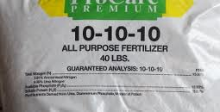
The primary macronutrients are nitrogen, phosphorus and potassium. These nutrients are the ones used in the largest quantities by plants and, as a result, are frequently the first elements to be depleted in the soil. Fertilizers generally contain these three nutrients and the percentage of each is given as a three-number combination. A general balanced fertilizer would be labeled (10-10-10) which would be 10% nitrogen, 10% phosphorus expressed as P₂O₅ and 10% potassium expressed as K₂O. Most lawns and grasses need nitrogen, so a (20-10-10) fertilizer would be a good choice.
Example of an all-purpose fertilizer

(https://www.yardcaregurus.com/what-do-fertilizer-numbers-mean/)

The secondary macronutrients are calcium, magnesium and sulfur. These elements are needed in smaller quantities than the primary macronutrients. Generally, soils have sufficient quantities of these elements. Dolomitic lime (a mixture of calcium carbonate and magnesium carbonate) is used when soils are too acidic, or deficient in calcium or magnesium. Sulfur usually comes from decaying organic matter.

Micronutrients are those elements needed in very small amounts by plants. The micronutrients are iron, manganese, zinc, copper, boron, molybdenum and chlorine. Although only needed in very small amounts, their importance is still great. If there is a shortage of them, it can limit the plant’s growth and crop yield. Without sufficient amounts, the plant can even die.

Below is a table giving some of the roles each of these essential elements play.

Element | Function
Primary Macronutrients
Nitrogen | · Necessary for formation of amino acids, the building blocks of protein  · Essential for plant cell division, vital for plant growth  · Directly involved in photosynthesis as an element in chlorophyll  · Necessary component of vitamins  · Aids in production and use of carbohydrates  · Affects energy reactions in the plant
Phosphorus | · Involved in photosynthesis, respiration, energy storage and transfer, cell division, and enlargement  · Promotes early root formation and growth  · Improves quality of fruits, vegetables, and grains  · Vital to seed formation  · Helps plants survive harsh winter conditions  · Increases water-use efficiency  · Hastens maturity
Potassium | · Carbohydrate metabolism and the break down and translocation of starches  · Increases photosynthesis  · Increases water-use efficiency  · Essential to protein synthesis  · Important in fruit formation  · Activates enzymes and controls their reaction rates  · Improves quality of seeds and fruit  · Improves winter hardiness  · Increases disease resistance
Secondary Macronutrients
Calcium | · Utilized for continuous cell division and formation  · Involved in nitrogen metabolism  · Reduces plant respiration  · Aids translocation of photosynthesis products from leaves to fruiting organs  · Increases fruit set  · Essential for nut development in peanuts  · Stimulates microbial activity
Magnesium | · Key element of chlorophyll  · Improves utilization and mobility of phosphorus  · Activator and component of many plant enzymes  · Increases iron utilization in plants  · Influences earliness and uniformity of maturity
Sulfur | · Integral part of amino acids  · Helps develop enzymes and vitamins  · Promotes nodule formation on legumes  · Aids in seed production  · Necessary in chlorophyll formation (though it isn’t one of the constituents)
Micronutrients
Boron | · Essential of germination of pollen grains and growth of pollen tubes  · Essential for seed and cell wall formation  · Promotes maturity  · Necessary for sugar translocation  · Affects nitrogen and carbohydrate
Chlorine | · Not much information about its functions  · Interferes with P uptake  · Enhances maturity of small grains on some soils  · Aids in plants metabolism
Copper | · Catalyzes several plant processes  · Major function in photosynthesis  · Major function in reproductive stages  · Indirect role in chlorophyll production  · Increases sugar content  · Intensifies color  · Improves flavor of fruits and vegetables
Iron | · Promotes formation of chlorophyll  · Acts as an oxygen carrier  · Reactions involving cell division and growth
Manganese | · Functions as a part of certain enzyme systems  · Aids in chlorophyll synthesis  · Increases the availability of P and Ca
Molybdenum | · Required to form the enzyme "nitrate reductase" which reduces nitrates to ammonium for protein synthesis  · Aids in the formation of legume nodules  · Needed to convert inorganic phosphates to organic forms in the plant
Zinc | · Aids plant growth hormones and enzyme system  · Necessary for chlorophyll production  · Necessary for carbohydrate formation  · Necessary for starch formation  · Aids in seed formation

(http://eldoradochemical.com/fertiliz1.htm)

Fertilizers

Soil used repeatedly to grow plants will eventually become deficient in the nutrients needed for healthy plant growth. Fertilizers are used to add nutrients to the soil so growing plants have an adequate supply. Fertilizers can either be organic or inorganic. Organic fertilizers are substances that are derived from natural organisms, such as plants and animals. Examples of organic fertilizers include manure (excreta from animals), bone meal, fish emulsion, and decomposed vegetation. Since these fertilizers are complex organic materials, they decompose slowly and the nutrients are released slowly. The nutrients in organic fertilizers are not water soluble. Soil microbes play an important role in converting nutrients into soluble ones that can be absorbed by the plant. These fertilizers contain a wide range of nutrients but at a low concentration. In addition, organic fertilizers tend to improve the soil structure and water-holding capacity.

Inorganic fertilizers are mineral in nature. Today most of these are synthetic and are the result of a chemical process. They are typically salts containing nitrogen, phosphorus, and potassium, as well as other macronutrients and micronutrients. Inorganic fertilizers may contain such salts as ammonium nitrate, NH₄NO₃, ammonium sulfate, (NH₄)₂SO₄, diammonium phosphate, (NH₄)₂HPO₄, potassium chloride, KCl, and potassium nitrate, KNO₃. Inorganic fertilizers usually contain the three essential nutrients—nitrogen, phosphorus and potassium. They can be produced so that the nutrient content is suitable for the type of plants being grown. These fertilizers are water-soluble and can be taken up by the plant almost immediately. For that reason, it is necessary to be careful in applying inorganic fertilizers, for too much can damage the plant. The inorganic fertilizer can be formulated for immediate use or for the slow release of the nutrients. The inorganic fertilizer does little to improve the soil texture and some have a high acid content, which can affect the soils fertility.

One of the problems with inorganic fertilizers is that the nitrogen compounds are very water soluble and, frequently, much of it is washed away before plants can absorb it. This requires the use of more fertilizer, which is expensive and creates environmental problems with excess nitrogen in natural waters. Slow release fertilizers are available, but they are expensive. These are usually made by coating urea with water-insoluble sulfur or a polymer. The slow release fertilizers have not been very effective in increasing crop yield.

Gehan Amaratunga, an engineer from the University of Cambridge, is experimenting with a new approach using nanotechnology.

They [Amaratunga and his colleagues] attached urea molecules to nanoparticles of hydroxyapatite, a naturally occurring form of calcium phosphate found in bone meal. Hydroxyapatite is nontoxic and a good source of phosphorus, which plants also need. In water, the urea-hydroxyapatite combination released nitrogen for about a week, compared with a few minutes for urea by itself. In field trials on rice in Sri Lanka, crop yields increased by 10%, even though the nanofertilizer delivered only half the amount of urea compared with traditional fertilizer.

(http://cen.acs.org/articles/95/web/2017/02/Slow-release-nitrogen-fertilizer-increase.html)

The nanofertilizer is a little more expensive than traditional fertilizer but since less fertilizer is needed the cost is not a factor. The experimentation with the nanofertilizer continues but looks very promising.

Photosynthesis

Photosynthesis is the process by which plants, algae and certain bacteria capture light energy and convert it to chemical energy. In the process, sugars, such as glucose, are synthesized from carbon dioxide and water. Oxygen is release as a byproduct. The sugar molecules provide organisms with two important resources: energy and organic carbon.

There are two types of photosynthesis: oxygenic photosynthesis and anoxygenic photosynthesis. Oxygenic photosynthesis is the most common and is what occurs in plants, algae and cyanobacteria. During oxygenic photosynthesis electrons are transferred from water to carbon dioxide, driven by light energy. Carbohydrates and oxygen are produced in the process. The process is complex and a series of multistep reactions. The overall reaction is generally given as:
6 CO₂ + 6 H₂O + light energy C₆H₁₂O₆ + 6 O₂

The anoxygenic photosynthesis uses electron donors other than water. This process usually occurs in bacteria, such as purple bacteria or green sulfur bacteria. Since water is not the electron donor, this process does not produce oxygen. The byproduct produced depends on the electron donor. An example of an electron donor is hydrogen sulfide, H₂S, which is used by many bacteria. When hydrogen sulfide is used, solid sulfur is the byproduct. The overall general equation is given as:
n CO₂ + 2n H₂A + light energy (CH₂O)_{n} + 2n A + n H₂O

where H₂A is the variable electron donor and A would be the by product.

The cellular components that play an essential role in photosynthesis are pigments, plastids, antenna, and reaction centers. Pigments are molecules that give plants, algae and bacteria their color. They are responsible for trapping sunlight. Different colored pigments absorb different wavelengths. There are three main groups of pigments. Chlorophylls are green pigments that absorb blue and red light. Carotenoids are pigments that are red, orange or yellow. They absorb bluish-green light. The third type of pigment is phycobilins; some of these are red and some are blue in color. They tend to absorb wavelengths of light that are not absorbed by the other two. They are seen primarily in cyanobacteria and red algae.

Plastids are organelles found in the cells of plants and algae and are the site of manufacture and storage of important chemical compounds used by the cell. Three plastids in plants include leucoplasts, chromoplasts and chloroplasts. Leucoplasts store fats and starch and do not involve synthetic activities. Chromoplasts contain many red, yellow and orange pigments commonly found in flowers and fruits. Chloroplasts contain chlorophylls; photosynthesis occurs in chloroplasts.

A large collection of pigment molecules (100–5000) create the components known as antennae. The pigment molecules are associated with proteins that allow them to be flexible so they can move toward the light. Antennae are complex light harvesting systems that capture the light energy from the sun and transfer it to the reaction centers.

The reaction center is a complex of pigments and proteins that converts light energy to chemical energy. This begins the process of electron transfer.

In plants, photosynthesis predominantly occurs in the leaves.
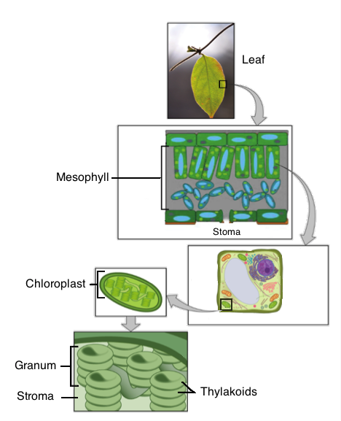
Structure of
photosynthesis components

(https://www.khanacademy.org/science/biology/photosynthesis-in-plants/introduction-to-stages-of-photosynthesis/a/intro-to-photosynthesis)
The cells in a middle layer of leaf tissue called the mesophyll are the primary site of photosynthesis. Small pores called stomata—singular, stoma—are found on the surface of leaves in most plants, and they let carbon dioxide diffuse into the mesophyll layer and oxygen diffuse out. Each mesophyll cell contains organelles called chloroplasts, which are specialized to carry out the reactions of photosynthesis. Within each chloroplast, disc-like structures called thylakoids are arranged in piles like stacks of pancakes that are known as grana—singular, granum. The membrane of each thylakoid contains green-colored pigments called chlorophylls that absorb light. The fluid-filled space around the grana is called the stroma, and the space inside the thylakoid discs is known as the thylakoid space. Different chemical reactions occur in the different parts of the chloroplast.

(https://www.khanacademy.org/science/biology/photosynthesis-in-plants/introduction-to-stages-of-photosynthesis/a/intro-to-photosynthesis)

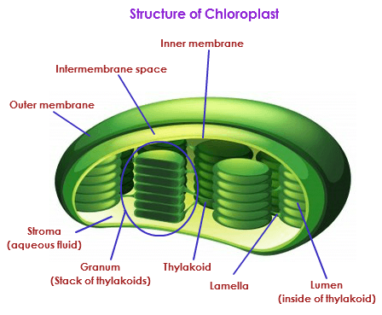
Photosynthesis is a complicated series of steps, but the process can be broken down into two stages: light-dependent reactions and light-independent reactions. The light-dependent reactions occur in the thylakoid membrane of the chloroplast, where chlorophyll pigment is located. When a photon of light hits the reaction center, it energizes an electron in chlorophyll. The chlorophyll releases an electron. The electron escapes by travelling through an electron transport chain in the thylakoid membrane.
Structure of chloroplast

(http://biology.tutorvista.com/animal-and-plant-cells/chloroplasts.html)

Every step in the electron transport chain brings each electron to a lower energy state. The energy is harnessed by producing ATP (adenosine triphosphate) and NADPH (nicotinamide adenine dinucleotide phosphate). ATP serves as a source of chemical energy for cells and NADPH is a reducing agent that supplies electrons and hydrogen ions, H⁺. Each chlorophyll molecule replaces its lost electron with an electron from a water molecule. Oxygen is released in the process.

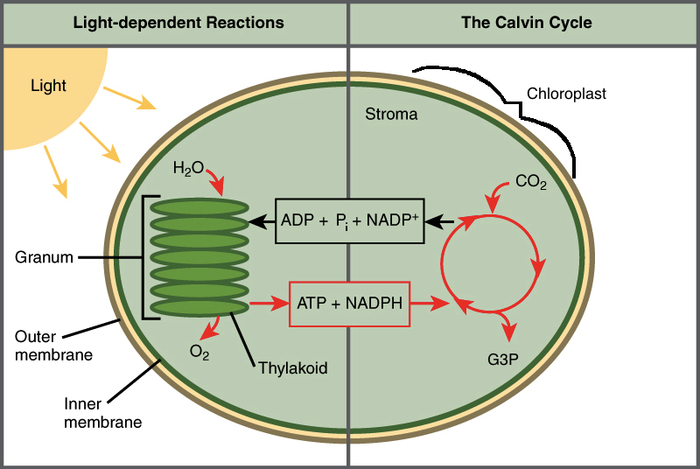
In plants, carbon dioxide diffuses through the leaf’s stomata (pores in the leaf) and enters the chloroplast stroma. This is where the light-independent reactions, also called the Calvin Cycle (see diagram at right), take place. Light is not required for these reactions. The ATP and NADPH molecules provide the energy for the reactions that take the carbon from carbon dioxide (from the atmosphere) and produce a three-carbon sugar called glyceraldehyde-3-phosphate (G3P). Cells then use G3P to build a variety of sugars, including glucose, as well as other organic molecules.
Photosynthesis processes

(https://www.khanacademy.org/science/biology/photosynthesis-in-plants/introduction-to-stages-of-photosynthesis/a/intro-to-photosynthesis)

Oxygen generation in space

Oxygen is necessary for life. On Earth, we have a plentiful supply of oxygen, and it is produced in photosynthesis. In space, there is an insufficient supply of oxygen to support life. On short space travels, the spaceship carries its own supply of oxygen in tanks. For extended stays in space, such as on the International Space Station, it is necessary to generate oxygen. On the International Space Station, the oxygen generators make oxygen by the electrolysis of water. This occurs by passing electric current through water. The reduction of water occurs at the cathode where electrons combine with water to produce hydrogen and hydroxide ions:
2 H₂O (l) + 2e─ H₂ (g) + 2 OH─ (aq)

Oxidation occurs at the anode, where electrons from water flow into the anode and to the cathode. This produces oxygen and hydrogen ions.
2 H₂O (l) O₂ (g) + 4 H⁺ (aq) + 4 e─

The water is delivered to the space station from Earth by re-supply ships. It is also condensed from the air in the space station and recycled from the astronauts’ urine. The space station’s solar panels generate the electricity.

As scientist look to send people to Mars, oxygen will need to be generated from whatever is available on Mars. As in the movie The Martian, NASA has announced that the Mars 2020 rover will carry an oxygen generator to the Mars surface. The Mars Oxygen In-situ Resource Utilization Experiment (MOXIE), developed by the Massachusetts Institute of Technology, will generate oxygen from carbon dioxide. The oxygen can be used for rocket fuel and, in the future, for human breathing. The Mars atmosphere is predominantly carbon dioxide, but the atmosphere is very thin. MOXIE will collect CO₂ from the atmosphere, compress it to a pressure of one atmosphere, and store it. It will then be fed into the Solid Oxide Electrolyzer (SOXE) where the CO₂ will be split electrochemically. The SOXE operates at temperatures between 800 ºC and 850 ºC, requiring sophisticated thermal insulation. An explanation of how the SOXE operates is given below.

MOXIE uses a solid oxide electrolysis (SOXE) stack developed by Ceramatec, Inc. for converting CO₂ to O₂. Its working elements are stacked scandia-stabilized zirconia (ScSZ) electrolyte-supported cells with thin screen-printed electrodes, coated with a catalytic cathode on one side and an anode on the other. These are separated by expansion-matched interconnects that direct the source, exhaust, and product gases to and from their respective manifolds, as illustrated in Fig. 1. The stacks operate in the 800–850°C range.

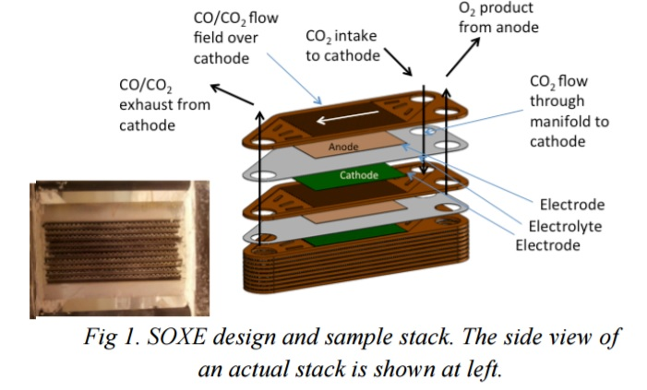

When CO₂ flows over the catalyzed cathode surface under an applied electric potential, it is electrolyzed according to the reaction CO₂ + 2e⁻ ⇒ CO + O⁼. The CO is exhausted, while the oxygen ion is electrochemically driven through the solid oxide electrolyte to the anode, where it is oxidized (O⁼ ⇒ O + 2e⁻). The O atoms combine to produce the gaseous O₂.

(http://ssed.gsfc.nasa.gov/IPM/PDF/1134.pdf)

Hydrazine

Hydrazine, also known as diamine and nitrogen hydride, is a highly reactive inorganic compound with the formula N₂H₄. It is a colorless, flammable liquid that has a pungent smell similar to ammonia. It is a toxic irritant and sensitizer that can damage the central nervous system, producing symptoms such a tumors and seizures. Hydrazine is very useful because it is a strong reducing agent, as well as serving as a precursor for some organic syntheses.

More than 100,000 metric tons of hydrazine are produced annually. Today hydrazine is produced by many methods. One of the most common methods is called the Olin-Raschig process, developed by a German chemist named Fredrick Raschig in 1907. The process occurs in two steps. Initially sodium hypochlorite (NaOCl), the active ingredient in bleach, is mixed with ammonia (NH₃) at 5 ºC. This forms chloramine (NH₂Cl) and sodium hydroxide (NaOH). This mixture is rapidly added to anhydrous ammonia under pressure and at 130 ºC. In addition to hydrazine, water and sodium chloride are also produced, as waste products.
NaOCl + NH₃ NH₂Cl + NaOH
NH₂Cl + NaOH + NH₃ N₂H₄ + H₂O + NaCl

The most common use of hydrazine is to produce blowing agents.

These are gases which are blown through a liquid which causes it to foam, and then harden into a lightweight solid, an example being expanded polystyrene [Styrofoam®]. The two main blowing agents made from hydrazine are azodicarbonamide and azobisisobutyronitrile. Azodicarbonamide is used to produce foamed plastic, because when heated it decomposes into N₂, CO, CO₂ and NH₃ which then get trapped as bubbles in the polymer. Azobisisbutyronitrile is also used as a foamer in plastics and rubber, but is also used as a radical initiator in polymerization reactions because it readily expels N₂ gas leaving two CN-substituted cyclopropane radicals behind to begin the free-radical chain reaction.

(http://www.chm.bris.ac.uk/motm/hydrazine/hydrazineh.htm)
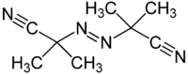
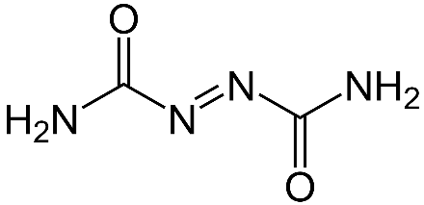
Azobisisobutyronitrile

(https://en.wikipedia.org/wiki/Azobisisobutyronitrile)
Azodicarbonamide

(https://en.wikipedia.org/wiki/Azodicarbonamide)

Sodium azide (NaN₃), which is used to activate automobile air bags, is produced by the reaction between hydrazine and sodium nitrite. Sodium azide decomposes rapidly when it is heated, creating a huge volume of gas filling the air bag to protect the person in the car.
NaNO₃ + N₂H₄ NaN₃ + H₂O₂
2 NaN₃ (s) 2 Na(s) + 3 N₂ (g)

Hydrazine is a strong reducing agent with by-products of only water and nitrogen gas. For that reason, it is commonly used as an oxygen scavenger and corrosion inhibitor in water cooling systems of power plants:
N₂H₄ + O₂ H₂O + N₂

Hydrazine is used to reduce metal oxides back to metals. An example of this is the reduction of plutonium oxide in nuclear waste back to plutonium metal.

As in The Martian, hydrazine is also used as rocket fuel propellant. It is used mainly for the maneuvering thrusters of spacecraft. Hydrazine was used to power the Space Shuttle auxiliary power units. Hydrazine-fueled rocket engines are used in the terminal descent of spacecraft. These were used on the Viking program landers in the 1970s. They were also used on the Phoenix lander in 2008 as well as the Curiosity rover in 2012.

Hydrazine is used as a monopropellant, which is a chemical propulsion fuel that does not require a separate oxidizer for the reaction. In the monopropellant engine, the hydrazine passes over an iridium metal catalyst that causes it to decompose rapidly, producing ammonia, nitrogen and hydrogen. The decomposition reactions (reactions #1 and #2 below) are extremely exothermic, causing the reaction chamber to reach temperatures of 800 ºC in milliseconds. The final reaction is endothermic which takes away some of the heat and produces even more nitrogen and hydrogen gas. These reactions produce a large volume of hot gases from a small volume of liquid, making hydrazine an efficient propellant. The hot gases are forced out of the rocket through a tight nozzle to create thrust.
- 3 N₂H₄ → 4 NH₃ + N₂
- N₂H₄ → N₂ + 2 H₂
- 4 NH₃ + N₂H₄ → 3 N₂ + 8 H₂

References
(non-Web-based information sources)
The references below can be found on the ChemMatters 30-year DVD, which includes all articles
published from the magazine’s inception in October 1983 through April 2013; all available Teacher’s Guides, beginning February 1990; and 12 ChemMatters videos. The DVD is available from the American Chemical Society for $42 (or $135 for a site/school license) at this site: http://ww.acs.org/chemmatters. Click on the “Teacher’s Guide” tab to the left, directly under the “ChemMatters Online" logo and, on the new page, click on “Get the past 30 Years of ChemMatters on DVD!” (the icon on the right of the screen).

Selected articles and the complete set of
Teacher’s Guides for all issues from the past three
years are available free online at the same Web site, above. Click on the “Issues” tab just below the logo, “ChemMatters Online”.
30 Years of ChemMatters !
Available Now!

The article “Life on Mars” describes the purpose and the experiments performed by the Viking 1 and Viking 2 spacecraft that landed on Mars in 1976. One of the purposes of the landers was to determine if there was life on Mars. The experiments describe the theory behind them, what they detected and the analysis of the results. (Scott, D. Life on Mars. ChemMatters, 1994, 12 (4), pp 10–13)

The exploration of Mars by the Pathfinder spacecraft and its robotic rover, Sojourner, are described in this article. The soil of Mars was examined, and it was determined that it has many similarities to the soil on Earth. The article explains the methods used to analyze the Martian soil and rocks. (Stone, C. Clues from a Far Planet. ChemMatters, 1998, 16 (2), pp 7–9.)

This article describes the purpose of the Mars Science Laboratory that was sent to Mars in 2010. The purpose of this mission was to search for carbon. In the article, the various methods to detect carbon are explained. (Bleacher, L. Follow the Carbon. Follow the What? ChemMatters, 2008, 26 (1) pp 16–19.)

The importance of nitrogen in fertilizer is described in this article. It includes a good explanation of the nitrogen cycle. The use of manure and some advantages of organic farming are described. The hazards of excess nitrogen in the environment is also explored. (Nolte, B. Nitrogen From Fertilizers: Too Much of a Good Thing. ChemMatters, 28 (2), pp 5–7.)

The Teacher’s Guide for the April 2010 ChemMatters fertilizer article above provides more information on nitrogen, its compounds and its pollution. It also contains the sources for a nitrogen cycle activity as well as a simulation on the nitrogen cycle.

Web Sites for Additional Information
(Web-based information sources)
Mars

This NASA site has a graphic comparison of Mars and Earth. (http://mars.nasa.gov/allaboutmars/facts/#infographic)

This is a short article produced by National Geographic and NASA about Mars, its water and its landscape. In addition, there are nice graphics of Mars, its moons and its relationship to our solar system. (http://science.nationalgeographic.com/science/space/solar-system/mars-article/)

At this site you will find a more detailed article about Mars. It includes information about the size, orbit, composition, moons, atmosphere and climate of Mars. There are also several imbedded videos in the article dealing with Mars. (http://www.universetoday.com/14701/mars/)

Another extensive article about Mars, it composition, atmosphere, and climate can be found at http://www.space.com/47-mars-the-red-planet-fourth-planet-from-the-sun.html.

Plant growth and nutrients

The basic needs of plants are briefly discussed at this site: http://www.aces.uiuc.edu/vista/html_pubs/hydro/require.html.

This is an extensive article about the nutrient requirements for plants. It provides information on the role each nutrient plays. (http://www.ncagr.gov/agronomi/pdffiles/essnutr.pdf)

More information about plant nutrients can be found at this site. The information at this site is a little more concise and given in a bulleted format. (http://www.ncagr.gov/cyber/kidswrld/plant/nutrient.htm)

This article provides a comparison between inorganic and organic fertilizer. It provides the comparison in a chart, as well as providing a discussion on the history, cost, and supply of nutrients. (http://www.diffen.com/difference/Chemical_Fertilizer_vs_Organic_Fertilizer)

At this site, a graphic comparison of organic and inorganic fertilizers can be found. (http://www.majordifferences.com/2013/10/difference-between-organic-manures-and.html#.WK3oNzsrJPZ)

Photosynthesis

A basic explanation of photosynthesis is given at this site. It includes a discussion of the cellular components essential for photosynthesis, as well as the photosynthetic process. (http://www.livescience.com/51720-photosynthesis.html)

This article on photosynthesis includes illustrations that help in the understanding of the process. (http://www.nature.com/scitable/topicpage/photosynthetic-cells-14025371)

A study guide on photosynthesis for students can be found at this site. It provides a review of the processes involved, study questions, and a photosynthesis quiz. (http://chemistry.about.com/od/lecturenotesl3/a/photosynthesis.htm)

The Khan tutorial on the introduction of photosynthesis can be found at this site. The explanation of photosynthesis includes graphics to aid in student understanding. More tutorials on the specific processes involved in photosynthesis can be accessed from this site as well. (https://www.khanacademy.org/science/biology/photosynthesis-in-plants/introduction-to-stages-of-photosynthesis/a/intro-to-photosynthesis)

Oxygen generation in space

This short NASA article discusses the Mars Oxygen ISRU Experiment (MOXIE), which will be on the Mars Rover in 2020 and will make oxygen from carbon dioxide. It includes a schematic of how it will work. (http://mars.nasa.gov/mars2020/mission/instruments/moxie/for-scientists/)

This article explains the scientific process that MOXIE will use to generate oxygen on Mars. (http://ssed.gsfc.nasa.gov/IPM/PDF/1134.pdf)

A technical paper on the production of oxygen using solid oxide electrolysis is found at this site. It explains the process as well as the experimentation that has occurred to test the process. (http://citeseerx.ist.psu.edu/viewdoc/download?doi=10.1.1.194.6749&rep=rep1&type=pdf)

At this site, the production of oxygen on the International Space Station is discussed and explained. (http://science.howstuffworks.com/oxygen-made-aboard-spacecraft.htm)

Hydrazine

At this site, information on hydrazine, as well as sources for the information, can be found: https://pubchem.ncbi.nlm.nih.gov/compound/hydrazine#section=Synonyms.

A discussion of the hydrazine and its uses can be found at https://eic.rsc.org/magnificent-molecules/hydrazine/2000023.article.

This article on hydrazine provides a little information on how it is produced and some of its uses. The uses described include: as a reducing agent, as a precursor for organic synthesis and blowing agents, and as a rocket thruster fuel. (http://www.chm.bris.ac.uk/motm/hydrazine/hydrazineh.htm)

